►

◄

UPDATED ClASSROOM STUDY MATERIAi-il

§ ii ii I

00000

000000

000

@ 8468022022

fm.~~-~~d © 9019066066

**DELHI LUCKNOW JAIPUR HYDERABAD PUNE AHMEDABAD CHANDIGARH GUWAHATI**

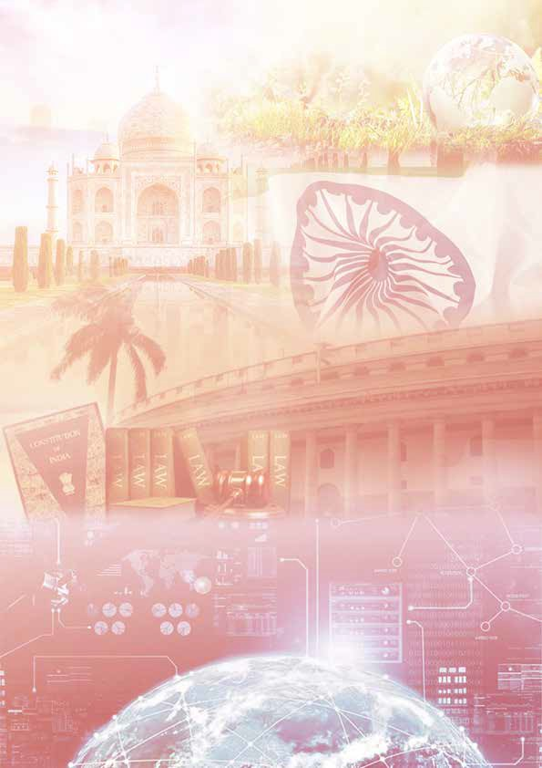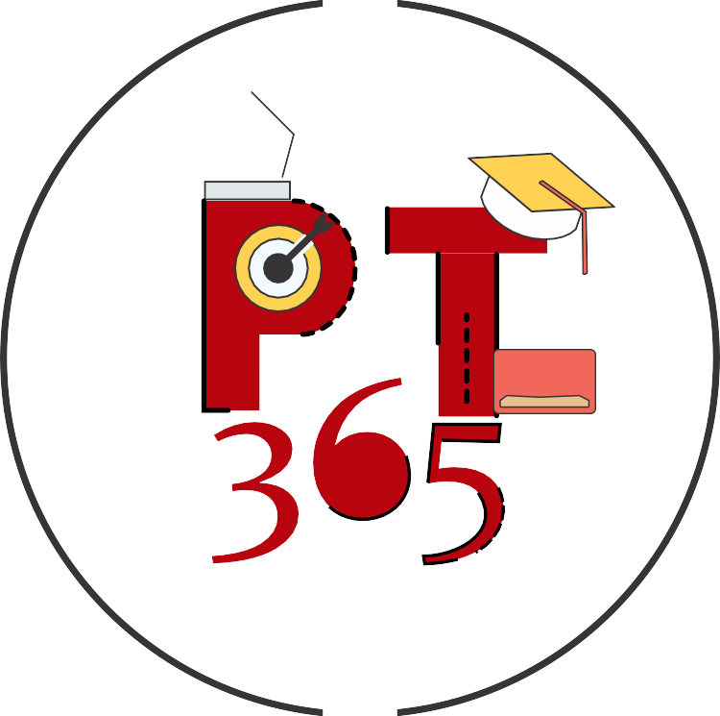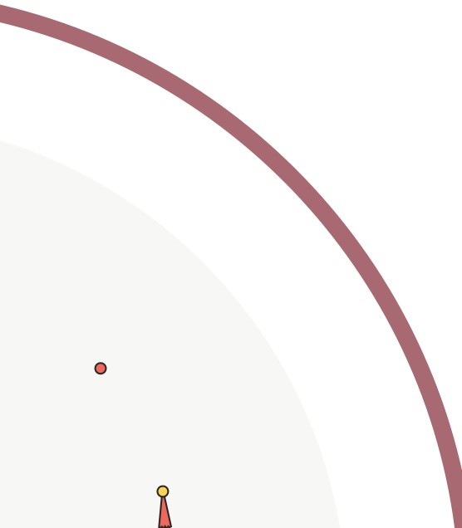

**PT 365 UPDATED 1**



**Table of Contents**

1. ***POLITY AND GOVERNANCE 4***
   1. **System of Judges Appointment in India _ 4**
   2. **Sedition Law in India 5**
   3. **Uniform Civil Code 5**
   4. **Government of National Capital Territory of Delhi (Amendment) Act (GNCTD) 2021 6**
   5. **Registered Unrecognized Parties 7**
   6. **Arbitration and Conciliation (Amendment) ACT, 2021 8**
   7. **Information Technology (Intermediary Guidelines and Digital Media Ethics Code) Rules, 2021 10**
      1. Guidelines Related to Social Media Intermediaries 11
      2. Guidelines Related to Digital media and OTT Platforms 12
   8. **Unlawful Activities [Prevention] Act 13**
   9. **Public Intent Data 14**
   10. **Overseas Citizens of India (OCI) Card _ 15**
   11. **Other Important News 15**
   12. **Errata 17**
2. ***INTERNATIONAL RELATIONS 19***
   1. **India and Persian Gulf region 19**
   2. **Suez Canal 20**
   3. **Comprehensive and Progressive Agreement for Trans-Pacific Partnership (CPTPP) 21**
   4. **Extradition 21**
   5. **Iran-Nuclear Agreement 22**
   6. **New START Nuclear Arms Treaty 24**
   7. **Organisation for the Prohibition of Chemical Weapons (OPCW) 24**
   8. **Other Organisations/Groups in News _ 26**
   9. **Critical Infrastructure 26**
3. ***ECONOMY 29***
   1. **Fiscal Policy 29**
      1. Fifteenth Finance Commission Report 29
      2. Wholesale Price Index 31
      3. Bond Yields 32
      4. Capital Gains Tax 34
      5. Equalization Levy 35
   2. **Banking and Monetary Policy 35**
      1. Digital Currency 42
      2. The Insurance (amendment) Act, 2021 43
   3. **External Sector 43**
      1. Free Trade Agreements 43
      2. International Monetary Fund (IMF) Quota

44

* 1. **Labour, Employment, Skill Development and Entrepreneurship 45**
     1. All-India Surveys 45
     2. Startup India Seed Fund (SISF) Scheme 46
  2. **Agriculture 47**
     1. Agricultural Infrastructure Fund (AIF) 47
     2. Other Agriculture Related Developments 48
  3. **Industry and associated issues 48**
     1. Production Linked Incentive (PLI) Scheme48
     2. Vehicle Scrapping Policy 50
     3. Companies (Corporate Social Responsibility (CSR) Policy) Amendment Rules, 2021 51
     4. Copyright (Amendment) Rules, 2021 53
  4. **Infrastructure 55**
     1. Major Port Authorities Bill, 2020 55
  5. **Indices in News 56**
  6. **Economic Concepts in News 57**
  7. **Economic Organizations in News 59**

1. ***ENVIRONMENT 60***
   1. **Climate Change 60**
      1. Climate-resilient Grains 60
      2. National Climate Vulnerability Assessment Report 61
      3. India’s Third Biennial Report to UNFCCC_ 63
      4. Other Global Initiative Related to Climate Change 64
   2. **Pollution 65**
      1. Commission for Air Quality Management (CAQM) 65
      2. New Emission Norms For Coal-Fired Power Plants 65
      3. Marine Litter 66
      4. Second World Ocean Assessment report 68
      5. Illegal Sand mining 69
   3. **Biodiversity 70**
      1. The Nagoya Protocol on Access and Benefit- sharing (ABS) 70
      2. National Marine Turtle Action Plan 2021-26
      3. Asset Reconstruction Company (ARC) 35 71
      4. National Bank for Financing Infrastructure And Development (NaBFID) 36
      5. Regulatory Review Authority 2.0 38
      6. Integrated Ombudsman Scheme 38
   4. **Payment Systems and FInancial Markets**

**39**

* + 1. New Umbrella Entity 39
    2. Digital Payment Ecosystem 40
    3. African Elephants 74
    4. Indian Rhino Vision 2020 74
    5. India’s first inter-state Tiger Translocation Project Fails 76
    6. Asia Environmental Enforcement Award 77
    7. Miyawaki Technique of Urban Forest Management 77
    8. Coastal Zone Management Plan (CZMP)_ 78
    9. Flora and Fauna in News 79
    10. Protected Areas in News 80



* + 1. Other Conservation Measures 82
  1. **Sustainable Development 83**
     1. World Sustainable Development Summit 2021 83
     2. SEEA Ecosystem Accounting (SEEA EA) 83
     3. Geothermal Energy 85
     4. Ethanol Blending 86
     5. Earth Hour 2021 87
     6. National River Linking Project (NRLP) 87
     7. Jal Jeevan Mission Urban 89
     8. Jal Shakti Abhiyan: Catch the Rain Campaign

90

* + 1. Sustainable Food Systems 91
    2. Other Important News 92
  1. **Disaster Management and geography _ 94**
     1. Flood Management 94
     2. Cloudbursts 95
     3. Atlantic Meridional Overturning Circulation (AMOC) 96
  2. **Reports in News 97**
     1. The Global Forest Goals Report 2021 97
     2. Other important Reports 97
  3. **Errata 100**

1. ***SOCIAL ISSUES 101***
   1. **Women and Child 101**
      1. Protection of Children from Sexual Offences (POCSO) Act, 2012 101
      2. Two-child Policy 102
      3. Medical Termination of Pregnancy (Amendment) Bill, 2020 102
      4. Reproductive Health 103
      5. Women and Men in India Report 104
      6. Global Gender Gap Report 105
   2. **Other Vulnerable Sections 106**
      1. State of the World’s Indigenous Peoples106
   3. **Education 108**
   4. **Health 108**
      1. Pradhan Mantri Swasthya Suraksha Nidhi (PMSSN) 108
      2. Other Initiatives in News 109
   5. **Nutrition and sanitation 109**
      1. Swachh Survekshan (SS) 2021 109
   6. **Miscellaneous 110**
      1. Other Important News 110
      2. World Happiness Report 2021 111
2. ***SCIENCE AND TECHNOLOGY 113***
   1. **BioTechnology 113**
      1. Genetically Modified (GM) Food crops _ 113
      2. Genome mapping in Indian Ocean 114
   2. **IT & Computer 115**
      1. National Strategy on Blockchain 115
      2. Artificial Intelligence (AI) 116
      3. Non-Fungible Token 118
      4. Satellite Based Internet Connectivity 119
      5. New Initiatives by National Internet Exchange of India 120

6.2.6. Other Important News 121

* 1. **Research and Development 121**
     1. AIM-PRIME (Program for Researchers on Innovations, Market-Readiness & Entrepreneurship) 121
     2. Other Important News 122
  2. **Space Technology 122**
     1. Humans in Space Policy 122
     2. Geo Spatial Data 124
     3. NASA’s Mars 2020 Perseverance Rover Mission 125
     4. Satellite launch vehicles by ISRO 126
     5. Space Debris 127
     6. Pink Moon 129
     7. The Unicorn–Closest Black Hole to Earth Ever Discovered 129
     8. Space Hurricane 131
     9. Novel technique for tracking Coronal Mass Ejections (CMEs) 132
     10. Miscellaneous 132
  3. **Health 134**
     1. Rare Diseases 134
     2. Malaria 135
     3. Reducing Risk of Zoonoses In Food Production 136
     4. Medical Oxygen 137
     5. Immunisation Agenda 2030 139
     6. Intensified Mission Indradhanush 140
     7. Integrated Health Information Platform (IHIP) 140
     8. Other important News 141
  4. **Defence 142**
  5. **Alternative Energy 142**
     1. National Hydrogen Energy Mission 142
     2. Aluminium-air Batteries 144
  6. **Miscellaneous 145**
     1. Large Hadron Collider Beauty Experiment (LHCb) 145
     2. Other Important News 146

1. ***CULTURE 148***
   1. **Sculpture and Architecture 148**
      1. Ancient buddhist monastery 148
      2. Ahom Kingdom 149
      3. Art Forms in news 151
   2. **Historical Events 151**
      1. Gurudwara Reform Movement 152
      2. Chauri Chaura 152
   3. **Personalities in News 153**
   4. **Festivals 154**
      1. Kumbh Mela 154
      2. 14th April: How India celebrates its new year

155

* 1. **Miscellaneous 156**

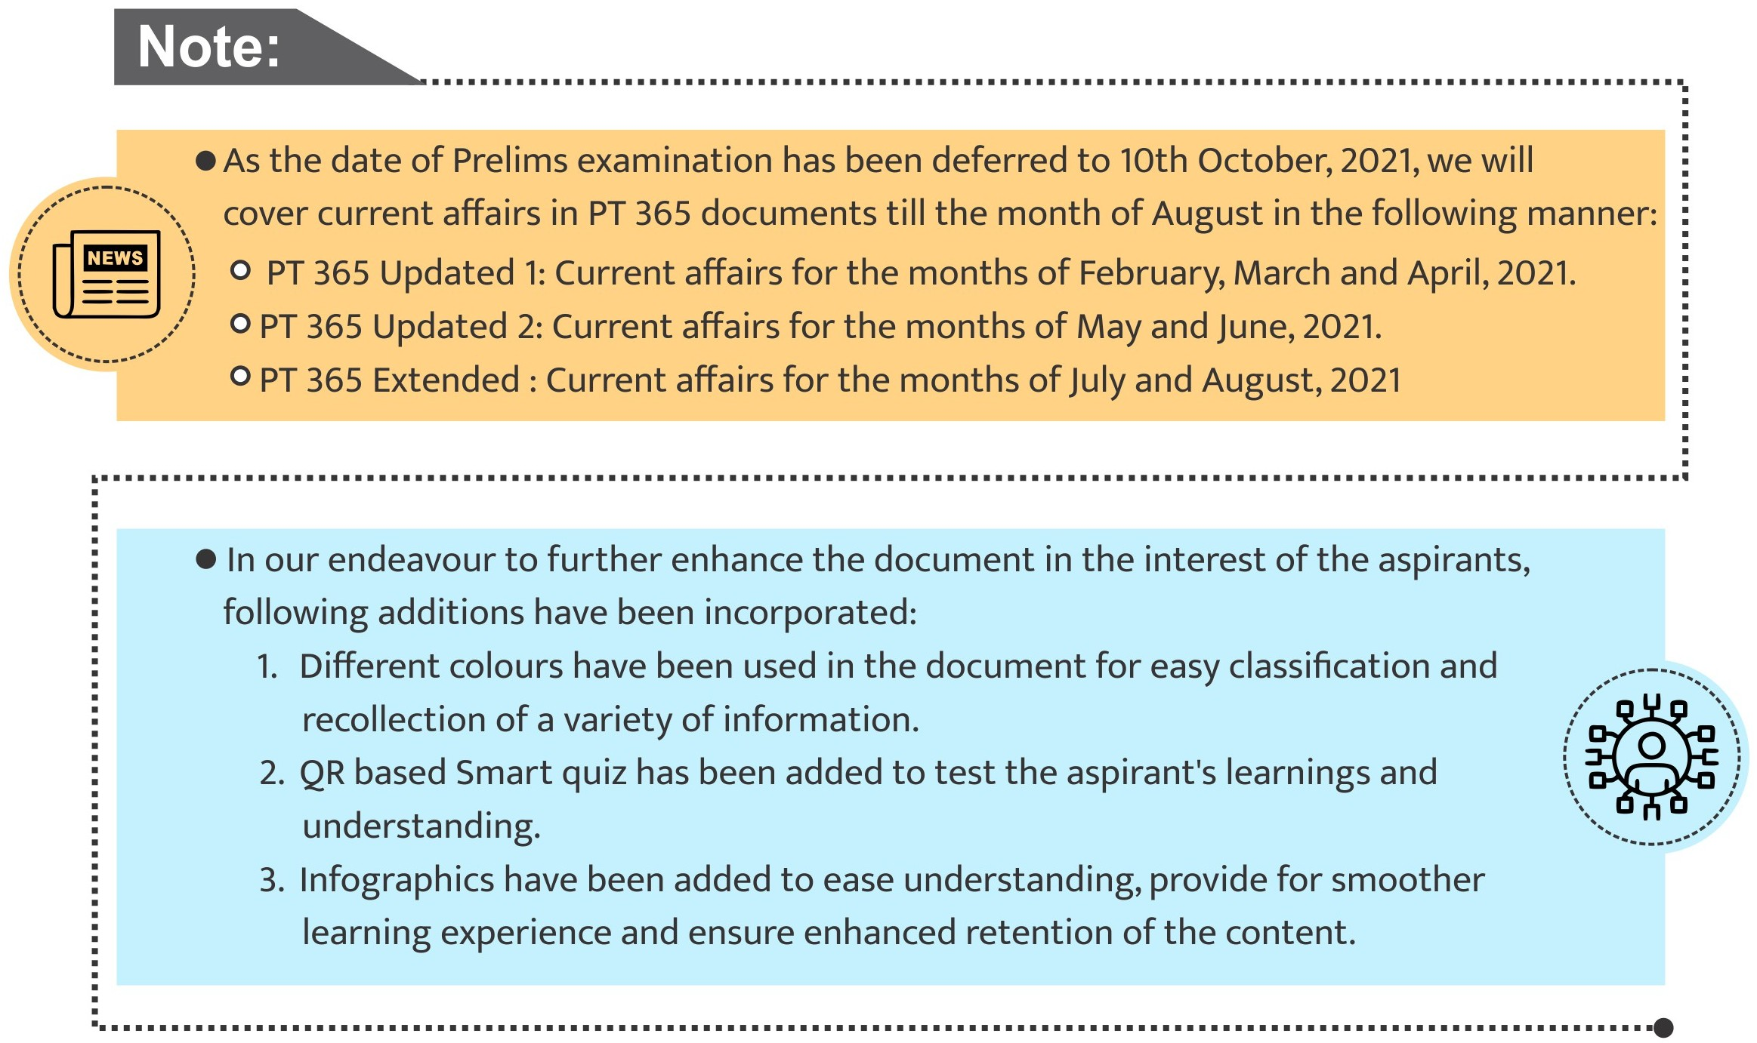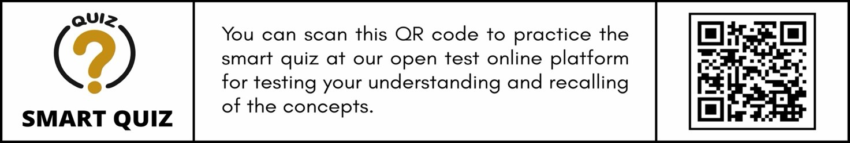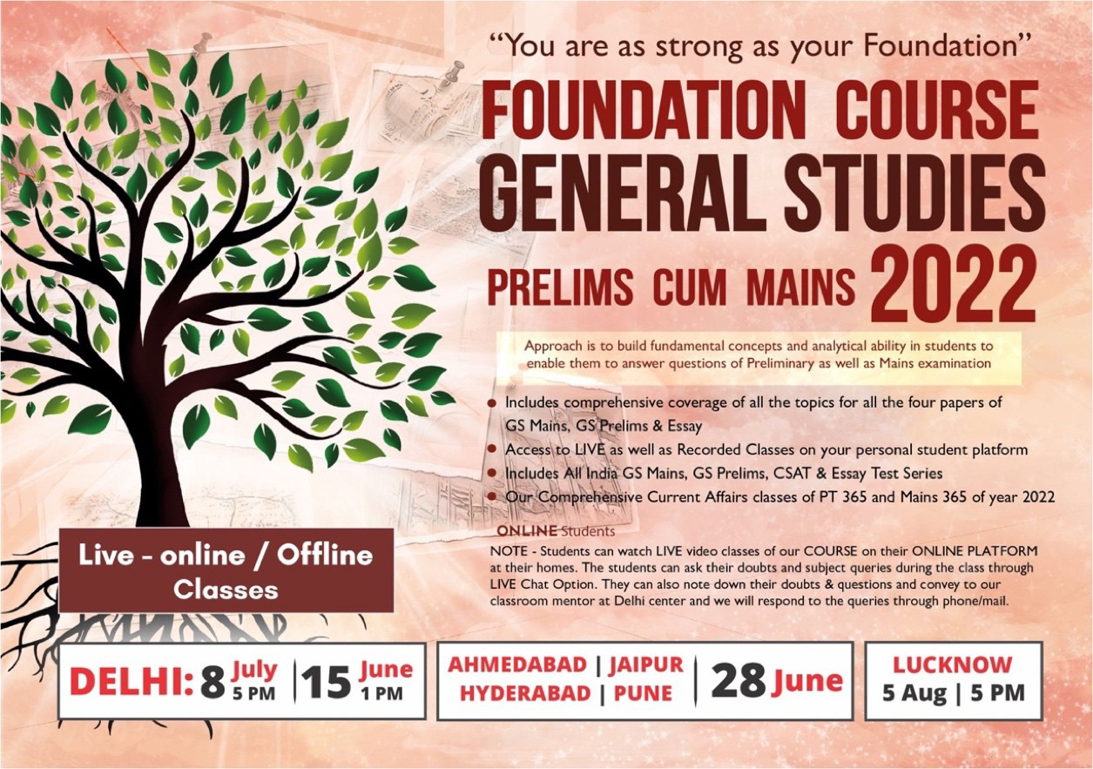

**Copyright © by Vision IAS**

*All rights are reserved. No part of this document may be reproduced, stored in a retrieval system or transmitted in any form or by any means, electronic, mechanical, photocopying, recording or otherwise, without prior permission of Vision IAS.*

# POLITY AND GOVERNANCE

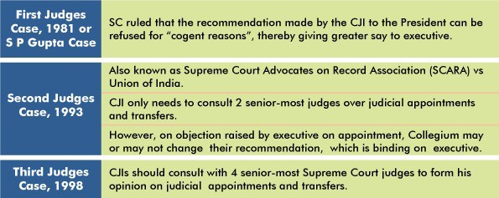

### 1.1. SYSTEM OF JUDGES APPOINTMENT IN INDIA

##### Why in news?

**Related Information:**

* **National Judicial Appointment Commission (NJAC): 99th Constitutional Amendment Act** created NJAC as proposed constitutional body to replace the Collegium system of appointing judges.

o However, **SC struck down the Act as it violates the independence of judiciary** and **Principle of Separation of Powers between the executive and judiciary**, which is a basic feature of the Constitution. Thus, restoring the Collegium System of appointment of Judges.

* **Draft Memorandum of Procedure, 2016:** The government drafted a fresh set of guidelines for making appointments to the higher judiciary. However, there is **lack of agreement between government and judiciary as of now.**

Recently, the Supreme Court asked the government to **clarify on the status of 55 recommendations made by the Collegium** for judicial appointments to various High Courts.

##### System of Judges appointment in India

* **Constitutional mandate:**
  + **Article 124**: President shall make SC Judges appointments after consulting with the Chief Justice of India (CJI) and other SC and HC judges as he considers necessary.
  + **Article 217:** For **HC judges’ appointment, President (under)** should consult the CJI, Governor, and Chief Justice of the High Court concerned.
* **Collegium system:** It is a system where a **committee of the Chief Justice of India, four senior judges of the Supreme Court and three members of a high court** (in case of appointments in the said high courts) take decisions related to **appointments and transfer of judges** in the Supreme Court and High Courts.
  + The **three judge cases** have come from 1981 to 1998 which **sets the collegium system** for appointing judges.

**Three Judges Cases**

**Related news**

**SC invoked Article 224A for the appointment of retired judges as ad hoc judges** to the high courts, especially those which have a lot of pending cases.

**About Ad-hoc Judges**

* **Article 127 and 224 and 224A** provides for appointment of Ad-hoc judges to SC and HC.
* Under **Article 127**, to address lack of quorum of judges, the Chief Justice of India, with the previous consent of the President and after consultation with the Chief Justice of the High Court concerned can appoint a judge as an ad hoc Judge.
* Under **Article 224**, additional or acting judges can be appointed for a period not exceeding 2 years or 62 years of age whichever is earlier to address a temporary rise in the business of the HC.
* **Article 224A** of the Constitution allows the Chief Justice of a HC to appoint a person who has been a judge earlier to sit as a judge of the court with the previous consent of the President.

o This has only been invoked thrice in the past and has more or less stayed dormant for years.

### 1.2. SEDITION LAW IN INDIA



##### Why in news?

**Supreme Court judgement on sedition law**

* **Kedar Nath Vs State of Bihar (1962):** The **Court upheld the constitutionality of sedition law** on the basis that this power was required by the state to protect itself.

o However, it had **added a vital caveat that "a person could be prosecuted for sedition only if his acts caused incitement to violence or intention or tendency to create public disorder or cause disturbance of public peace".**

* **Balwant Singh v. State of Punjab (1995):** Supreme Court had clarified that **merely shouting slogans** which evoked no public response **does not amount to sedition.**

**Viewpoint of Law Commission(LC) of India on Sedition**

* In its **39th Report (1968**), the LC had rejected the idea of repealing the section.
* In its **42nd Report (1971),** the panel wanted the scope of the section to be expanded to cover the Constitution, the legislature and the judiciary, in addition to the government established by law.
* In **267th Report (2017),** the LC distinguished between sedition and hate speech, providing that the offence of hate speech affects the State indirectly by disturbing public tranquillity, while the sedition is directly an offence against the State.
* In 2018, the LC **published a consultation paper recommending that it is time to re-think or repeal the Section 124A of the Indian Penal Code** that deals with sedition.
* In the recent consultation paper on the sedition, the **Law Commission has suggested invoking 124A to only criminalize acts committed with the intention to disrupt public order** or to overthrow the Government with violence and illegal means.

Supreme Court rejected a plea urging it to re- examine the constitutional validity of Section 124A of IPC, which deals with sedition.

##### Background

* The law was **originally drafted in 1837 by Thomas Macaulay**, the British historian- politician, **but was inexplicably omitted** when the IPC was enacted in 1860.
* Section **124A was inserted in 1870** by an amendment introduced by Sir James Stephen when it felt the need for a specific section to deal with the offence. It was one of the many draconian laws enacted to stifle any voices of dissent at that time.

##### The first case was registered in 1891, when Jogendra Chandra Bose, editor of a newspaper ‘Bangobasi’ was booked for publishing an article criticising “Age of Consent Bill”.

* **Bal Gangadhar Tilak, Annie Besant, the Ali Brothers, Maulana Azad, Gandhi** and very many others suffered imprisonment under this law.

##### About Sedition

* **Indian Penal Code** defines sedition **(Section 124A)** as an **offence committed** only when **any person brings or attempts to bring into hatred or contempt**, or

##### excites or attempts to excite disaffection towards the government established by law in India by:

* + **words**, either **spoken or written**
  + **signs**
  + **visible representation**, or **otherwise**
* **‘Disaffection’ includes disloyalty** and **all feelings of enmity**.
* Sedition case **comes under Offences Against State category** that also includes cases filed under Unlawful Activities Prevention Act, damage to property Act, Official Secrets Act etc.
* It is a **non-bailable offence**. **Punishment** ranges from imprisonment up to 3 years to a life term, to which fine may be added.
* A person charged under this law is **barred from a government job**. They have to live without their passport and must produce themselves in the court at all times as and when required.

### 1.3. UNIFORM CIVIL CODE

##### Why in news?

Recently, the Supreme Court sought a reply from the Centre on a PIL (Public Interest Litigation) seeking gender and religion-neutral uniform grounds of succession and inheritance for citizens in the country.

##### About Uniform Civil Code (UCC)

* A UCC refers to a **single law, applicable to all citizens of India in their personal matters** such as marriage, divorce, custody, adoption and inheritance.
* A UCC is intended to **replace the system of fragmented personal laws,** which currently govern interpersonal relationships and related matters within different religious communities.
* **Article 44 of the Constitution** lays down that the ‘State shall endeavor to secure a Uniform Civil Code for the citizens throughout the territory of India.’

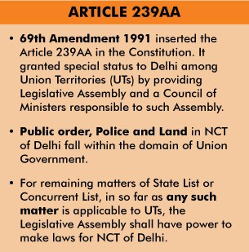

**Governance of personal laws in India**

* At present **different religious communities in India are currently governed by a system of personal laws**. These laws largely focus on the following areas:
  + Marriage and divorce
  + Custody and Guardianship
  + Adoption and Maintenance
  + Succession and Inheritance
* **Hindu personal law is codified in four Acts**: the Hindu Marriage Act, Hindu Succession Act, Hindu Minority and Guardianship Act, and Hindu Adoptions and Maintenance Act.
  + **The term ‘Hindu’ also includes Sikhs, Jains and Buddhists** for the purpose of these laws.

•

•

•

**Muslim personal law** is not codified per se and **is based on their religious texts.**

In the Northeast, there are more than 200 tribes with their own varied customary laws. **The Constitution protects local customs in Nagaland**, **Meghalaya and Mizoram.** Even reformed Hindu law, in spite of codification, protects customary practices.

**Goa is, at present, the only state in India with a uniform civil code.**

* The **Portuguese Civil Code of 1867** which continues to be implemented after India annexed Goa in 1961, **applies**

**to all Goans, irrespective of their religious or ethnic community**.

* However, the Portuguese Code is not a completely uniform civil code. It makes certain provisions on religious bases. The most notable example **is Hindu men being allowed bigamy if the wife fails to deliver a child** by the age of 25, **or a male child** by the age of 30.

**1.4.**

**GOVERNMENT**

**OF NATIONAL**

**CAPITAL TERRITORY OF DELHI (AMENDMENT) ACT (GNCTD) 2021**

* + Article 44 is one of the **Directive Principles of State Policy.** These, as defined in Article 37, are **not justiciable** (not enforceable by any court) but the principles laid down therein are **fundamental in governance.**

##### Why in news?

Recently, **Government of National Capital Territory of Delhi (Amendment) Act (GNCTD) 2021** was passed.

##### Need of the Law

* 2021 Act **amends GNCTD Act, 1991** and gives certain powers and responsibilities to the Legislative Assembly and the Lieutenant Governor (LG), in line with the constitutional scheme of governance of NCT.

##### It promotes harmonious relations between the legislature and the

**Related information Puducherry Case**

* Earlier, CM of Puducherry **has protested against continual interference of the LG i**n the daily affairs of the Puducherry government and running an alleged parallel administration.
* The Madras HC, quashing the clarification of Central Government, ruled that the **LG must work on the aid and advice of the Council of Ministers** and not interfere in the day-to-day affairs of the government.
* **Article 239A(1)** allows Parliament to create a law for Puducherry and thus Parliament enacted **Government of Union Territories Act, 1963** which governs Puducherry and vests the legislative assembly with the power to make laws on **any of the matters** enumerated in the **State List or the Concurrent List**.
* Recently, President’s rule was imposed in Puducherry on recommendation of **Lieutenant Governor** as no party claimed to form a government following **loss of vote of confidence by the previous government**.

**executive.**

* The Centre stated that there **was no structural mechanism within the 1991 Act** to ensure time- bound implementation of the rules.
  + Also, the **law gives no clarity about what proposal or matters need** to be taken up with the LG before issuing any order.
  + The Centre has also

stated that this amendment has been brought **to give effect to the "interpretation made by Hon'ble Supreme Court** in Government of NCT of Delhi v. Union of India (UoI) case, 2018."

**About the 2021 Act**

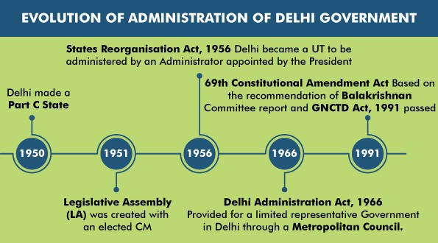

|  |  |  |
| --- | --- | --- |
| **Specification** | **GNCTD (Amendment) Act, 2021** | **Govt of NCT of Delhi Vs UoI, 2018** |
| **Meaning of “government”** | * **The term “government”** in any law made by the Legislative Assembly **shall mean the L-G.** | * The **L-G would be bound by the aid and advice of the Council of Ministers (CoM)** in matters that were not directly under the control of the L-G. |
| **L-G’s**  **concurrence on executive orders** | * All executive action by the government, whether taken on the advice of the Ministers or otherwise, must be taken in the name of the LG. * On certain matters, as specified by the LG, his opinion must be obtained before taking any executive action on the decisions of the Minister/ Council of Ministers. | * **Barring police, public order and land the L-G’s concurrence is not required** on other issues. * However, the **decisions of the CoM will have to be communicated to the L-G.** * **Requiring prior concurrence** of the Lieutenant Governor would absolutely **negate the ideals of representative governance** and democracy conceived for the NCT of Delhi by **Article 239AA of**   **the Constitution.** |
| **Inquiry by the Assembly into administrative decisions** | * Legislative Assembly shall **not make any rule to enable itself or its Committees to consider the matters of day-to-day administration** of the Capital or conduct inquiries in relation to the administrative decisions. * **Any of the rule made in contravention of this provision**, before the commencement of the   GNCTD Act, 2021, **shall be ‘void’.** |  |
| **LG’s assent to Bills passed by the Legislative Assembly** | * The L-G will **not assent to and pass on to the President** for consideration any Bill which “incidentally covers any of **the matters which falls outside the purview of the powers conferred on the Legislative Assembly”.**   o The L-G has the power to refer any matter, over which there is a disagreement with the  elected government, to the President under Article 239AA (4). |  |

### 1.5. REGISTERED UNRECOGNIZED PARTIES

##### Why in News?

Recently, a report by Association for Democratic Reforms (NGO) presented several **findings on registered unrecognised political parties (RUPP).**

##### Benefits of recognized political party

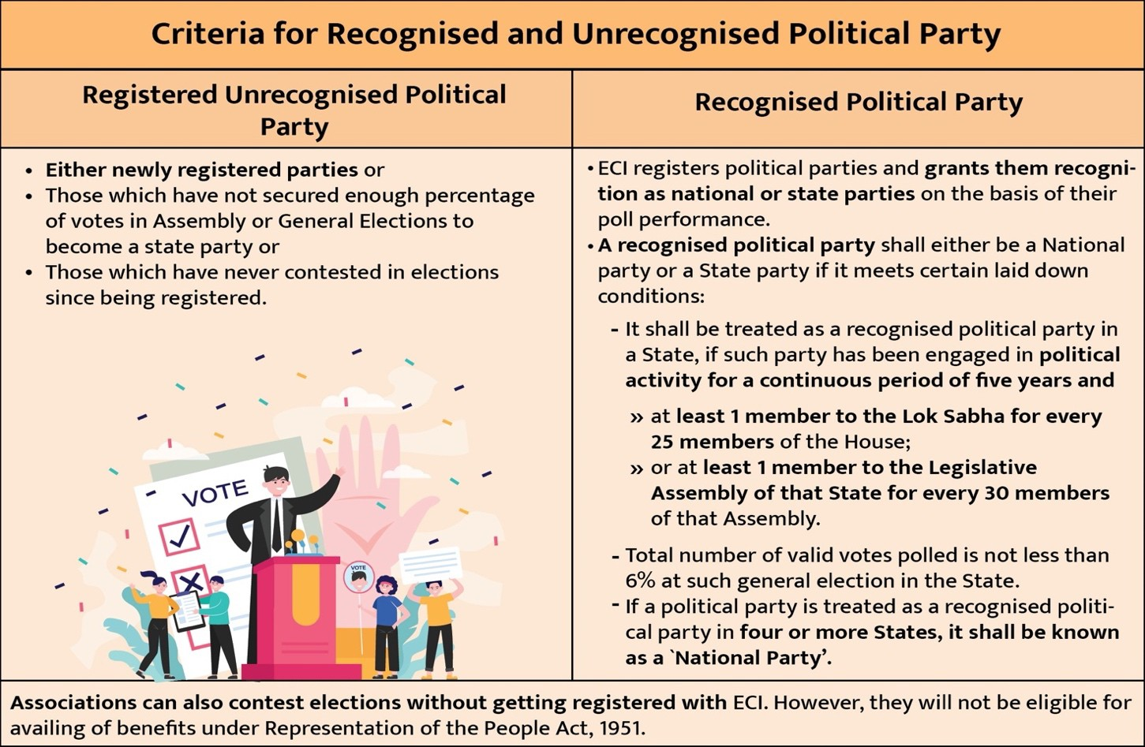

* **Exclusive allotment of election symbols** to the candidates fielded by the party. A RUPP can select a symbol only from a list of free symbols.
* **Need only one proposer** for filing the nomination.
* **Entitled for two sets of electoral rolls** free of cost.
* **Get broadcast/telecast facilities** over Akashvani/Doordarshan during general elections.
* **Can have a maximum of 40 Star campaigners** and a RUPP can nominate a maximum of 20 Star Campaigners.
* **Eligible for subsidized lands** for party offices.

### 1.6. ARBITRATION AND CONCILIATION (AMENDMENT) ACT, 2021

##### Why in news?

Recently, Parliament enacted the Arbitration and Conciliation (Amendment) Act, 2021.

##### Background

* **The Arbitration and Conciliation Act, 1996** was enacted with a view to consolidate and amend the law relating to domestic arbitration, international commercial arbitration, enforcement of foreign arbitral awards and the law relating to conciliation.
* Further, the act was **amended in 2015**, to make arbitration process user friendly, cost effective and ensure speedy disposal and neutrality of arbitrators.
* It was **again amended in 2019** to promote institutional arbitration in the country.
* **Arbitration and Conciliation (Amendment) Ordinance, 2020** was brought to ensure that all the stakeholder parties get an opportunity to seek unconditional stay of enforcement of arbitral awards.

##### About Arbitration and Conciliation (Amendment) Act, 2021

* Arbitration and Conciliation (Amendment) Act, 2021 replaces the **Arbitration and Conciliation (Amendment) Ordinance, 2020**.

##### Key features of the Act:

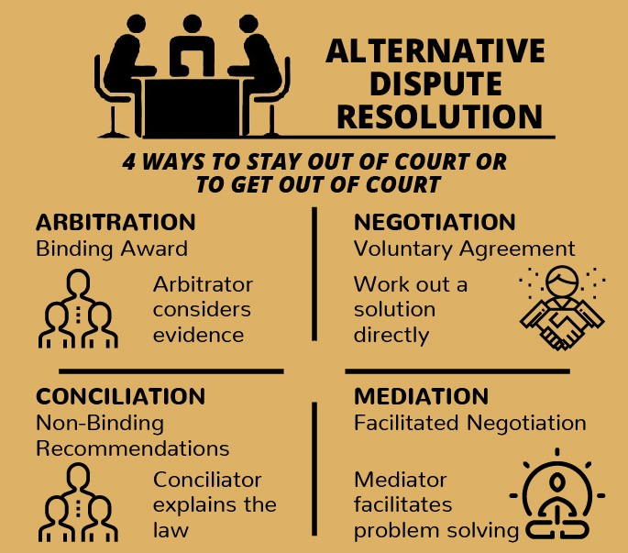

**Alternative Dispute Resolution (ADR) mechanism**

* Arbitration and Conciliation are **modes of the Alternative Dispute Resolution (ADR) mechanism**, in which disputes are settled without litigation.
* ADR mechanism **facilitate parties to deal with the underlying issues in dispute in a more cost-effective manner and with increased efficacy**.
  + **Automatic stay on awards:** Bill clarifies that a stay on the arbitral award may be granted by the Court, even during the pendency of the setting aside application, if it is prima facie satisfied that the relevant arbitration agreement was **induced by fraud or corruption.**
    - Presently, 1996 Act **allowed a party to file an application to set aside an arbitral award.** However, according to 2015 Act, **an automatic stay would not be granted** on operation of the award by mere filing an application for setting it aside..
  + **Qualifications of arbitrators:** Bill removes 8th Schedule for arbitrators and states that the qualifications, experience, and norms for accreditation of arbitrations will be specified under the regulations by Arbitration Council of India (ACI).
    - **1996 Act specified certain qualifications, experience, and accreditation** norms for arbitrators in a separate 8th schedule. Further, the general norms applicable to arbitrators include that they must be conversant with the Constitution of India.

**About Arbitration Council of India (ACI)**

* **Arbitration and Conciliation (Amendment) Act 2019** seeks for the **establishment and incorporation of an independent body namely, Arbitration Council of India (ACI).**
* ACI is set for **grading of arbitral institutions and accreditation of arbitrators.**
* **ACI will be headed by a Chairperson,** who has been a **Judge of the Supreme Court or a Chief Justice or Judge of a High Court or an eminent person** appointed by central government in consultation with the Chief Justice of India.

o Other members will include an eminent arbitration practitioner, an academician with experience in arbitration, and government appointees.

* + - According to 8th Schedule,

arbitrator must be:

* + - * an advocate under the Advocates Act, 1961 with 10 years of experience, or
      * an officer of the Indian Legal Service, among others.

**Related News:**

**NITI Aayog Launched Online Dispute Resolution (ODR) Handbook About Online Dispute Resolution (ODR)**

* ODR is the **resolution of disputes outside courts**, particularly of small and medium-value cases, using digital technology and techniques of **alternate dispute resolution (ADR),** such as negotiation, mediation, and arbitration.
* ODR realizes the notion that ‘courts should be a service not a place’.
* The **developments in information and communication technology (ICT)** and **increased access to internet** has played a key role in ODR.
* ODR play a key role in achieving the ideal enshrined in Indian constitution of **‘access to justice’ for all**.
* **Models under ODR:**
  + **Opt-in model:** It is voluntary to enter into mediation
  + **Opt-out model:** It is mandatory to enter into mediation for at least one session, and then the parties have the liberty to opt out if they feel so

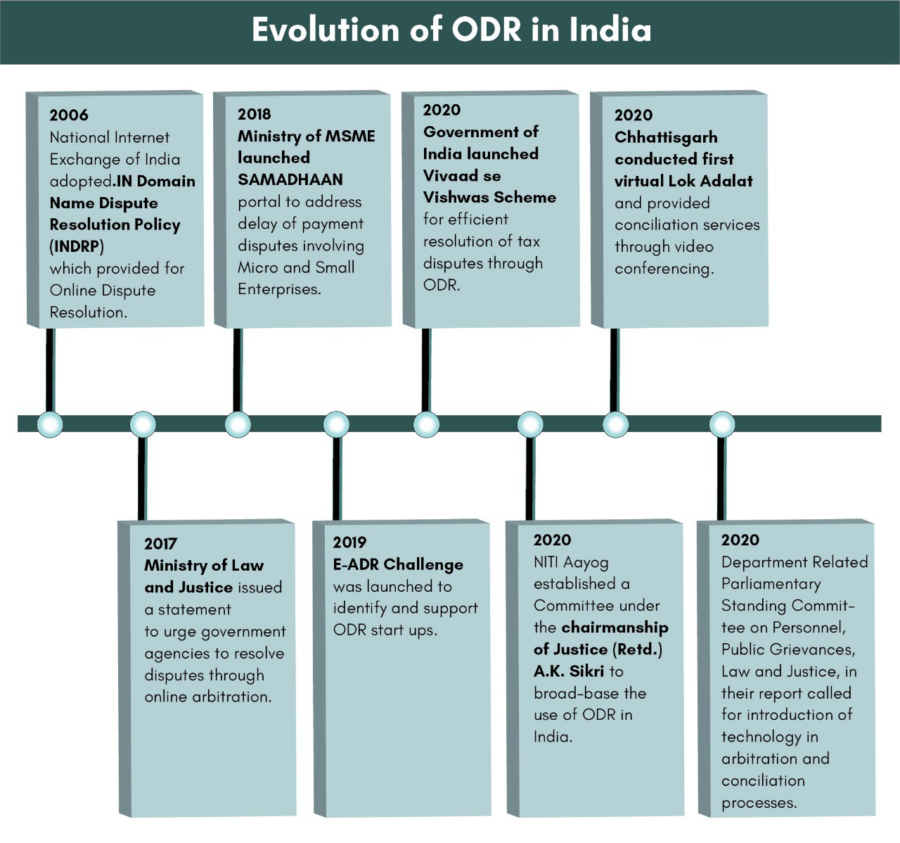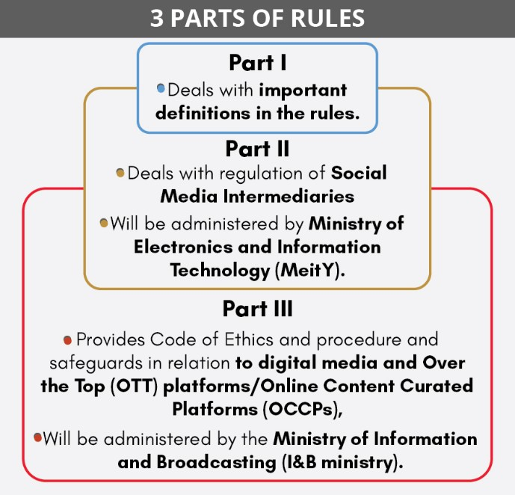

**1.7. INFORMATION TECHNOLOGY (INTERMEDIARY GUIDELINES AND DIGITAL MEDIA ETHICS CODE) RULES, 2021**

##### Why in news?

The Government of India recently notified Information Technology (Intermediary Guidelines and Digital Media Ethics Code) Rules 2021.

##### About Information Technology (Intermediary Guidelines and Digital Media Ethics Code) Rules, 2021

* Rules 2021 has been framed by the Central Government in exercise of powers under **section 87 (2) of the Information Technology Act, 2000** and in supersession of the earlier Information Technology (Intermediary Guidelines) Rules 2011.

**1.7.1. GUIDELINES RELATED TO SOCIAL MEDIA INTERMEDIARIES**

##### Key provisions



**Important definitions**

* **Digital media** means digitized content that can be transmitted over the internet or computer networks and includes content received, stored, transmitted, edited or processed by-
  + an **intermediary;** or
  + a **publisher of news and current affairs content** or a publisher of online curated content;
* **News and current affairs** includes newly received or noteworthy content including analysis, especially about recent events primarily of socio-political, economic or cultural nature, made available over the internet or computer networks,
  + Any digital media shall be news and current affairs content where the context, substance, purpose, import and meaning of such information is in the nature of news and current affairs content.

•

•

**Social media intermediary** means an intermediary which

primarily or solely enables online interaction between two or more users and allows them to create, upload, share, disseminate, modify or access information using its services. **Significant social media intermediary (SSMI**) means a social media intermediary having number of registered users in India, above such threshold as notified by the Central Government.

o The threshold for SSMI has been set at **50 lakh (5 million) registered users.**

•

**Online curated content** means any curated catalogue of

audio-visual content, other than news and current affairs content and made available on demand etc.

* **Publisher of news and current affairs content** means an online paper, news portal, news aggregator, news agency which is functionally similar to publishers of news and current affairs content but shall not include newspapers, replica e-papers of the newspaper and any individual or user who is not transmitting content in the course of systematic business, professional or commercial activity.
* **Due diligence to be followed by intermediaries:** Rules prescribe due diligence that must be followed by social media intermediaries like retention of user information for a period of 180 days, reporting cyber security incidents etc.
  + In case, due diligence is not followed by the intermediary, **safe harbour provisions will not apply to them.**
  + These **safe harbour provisions have been defined under Section 79 of the IT Act**, and protect social media intermediaries by giving them immunity from legal prosecution for any content posted on their platforms.
* **Grievance Redressal Mechanism:** Intermediaries shall appoint a Grievance Officer to deal with complaints and share the name and contact details of such officer.
  + Grievance Officer shall acknowledge the **complaint within 24 hours and resolve it within 15 days from its receipt.**
* **Ensuring Online Safety and Dignity of Users, especially Women Users:** Intermediaries shall remove or disable access within 24 hours of receipt of complaints of contents that exposes the private areas of individuals or is in the nature of impersonation including morphed images etc.

##### Two Categories of Social Media

**Intermediaries i.e., social media intermediaries and significant social media intermediaries (SSMI):** This distinction is done to encourage innovations and enable growth of new social media intermediaries without subjecting smaller platforms to significant compliance requirement.

##### Additional due diligence to be followed by SSMI include:

* + **Appointment of a Chief Compliance Officer** for ensuring compliance with the Act and Rules**,**
  + **Appointment of Nodal Contact Person** for 24x7 coordination with law enforcement agencies
  + **Appointment of a Resident Grievance Officer** to perform the functions mentioned under Grievance Redressal Mechanism. These above officers must be residents of India.
  + **Publishing a monthly compliance report** mentioning the details of complaints received, action taken on the complaints and details of contents removed.
  + **Identification of the first originator of the information**: SSMI providing services primarily in the nature of messaging shall enable identification of the first originator of the information (without requiring disclosing the contents of any message) that is required **only for the purposes of prevention, detection, investigation, prosecution or punishment of an offence related to:** (refer to infographics given below)
  + **Publication of a physical contact address in India** on its website or mobile app or both.
  + **Deployment of technology-based measures**: To proactively identify information that depicts any act or simulation in any form depicting rape, child sexual abuse or conduct etc.

o **Voluntary User Verification Mechanism:** Users who wish to verify their accounts voluntarily to be provided an appropriate mechanism to do so with provision of demonstrable and visible mark of verification.

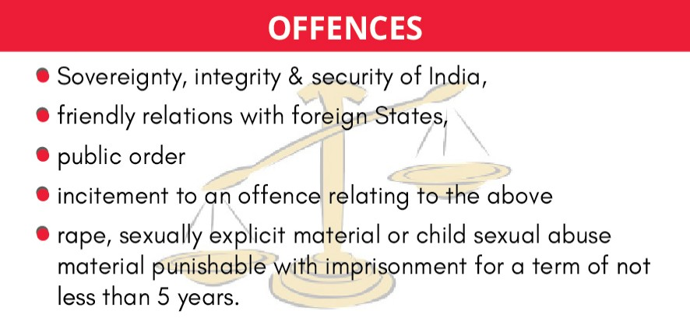

* + **Giving users an opportunity to be heard:** In cases where significant social media intermediaries removes or disables access to any information on their own accord, then a prior intimation should be communicated to the user explaining the grounds and reasons for such action and

the user must be provided an adequate and reasonable opportunity to dispute the action.

* **Removal of Unlawful Information:** An intermediary upon receiving order by a court or being notified by the Appropriate Govt. or its agencies should not host or publish any information which is prohibited under any law in relation to the interest of the sovereignty and integrity of India, public order, friendly relations with foreign countries etc.

**1.7.2. GUIDELINES RELATED TO DIGITAL MEDIA AND OTT PLATFORMS**

##### Key provisions

Rules establish a soft-touch **self-regulatory architecture and a Code of Ethics and three tier grievance redressal mechanism** for news publishers and OTT Platforms and digital media**.** They have been notified under **section 87 of IT Act** empowering the I&B Ministry to implement this part of the Rules which prescribe the following:

##### Code of Ethics

* **As applicable to OTT platforms:**
  + OTT platforms, called as the publishers of online curated content in the rules, would **self-classify the content into five age-based categories**- U (Universal), U/A 7+, U/A 13+, U/A 16+, and A (Adult) based on factors such as themes and messages, violence, nudity, drug and substance abuse etc.
  + **Platforms would be required to implement parental locks for content** classified as U/A 13+ or higher, and reliable age verification mechanisms for content classified as “A”.
  + **Platforms should prominently display the classification rating** specific to each content or programme together with a content descriptor and advisory on viewer discretion at the beginning of every programme enabling the user to make an informed decision, prior to watching the programme.
  + Measures to be taken to improve **accessibility of online curated content by persons with disabilities.**
  + **General Principles:** OTTs should-
    - **not** transmit/publish/exhibit **any content which is prohibited under any law** or by any court.
    - **take into consideration India’s multi-racial and multi-religious context** and ‘exercise due caution and discretion’ while featuring activities, beliefs, practices, or views of any racial or religious groups.
    - **take into consideration the factors such as sovereignty and integrity of India**, security of the State, public order etc. when deciding to feature or transmit or publish or exhibit any content.
* **As applicable to Publishers of News and current affairs on digital media**: They would be required to observe-
  + Norms of Journalistic Conduct of the Press Council of India under the Press Council Act, 1978;
  + Programme Code under section 5 of the Cable Television Networks Regulation Act, 1995;
  + Content which is prohibited under any law.

##### Three-level grievance redressal mechanism

* **Level-I: Self-regulation by the publishers**: Publisher shall appoint a Grievance Redressal Officer based in India who shall take decision on every grievance received by it within 15 days.
* **Level-II: Self-regulation by the self-regulating bodies of the publishers**: There may be one or more self- regulatory bodies of publishers. Such a body have to:

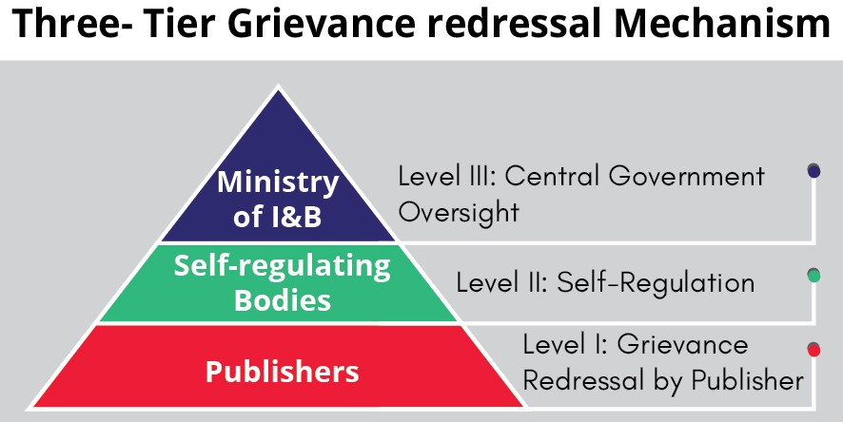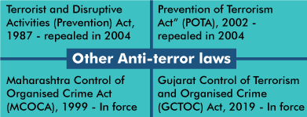

##### be headed by a retired judge of the Supreme Court, a High Court or independent eminent person

and have not more than 6 members.

* + be registered with the I&B Ministry.
  + **oversee the adherence by the publisher to the Code of Ethics** and address grievances that have not be been resolved by the publisher within 15 days.
* **Level-III: Oversight mechanism:** I&B Ministry shall formulate an oversight mechanism. It shall:
  + Publish a **charter for self-regulating bodies**, including Codes of Practices,
  + Issue orders and directions to the publishers for maintenance and adherence to the Code of Ethics,
  + **Establish an Inter-Departmental Committee for hearing grievances**: To examine complaints or grievances and make recommendations like warning, censuring, admonishing or reprimanding an entity, requiring an apology by an entity; deletion or modification of content etc.

##### Other Regulations

* **Blocking of information in case of emergency**: An Authorized Officer, in any case of emergency nature, will examine if it is necessary or expedient and justifiable to block content within the grounds referred to in sub-section (1) of section 69A of the Act.
* **Furnishing of information**: A publisher of news and current affairs content and a publisher of online curated content operating in the territory of India, shall
  + inform the Ministry about the details of its entity.
  + publish periodic compliance report every month mentioning the details of grievances received and action taken thereon.

### 1.8. UNLAWFUL ACTIVITIES [PREVENTION] ACT

##### Why in news?

Ministry of home affairs has stated that there was over 72% rise in number of UAPA (Unlawful Activities [Prevention] Act) cases in 2019 compared to 2015.

##### About UAPA

* The Unlawful Activities (Prevention) Act, 1967 (Act) was enacted to **provide for more effective prevention of certain unlawful activities of individuals and associations,** and for **dealing with terrorist activities,** and related matters.
* **Act defines “Unlawful activity”** as “any action taken by individual or association that leads to **cession of a part of the territory of India, questions the sovereignty of India or disrupt the integrity of India** etc.
* Under the Act, Central government can **declare a person or an organization as a terrorist/ terrorist organisation**, if it/ he:
  + commits or participates in acts of terrorism,
  + prepares for terrorism,
  + promotes terrorism, or
  + is otherwise involved in terrorism.
* It gives **powers to the central government to impose all-India bans on associations** which are declared ‘unlawful’ under the Act. It provides for **tribunal to review or to hear an appeal against the ban.**
* Both **Indian nationals and foreign nationals can be charged** under the Act. Also, Act holds offenders accountable in the same manner even if **crime is committed on foreign land outside India.**

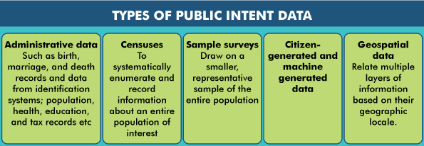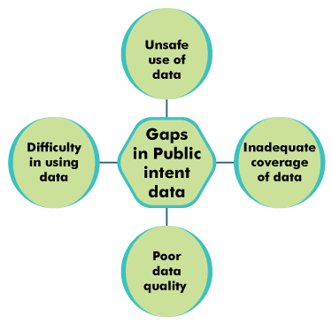

* Under the Act, Cases can be **investigated by both State police and National Investigation Agency (NIA).**

**Amendments to UAPA**

* **Amendments in 2004:** Criminalized indirectly supporting a terrorist organisation by raising of funds for a terrorist act or membership of a terrorist organization etc.
* **Amendments in 2008:** Broadened the scope of the provision of “funds” to ensure a wider coverage of the financing of terrorism offences.
* **Amendments in 2012:** Expanded the definition of “terrorist act” to include offences that threaten the country’s economic security.
* **Amendments in 2019:**
  + Government is empowered to **designate individuals as terrorists**. Earlier, only organisations could be designated as terrorist organisations.
  + If investigation is conducted by an officer of the National Investigation Agency (NIA), **approval of Director General of NIA would be required for seizure of property connected with terrorism**. (Earlier, approval of Director General of Police was required).
  + **Empowered officers of NIA**, of rank of Inspector or above, to investigate cases.
  + Added International Convention for Suppression of Acts of Nuclear Terrorism (2005) to the Schedule under the Act.

### 1.9. PUBLIC INTENT DATA

##### Why in News?

Recently, the **World Bank’s World Development Report** has highlighted the **concept of Public Intent Data.**

##### More about the Report

* The report has been released by World Bank in 2021 and is titled ‘**World Development Report 2021: Data for Better lives.’**
* Report explores the potential of data for public good. It presents **how public intent data can play a transformative role in the public sector.**

##### What is Public Intent Data?

* Public intent data is data **collected with the intent of**

**serving the public good** by informing the design, execution, monitoring, and evaluation of public policy, or through other activities.

* This data acts as a **prerequisite for many government functions and can improve societal well-being** by enhancing service delivery, prioritizing scarce resources, holding governments accountable, and empowering individuals.

### 1.10. OVERSEAS CITIZENS OF INDIA (OCI) CARD



##### Why in news?

Centre eased Norms for Re-issue of Overseas Citizens of India (OCI) Cards.

##### More on news

* Currently, OCI card is required to be **re-issued each time a new passport is issued up to 20 years** of age and **once after completing 50 years of age**, in view of biological changes in the face of the applicant.
  + This has been dispensed with and now OCI card has to be **reissued only once** when a new passport is issued after his/her completing 20 years of age.
  + **For others reissuance is not required. About OCI**

|  |  |
| --- | --- |
| **Who?** | * A **person registered as OCI cardholder** under section 7A of Citizenship Act, 1955. * Eligibility: A **foreign national who**   + was eligible to be citizen of India on 26th January, 1950   + is a child or a grandchild or a great grandchild of such a citizen   + is a spouse of citizen of India or of an OCI Cardholder with certain conditions etc. * Citizens of **Pakistan, Bangladesh or other country notified by Central Government are not eligible.** |
| **What**  **benefits one is**  **entitled to?** | * **Multiple entry lifelong visa** for visiting India for any purpose. * **Exemption from registration for any length of stay in India.** * **Parity with NRIs in**   + **financial, economic and educational fields** except in the acquisition of agricultural or plantation properties.   + **inter-country adoption** of Indian children   + **Pursuing professions**- Doctors, dentists, nurses, pharmacists, advocates, CAs.   + **Appearing for the All-India Pre-Medical Test or such other tests** * **Parity with the Indian nationals** for airfare tariffs for domestic travel and entry fees to any national parks, wildlife sanctuaries, national monuments, historical sites and museums in the country |
| **Restrictions**  **on OCI card holders** | * Special permission required **to undertake research work, internship or employment in any foreign**   **diplomatic missions,** foreign government organisations in India.   * **Not entitled to undertake Missionary, mountaineering, journalism and Tabligh activities** without prior permission. * **Require protected area (PA) permit/ Restricted Area (RA) Permit** to visit any place falling in PA/RA. * **Not entitled to vote, cannot hold constitutional post**. * **Not entitled for appointment to public services** and posts in connection with affairs of Union or states. |

### 1.11. OTHER IMPORTANT NEWS

|  |  |
| --- | --- |
| **Governing Council of NITI Aayog** | * Recently, sixth meeting of the Governing Council of NITI Aayog was held under the chairmanship of Prime Minister * Council deliberated on several steps for making India a manufacturing powerhouse, such as reducing compliance burden, initiating reforms at the State level, improving logistics, promoting exports through district-level competition and creating jobs. * **About the Governing Council of NITI Aayog**   + **Composition of Governing Council: Prime Minister of India, Chief Ministers of all the States and Union Territories with Legislature, Lt Governors of other UTs, Ex-Officio Members and Special Invitees.**   + **Function:** Governing Council presents a platform to discuss inter-sectoral, inter- departmental and federal issues to accelerate the implementation of the national development agenda.     - It is the premier body tasked with evolving a shared vision of national development priorities, sectors and strategies with the active involvement of States in shaping the development narrative. Including today, a total of Six meetings have been held so far. * NITI Aayog has been mandated with **fostering Cooperative Federalism through structured support initiatives and mechanisms with the States** on a continuous basis, recognizing that strong States make a strong nation on the principles **of ‘SabkaSaath, Sabka Vikas, Sabka Vishwas’.** |



|  |  |  |  |  |  |  |
| --- | --- | --- | --- | --- | --- | --- |
|  | * It seeks to **design and assist the implementation of strategic, long-term policy frameworks and programme initiatives,** while monitoring their progress and efficacy**.** | | | | | |
| **Democracy Index** | * Index is released by **Economist Intelligence Unit (EIU)** giving insight into the current state of democracy worldwide for 167 countries. * **India slipped two places to 53rd position in 2020 Democracy Index** while Norway topped the index.   o Decline in ranking was **attributed to "democratic backsliding" by authorities and "crackdowns" on civil liberties.**   * Out of 167 countries, Index classifies 23 countries as full democracies, 52 as flawed democracies, 35 as hybrid regimes and 57 as authoritarian regimes. * **India has been classified as a ‘flawed democracy’** along with countries US, France, Brazil etc. | | | | | |
| **Election Commissioner s (ECs)** | * Recently, the Supreme Court (SC) held that **independent persons**, **and not serving bureaucrats**, should be appointed as **State Election Commissioners**. * **Chief election commission and State election commissions** are **constitutional bodies** with following service conditions and mandate. | | | | | |
|  | **Institution** | **Chief election commissioner (Art. 324(2))** | **Election Commissioners**  **(Art. 324(2))** | **State election commissioner (Article**  **243K)** |  |
| Appointment  By | President | President | Governor |  |
| Removal | Same as removal of Judge of Supreme Court | On the  recommendation  of CEC | Same as removal of Judge |  |
| Tenure | 65 years or 6 years whichever is  earlier | Same as CEC | Varies from state to state |  |
| Mandate | To conduct election for the President, Vice President and Members of the Parliament  and state legislatures | Same as CEC | To conduct elections for the Municipal bodies and Panchayats. (Article  243ZA) |  |
| **Three- language policy** | * Ministry of Home Affairs has said that the **three-language policy is not applicable to offices of the Union government.**   o In these offices bilingual policy is applicable in accordance with the **Official Language Act, 1963.**   * **Three-language policy** was first devised by the centre through **the National Education Policy, 1968.** * The policy **mandated the states to implement a three-language formula** for secondary stage education. * The 3 languages referred to are **Hindi (or any modern Indian languages in Hindi speaking areas), English and the regional language** of the respective States. | | | | | |
| **Prevention of Insults to National Honour Act (Act), 1971** | * A case was filed under the Act for draping Tricolour over body of a farmer who had died during the farmers’ agitation. * **Act penalises desecration of or insult to Indian national symbols**, such as National Flag, the Constitution, National Anthem, and Indian map, and contempt of Constitution of India. * Under Act, **disrespect to Indian National Flag** includes, “**using National Flag as a drapery in any form whatsoever except in State funerals or armed forces or other para-military forces funerals”.**   o State funerals are held when people who are holding or have **held office of President, Vice- President, Prime Minister, Cabinet Minister, Chief Minister** pass away.   * **Flag Code of India, 2002** which deals with laws, practices and conventions that apply to display of the national flag also states the same on draping flag over the body. * **Also, fundamental duties (Article 51A)** prescribe to abide by the Constitution and respect its ideals and institutions, the National Flag and the National Anthem. | | | | | |
| **Outcome- Based Budget** | * **Jharkhand tables the “First Outcome-Based Budget”** * **Outcome-Based Budget** measures the **outcomes of all government programmes and whether the money has been spent for the purpose it was sanctioned**. * Under this, each ministry handling a sector is required to present a **preliminary outcome budget to the Ministry of Finance, which compiles them.** * This helps in **establishing correlation between outlay, output and outcome of budget**.   + **Outlay-** amount that is provided for a given scheme or project.   + **Output-** measurable product of program activities, expressed in Physical terms. | | | | | |

|  |  |
| --- | --- |
|  | o **Outcome-** goes beyond mere ‘outputs’, it covers quality and effectiveness of goods or  services. |
| **No-confidence motion (NCM)** | * Haryana Government faces No-confidence motion in assembly. * Constitution does not mention about either a Confidence or a No-confidence motion (NCM).   **Rules of procedure framed by state legislatures provides for NCM.**   * + Article 164(2) provides collective **responsibility of Council of Ministers (CoM) to Legislative Assembly.** * If any member of assembly feels that government in power does not have a majority then he/she can move a NCM. The **member need not give a reason for moving NCM.**   + NCM **can be moved against entire CoM only.** * **There is a variation,** among different States/UTs, **relating to support of members required** to admit NCM (for Lok Sabha support of 50 members is required). * Speaker then, once satisfied that the motion is in order, **will ask the House if the motion can be adopted.**   + If the motion is accepted, then **party in power has to prove its majority.** * If the **NCM is passed, CoM must resign** from the office. |
| **Electoral Bonds** | * Association for Democratic Reforms filed the plea stating that **sale of electoral bonds would further increase illegal and illicit funding of political parties** through shell companies. * Earlier, in an affidavit to SC, **Election commission also raised concerns towards electoral bonds**   as it could **increase use of black money for political funding** |

 **1.12. ERRATA**

##### PT 365 (May-Jan 2021) Magazine

* **Article 1.1: Basic Structure:** In the infographic titled ‘Evolution of Doctrine of Basic Structure’, the year for Shankari Prasad Case is given as 1961.

##### Correct year is 1951.

* **Article 3.2: Borrowing powers of Centre and State Government:** In the infographic titled ‘Borrowing powers of Centre and States, it is given that State borrowing powers are given under Article 292 of the Constitution.

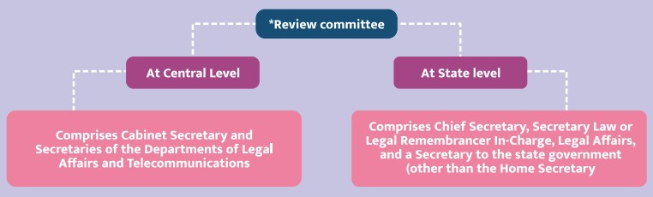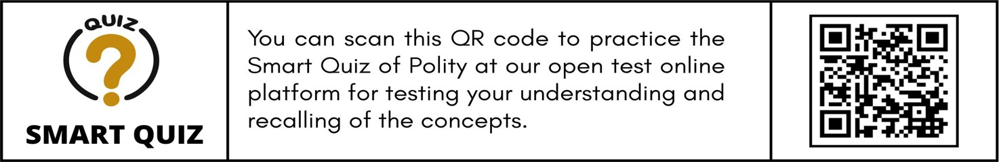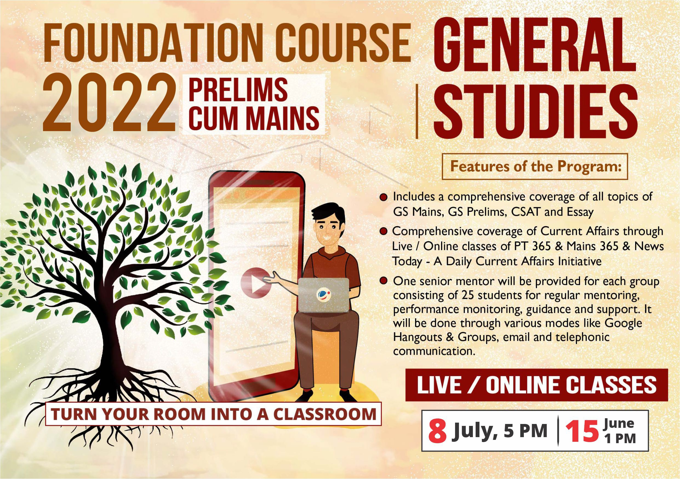

##### Correct Article is: Article 293

* **Article 4.2: Mechanisms to investigate charges against a Supreme Court Judge:** In the table, it is mentioned that removal proceedings are as per Artcle 124(4) of the constitution.
  + **Correct Information:** The removal procedure for Judges is guided by Article 124(4) but **detailed procedure is mentioned in the Judges Inquiry Act, 1968.**
* **Article 8.7 : Internet Shutdowns:** In the infographic titled’ Provisions regarding Internet Shutdowns’, information about composition of Review committee at Centre and State Level has been interchanged.
  + **Correct Information:**

# INTERNATIONAL RELATIONS



### 2.1. INDIA AND PERSIAN GULF REGION

##### Why in news?

Indian Air Force participated for the **first time in Exercise Desert Flag-VI (annual multi-national exercise) hosted by the United Arab Emirates** Air Force indicating India's growing military ties with the Persian Gulf Region.

|  |  |
| --- | --- |
| **About Persian Gulf Region**   * The Persian   Gulf region  **includes 8**  **countries**- Iran, Oman,  United Arab Emirates, Saudi Arabia, Qatar, Bahrain, Kuwait, and Iraq **bordering the Persian**  **Gulf** (an  extension of the Indian Ocean (Gulf of Oman) through  the Strait of Hormuz).   * The Persian Gulf and its coastal areas   are the **world's** |  |
|  |
| **largest single source of petroleum (50 percent of the world's oil reserves)**, and related industries dominate the region.  o **Safaniya Oil Field, the world's largest offshore oilfield**, is located in the Persian Gulf.   * The Persian Gulf has **many fishing grounds, extensive coral reefs (mostly rocky) and abundant pearl oysters**, but its ecology has been damaged by industrialization and oil spills. * The Persian Gulf was a **battlefield of the 1980–1988 Iran–Iraq War**, and is the namesake of the **1991 Gulf War** (Iraq's invasion of Kuwait). * **India’s historical connection with the Gulf** dates back more than five thousand years, to trading between the ancient civilisations of the Indus Valley and the Dilmun (linked with present-day Bahrain). The Indian rupee was legal tender in Kuwait, Bahrain, Qatar, Oman and the Trucial states – now the United Arab Emirates (UAE) – until the early 1960s. * Today, the Gulf is **an integral part of India’s ‘extended neighbourhood’,** both by way of geographical proximity and as an area of expanded interests and growing Indian influence. | |

##### Strategic importance of PGR for India

**Gulf Cooperation Council**

* GCC was established by an agreement concluded in **1981 among Bahrain, Kuwait, Oman, Qatar, Saudi Arabia and UAE** in view of their special relations, geographic proximity, similar political systems based on Islamic beliefs, joint destiny and common objectives.
* The Secretariat of GCC is located in **Riyadh, Saudi Arabia.**
* It is a political, economic, social, and regional organisation according to its charter.

India’s relations with the Persian Gulf countries have been exceptionally significant since ancient times and are multifaceted. The foundation of the relationship is based on the **3Es, namely, energy, economy and expatriates**.

##### Economic relation

* + **Trade:** The **India-Gulf trade** in 2019-20

was nearly **19% India’s global trade.** The United Arab Emirates **(UAE) and Saudi Arabia are India’s third**

**and fourth-largest trading partners** respectively and UAE also features in the top 10 sources of FDI inflows into India.

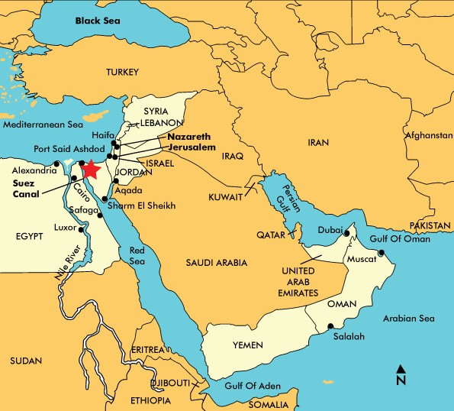

* + - Trade is dominated by import of crude oil and natural gas. India mainly exports finished precious stones and jewelry items, mineral fuels and refined oil, and electronic items to the Gulf countries.
  + **Investment:** India and the countries in the region have invested in infrastructure development in both India as well as in the Gulf. For instance, Saudi Arabia and Abu Dhabi signed an agreement to jointly develop the largest refinery in the world in Ratnagiri, Maharashtra.

##### Energy Security: Fifty-three per cent of India's oil imports and 41 per cent of gas imports come from the region.

* **Remittance:** Around **9 million Indians reside in PGR remitting $ 40-50 billion** which is two percent of India’s GDP and two-thirds of total remittances to the country.
* **India as their strategic partner:** India has extended its strategic partnerships with four countries in the Gulf, namely, Iran, Oman, Saudi Arabia and the UAE since 2003 on issues such as counter-terrorism, money laundering, cyber security, organised crime, human trafficking and anti-piracy.

### 2.2. SUEZ CANAL

##### Why in news?

One of the world’s largest container ships, named **Ever Given**, was wedged across the Suez Canal, blocking one of the busiest maritime trade corridors in the world.

##### Suez Canal and its significance

* Suez Canal is **193-kilometer- long artificial waterway in**

**Egypt**, to

connect the **Mediterranean Sea and the Red Sea.**

* It enables more **direct**

**shipping between Europe and Asia,** eliminating need to circumnavigate Africa via Cape of Good Hope.

* It provides a crucial **link for oil, natural gas and cargo being shipped** from East to West and about **10% of all global trade, amounting nearly $10 billion** worth of goods every day flows through the Suez Canal.
  + Among other goods, **54.1 million tons of cereal, 53.5 million tons of ores and metals, and 35.4 million tons of coal and coke** in 2019 passed through the canal.
* Also, **Canal has no locks, so it can even handle aircraft carriers**, which is very important for security reasons.

**Suez War 1956**

* **Egypt went bankrupt** in 19th century while trying for industrialization. Due to this the Governor of **Egypt had to sell his shareholding in the company that managed Suez Canal, to the British.**
* Thus since 1875, **control of canal was with France and Britain**. Consequently, Egypt was colonized by Britain. It gained **independence in 1922** but British troops remained to maintain control over the canal.
* The **crisis began in 1956 when Egypt’s president nationalized the canal** after the British had departed.
* He took other steps that were **deemed security threats by Israel and its Western allies**, leading to a military intervention by Israeli, British and French forces.
* The crisis briefly closed the canal and raised the **risk of entangling the Soviet Union and the United State**s.
* **Crisis ended in early 1957** under an agreement supervised by the **United Nations, which sent its first peacekeeping force to the area**.
* The outcome was seen as a **triumph for Egyptian nationalism,** but its legacy was an undercurrent in the Cold War.

**2.3. COMPREHENSIVE AND PROGRESSIVE AGREEMENT FOR TRANS- PACIFIC PARTNERSHIP (CPTPP)**

##### Why in News?

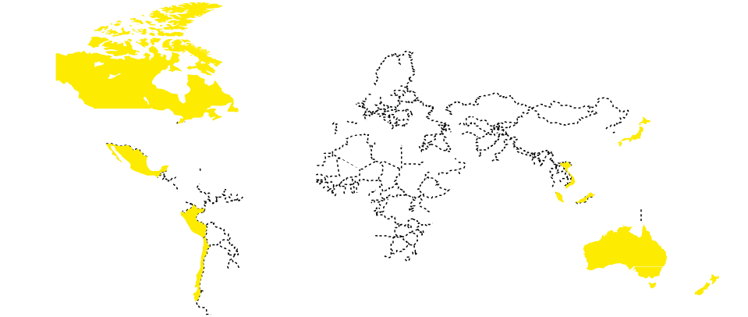

**THE CPTPP MARKETS**

**11 Paciﬁc Rim Nation 500 MILLION CONSUMERS $13.5 TRILLION IN GDP**

Recently, U.K. announced to apply for joining CPTPP- a free trade block of Asia- Pacific Countries.

##### About CPTPP

* CPTPP is a **free trade agreement between 11**

**Singapore**

**Vietnam Japan**

**Malaysia Brunei**

**Canada**

##### countries in the

**Mexico**

**Asia-Pacific**.

* CPTPP was **formerly known as the Trans-Pacific Partnership (TPP).** After U.S.

**Australia**

**New Zealand**

**Peru**

**Chile**

withdrawal from

TPP, remaining members renamed it CPTPP.

* CPTPP features ambitious market-access commitments in trade in **goods, services, investment, labour mobility and government procurement.**
  + It also covers the **protection of the environment and labour rights.**

##### Benefits of CPTPP

* + **Removes tariff on an estimated 95% of goods** traded between CPTPP members and will provide greater market access.
  + **Provides easier Rules of origin (ROO) criteria** to importers/exporters.
  + **Facilitates free cross-border data flow** and removal of localization requirements.
  + Product specific rules to **help Small and Medium Enterprises.**
  + **Simple, effective, clear and predictable customs procedure** to reduces processing times at the border.
  + **Increases predictability and eliminates many barriers** encountered at the border, such as quotas and labour market tests.

### 2.4. EXTRADITION

##### Why in News?

Recently, UK court paved way for Nirav Modi to be extradited to India.

##### More on News

* Fugitive jeweller Nirav Modi is **wanted by Central Bureau of Investigation and Enforcement Directorate**

in Rs 13,500-crore bank loan fraud case.

* + India-UK Extradition Treaty was signed in 1992.

**About Extradition**



|  |  |
| --- | --- |
| **What is Extradition?** | * According to Supreme Court, Extradition is the delivery on the part of one State to another of those whom it is **desired to deal with for crimes of which they have been accused or convicted** and are justifiable in the Courts of the other State. * An Extradition request for an accused can be initiated **in the case of under-investigation, under- trial and convicted criminals.** * Extradition Act 1962 (modified in 1993) **provides India’s legislative basis for extradition.**. |
| **What are Extradition Treaties?** | * 1962 Act defines an Extradition Treaty as a **Treaty, Agreement or Arrangement made by India with a Foreign State, relating to Extradition of fugitive criminals** and includes any treaty, agreement or arrangement relating to Extradition of fugitive criminals made before 15th August 1947, which extends to and is binding on, India. * **Most of them seem to embody at least five principles**:   + Extradition applies only with respect to offences clearly stipulated as such in the treaty   + Should be an offence under the national laws of the extradition requesting country as well as of the requested country.   + Requested country must be satisfied that there is a prima facie case made out against the offender/accused.   + Extradited person must be proceeded against only against the offence (rule of speciality) for which his extradition was requested.   + He must be accorded a fair trial. |
| **Nodal Authority for**  **Extradition** | * Consular, Passport & Visa (CPV) Division, Ministry of External Affairs (MEA). |
| **Who can make a request and Which countries can India make an extradition request to?** | * **Can only be made by MEA.** Extradition is not available at the request of members of the public. * India is able to make an **extradition request to any country** (1962 provides for the process of extradition with non-Treaty foreign States also).   o In case of urgency, **India may request the provisional arrest of the fugitive**, pending presentation of an extradition request.   * Indian nationals who return to India after **committing offences in West Asia/Gulf countries are not extradited to those countries** and are prosecuted in India in accordance with Indian Law. * **Extradition of Indian Nationals to following countries is barred** by the bilateral Extradition Treaty: France, Germany, Spain, UAE, Bulgaria, Kuwait, Poland, Russia, Turkey, Ukraine, Uzbekistan, Vietnam. * Also, **India may not extradite national to following countries:** Saudi Arabia, Bahrain, Belarus, Hong Kong, South Korea, Mongolia, Nepal, and Tunisia. |
| **Bars to Extradition** | * **No treaty**: In absence of a treaty, States are not obligated to extradite aliens/nationals * **No treaty crime**: Extradition is generally limited to crimes identified in the treaty which may vary in relation to one State from another, as provided by the treaty. * **Military and Political Offences**: Extradition may be denied for purely military and political offences. Terrorist offences and violent crimes are excluded from the definition of political offences. * **Want of Dual Criminality**: Dual criminality exists when conduct constituting the offence amounts to a criminal offence in both India and the foreign country. * **Procedural considerations**: Extradition may be denied when due procedure as required by the 1962 Act is not followed. |

### 2.5. IRAN-NUCLEAR AGREEMENT

##### Why in News?

With the ongoing EU mediated indirect negotiations between USA and Iran, the hopes on the revival of Iran Nuclear deal with possible USA reentry has reached a new high.

**Iran’s Nuclear Programme**

* Iran started its nuclear programme in 1950s with USA help under **Atoms for peace** initiative.
* Iran signed the **Non-proliferation Treaty** in 1968 as part of the 62 original signatories and ratified it in 1970.
* But in 2005, IAEA found Iran in non-compliance to the **NPT safeguards agreement** leading to nuclear related sanctions on Iran by UN Security Council.
* After years of negotiations, **in 2015 Iran agreed** to curb its nuclear programme with access to inspection in exchange for sanctions relief.

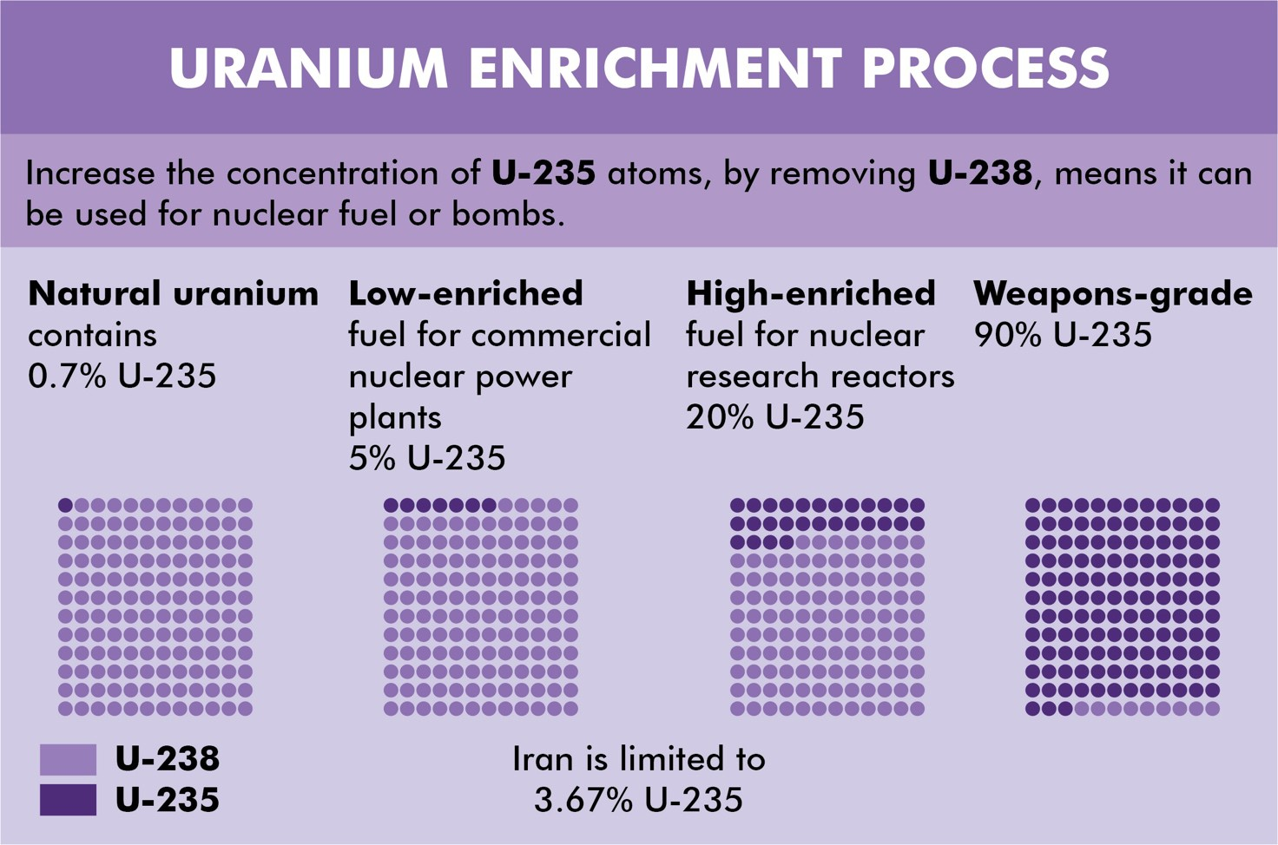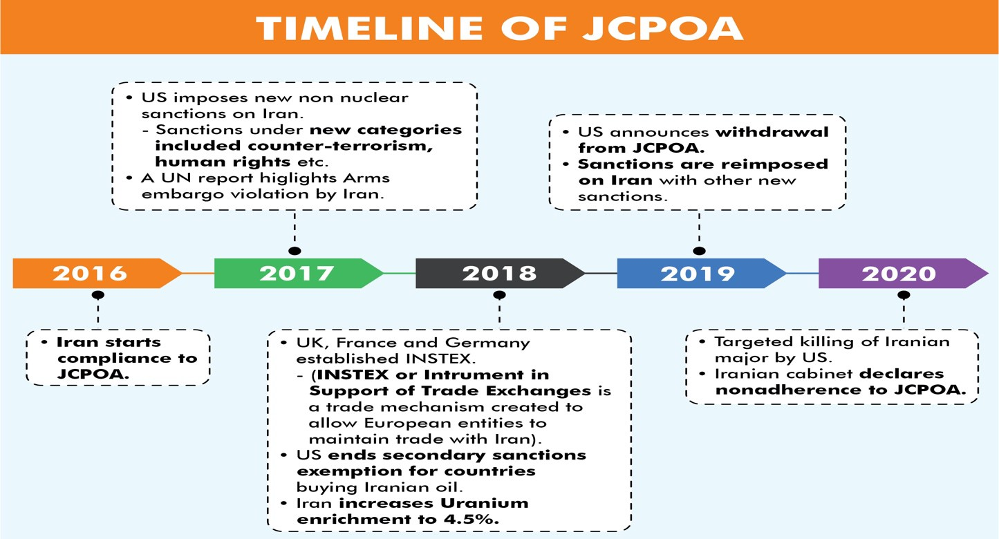

##### What is Iran-nuclear Agreement?

* The Iran nuclear agreement, also known as the **Joint Comprehensive Plan of Action (JCPOA),** is an accord signed between **Iran and P5+1** nations (US, UK, China, Russia, France and Germany) in 2015.
* The **High Representative of the European Union** for Foreign Affairs and Security Policy were part of it and UNSC endorsed it through **United Nations Security Council Resolution 2231.**
* The objective of the deal was to cut off Iran’s ability to pursue a nuclear weapon and reverse economic sanctions by through various steps.

**2.6. NEW START NUCLEAR ARMS TREATY**

##### Why in News?

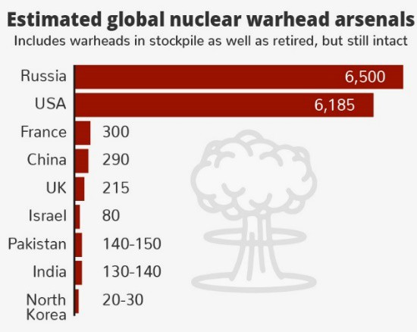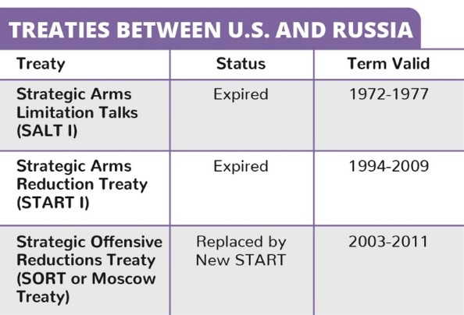

**Audit of other Global Bodies by CAG**

* Comptroller and Auditor General of India is currently the **External Auditor** of:
  + **World Health Organization (2020-2023)**
  + **Food and Agriculture Organization (2020-2025)**
  + **Inter Parliamentary Union (2020-2022).**

•

•

CAG is the Chair of the **United Nations Panel of**

**External Auditors.**

CAG is also **member** of the **Governing Boards** of **International Organization of Supreme Audit Institutions (INTOSAI).**

Recently, United States (US) has extended the New START (Strategic Arms Reduction Treaty) nuclear arms control treaty with Russia for five years.

##### About New START Treaty

* New START treaty is the **last remaining arms reduction pact between** US and Russia.
* The treaty, which first went into effect in 2011, **limits**

##### U.S. and Russia to deploying no more than 1,550 strategic nuclear warheads each and imposes restrictions on the land- and submarine-based missiles and bombers to deliver them.

* The treaty contains **detailed procedures for the implementation and verification** of the central limits on strategic offensive arms (discussed above) and all treaty obligations.
* **New START replaced the 1991 START I treaty,** which expired December 2009, and superseded the 2002 Strategic Offensive Reductions Treaty (SORT), which terminated when New START entered into force.

**2.7. ORGANISATION FOR THE PROHIBITION OF CHEMICAL WEAPONS (OPCW)**

##### Why in news?

India’s Comptroller and Auditor General (CAG), has been appointed as external auditor of the Organisation for the Prohibition of Chemical Weapons (OPCW).

##### More on news

* **Conference of the State Parties of OPCW** selected CAG as the **External Auditor for a 3-year term** starting in **2021**.
* In the past also, India’s **CAG has held the position of External Auditor of OPCW** during the period from

**1997 to 2003.**

**India’s relation with OPCW**

* **India is a signatory** to the **Chemical Weapons Convention (CWC)** and **member of Executive Council of OPCW**.
* Pursuant to provisions of the Convention, India **enacted the Chemical Weapons Convention (CWC) Act, 2000**.
* Under the Act, **National Authority Chemical Weapons Convention (NACWC)** has been

##### established for implementing the provisions of the convention.

**About OPCW**

* It was established by the **Chemical Weapons Convention** in 1997 (see box).

##### Structure of OPCW

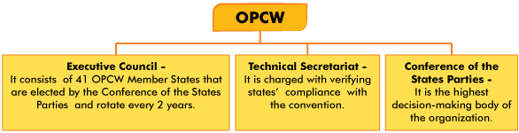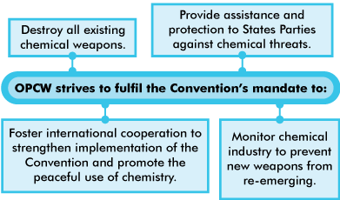

* It is **authorized to perform inspections** to verify that signatory states are complying with the convention, which includes a **commitment to grant inspectors full access to chemical weapons sites.**

##### It also performs testing of sites and victims of suspected chemical weapons attacks.

* + OPCW’s **Investigation and Identification Team (IIT),** established in 2018 is responsible **for identifying the perpetrators of the use of chemical weapons in the Syrian Arab Republic.**
  + Recently, IIT released 2nd report, which concluded that **units of Syrian Arab Air Force used chemical weapons in Saraqib, Syria** in 2018.

##### The OPCW is not a United Nations (UN) organisation, however, it has a working relationship with the UN.

* + By the 2001 Relationship Agreement between the OPCW and the United Nations, the **OPCW reports on its inspections and other activities to the UN** through the office of the UN Secretary-General.

**Chemical Weapons Convention (CWC)**

* Convention on the Prohibition of the Development, Production, Stockpiling and Use of Chemical Weapons and on their Destruction- 1993 (also known as CWC) was adopted by the **Conference on Disarmament** in **1992**.
* The treaty **entered into force in 1997**.
* It aims to eliminate an entire category of weapons of mass destruction by **prohibiting the development, production, acquisition, stockpiling, retention, transfer or use** of chemical weapons by States Parties.
* A unique feature of the Convention is its incorporation of the **‘challenge inspection’**, whereby any State Party in doubt about another State Party’s compliance can request a surprise inspection.
  + Under the ‘challenge inspection’ procedure, States Parties have committed themselves to the **principle of ‘anytime, anywhere’ inspections** with **no right of refusal.**

**International efforts at chemical disarmament**

* **The Strasbourg Agreement (1675)**
  + It was the **first international agreement** limiting the use of chemical weapons.
  + It was **signed between France and Germany** prohibiting the use of poison bullets.
* **Brussels Convention on the Law and Customs of War (1874)**
  + It was signed to:
    - **prohibit** employment of **poison or poisoned weapons**
    - **prohibit** use of **arms, projectiles or material** to cause unnecessary suffering
  + The **agreement never entered into force**.
* **Hague Convention (1899)**
  + It came into existence during **Hague Peace Conference**.
  + Contracting parties agreed to ‘**abstain from the use of projectiles, the sole object of which is the diffusion of asphyxiating or deleterious gases**.
* **Protocol for the Prohibition of the Use of Asphyxiating, Poisonous or Other Gases, and of Bacteriological Methods of Warfare (1925)**
  + Commonly known as the **Geneva Protocol**, it was signed post World War-I due to public outcry at horrors of chemical warfare and to prevent its recurrence.
  + However, the protocol **does not prohibit** the development, production or possession of chemical weapons.
  + It **only bans the use** of chemical and biological weapons in war.

### 2.8. OTHER ORGANISATIONS/GROUPS IN NEWS



|  |  |
| --- | --- |
| **South Asia Subregional Economic Cooperation (SASEC)** | * Recently, finance minister invited Asian Development Bank to set up the SASEC Secretariat in India. * SASEC is formed in 2001 which comprises **seven countries** namely **India**, Bangladesh, Bhutan, Maldives, Nepal, Sri Lanka and **Myanmar**. * It aims to **increase economic growth** by building cross-border connectivity, **energy cooperation,**   promote regional prosperity, and build a better quality of life for the people of the sub-region.   * SASEC countries share a **common vision of boosting intraregional trade and cooperation in South Asia**, while also developing connectivity and trade with Southeast Asia through Myanmar, to the People’s Republic of China, and the global market. * The **Asian Development Bank (ADB)** serves as **Secretariat** to the SASEC Program. |
| **Small Island Developing States (SIDS**) | * SIDS were recognized as a distinct **group of developing countries facing specific social, economic and environmental vulnerabilities** at the United Nations Conference on Environment and Development (UNCED), also known as the **Earth Summit, held in Rio de Janeiro, Brazil (3-14 June 1992).** * This recognition was made specifically in the context of **Agenda 21.** * Three geographical regions have been identified for the location of SIDS, namely, the **Caribbean, the Pacific and the Atlantic, Indian Ocean, Mediterranean and South China Sea.** |
| **United Nations Capital Development Fund (UNCDF)** | * Indian-origin Preeti Sinha has been appointed as Executive Secretary of UNCDF. * UNCDF provides **public and private finance work** for the poor in the world’s 46 least developed countries (LDCs). * It was **established by the UN General Assembly** in 1966. * Its mandate is to “**assist developing countries in development of their economies by supplementing existing sources** of capital assistance by means of grants and loans”.   o Mandate was modified in 1973 to **serve first and foremost but not exclusively the LDCs.** |
| **Stockholm International Peace Research Institute (SIPRI)** | * SIPRI is an **independent international institute dedicated to research into conflict, armaments, arms control and disarmament**. * **Established in 1966**, SIPRI provides data, analysis and recommendations, based on open sources, to policymakers, researchers, media and the interested public. * According to the SIPRI report, **India's import of arms decreased by 33%** between 2011–15 and 2016–20.   + India’s **top three arms suppliers** during 2016-20 were Russia (accounting for 49% of India’s imports), France (18%) and Israel (13%)   + **Russia was the most affected supplier**, although India's imports of US arms also fell.   + Five largest arms exporters in 2016-20 were the US, Russia, France, Germany and China,   while the top importers were Saudi Arabia, India, Egypt, Australia and China. |
| **Houthi rebel group** | * US administration has notified that it would **remove Houthis from its list of foreign terrorist organizations.**   o This **would help assist humanitarian groups** provide crucial aid to the warring sides in Yemen.   * Houthi rebels **emerged from Yemen’s northern province Saada** bordering Saudi Arabia. They are considered to be backed by Iran and have been **fighting a complex war with Yemeni Government.** * **Saudi Arabia and other Sunni Arab states** had earlier begun an air campaign for defeating Houthis. |

**2.9. CRITICAL INFRASTRUCTURE**

##### Why in News?

Recently, Ministry of Power (MoP) claimed that State-sponsored Chinese hacker groups had targeted various Indian power centres.

##### More on News

* MoP claimed that **no data breach/ data loss has been detected** as attempts from these groups have been thwarted after government cyber agencies warned about their activities.
  + National Critical Information Infrastructure Protection Centre (**NCIIPC) warned about the threat from a malware called Shadow Pad.**
* Also, a recent report in New York Times claimed that **Red Echo, a hacker group** affiliated with the Chinese government, targeted India’s critical power grids through Shadow Pad malware (type of malicious software designed to harm or exploit any programmable device, service or network).

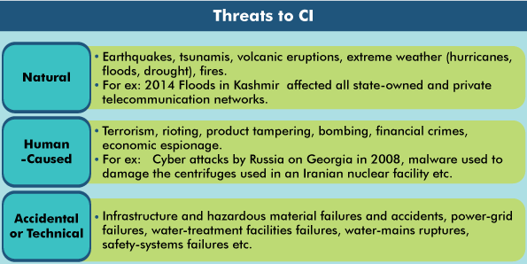

**Critical Infrastructure protection in India**

* In 2014, India established the **National Critical Information Infrastructure Protection Centre (NCIIPC)** to regulate and protect the nation’s Critical Information Infrastructures (CIIs).
  + CIIs, as defined by the Information Technology Act of 2000, are **vital computer resources that, if incapacitated or destroyed, will leave a debilitating impact on national security, economy, public health or safety** across both public and private sectors.
  + **CI organizations in multiple sectors** such as power and utilities, telecommunications and transport, and strategic and public enterprises **operate according to the guidelines issued by NCPIIC.**

•

•

•

•

•

•

**Indian Computer Emergency Response Team (CERT-In):** National nodal agency for responding to computer

security incidents.

**National Cyber Security Coordinator (NCSC)** under National Security Council Secretariat coordinates with different agencies at the national level for cyber security matters.

**National Cyber Coordination Centre** to generate necessary **situational awareness of cyber security threats** and enable timely information sharing for proactive, preventive and protective actions.

A new **Division under the Ministry of Home Affairs** for Cyber and Information Security.

**Guidelines have been issued for Chief Information Security Officers (CISOs)** regarding their key roles and responsibilities for securing applications / infrastructure and compliance.

**Cyber Swachhta Kendra** (Botnet Cleaning and Malware Analysis Centre) has been launched for detection of malicious programs and provide free tools to remove the same.

**Related News**

**Cyber Volunteer Program (CVP)**

* Ministry of Home Affairs (MHA) informed that a **CVP has been rolled out** for cyber hygiene promotion to-
  + **Bring together citizens to contribute to the fight against cybercrime** in the country.
  + **Assist State/UT LEAs** (law enforcement agencies) to curb cybercrimes.
* CVP is **envisaged by Indian Cyber Crime Coordination Centre (I4C)**.
  + I4C, under MHA, acts as a **nodal point at National level in the fight against cybercrime.**
  + It **brings together academia, industry, public and government** in prevention, detection, investigation and prosecution of cybercrimes.

##### About Critical Infrastructure (CI)

* CI describes the physical and cyber systems and assets that are so vital to a country that their incapacity or

destruction would have a debilitating impact on national security and the economic and social welfare of a state.

* + **Chemicals, Dams, emergency services, Power & Energy, Banking & financial services**, government facilities, healthcare, information technology, transportation, nuclear reactors etc. are considered parts of CI of a country.

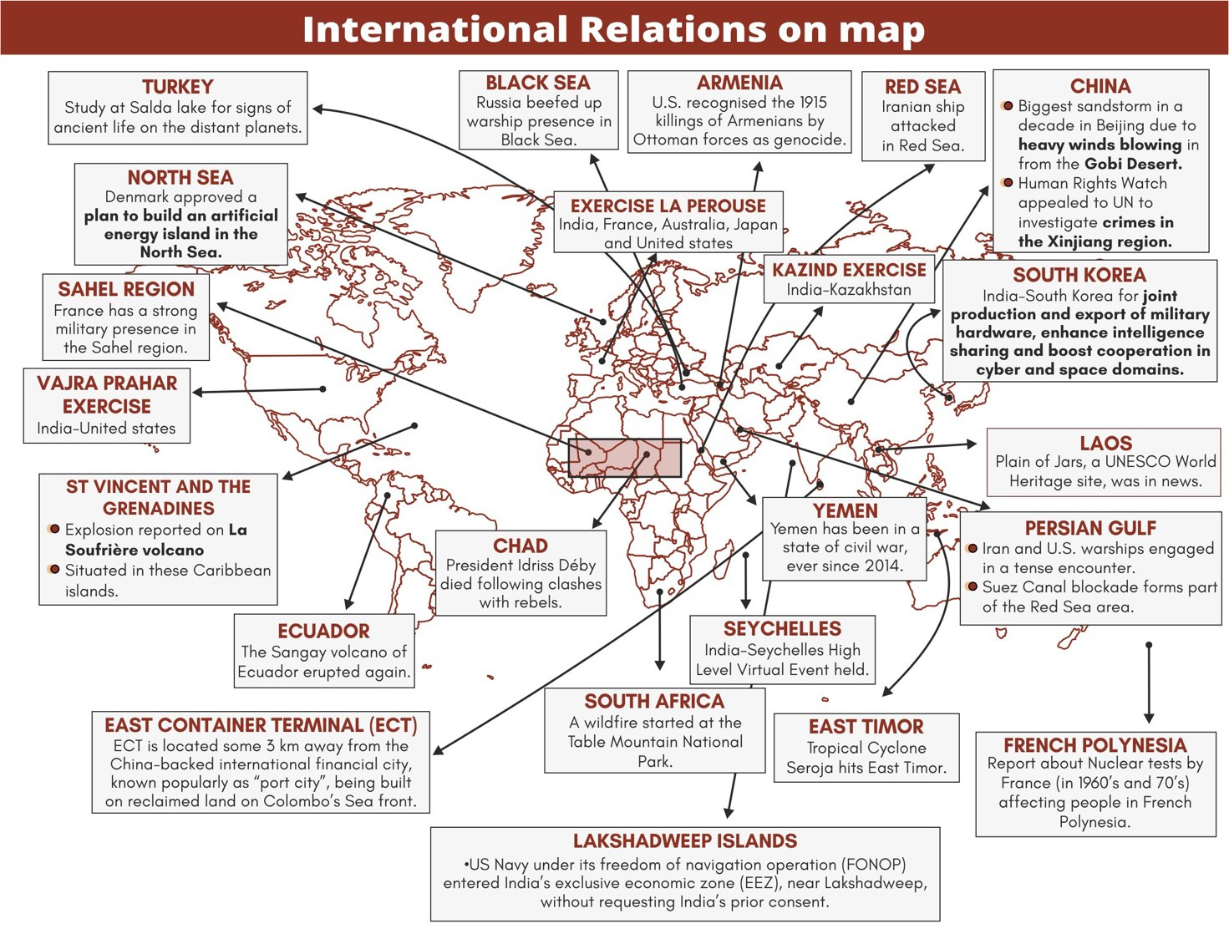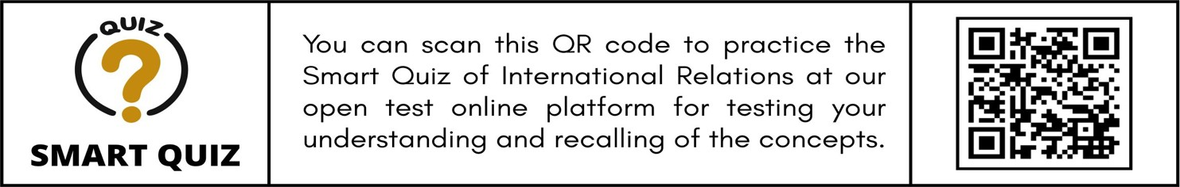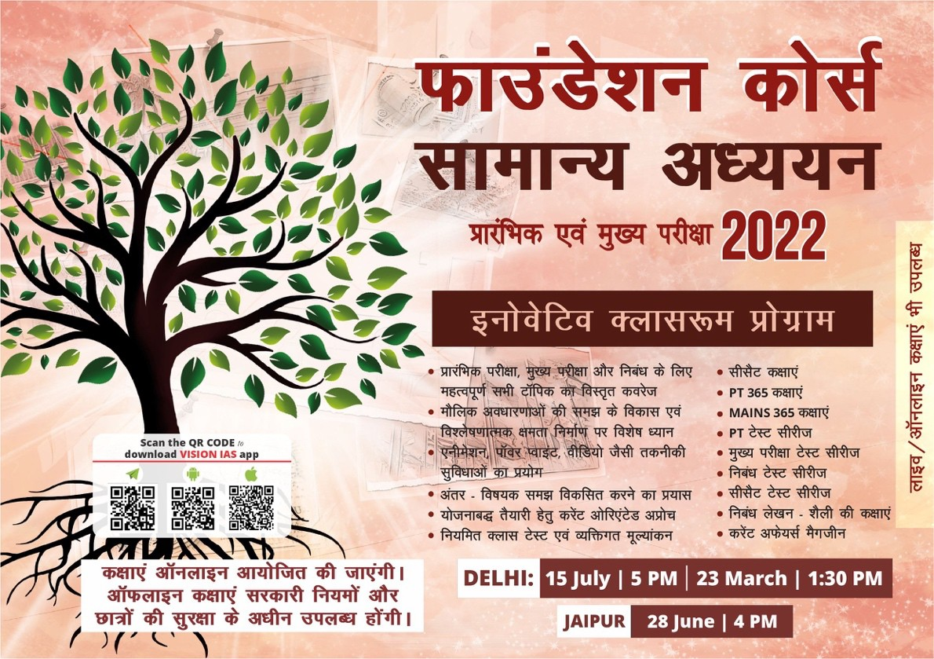

# ECONOMY

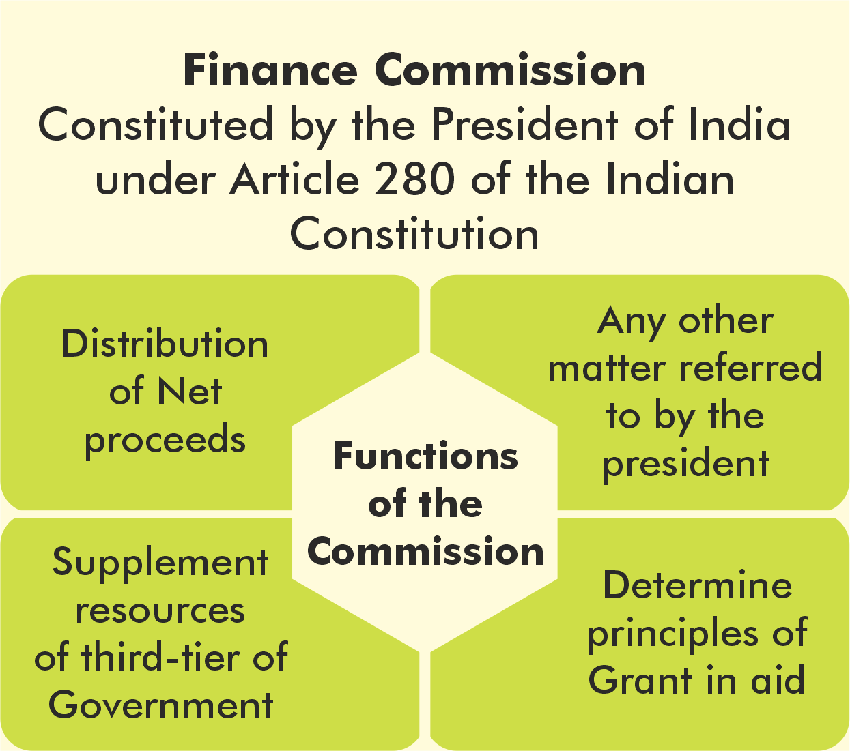

### 3.1. FISCAL POLICY

**3.1.1. FIFTEENTH FINANCE COMMISSION REPORT**

##### Why in News?

The Fifteenth Finance released its report which was recently tabled in the Parliament.

##### About the Fifteenth FC

* The Commission was **chaired by Mr. N.K. Singh** and the report was titled ‘**Finance Commission in COVID times.’**
* The Commission was required to **submit two reports**. The first report, consisting of recommendations for the **financial year 2020-21**. The final report with **recommendations for the 2021-26 period.**
  + Also, this is also the **first ever Commission to have given recommendations spanning a period of six years**, that is, 2020-26.

##### How the Terms of Reference (ToR) of Fifteenth FC were different from previous commissions?

* **Fiscal Consolidation Roadmap:** The Commission was asked to review the current finances of both state and central government and recommend a fiscal consolidation roadmap for sound fiscal management.
* **Indirect Taxation System:** The commission was asked to evaluate the impact of the GST, including the need for payment of compensation for possible loss of revenues for 5 years, and abolition of a number of cesses.
* **Measurable Performance Incentives:** The Commission was asked to consider proposing of measurable performance-based incentives for States, at the appropriate level of government in areas like deepening of tax nets, population control, power sector reforms etc.
* **Using 2011 population against 1971 population data:** The Commission had to use the population data of 2011 while making its recommendations. This was tricky as there was an active opposition from Southern States on usage 2011 population data.
* Other unique demands:
  + Analysing the possibility of **creation of a non-lapsable defence fund.**
  + Reviewing the present arrangements on **financing Disaster Management initiatives. What are the recommendations given by the Fifteenth FC Report for 2021-26 period?**

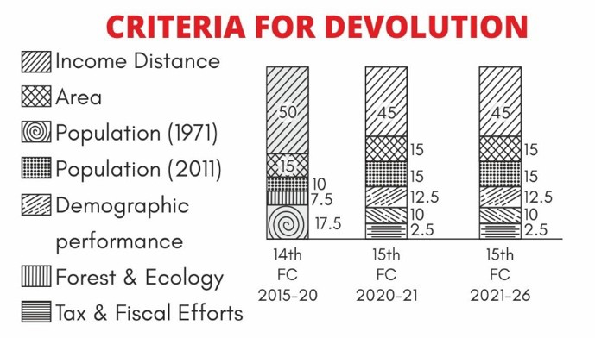

|  |  |
| --- | --- |
| **Vertical Devolution** | The commission has recommended **maintaining the vertical devolution at 41%.**   * The idea is to **maintain the same level of devolution as recommended by 14th FC** (i.e., 42%), the **adjustment of about 1%** has been made due to the changed status of the erstwhile State of Jammu and Kashmir into the **new Union Territories of Ladakh and Jammu and Kashmir.** * **Gross tax revenue for 5-year period** is expected to be **135.2 lakh crore**. Out of that, Divisible pool (after deducting cesses and surcharges & cost of collection) is **estimated to be 103 lakh crore.** |
| **Horizontal Devolution** | The horizontal devolution is primarily based on **three principles namely need of states, equity among states and performance of states.** To balance all three principles, six criteria are used to calculate tax distribution- Income Distance, Area, Population (2011), Demographic Performance,  Forest and Ecology and Tax and Fiscal Transfers. |



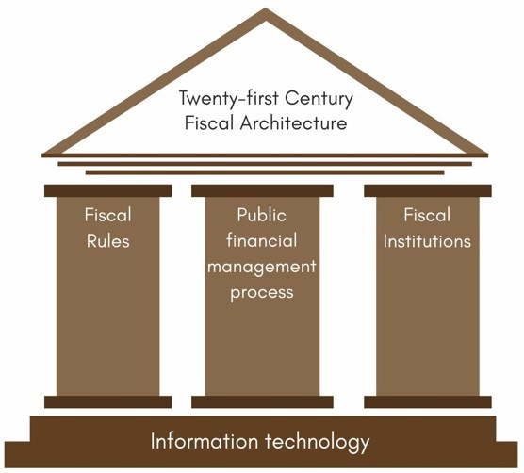

|  |  |
| --- | --- |
| **Grants to States** | * **Revenue deficit grants**: 17 states will receive grants worth Rs 2.9 lakh crore to eliminate revenue deficit. * **Sector-specific grants**: Sector-specific grants of Rs 1.3 lakh crore will be given to states for sectors like health, education, implementation of agricultural reforms etc. **A portion of these grants will be performance-linked.** * **State-specific grants**: The Commission recommended state-specific grants of about 0.5 lakh crore. These will be given in the areas of social needs, administrative governance and infrastructure etc. * **Grants to local bodies**: The total grants to local bodies will be Rs 4.36 lakh crore (**a portion of grants to be performance-linked).**   + **Grants to local bodies (other than health grants)** will be distributed among states based on population and area, with 90% and 10% weightage, respectively.   + Also, **no grants will be released to local bodies** of a state after March 2024 if the state **does not constitute State Finance Commission** and act upon its recommendations by then. * **Disaster risk management**: The Commission recommended retaining the existing cost- sharing patterns between the centre and states for disaster management funds. The cost- sharing pattern between centre and states is: (i) 90:10 for north-eastern and Himalayan states, and (ii) 75:25 for all other states. State disaster management funds will have a corpus of Rs 1.6 lakh crore (centre’s share is Rs 1.2 lakh crore). * **Incubation of new cities**: Finance Commission has recommended Rs 8,000 crore to states for incubation of new cities, granting Rs 1,000 crore each for eight new cities. The focus of urban grants for million-plus cities is improvement in air quality and meeting the service level   benchmark of solid waste management and sanitation. |
| **Total transfers** | * Including total grants of Rs. 10.33 lakh crore and tax devolution of Rs. 42.2 lakh crore (41% of 103 lakh crore), aggregate transfers to States is estimated to remain at around 50.9 per cent of the divisible pool during 2021-26 period. * Total transfers (devolution + grants) constitutes about **34 per cent of estimated Gross Revenue Receipts of the Union.** |
| **Fiscal Management and Consolidation Roadmap** | The Commission suggested that the centre bring down fiscal deficit to 4% of GDP by 2025-26. For states, it recommended the fiscal deficit limit (as % of GSDP) of: (i) 4% in 2021-22, (ii) 3.5% in 2022- 23, and (iii) 3% during 2023-  26.   * **Extra annual borrowing worth 0.5% of GSDP** will be allowed to states during first four years (2021-25) upon undertaking power sector reforms including: (i) reduction in operational losses,   (ii) reduction in revenue gap, (iii) reduction in payment of cash subsidy by adopting direct benefit transfer, and (iv) reduction in tariff subsidy as a percentage of revenue.   * It recommended   forming a **high-powered inter-governmental group** to: (i) **review the Fiscal Responsibility and Budget Management Act (FRBM),** (ii) recommend a new FRBM framework for centre as well as states and oversee its implementation.   * The **inverted duty structure** between intermediate inputs and final outputs present in GST **needs to be resolved**. **Revenue neutrality of GST rate should be restored** which has been compromised by multiple rate structure and several downward adjustments. * **A comprehensive framework for public financial management** should be developed. **An independent Fiscal Council** should be established with powers to assess records from the Centre as well as states. |

|  |  |
| --- | --- |
| **Other recommendations** | * **Disaster Management Fund:** Setting up the **state and national level Disaster Risk Mitigation Fund (SDRMF**), in line with the provisions of the Disaster Management Act. * **Defense Modernization Fund:** Creation of a separate **non-lapsable fund for modernization of defense and internal security**. The objective is to bridge the gap between defense budget allocations and the projected budgetary requirements.   o The Commission has also recommended that Rs **1,000 crore per annum should be allocated from this fund for the welfare of families of the defense and CAPF personnel** who sacrifice their lives in frontline duties.   * **Health**: States should **increase spending on health to more than 8% of their budget by 2022.**   Primary healthcare expenditure should be two-thirds of the total health expenditure by 2022**.**   * **Centrally sponsored schemes (CSS):** A threshold should be fixed for annual allocation to CSS below which the funding for a CSS should be stopped (to phase out CSS which outlived its   utility or has insignificant outlay) |

**Related News**

**Centre has tightened the procedure for grant of central funds under Centrally Sponsored Scheme (CSS) through new rules. About new rules**

* Each state will be required to set up a

**Single Nodal Agency (SNA) for each CSS**.

* Centre will release the funds to the state’s account which should be transferred to concerned SNA’s account **within 21 days.** This has to be released **within 40 days by the State govt.**
* **Phased and conditional funding** from the centre-
  + **No more that 25% of total central funding** in beginning of financial year.
  + Further funding on the condition that **state government has transferred** and ensured **utilisation of 75% of the total released funding**.
* **All interest earned** from the funds should **be mandatorily remitted to the respective Consolidated Fund of India**.
* All SNAs and IAs will **get mapped to the centrally run Public Financial Management System (PFMS)** to track and monitor fund flow.

**3.1.2. WHOLESALE PRICE INDEX**

##### Why in News?

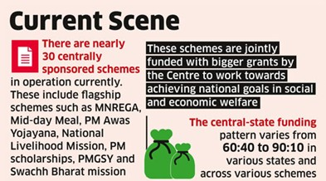

**Significance of WPI**

* Used as a **deflator of various nominal macroeconomic variables** including Gross Domestic Product (GDP).
* Used for the purpose of **escalation clauses** in the supply of raw materials, machinery and construction work.
* WPI also has sub-index called **WPI Food Index (**aggregate of WPI for Food Products under Manufactured Products and Food Articles under Primary Article) which along with Consumer Price Index (CPI) Food Price Index published by Central Statistics Office (CSO) helps to **monitor the food inflation effectively**.

The annual rate of Wholesale Price Index (WPI) stood at 7.39% for the month of March, 2021 over March, 2020 which is **the highest wholesale inflation rate since October 2012.**

##### About WPI

* The Wholesale Price Index (WPI) reflects **changes in the average prices of goods at the wholesale level** — that is, commodities sold in bulk and traded between business or

entities rather than goods bought by consumers.

* **It does not consider the price of services** and does not reflect the consumer price situation in the country.
* **Released by**: Economic Advisor in the Ministry of Commerce and Industry
* **Base year:** Its base year is 2011-12 (revised in 2017 from 2004-05)
* **Components of WPI:** The index is based on the wholesale prices of a basket of 697 commodities categorised under three groups — Primary articles, Fuel and power and Manufactured products.

|  |  |  |
| --- | --- | --- |
| **Wholesale Price Index (WPI) vs. Consumer Price Index (CPI)** | | |
|  | **WPI** | **CPI** |
| **Indicates** | Change in average prices for bulk sale of  commodities at the first stage of transaction | Average change in prices at retail level paid by the  consumer |
| **Covers** | Goods only | Both Goods and Services |
| **Base Year** | 2011-12 | 2011-12 |
| **Published by** | Office of Economic Advisor (Ministry of  Commerce and Industries) | National Statistical Office (Ministry of Statistics  and Programme implementation) |

##### Reasons for surge in WPI

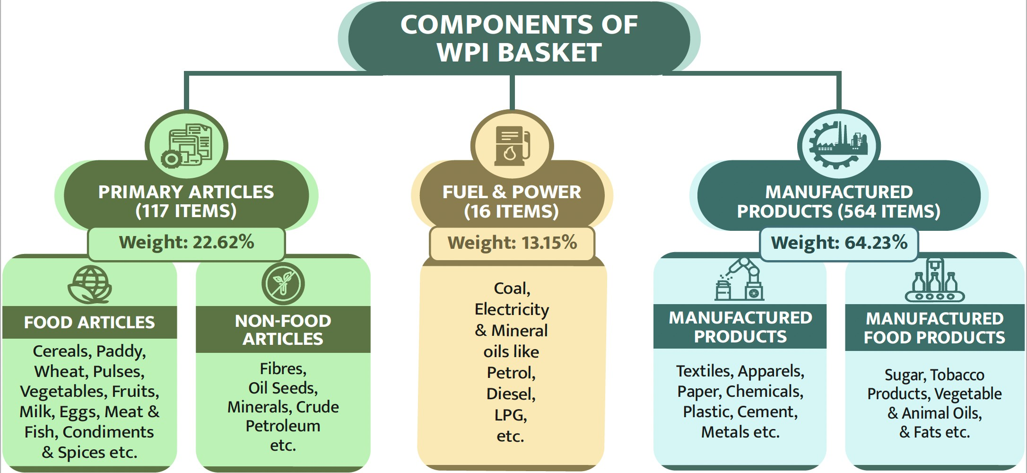

* **Supply disruptions:** Pandemic induced local lockdowns and supply disruptions have resulted into supply disruptions causing rise in prices.
* **Depreciation of Rupee**: The rupee has been depreciating because of the Reserve Bank of India (RBI)’s measures to keep the interest rate on government bonds low. Also, the outflows by foreign portfolio investors have placed an additional pressure on the rupee.
  + A decline in the external value of rupee makes India’s imports, particularly crude oil, metals and edible oils more expensive.
* **Rise in price of commodities**: The prices of crude oil, petroleum products and basic metal substantially increased in March 2021 as compared to the corresponding month of last year.
* **Seasonalilty of products**: As summer sets in, perishable products (especially vegetables) usually see higher inflation.
* **Unreliability of data:** The sharp rise in annual rate in March can be attributed to the low base as data for March 2020 was computed with a low response rate that could have given lop-sided results.
  + Month-on-month (March 2021 over February 2021) rate of inflation stood at 1.57 %.

##### Implications

* **Increase in retail inflation:** There are concerns that the higher inflation on the wholesale side could eventually spill over to the retail level.
* **Policy rate cuts:** Although WPI numbers are not the Reserve Bank of India’s main metric for the purpose of setting monetary policy; the sharp spike may result in Monetary Policy Committee looking at precautionary rate cuts.
* **Higher inflationary expectations**: The apprehensiveness about future inflation may result in people making purchases earlier than planned and cause a rise in actual current inflation.
* **Dual pressure on economy**: Higher inflation and restrictions due to COVID-19 may weaken Indian economy further resulting into various disruptions such as higher unemployment.

**3.1.3. BOND YIELDS**

##### Why in News?

Recently, the US 10-year Treasury Bond yields have witnessed a sharp increase. Experts estimate that this development will have an indirect effect on the Indian Economy.

##### What are Bonds?

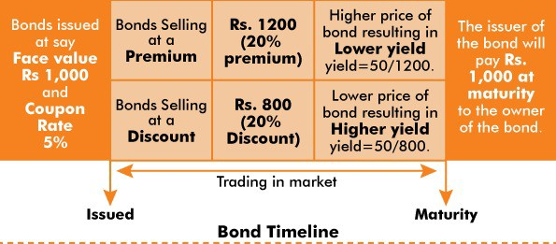

A bond is a fixed income instrument that **represents a loan made by an investor to a borrower (typically corporate or governmental)**. A bond could be thought of as a contract between the lender and borrower that includes the details of the loan and its payments.

##### Following are the key characteristics of Bonds-

* **Face value** is the money amount the bond will be worth at maturity; it is also the reference amount that is used for calculating the interest payments.
* **The coupon rate** is the rate of interest the bond issuer will pay on the bond. For example, a 5% coupon rate means that bondholders will receive 5% of the face value of the bond as interests.
* **The maturity date** is the date on which the bond will mature, and the bond issuer will pay the bondholder the face value of the bond.

##### What are Bond Yields and how are they determined?

* Bond Yields **in essence shows the financial return**, the owner of the bond is going to get from the bond at any given time. The simplest version of yield is calculated in the following manner:
* **Yield = [coupon amount x 100]/price.** If the price of the bond remains constant (i.e., equal to the face value), then the yield of the bond is same as the coupon rate.
* **But the Bond prices** seldom remain constant and are **subject to change on a daily basis due to factors like money supply in the economy, interest rates etc.** (we shall see these relationships in the next section) The fluctuations in prices of Bonds leads to two scenarios-
  + **Bonds trading at a premium:** If the Bond is trading at a value higher than its face value, it is said to be trading at a premium. In this case, **Yield of the bond goes lower than the coupon rate.**
  + **Bonds trading at a discount:** If the Bond is trading at a value lower than its face value, it is said to be trading at a discount. In this case, **Yield of the bond goes higher than the coupon rate.**

As can be seen from the example, when Bond prices increase, Bond yields decrease and vice versa. Therefore, it can be said that the **Bond Prices have an inverse relationship with Bond Yields.**

##### How Bond Yields interact with other key economic variables?

* **Interest Rates and Monetary Policy:** Prevailing interest rates in the market indirectly determine what is the market rate of return for the investment. The Bond yields are evaluated against this market return.
  + For example, if the market rate of return is 10% and Bond coupon rate is 5%, the investors will not find the Bond attractive, and its price will decrease. On the other hand, if the market rate of return is 1% and the Bond coupon rate is 5%, investors will find the Bond attractive, and its price will increase. Also, the increase in the bond price will lead to decrease in Bond Yield and vice versa.
* **Stock Prices:** The government bond yields act as a proxy for the ‘risk-free rate’ prevailing in the market. Therefore, if government Bond yields are higher, the return provided by the stock market becomes less attractive, thus driving down the general demand and price of the stocks. Also, if the yields are lower, opposite outcome would take place.
  + The higher bond yields also indirectly **push up the borrowing costs for companies as well as individuals**. This reduces the earnings available for shareholders as dividends and directly affects the budgets of retail borrowers.

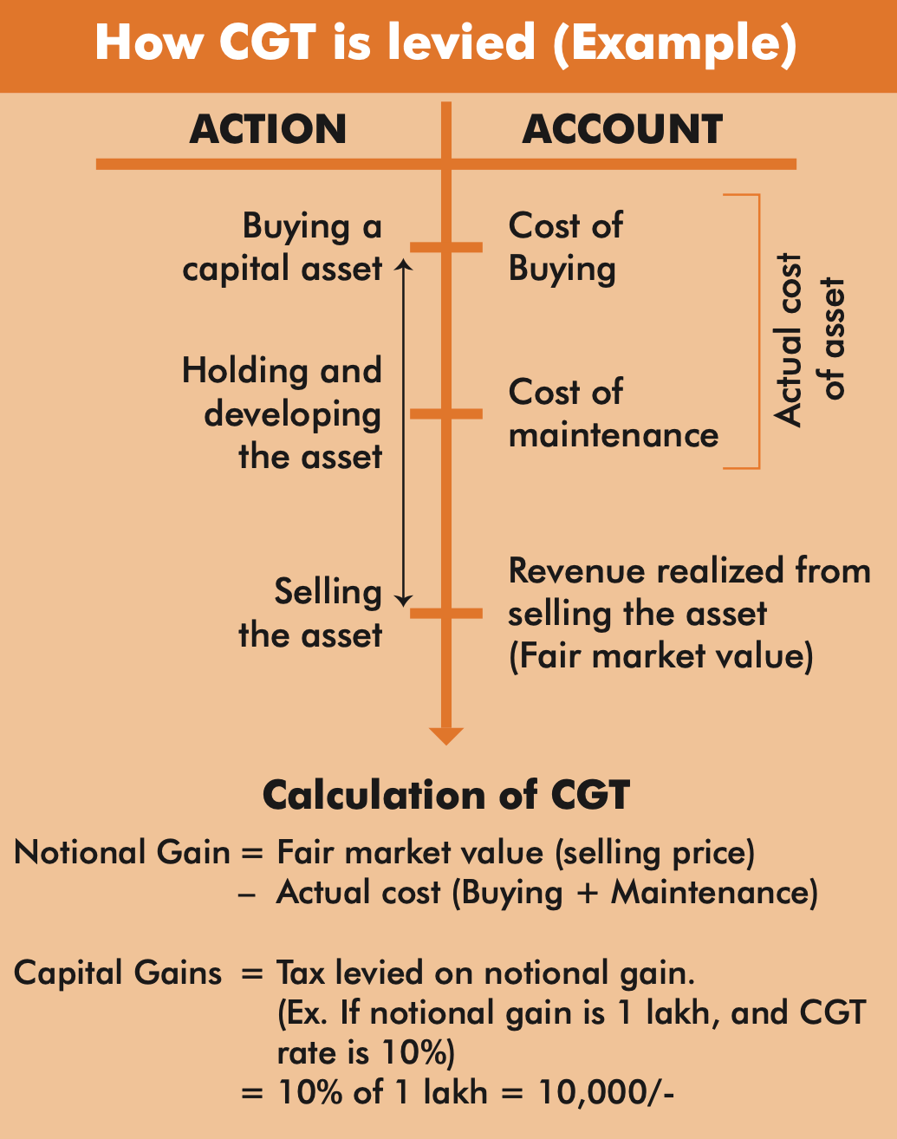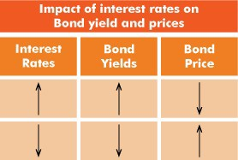

##### What could be the impact of rising US Bond Yields on India?

Since capital flows from one country to another, changing market dynamics of one large economy directly or indirectly has an impact on other large economies. Impacts of rising US Bond prices could be of following nature-

* **Decreased flow of investment:** The US is a source of flow into equity markets of other countries, including India, and a rise in rates in the US makes **keeping money in domestic bonds lucrative for the country’s investors.**
* **Potential depreciation of Rupee:** The flow of capital that gets decreased due to rising yields can directly affect the prevalent Rupee-Dollar market equilibrium and may lead to depreciation in Rupee.
* **Driving up domestic borrowing costs:** If bond yields in the US push up yields in India, this can affect the returns of companies by increasing their borrowing costs.

**Related News**

**Government Securities Acquisition Programme (G-SAP)**

In the recent bi-monthly monetary policy announcement, the Reserve Bank of India (RBI) announced a new programme- the **Government Securities Acquisition Programme (G-SAP)-to purchase government bonds** worth Rs. 1 lakh crore in first quarter of FY2022.

**About G-SAP**

* It is an unconventional monetary policy tool similar to Open Market Operations (OMOs)-the purchase and sale of government securities (G-Secs) by RBI on behalf of government- to reduce volatility in the bond market.
* **Difference between OMO and G-SAP:** The RBI periodically purchases government bonds from the market through OMO while in G-SAP there is an upfront **commitment by the central bank to the markets that it will purchase bonds worth a specific amount.** G-SAP is an OMO with a ‘distinct character’.

**3.1.4. CAPITAL GAINS TAX**

##### Why in News?

Recently, the Finance Bill, 2021 proposed an amendment to the regulations relating to Capital Gains Tax (CGT).

##### More about the News

* The amendment imposes CGT on any assets or shares received by a partner of a company when s/he retires.
  + The guideline also clarified that where a partner receives any money or other asset at the time of dissolution or reconstitution of the firm/association, the profits or gains that arise shall be chargeable under ‘**capital gains’.**
* Further, the tax will be levied on notional gain i.e., the gain realized from the difference between the fair market value and the actual cost in the case of asset transfer.

##### What is Capital Gains Tax (CGT)?

**Capital Gains Tax is a tax on growth of value of investments** incurred when individuals and corporations sell those investments. Following

can be cited as the key characteristics of the CGT levied in India-

* The tax **doesn't apply to unsold investments**, so stock shares that appreciate every year will not incur capital gains taxes until they are sold, no matter how long they are held.



* **Capital gains treatment only applies to “capital assets”** such as stocks, bonds, jewelry, coin collections, and real estate property among others. In other words, it **applies only to transactions** which are capital in nature i.e., **result in change of assets or liabilities.**
* Capital gains are **not applicable to an inherited property as there is no sale**, only a transfer of ownership. However, if the person who inherited the asset decides to sell it, capital gains tax will be applicable.
* The CGT framework divides the tax in two types based on the time for which they are held-
  + **Short-term Capital Gains Tax (STCG) on Short-term capital asset**: When an asset is held for a period of 36 months or less, it is termed as a short-term capital asset.
    - The criteria of 36 months have been reduced to 24 months for immovable properties such as land, building and house property. For instance, if you sell house property after holding it for a period of less than 24 months, any income arising will be treated as short-term capital gain.
  + **Long-term Capital Gains Tax (LTCG) on Long-term capital asset**: An asset that is held for more than 36 months is a long-term capital asset.

**3.1.5. EQUALIZATION LEVY**

##### Why in News?

Finance Bill 2021 proposes changes to Equalisation levy (EL)

##### About Equalization Levy

* **In India 6% EL was introduced in 2016.** It is applicable to payments for digital advertisement services received by non-resident companies without a permanent establishment in India, if these exceeded ₹1 lakh a year.
  + In 2020-21, ambit of levy was **widened by including e-commerce companies**. Applicable tax rate is 2% (plus a surcharge) on the amount received by an e-commerce operator.

**Changes in Finance Bill include**

* **Royalty and fees for technical services will be excluded** from EL.
* **Goods owned by Indians not to attract Equalization Levy.**
* EL **applies even to companies that do not own the goods or provide services on their platforms** and if any part of the transaction is online, even if it's only an online payment.
  + This is expected **to bring more players within the ambit** of this levy.
* Online sale of goods and online provision of services **will include online activities like acceptance of offer for sale; or placing of purchase order; or acceptance of the purchase order etc.**
* Earlier **India argued against US Trade representative’s claim of levy being discriminatory** and restricting US commerce.

### 3.2. BANKING AND MONETARY POLICY

**3.2.1. ASSET RECONSTRUCTION COMPANY (ARC)**

##### Why in news?

Union budget 2021-22 has proposed a new ARC/Bad Bank to consolidate and take over existing bad loans.

##### About the Proposal

* The ARC/bad bank proposed in the Budget **will be set up by banks** (both state-owned and private sector banks), and there will be **no equity contribution from the government.**
  + However, the **Government may provide sovereign guarantee** that could be needed to meet regulatory requirements.
* It will have an **Asset Management Company (AMC)** to manage and sell bad assets.
  + AMC manages funds for individuals and companies. They make **well-timed investment decisions** on behalf of their clients to grow their finances and portfolio.
* It will look to **resolve stressed assets of Rs 2-2.5 lakh crore** that remain unresolved in around 70 large accounts.
* The **bank will get 15% cash and 85% security receipts** against bad debt that will be sold to the ARC.

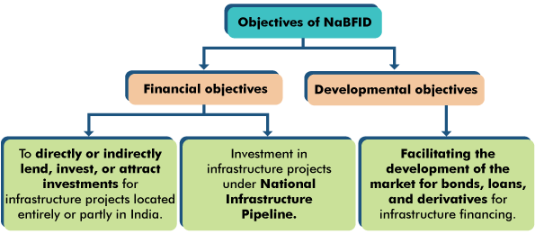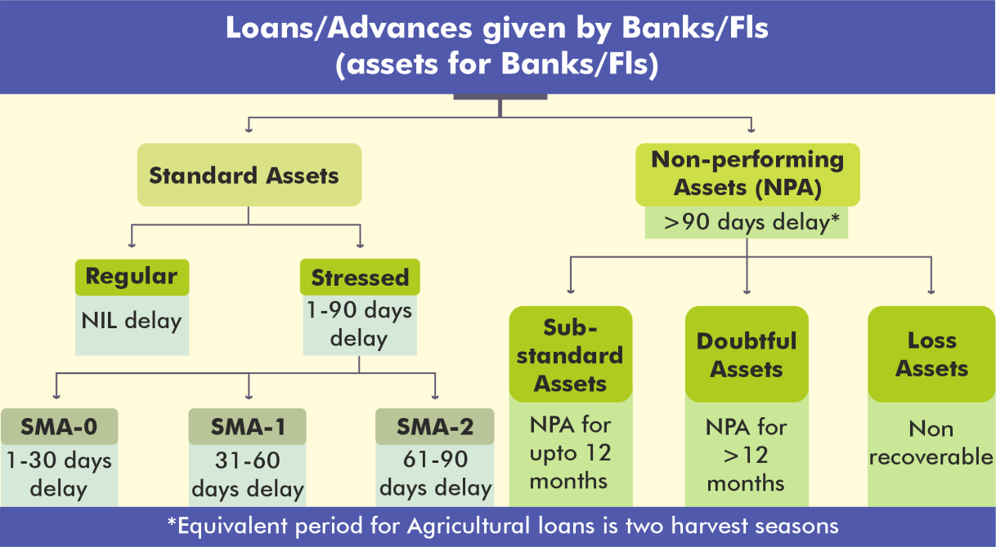

* This structure will **reduce the load of stressed assets** on the bank balance sheet and look to resolve these bad debts in a **market-led way.**

##### About Asset Reconstruction Company (ARC)

* An ARC or bad bank is a special type of financial institution (FI) that **buys the debtors of the bank** at a mutually agreed value and attempts to recover the debts or associated securities by itself.
  + A bad bank **makes a profit** in its operations if it

manages to **sell the loan at a price higher** than what it paid to acquire the loan from a commercial bank.

* **Narsimham Committee – I (1991)** first envisaged setting up of a central Asset Reconstruction Fund to facilitate Banks to improve their balance sheets by cleaning up their non-performing loans portfolio.
* **Asset Reconstruction Company (India) Ltd or Arcil, was first ARC** set up in 2002 by four banks: SBI, ICICI Bank, PNB and IDBI Bank.
* ARCs are incorporated as **company** under the Companies Act.

##### They are registered with Reserve Bank of India (RBI) under SARFAESI Act, 2002.

* RBI mandates ARCs to maintain a **minimum NOF (Net Owned Fund) of Rs 100 crore and a capital adequacy ratio of 15%** of its risk weighted assets.
* **The Insolvency and Bankruptcy Code (IBC), 2016,** allows ARCs to acquire equity through conversion of debt into equity. However, they are not allowed to bid for equity in stressed companies directly.
* **Since the enactment of SARFAESI Act,** many ARCs have come into existence. However, the establishment of new ARC was driven by the fact that existing ARCs were not able to deal with the problems of NPA as **existing ARCs are thinly capitalized and exhibited slow resolution of bad loans.**

**3.2.2. NATIONAL BANK FOR FINANCING INFRASTRUCTURE AND DEVELOPMENT (NABFID)**

##### Why in news?

Recently, the Parliament passed **National Bank for Financing Infrastructure and Development (NaBFID) Bill, 2021.**

##### About NaBFID Bill, 2021

* Bill **seeks to set**

**up NaBFID, a Development Financial Institution (DFI)** to support the development of long-term non- recourse infrastructure financing.

* **Shareholding of NaBFID:** NaBFID will be **set up as a corporate body** with authorised **share capital of 1 lakh crore rupees held by central government**, multilateral institutions, sovereign wealth funds, pension funds, insurers, financial institutions, etc.
  + Initially, **central government will own 100% shares** of the institution which may subsequently be

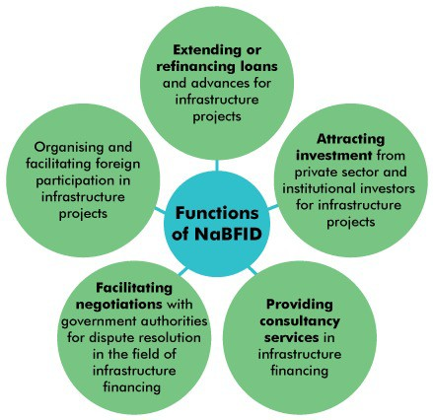

##### reduced up to 26% once the institution has achieved stability and scale.

* **Source of funds:** NBFID may raise money in the **form of loans or otherwise both in Indian rupees and foreign currencies,** or the issue and sale of various financial instruments including **bonds and debentures.**

##### NBFID may borrow money from central government, RBI, scheduled commercial banks, mutual funds, and multilateral institutions such as World Bank and Asian Development Bank.

* **Management:** NBFID will be **governed by a Board of Directors** and the **Chairperson appointed by the central government in consultation with RBI.**
  + A **body constituted by the central government will recommend candidates** for the post of the Managing Director and Deputy Managing Directors.
  + The Board will appoint **independent directors based on the recommendation of an internal committee.**
* **Government Support**: The central government will provide **grants worth Rs 5,000 crore to NBFID** by the end of the first financial year.
  + The government will also provide **guarantee at a concessional rate of up to 0.1%** for borrowing from multilateral institutions, sovereign wealth funds, and other foreign funds.
  + **Costs towards insulation from fluctuations in foreign** may be reimbursed by the government in part or full.
  + Upon request by NBFID, the government **may guarantee the bonds, debentures, and loans issued by NBFID.**
* **Investigation and prosecution**: Courts will also require prior sanction for taking cognisance of offences in matters involving employees of NBFID. No investigation can be initiated

against employees of NBFID without the prior sanction of

* + the central government in case of the chairperson or other directors
  + the managing director in case of other employees.

**Evolution of DFIs in India**

* After Independence, government has set up the **Industrial Finance Corporation (IFCI) under The Industrial Finance Corporation of India Act, 1948 and State Financial Corporations (SFCs) were formed under State Financial corporations (SFCS) Act 1951** to embark on long term term-financing for industries.
* Later in **1955, the Industrial Credit and Investment Corporation of India (ICICI), the first development finance institution in the private sector** set up with backing and funding of the World Bank.
* Later **Refinance Corporation for Industry (1958)**, **Agriculture Refinance Corporation (1963), Rural Electrification Corporation Ltd and HUDCO** were established.
* **Licences:** The **RBI in consultation with the government issue licences and specify conditions** for setting up of private sector DFIs and also RBI prescribe regulations for these DFIs.

##### About Development Financial institution (DFI)

* DFI known as a **development bank or a development finance**

**company** are institutions that provides **long term development finance to various sectors like industry, agriculture, housing and infrastructure.**

* DFIs play a **pivotal role in extending credit and boosting economies**, especially in developing countries.
* DFIs can be **either wholly or partially owned by the government and few have majority private ownership,** determined by the nature of the activities being financed, and their associated risk-returns profile.



* There is **no specific use of the term ‘DFI’ in either the RBI Act, 1934 or the Companies Act, 1956** or various statutes establishing DFIs, while some financial institutions under RBI Act and Companies Act perform the role of DFIs in the broadest sense.

##### How DFIs are different from banks?

|  |  |  |
| --- | --- | --- |
| **Parameter** | **Commercial Bank** | **Development financial institutions** |
| **Definition** | Banks that provide services to individuals and  industries. | Banks that function as multi-purpose financial  institutes, with a broad development agenda. |
| **Set up** | Set up under the Companies Act, as Banking  Companies. | Set up under specialized act E.g. Industrial  Finance Corporation Act |
| **Funds** | Funds are raised through investments and  deposits made by Depositors | Funds are borrowed and acquired by grants,  selling securities |
| **Loan provided** | Short and Medium-term loans | Medium and Long-term loans |
| **Clients** | Individuals, and Business Entities | Government and Corporates |

**3.2.3. REGULATORY REVIEW AUTHORITY 2.0**

**Why in news?**

RBI has announced the setting up of a regulatory review authority, RRA 2.0, to review its regulations internally and in consultation with other stakeholders.

##### About Regulatory Review Authority (RRA)

RBI acts as the **regulator and supervisor** of our financial system as well as of Payment and Settlement Systems. As part of it, RBI prescribes **broad parameters of banking operations** within which the country's banking and financial system functions. The RRA plays the role of revisiting this regulatory framework.

* In **1999**, first Regulatory Review Authority was set up for a **period of one year** to streamline its procedures for increased effectiveness and simplifying regulatory prescriptions,
* It helped in paving the way for issuance of **master circular** and reduced **reporting burden** on regulated entities.

##### Second Regulatory Review Authority

* **RBI Deputy Governor M. Rajeshwar Rao is appointed as the second Regulatory Review Authority** for a period of one year from 01 May 2021.

##### It will focus on streamlining regulatory and supervisory instructions, reducing compliance burden of the regulated entities by simplifying procedures and reducing reporting requirements, wherever possible.

* The RRA 2.0 will **engage with all regulated entities and stakeholders** internally as well as externally.

**3.2.4. INTEGRATED OMBUDSMAN SCHEME**

##### Why in news?

Recently, **Reserve Bank of India (RBI) announced an integrated ombudsman** scheme “**One Nation One Ombudsman**” to improve grievance redressal mechanism for bank customers.

##### More about News

* **Currently, there are three separate ombudsmen** for banks, non-banking finance companies (NBFCs) and non-bank prepaid payment issuers (PPIs) that are wallets.

##### These are operated by the RBI from 22 ombudsman offices located across the country.

* Now, the RBI has decided to integrate the three Ombudsman schemes and introduce centralised processing of grievances following **a ‘One Nation One Ombudsman’ approach.**
* The move is expected to make the ombudsman mechanism **simpler, efficient and more responsive.**

##### About Bank Ombudsman (BO)

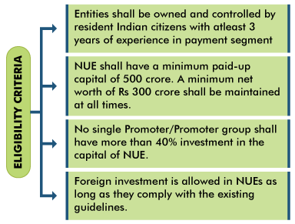

**Related information**

**Internal Ombudsman (IO) Scheme, 2018**

* It was launched by the RBI to **strengthen the internal grievance redressal system** of banks and ensure the complaints of the customers are redressed at the level of the bank itself.
* All Scheduled Commercial Banks having **more than 10 banking outlets** (excluding Regional Rural Banks), are required to **appoint IO in their banks.**
* The IO is mandated to **examine customer complaints** related to the **deficiency in service** on the part of the bank (including those listed in the BOS 2006)**.**
* **Banks** are mandated to **internally escalate all the complaints which are not fully redressed** to their respective IOs before conveying the final decision to the complainant.

o Thus, the **customers of banks need not approach the IO directly.**

* **Banks’ internal audit mechanism** is required to monitor the scheme apart from regulatory oversight by RBI.

**Ombudsman Scheme for Digital Transactions (OSDT)**

* RBI launched OSDT in 2019 **under Payment and Settlement Systems Act, 2007.**
* It provides a **cost-free and expeditious complaint redressal mechanism relating to deficiency in customer services in digital transactions** conducted through non-bank entities (like mobile wallets or tech enabled payment companies using UPI for settlements) regulated by RBI.
* **Ombudsman for Digital Transactions** is a senior official appointed by the RBI (appointed for a period not exceeding 3 years at a time).
* BO is a quasi-judicial authority which is an **Alternate Dispute Redressal mechanism** for resolution of disputes between a bank and its customers.
  + RBI in 1995 introduced the BO scheme under Section 35A of the Banking Regulation Act, 1949.
  + **In 2006, the RBI revised the BO scheme** under which the BO and the staff in the offices of the BO are drawn from the serving employees of the Reserve Bank.
* It is **fully funded by the RBI and virtually covers all banking transactions** related grievances except their business decisions like sanctioning of credit etc
* It covers grievances of the customers against **Commercial Banks, Scheduled Primary Cooperative Banks and Regional Rural Banks**.
* One can file a complaint before the BO if the bank rejects the complaint **or the satisfactory reply is not received from the bank within a period of one month** after the bank concerned has received one's complaint.

**Related News**

**RBI has stated that tenure of private bank chiefs must end in 15 years**

* The RBI has laid down **a set of instructions for private bank that** would **help improve the corporate bank governance.** Few **key instructions include-**
  + **Subject to the statutory approvals** required from time to time, the post of the MD & CEO or Whole-time Director cannot be held by the same incumbent for more than 15 years.
  + Thereafter, they could be **reappointed after a three-year cooling period**.
    - During this period, the individual shall **not be appointed or associated with the bank or its group entities**, either directly or indirectly.

### 3.3. PAYMENT SYSTEMS AND FINANCIAL MARKETS

**3.3.1. NEW UMBRELLA ENTITY**

##### Why in News?

Recently, Reserve Bank of India (RBI) extended the deadline to apply for NUE (New Umbrella Entity) to March 31.

##### About NUE

* **Objective is to** set up new pan-India umbrella entity/entities **focusing on retail payment systems.**
* NUE will be **authorised under the Payment and Settlement Systems Act, 2007** and shall be a company incorporated under the **Companies Act, 2013.**

**Need for NUEs**

**About National Payments Corporation of India (NPCI)**

* NPCI is an **umbrella organisation for operating retail payments and settlement systems** in India.
* It is an **initiative of RBI and Indian Banks’ Association (IBA)** under the provisions of the Payment and Settlement Systems Act, 2007.
  + 10 core promoter banks are State Bank of India, Punjab National Bank, Canara Bank, Bank of Baroda, Union Bank of

India, Bank of India, ICICI Bank, HDFC Bank, Citibank and HSBC

* It has been incorporated as a “**Not for Profit” Company under Companies Act 1956** with an intention **to provide infrastructure to the entire Banking system in India** for physical as well as electronic payment and settlement systems.

**Related News**

**NPCI transfers automatic bill payments business to new subsidiary**

* As per RBI directive, National Payments Corporation of India (NPCI) has transferred all its **Bharat Bill Payment System (BBPS) transaction mandates to a new subsidiary called NPCI Bharat BillPay Limited (NBBL).**
  + **BBPS** is an **interoperable bill payments platform** used by banks, fintech companies and biller merchants to automate bill collection and request solutions.
* **NBBL has** come into effect from April 1, and is a **wholly-owned subsidiary of NPCI.**
* **NPCI is** an umbrella organisation for operating retail payments and settlement systems in India. It is formed under

**Payment and Settlement Systems Act, 2007.**

**3.3.2. DIGITAL PAYMENT ECOSYSTEM**

##### Why in news?

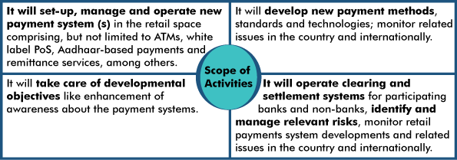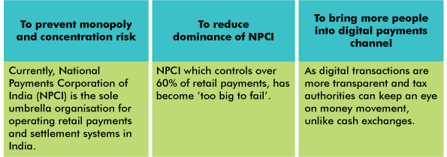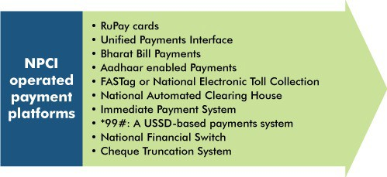

Reserve Bank of India (Digital Payment Security Controls) directions, 2021 has been published to strengthen India's digital payments architecture.



**Various initiatives taken to promote digital payments**

* **Payment and Settlement Systems (PSS) Act 2007:** It **provides for the regulation and supervision of payment systems in India** and designates RBI as the authority for that purpose and all related matters.
* **Rationalisation of Merchant Discount Rate (MDR)**

o MDR is the rate **charged to a merchant for the payment processing of debit and credit card** transactions.

•

•

•

**Payments Infrastructure Development Fund (PIDF) by RBI** to

encourage acquirers to deploy Points of Sale (PoS) infrastructure. **DigiShala:** Free Doordarshan DTH educational channel for creating awareness regarding various forms of electronic payment.

**Vittiya Saksharta Abhiyan:** It aims to actively engage the youth/ students of Higher Education Institutions to encourage and motivate all payers and payees to use a digitally enabled cashless economic system for transfer of funds.

##### About Reserve Bank of India (Digital Payment Security Controls) directions, 2021

* Directions are issued to set up a **robust governance structure and implement common minimum standards** of security controls for digital payment products and services in following way.

|  |  |  |
| --- | --- | --- |
| **Value of Digital Payments to GDP- India** | | |
|  | **Digital Payments Value to GDP (%)**  **1000**  **862**  **800 802**  **660 668 730**  **600**  **400**  **200**  **0**  **2014-15 2015-16 2016-17 2014-18 2018-19** |  |

* **Applicability:** Applicable to Regulated Entities (REs)

**scheduled commercial**

##### banks, small finance banks, payment banks and credit card issuing NBFCs.

o It is also applicable to **third-party payment applications, payment operators and gateways**.

|  |  |  |  |  |
| --- | --- | --- | --- | --- |
| **Digital Payment Trend in india** | | | | |
|  |  | **Digital Payments Volume (in crore) and**  **Value (in ₹ lakh crore)**  **1371**  **1122**  **920 1471**  **978**  **595**  **FY 2015-16 FY 2016-17 FY 2014-18**  **Volume Value (RHS)** |  | **2000** |
| **3000** |  | **1638** | **1500** |
| **2000** |  | **2339** | **1000** |
| **1000** | **823** |  | **500** |
| **0** | **352** |  | **0** |
|  | **FY 2014-15** | **FY 2018-19** |  |

##### Under the directions

* + **REs shall formulate a policy with approval of Board** for digital payment products and services.
  + REs shall **implement multi-tier application architecture**, **segregating application, database and presentation layer** in the digital payment products and services, by following ‘secure by design’ approach.
  + REs shall have **Fraud Risk Management.**
  + A **real time/ near-real time reconciliation framework** for all digital payment transactions between RE and all other stakeholders.
  + **Customer Protection, Awareness and Grievance Redressal Mechanism.**
  + **Internet banking, Mobile payments application, Card payments security controls.**

**About Digital Payment Ecosystem in India**

* **Payment and Settlement Systems**

**Act, 2007 (PSS Act, 2007) defines Digital Payments/electronic funds transfer** as any transfer of funds by way of instruction, authorization or order to a bank to debit or credit an account maintained with that bank through electronic means.

* + It includes point of sale transfers; ATM transactions, direct deposits or withdrawal of funds, transfers initiated by telephone, internet and, card payment.
* Digital payment can be done by different modes like **NEFT, RTGS, IMPS, debit and credit cards, UPI** etc.

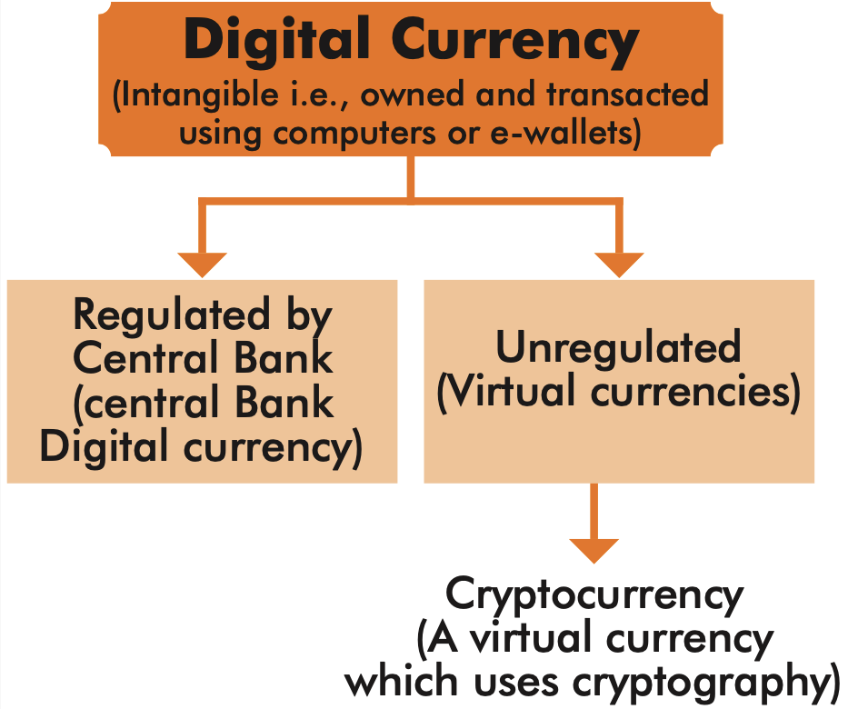

* In India **volume segment of digital payments is dominated by Debit Cards, PPIs and IMPS** and constitute close to 50 % of the total volume.
* While, **value segment is dominated by RTGS and NEFT** and constitute about 53 % of the total value of Digital Payments.
* **Digital transactions per capita** increased from 2.38 transactions per capita in financial year 2014 to **22.42 in financial year 2019.**

**Related News**

**Digital Intelligence Unit (DIU)**

* Centre has decided to **set up Digital Intelligence Unit (DIU) as a nodal agency** to tackle unsolicited commercial communication (UCC), fraud, pesky SMSes and calls, especially in the digital payments space.
* DIU will **coordinate with various law enforcement agencies, financial institutions and telecom service providers**

in investigating any fraudulent activity involving telecom resources.

* **Telecom Analytics for Fraud Management and Consumer Protection (TAFCOP)** will also be set up at all the 22- license service area level.
* Additionally, a **website and mobile application for grievance redressal** will also be developed.
* Telecom operators **need to meet and strictly follow the ministry directives on UCC.**

o In case of any violations by the companies, a **financial penalty is also proposed including disconnection of resources** in case of repetitive violations.

* The above system will **strengthen the trust of people in the digital ecosystem and will make financial digital transactions** primarily through mobile more secure and reliable, which will result in promotion of Digital India.

**3.3.3. DIGITAL CURRENCY**

##### Why in News?

Recently, China has floated its own Central Bank backed digital currency ‘eCNY’ in selected cities on a trial basis.

##### What is a Digital currency?

In the broadest sense, a digital currency is a form of currency that is available only in digital or electronic form, and not in physical form. It is also called digital money, electronic money, electronic currency, or cyber cash.

##### How has Indian dispensation responded to developments regarding digital currency?

In India, despite government threats of a ban, cryptocurrency transaction volumes have been rising and about 8 million investors now hold 100 billion rupees ($1.4 billion) in crypto

investments. User registrations and money inflows at local crypto exchanges such as ZebPay, Unocoin etc. have been soaring especially in the last 2-3 years.

In this context of large demand for digital currencies, following steps have been seen-

* The **Reserve Bank of India** voiced its **concern against cryptocurrencies**. At the same time, moving forward for developing its own digital currency.
  + To this effect, RBI issued an order in 2018 forbidding Banks from dealing in cryptocurrencies.
  + This ban was struck down by Supreme Court in 2020. The court also ordered the government to take a position and draft a law on the matter.
* In this context, the Government of India is mooting a **law to ban mining, trading and holding of cryptocurrencies.**
  + Also, further tightening the regulatory regime, the **Ministry of Corporate Affairs (MCA)** has made amendments to rules in the Companies Act, **mandating firms to disclose their investments in cryptocurrencies.**
* The measure is in line with a **government agenda** that called for **banning private virtual currencies such as bitcoin** while building a framework for an official digital currency.

**3.3.4. THE INSURANCE (AMENDMENT) ACT, 2021**

##### Why in News?



**Related News**

IRDAI has advised **all Insurance companies for issuance of Digital Insurance Policies via DigiLocker.**

* DigiLocker is a **flagship initiative of Ministry of Electronics & IT (MeitY)** under Digital India Corporation (Not for Profit Company under MeitY).
* DigiLocker **aims at ‘Digital Empowerment’ of citizen by providing access to authentic digital documents** to citizen’s digital document wallet.
* Through DigiLocker citizens can access their digital documents anytime, anywhere, **legally at par with originals**. Insurance Regulatory and Development Authority of India (IRDAI) **has allowed insurers to invest in debt securities issued by infrastructure investment trusts (InvITs) and real estate investment trusts (REITs).**
* The move is expected to improve the **overall yield of the portfolios** held by the firms, while providing more **long- term funding to the realty** sector.

•

o o o

**Key highlights of IRDAI note**

Insurance companies can **invest in bonds** of InvITs or Reits of **any ratings.**

Insurers **cannot invest more than 10% of the outstanding debt instruments** in a single InvIT or REITs.

**75% of the insurers’ investments have to be in AAA-rated assets**, while 25% can go to instruments rated AA or even A-.

Recently, the Parliament has passed the Insurance amendment Act, 2021.

##### Key provisions of the Act

* The act amends the Insurance Act, 1938 and would be implemented from April 1, 2021.
* **Foreign investment:** It raises the foreign direct investment (FDI) in the insurance sector to 74% from the existing 49% **and removes restrictions on ownership and control**.
  + However, such foreign investment may be subject to additional conditions as prescribed by the central government.
* **Investment of assets:** The Act requires insurers to hold a minimum investment in assets which would be sufficient to clear their insurance claim liabilities. If the insurer is incorporated or domiciled outside India, such assets must be held in India in a trust and vested with trustees who must be residents of India.
  + This provision will no longer apply to an insurer incorporated in India, in which at least:
    - 33% capital is owned by investors domiciled outside India, or
    - 33% of the members of the governing body are domiciled outside India.

### 3.4. EXTERNAL SECTOR

**Types of Trade Agreements**

* **Preferential Trade Agreement (PTA)** is an agreement in which two or more partners give preferential right of entry to certain products. Here a **positive list is maintained** i.e. list of the products on which two partners have agreed to provide preferential access.
* **Free Trade Agreement**: Here a **negative list of products and services** is maintained by the negotiating countries on which the terms of FTA are not applicable hence it is more comprehensive than PTA.
* **Comprehensive Economic Cooperation Agreement (CECA)** is wider than above two and covers negotiation on trade tariff.
* **Comprehensive Economic Partnership Agreement (CEPA)** is more comprehensive than CECA and encompasses trade facilitation and customs cooperation, competition, and IPR etc.c

**3.4.1. FREE TRADE AGREEMENTS**

##### Why in News?

Recently, Parliamentary Standing Committee on Commerce called for FTA renegotiation with Japan, Korea, ASEAN.

##### More on News

* Free trade agreements (FTAs) **allow imports of most of the items at nil or concessional basic customs duty rate** thereby encouraging bilateral and multilateral trade.

##### Need for renegotiation is felt because

* + As per NITI Aayog study, **utilisation rate of FTAs by Indian exporters is very low** (between 5% and 25%), because of difficulties faced in negotiating the rules.
  + **Imports under FTAs are on rise and benefits under FTAs were also being misused** which caused an adverse effect to the domestic industry.
    - Violation of **rules of origin (ROO) provisions for** dumping of Chinese products from ASEAN.
    - ROO are criteria needed to determine national source of a product.
    - India’s **trade deficit with ASEAN had increased** over the years.

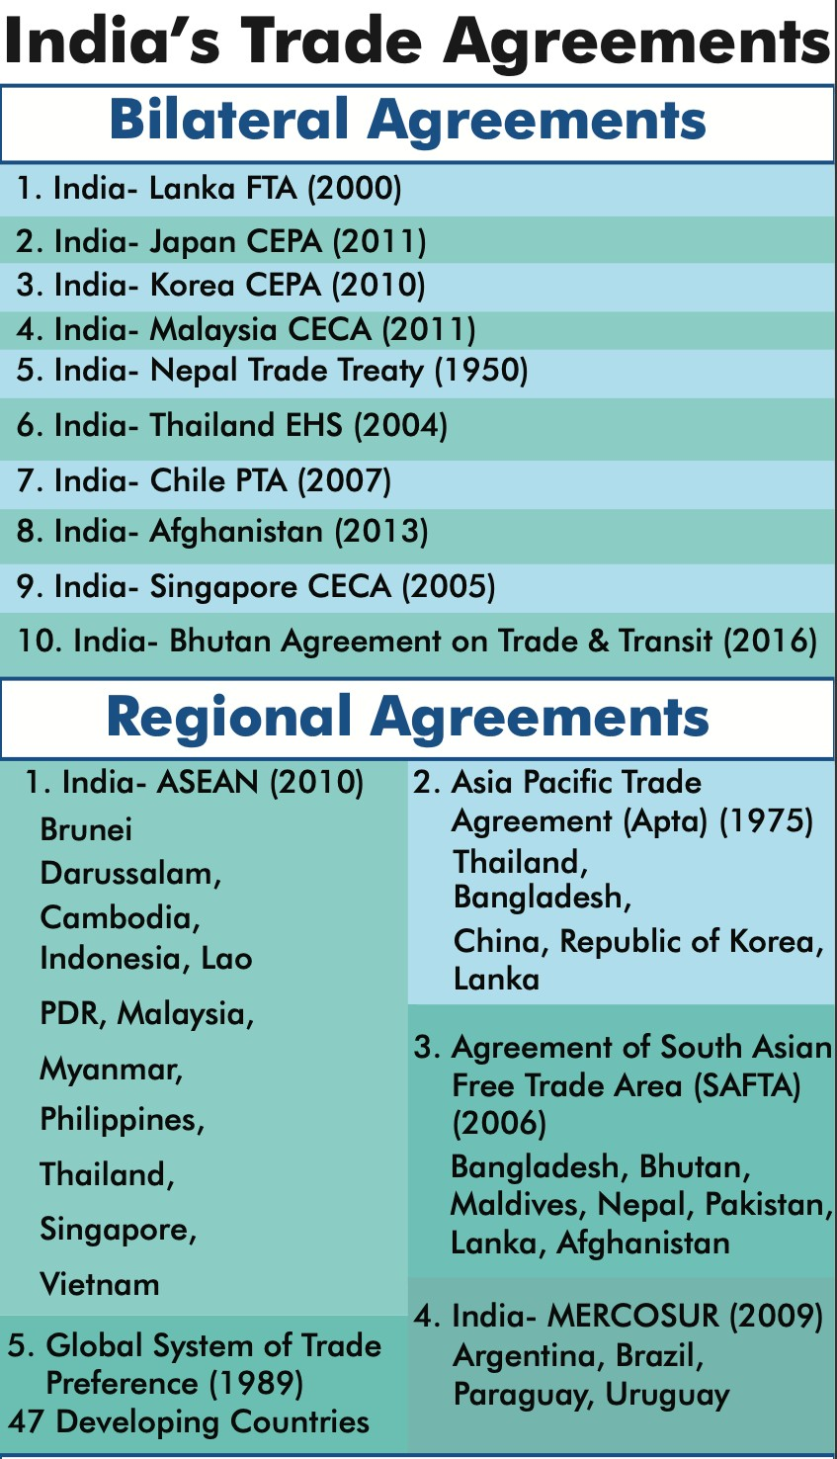

##### Some suggestions by Committee

* + Until reciprocity is ensured in FTAs, **concessional tariffs in sectors like steel should be suspended.**
  + **Periodic compliance assessment** to be carried out w.r.t ROO.

##### Recommend more international trade agreements that are beneficial to the country.

* Recently the government also **notified Customs (Administration of Rules of Origin under Trade Agreements) Rules, 2020 to address duty evasion** through routing exports to India under FTAs.

**Related Events**

**Cabinet approves Comprehensive Economic Cooperation and Partnership Agreement (CECPA) between India and Mauritius**

* Under this, two trading partners **cut or eliminate duties on a host of products** besides liberalising norms to promote services trade.
* **Salient features of CECPA**
  + It will be the **first trade Agreement to be signed by India with a country in Africa**.
  + It will cover **Trade in Goods, Rules of Origin, Trade in Services, Technical Barriers to Trade (TBT), Sanitary and Phytosanitary (SPS) measures, Dispute Settlement, Movement of Natural Persons**, Telecom, Financial services, Customs Procedures and Cooperation in other Areas etc.

**India’s FTA partners upset over India’s new rules to trace Good’s Origin**

* Countries such as Japan, South Korea, have raised concerns at the World Trade Organization (WTO) that India **insistence on additional documents to determine the origin of imported goods** could raise non-tariff barriers to trade.
* Earlier, notification was issued under **Customs (Administration of Rules of Origin under Trade Agreements) Rules, 2020 (CAROTAR)**.
* India responded that CAROTAR 2020 relates to **imports under bilateral FTA**, which does not fall within the purview of (Trade Policy Review Mechanism) TPRM.
  + TPR is conducted under **TPRM** of WTO to ensure improved adherence by all Members to rules, disciplines and commitments made under different agreements.

**3.4.2. INTERNATIONAL MONETARY FUND (IMF) QUOTA**

##### Why in News?

Recently, India advocated for better BRICS coordination on IMF quota.

##### About IMF Quota

* As per an IMF resolution, the **16th General Review** of Quotas should be concluded by **December 15, 2023.**
  + **Last review in Feb 2020**, kept the quotas unchanged.

##### About IMF quotas

* + The IMF is a **quota-based institution**. Quotas are the building blocks of the IMF’s financial and governance structure.
  + Quotas are **denominated in Special Drawing Rights (SDRs)**.
* SDR is an **international reserve asset created by the IMF to supplement the official reserves** of its member countries.

##### SDR is not a currency.

* + The IMF's Board of Governors conducts general reviews of quotas at regular intervals (no more than five years apart). **Any changes in quotas must be approved by an 85% majority** of the total voting power, and a member’s own quota cannot be changed without its consent.

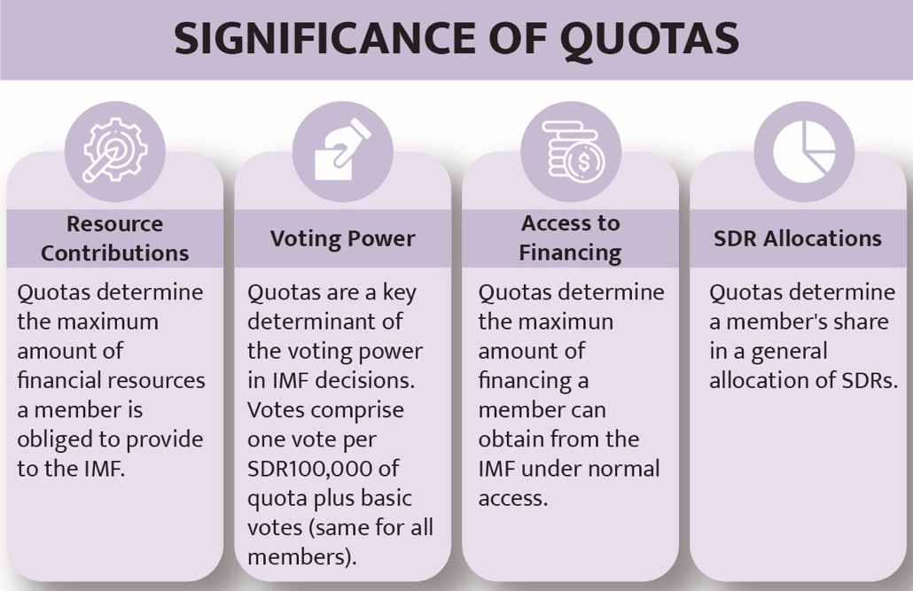

**3.5.**

**LABOUR,**

**EMPLOYMENT,**

**SKILL**

**DEVELOPMENT**

**AND**

**ENTREPRENEURSHIP**

* **Any adjustment in quota shares could result in** increase in voting rights of emerging countries **in line**

##### with their relative positions in the world economy (also see infographic)

* It could result in increase in share of emerging markets and developing countries as a whole, while protecting the voice and representation of the poorest.

**Related News**

**International Monetary and Financial Committee (IMFC)**

* Finance Minister attended International Monetary and Financial Committee (IMFC) meeting of IMF.
* IMFC **advises and reports to IMF Board of Governors on supervision and management of international monetary and financial system**, including on responses to unfolding events that may disrupt the system.

o Although **the IMFC has no formal decision-making powers**, in practice, it has become a key instrument for providing strategic direction.

* The IMFC **has 24 members who are central bank governors** or ministers and the **body meets twice an year.**

**3.5.1. ALL-INDIA SURVEYS**

##### Why in News?

Recently, Labour Bureau launched two of the five all-India surveys.

##### About the Surveys

* First surveys to be launched are the **All-India Survey of Migrant Workers and All-India Quarterly Establishment based Employment Survey (AQEES).**
  + These surveys have been **developed and designed by the Labour Bureau** to plug-in the data gap on various aspects of labour and employment and will aid evidence-based policy making processes.
  + It will be path breaking in their **“Paperless” data collection** and use of **latest technology** is likely to reduce the survey completion time by at least 30 - 40%.

##### Labour Bureau under the Ministry of Labour & Employment, is responsible for the collation, collection and publication of statistics and related information on wages, earnings, productivity, absenteeism, labour turn-over, industrial relations etc.

* + It also releases Consumer Price Index Numbers (CPI) for Industrial Workers, Rural Labourers and Agricultural Labourers.

**3.5.2. STARTUP INDIA SEED FUND (SISF) SCHEME**

##### Why in News?

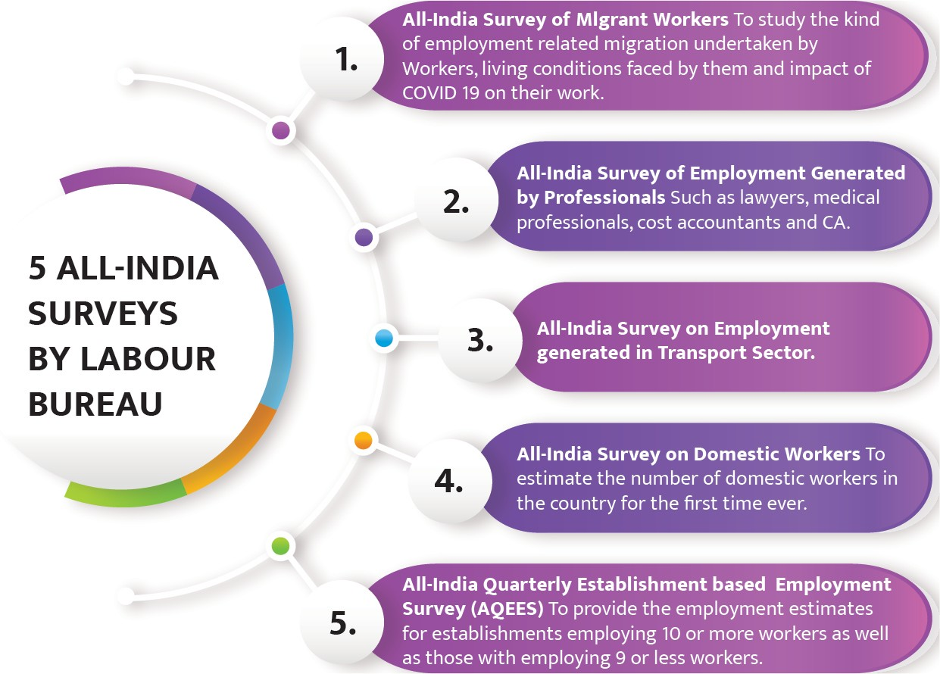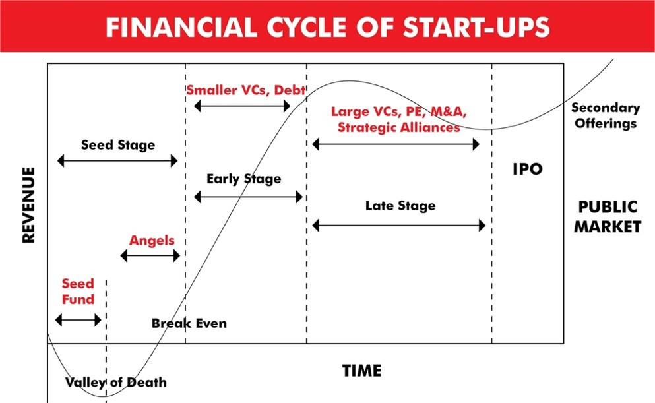

Ministry of Commerce & Industry launches ₹945 crore Startup India Seed Fund (SISF) Scheme

##### About SISF

* It aims to provide financial **assistance to startups for proof of concept, prototype development, product trials, market entry, and commercialization.**
  + SISF is expected to support an estimated 3,600 startups through

300 incubators and will **create a robust startup ecosystem, particularly in Tier 2 and Tier 3 towns.**

* + It was announced at recently held ‘**Prarambh: Startup India International summit’.**
* **₹945 crore will be divided over the next 4 years** (2021-25) for providing seed funding to eligible startups through eligible incubators.
  + Preference would be given to startups creating innovative solutions in sectors such as **social impact, waste management, financial inclusion, education, biotechnology, healthcare, etc.**
* **An Experts Advisory Committee,** constituted by Department for Promotion of Industry and Internal Trade,

##### will be responsible for overall execution and monitoring of the scheme.

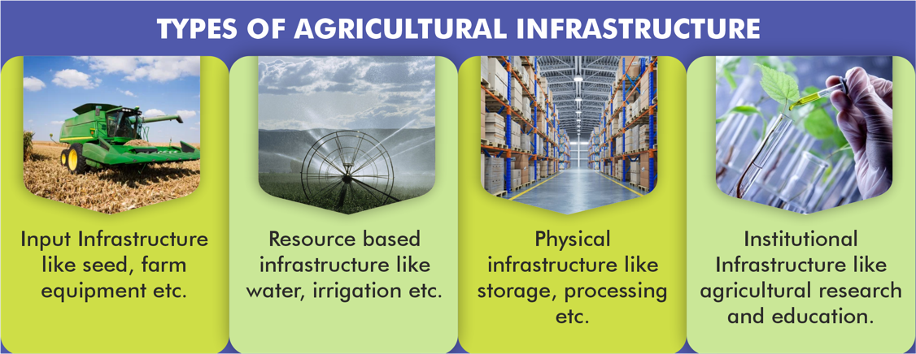

* **Eligibility Criteria for startups\***
  + A startup, recognised by DPIIT, **incorporated not more than 2 years ago** at the time of application.
  + Startup **should not have received more than Rs 10 lakh** of monetary support under any other Central or State Government scheme. This does not include prize money from competitions and grand challenges, subsidized working space, etc.
  + **Shareholding by Indian promoters** in the startup should be **at least 51%** at the time of application to the incubator for the scheme, as per Companies Act, 2013
  + Preference would be given to startups creating innovative solutions in sectors such as social impact, waste management, water management, financial inclusion, etc.

##### Other Initiatives for Startup Funding

* + **A National Seed Fund** was announced in Budget 2020-21 to support ideation and development of early- stage start-ups.
  + **Fund of Funds for Startups**, with a corpus of Rs. 10,000, under Start-up India scheme.
  + Venture capital scheme, Multiplier grants scheme, MUDRA Yojana etc.
* India is currently the **third-largest startup ecosystem in the world** with close to **38 unicorns** (as of 2019) and with a collective **valuation at around $130 billion.**

***\*The scheme also provides separate eligibility criteria for Incubators.***

### 3.6. AGRICULTURE

**3.6.1. AGRICULTURAL INFRASTRUCTURE FUND (AIF)**

##### Why in News?

In the Union Budget 2021-22, Finance Minister announced that Agricultural Produce Marketing Committees (APMCs) will become eligible beneficiaries to utilize Agriculture Infrastructure Fund (AIF).

##### About AIF

* It is a Central Sector Scheme, under Ministry of Agriculture & Farmers Welfare, to provide **medium - long term debt financing facility** through interest subvention and credit guarantee.
* **Beneficiaries include** farmers, Primary Agricultural Credit Societies (PACS), Farmer Producers Organizations (FPOs), Agri-entrepreneurs, Startups, Central/State agency or Local Body sponsored Public- Private Partnership Projects, **APMCs** etc.

##### Eligible projects include:

* + **Post Harvest Management Projects like:** Supply chain services including e-marketing platforms, Warehouses, Silos, Sorting &grading units, Cold chains, Logistics facilities etc.
  + **Building community farming assets** like Organic inputs production, Infrastructure for smart and precision agriculture, supply chain infrastructure for clusters of crops including export clusters etc.
* Under AIF, **Rs. 1 Lakh Crore will be provided by banks and financial institutions as loans** with interest subvention of 3% per annum on loans up to Rs. 2 crore, this subvention will be available for a maximum period of 7 years.
  + Further, **credit guarantee coverage** will be available for eligible borrowers from this financing facility **under Credit Guarantee Fund Trust for Micro and Small Enterprises (CGTMSE) scheme** for a loan up to Rs. 2 crore.

The fee for this coverage will be paid by the Government.

* The Scheme **will be operational from 2020-21 to 2029-30.** Disbursement in four years starting

with sanction of Rs. 10,000 crore in the first year and Rs. 30,000 crore each in next three financial years.

* Moratorium for repayment may vary subject to minimum of 6 months and maximum of 2 years.



* AIF will be managed and **monitored through an online Management Information System (MIS) platform.**
  + **National, State and District Level Monitoring Committees** will ensure real-time monitoring and effective feedback about the implementation of scheme.

**3.6.2. OTHER AGRICULTURE RELATED DEVELOPMENTS**

|  |  |  |
| --- | --- | --- |
| **Fertilizer Usage** | * As per the data, the use of chemical fertilizers in the country during 2019-20 was more than 2018-19. **Fertilizers used were mostly nitrogen (N) followed by phosphorous (P) and potassium (K).**   o **Puducherry, Telangana and Punjab are the top three states** in consumption of major fertilisers**.**   * The current consumption of **NPK ratio is 6.7:2.4:1, which is highly skewed towards nitrogen, against an ideal ratio of 4:2:1.** |  |
| **e-SANTA** | * Union Minister of Commerce & Industry (MoCI) virtually inaugurated **e-SANTA (Electronic Solution for Augmenting NaCSA farmers' Trade in Aquaculture).** * **e-SANTA is an** electronic marketplace **providing a platform** to connect aqua farmers and exporters. * It will **raise income, lifestyle, self-reliance, quality levels,** and traceability **for aqua farmers.** * **National Centre for Sustainable Aquaculture** (NaCSA) is an extension arm of Marine Products Export Development Authority (MPEDA), **under the Ministry of Commerce and Industry.** | |
| **Madhukranti and Honey Corners** | * **Madhukranti** is an initiative of **National Bee Board (NBB)** under **National Beekeeping & Honey Mission (NBHM).**   + This portal is being developed **for online registration to achieve traceability source** of Honey and other beehive products on a digital platform.   + It will **check adulteration and contamination in honey** with end-to-end record to track the source of honey. * **Honey Corners** is meant for sale of honey from dedicated sale space **at NAFED stores** to promote marketing of honey and other beehive products. | |
| **Marine Products Export Development Authority (MPEDA) to**  **certify Shrimp Farms** | * MPEDA has launched an Antibiotic-free **Certification scheme called ‘Shaphari’** to certify hatcheries and farms that adopt good aquaculture practices.   + ‘Shaphari’ is a Sanksrit word that means superior quality of fishery products suitable for human consumption. * Shaphari is based on the **UN’ Food and Agriculture Organization’s technical guidelines on aquaculture certification**. * It will have two components:   + **Certifying hatcheries** for the quality of their seeds   + **Approving shrimp farms** that adopt the requisite good practices * The entire **certification process will be online to minimise human errors and ensure higher credibility and transparency** * MPEDA is a **statutory body that was established in 1972 under the Ministry of Commerce & Industry for promotion of export of marine products from India**. | |

### 3.7. INDUSTRY AND ASSOCIATED ISSUES

**3.7.1. PRODUCTION LINKED INCENTIVE (PLI) SCHEME**

##### Why in news?

Recently Cabinet approved Production Linked Incentive (PLI) Scheme for Telecom, Pharmaceuticals, IT Hardware sectors and food processing industry.



##### Details of the PLI scheme for the sectors

|  |  |  |  |  |
| --- | --- | --- | --- | --- |
| **Basis** | **PLI Scheme for Telecom** | **PLI Scheme for Pharmaceuticals** | **PLI Scheme for IT hardware** | **Food processing industry** |
| **Duration and Outlay** | Outlay of **₹ 12195 Crores over 5 years** | Rs 15,000 crore from 2021-  2029. | Rs. 7,350 crore over 4 years. | Rs. 10900 crore  from 2021-22 to 2026-  27.  Rolled out on All India basis. |
| **Objective** | * It will **make India a global hub for manufacturing** telecom equipment. * To create jobs and **reduce imports especially from China.** * Seeks to **promote local manufacturing** in MSME category. | * Enhance **India's manufacturing capabilities by increasing investment** and production. * **Product diversification** to high value goods by creating global champions from India. | * Boost **domestic manufacturing and attract large investments** in global value chain. | * Support food manufacturing entities for   **expansion of processing capacity** and **Branding abroad** to incentivise emergence of strong Indian brands.   * Support **creation of global food manufacturing champions.** * Increase **employment opportunities** of off-farm jobs, * Ensuring **remunerative prices of farm produce**. |
| **Categories** | **Sectors included:**   * Core transmission equipment, * 4G/5G next-generation Radio Access Network and Wireless Equipment, * Access & Customer Premises Equipment, * Internet of Things Access Devices, * Other Wireless Equipment and Enterprise equipment like Switches, Routers etc.   **Incentives -**   * **Investor will be incentivized up to 20 times of minimum investment threshold** enabling them to utilize their unused capacity. * **Minimum Investment threshold** for MSME is | Scheme shall **extend incentives based on net incremental sales** to following categories:   * **Category 1-**   Biopharmaceuticals; Complex generic drugs, etc   * **Category 2**- Active Pharmaceutical Ingredients. * **Category 3-**   Repurposed drugs; Auto immune drugs, etc.  **Incentives -**   * **For First and Second Category:**   **10%** of incremental sales value for the first four year of the scheme, followed by **8%** for the fifth year and **6%** for the sixth year of production under the scheme. | Scheme shall | * **Ready to Cook/ Ready to Eat (RTC/ RTE) foods,** Processed Fruits & Vegetables, Marine Products, Mozzarella Cheese. * **Organic products of SMEs** including Free Range -Eggs, Poultry Meat, Egg Products etc. * Coverage under the PLI Scheme will **not affect**   **eligibility under other schemes** like Pradhan Mantri Kisan Sampada Yojana. |
| **covered** | **extend incentives** |
| **and** | **based on net** |
| **incentives** | **incremental sales** |
|  | to Laptops, |
|  | Tablets, All-in-One |
|  | Personal |
|  | Computers and |
|  | Servers. |
|  | **Incentives –** |
|  | Scheme will **offer 1-** |
|  | **4% cash** |
|  | **incentives** on net |
|  | incremental sales |
|  | (over **base** |
|  | **year** 2019-20) for IT |
|  | products |
|  | manufactured in |
|  | India. |

|  |  |  |  |  |
| --- | --- | --- | --- | --- |
|  | Rs. 10 Crores and for others Rs. 100 Crores.   * **Incentive structure ranges between 4% and 7%** for different categories and years. | * **For Third Category: 5%** of incremental sales value for the first four years, **4%** for the fifth year and **3%** for the sixth year. |  |  |

|  |  |  |
| --- | --- | --- |
| **Cabinet also approved Production Linked Incentive (PLI) scheme for Solar PV Modules and White Goods** | | |
| **Scheme** | **PLI Scheme 'National Programme on High**  **Efficiency Solar PV (Photo Voltic) Modules'** | **PLI Scheme for White Goods (Air Conditioners and**  **LED Lights)** |
| **Objective** | Achieving **manufacturing capacity of Giga Watt (GW) scale** in high efficiency solar PV modules | To create complete component ecosystem in India and **make India an integral part of global supply**  **chains.** |
| **Outlay** | Rs.4,500 crore. | Rs. 6,238 crores. |
| **Incentive** | PLI will be disbursed for 5 years post commissioning of solar PV manufacturing plants,  **on sales of high efficiency solar PV modules.** | Incentive of **4% to 6% on incremental sales of goods manufactured in India** for a period of five years. |
| **Need** | Solar capacity addition presently depends largely upon **imported solar PV cells and modules** due to limited domestic manufacturing capacities. | Need to make manufacturing in Indiaglobally competitive by removing sectoral disabilities, creating economies of scale and ensuring  efficiencies. |

**3.7.2. VEHICLE SCRAPPING POLICY**

**Why in News?**

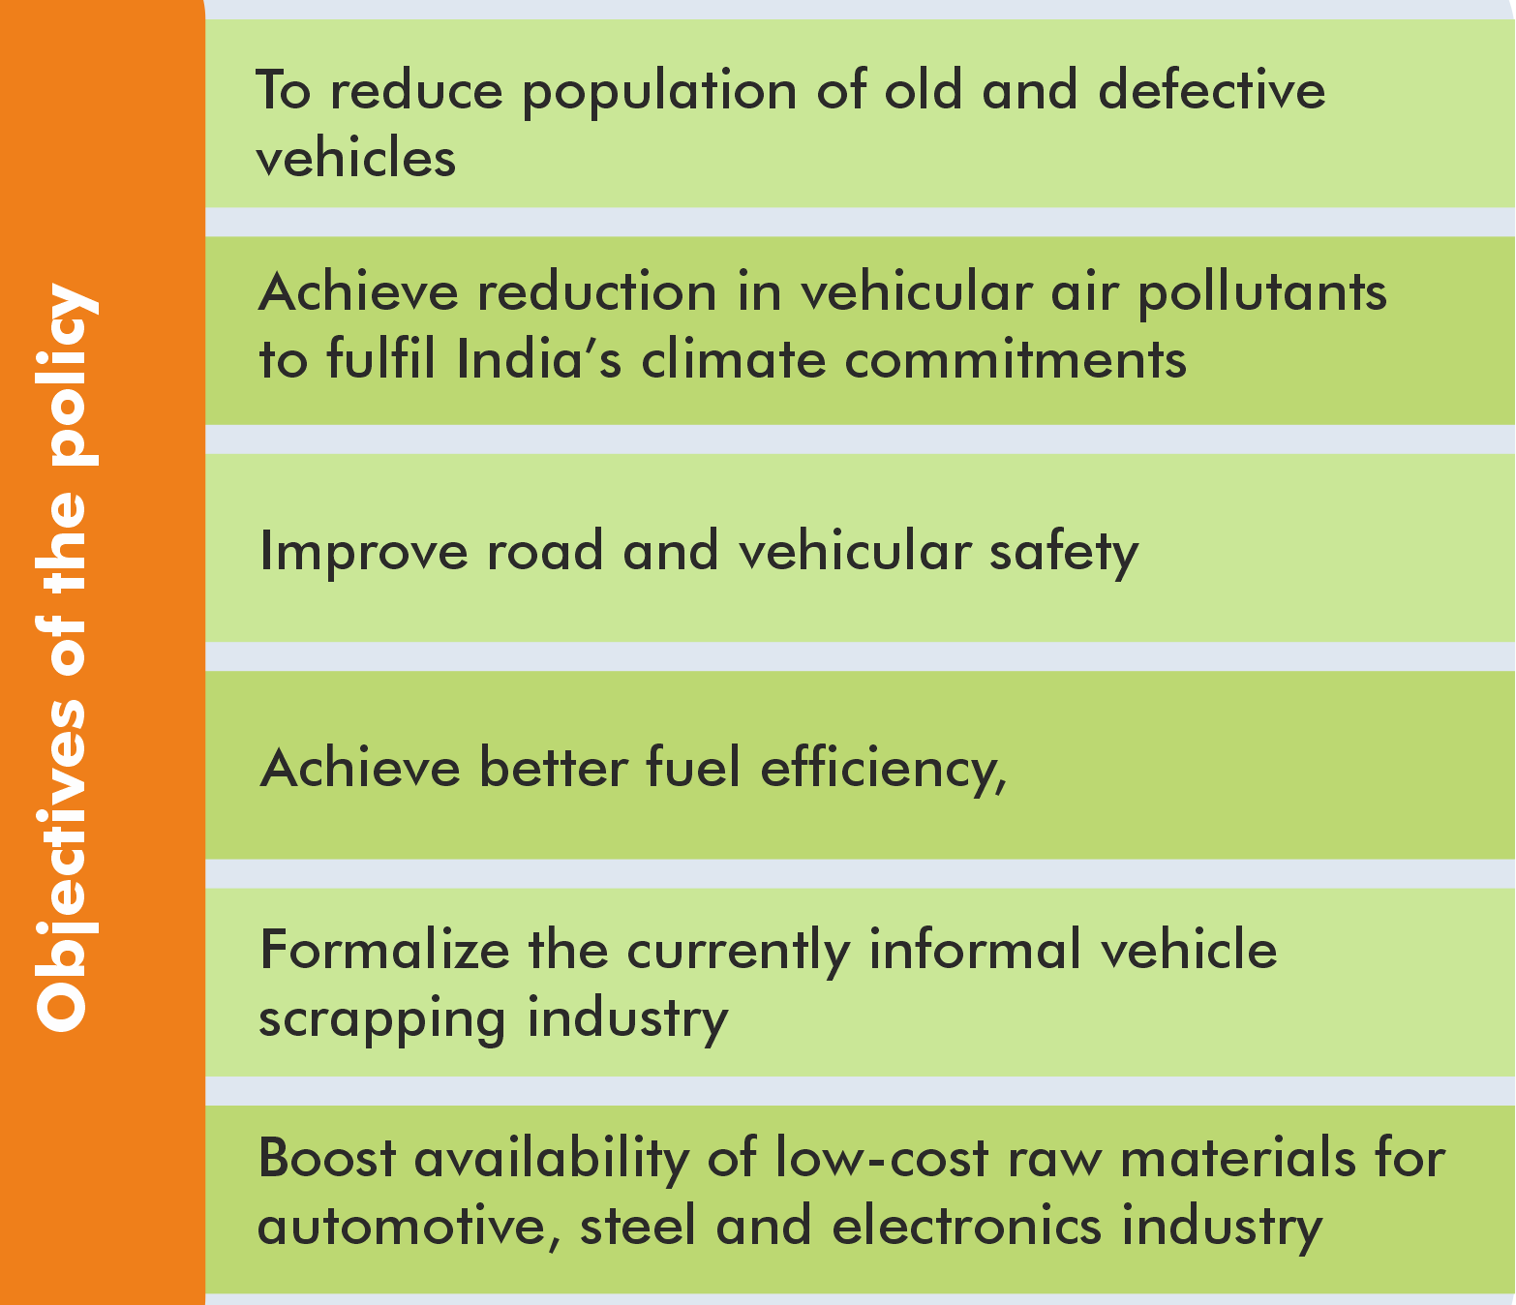

Ministry of Road Transport and Highways (MoRTH) announced Vehicle Scrapping Policy (VSP).

##### Key proposals in VSP

* **De-registrations of vehicles**
  + **Commercial vehicles to be de-registered after 15 years** in case of failure to get the fitness certificate.
  + **Private Vehicles be de-registered after 20 years if found unfit** or in case of a failure to renew registration certificate.
  + **All government vehicles** may be de- registered and scrapped after 15 years from the date of registration.

**Related News**

* Ministry of Road Transport and Highways (MoRTH) has approved a **proposal to levy a “Green Tax” on old vehicles which are polluting the environment.**
* **Main principles to be followed** while levying the Green Tax are:
  + **Transport vehicles older than 8 years could be charged** Green Tax at the time of renewal of fitness certificate, at the rate of 10 to 25 % of road tax.
  + **Higher Green tax** (50% of Road Tax) for vehicles being registered **in highly polluted cities.**
  + Differential tax, depending on fuel (petrol/diesel) and type of vehicle.
  + Revenue collected from the **Green Tax to be used for tackling pollution.**

##### Incentives to scrap old and unfit vehicles

through registered scrapping centres (RSC).

* + **State governments to offer road tax rebate** of up to 25% for personal vehicles and 15% for commercial vehicle.
  + **Manufacturers to provide 5% discount on purchase of a new vehicle** against the scrapping certificate.
  + **Registration fees may also be waived** for purchase of new vehicle against the scrapping certificate.

##### Setting up of highly specialised Registered Vehicle Scrapping Facilities (RVSFs) across

India by encouraging public and private participation.

* + MoRTH also announced **draft rules to promote setting up of Registered Vehicle Scrapping Facility**

across India.

##### What is vehicle scrapping?

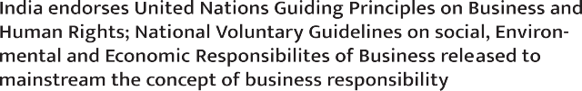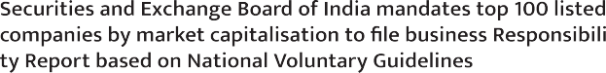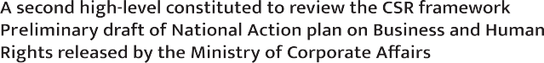

* It is the **process in which End of life – vehicles (ELV) are disposed of**, typically using shredders that tear them down into tiny pieces of metal which can then be recycled.
  + It covers activities such as **depolluting, dismantling, segregation of material, safe disposal of non- reusable parts etc.**
  + If 1990 is taken as base year, there are **approximately 37 lakh Commercial Vehicles (CV) and 52 lakh Personal Vehicles (PV) eligible for voluntarily scrapping.**

##### ELV means all vehicles

* + No longer validly registered,
  + With cancelled registrations under Motor Vehicle Act, 1988 or due to an order of court,
  + Self-declared by owners as a waste vehicle due to circumstances that may be arising from fire, damage, natural disasters, riots, accidents etc.

**Update: Commercial Vehicles of Any Age Can Be Scrapped If It Fails Fitness Test Twice**

* **Ministry of Road Transport** issued the draft rule in which any **commercial vehicle** irrespective of its age and even before it attains 15 years would be phased out, if it fails to pass the automated fitness test after two chances.
  + Such vehicles will be **automatically deregistered from the VAHAN Database**.
  + These will come into effect from October 1, 2020.
* **Other key highlights of rules**
  + Owner of a vehicle can **apply for a re-evaluation of its vehicle** through automated tests.
  + Automated Testing Station shall act as a **test-only facility** and shall not provide any services related to repair of vehicles or sale or manufacturing of auto spares.

**3.7.3. COMPANIES (CORPORATE SOCIAL RESPONSIBILITY (CSR) POLICY) AMENDMENT RULES, 2021**

##### Why in news?

Recently, Ministry of Corporate Affairs brought into effect the **Companies (CSR Policy) Amendment Rules, 2021** by amending amend the Companies (CSR Policy) Rules, 2014.

##### About Corporate Social Responsibility (CSR)

* It is a management concept whereby companies **integrate social and environmental concerns in their business operations** and interactions with their stakeholders.
* In 2013, **Companies Act 2013 introduced changes** with respect to company formation, administration, and governance, and incorporated an **additional section i.e. Section 135 on CSR obligations** for companies listed in India.
  + With this, **India became the first country to legislate CSR activities** under Companies Act 2013.

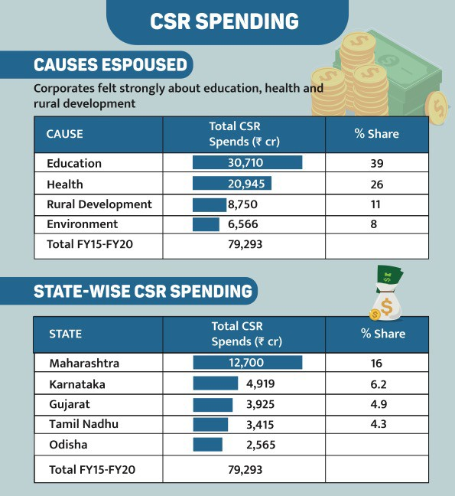

* Every qualifying company requires **spending of at least 2% of its average net profit (Profit before taxes) for the immediately preceding 3 financial years** on CSR activities in India.

##### Companies applicable to

* + annual turnover of 1,000 crore and more or
  + net worth of Rs. 500 crore and more or
  + net profit of Rs. 5 crore and more.

##### CSR is also applicable to branch and project offices of a foreign company in India.

* **Various CSR activities includes:**
  + eradicating extreme hunger and poverty,
  + promotion of education, promoting gender equality and empowering women,
  + reducing child mortality and improving maternal health ensuring environmental sustainability,
  + employment enhancing vocational skills,
  + social business projects.
  + **Contributions to the PM CARES Fund or any other fund set up by the Central government** for socio economic development and relief and welfare of the schedule caste, tribes, other backward classes, minorities and women will also be considered for CSR
* In 2019, amendments introduced, which require companies to **deposit the unspent CSR funds into a fund prescribed under the Act** within the end of the fiscal year.

##### Newly amended rules

* **Exclusion from CSR activities:**
  + Activities undertaken in **pursuance of normal course of business of the company**.
    - **Exception: A company engaged in R&D of a new vaccine, drugs and medical devices in their normal course of business** may undertake such activities related to Covid

19 for the financial year 2021, 2021-22 & 2022-23 as CSR.

##### Activities

**undertaken outside India**, except training of National or International level Indian sportspersons.

* + Contribution of any amount **to any political party;**

##### Activities

**benefitting employees of the company**, as under Code on Wages, 2019.

* + **Activities supported by the company on sponsorship basis**, for deriving marketing benefits for its products/services.
  + **Activities carried out for fulfilment of any other statutory obligations** under any law in force in India.



* **Mandatory registration:** Entities have to **register itself with the Central Government** and **fill the CSR-1 Form electronically** with the Registrar of Companies from April 1, 2021.
* **Engagement of external organizations** for design, evaluation, capacity building and monitoring of CSR projects has also been **permitted**.
* **Annual Action plan:** CSR committees of Companies shall be required to **formulate an annual action plan**

and recommend the same to the board of the company.

* **Administrative overheads:** Board of company needs to ensure administrative overheads do not exceed 5% of the total CSR expenditure for a financial year.
  + Administrative overheads mean the **expenses incurred for general management and administration of CSR functions in the company** and explicitly excludes any expenses incurred for the designing, implementation, monitoring, and evaluation of a particular CSR project.
* **Surplus cannot be utilised for other purposes:** Surplus from any project cannot be utilized for any business profits and must be reinvested into the same CSR project or may be transferred into fund.
* **Impact assessment:** Any corporation with a CSR obligation of Rs 10 Cr or more for the 3 preceding financial years would be **required to hire an independent agency to conduct impact assessment** of all of their projects with outlays of Rs 1 Cr. or more.
* **Mandatory disclosure of CSR projects:** It would be placed on the website of the company to ensure accountability of companies and a closer check on the compliance of rules.

**Related News**

**Ministry of Corporate Affairs (MCA) amends Companies (Accounts) Rules under Companies Act**

* **As per the amendments**:
  + **Firms are mandated to disclose their investments in cryptocurrencies**, spend on corporate social responsibility (CSR), and **benami property transactions, in their financial statements**.
  + Companies are mandated to **record audit trails of their accounts** aimed at curbing backdated entries.
* Disclosure **aims to improve transparency for the stakeholders.** New rules will come into effect from April 1, 2021.

**3.7.4. COPYRIGHT (AMENDMENT) RULES, 2021**

##### Why in news?

Recently, the **Ministry of Commerce & Industry** has notified Copyright (Amendment) Rules, 2021.

##### What is a copyright?

* A Copyright is a **form of intellectual property protection** granted under the Indian law to the **creators of original works of authorship** such as-
  + **Literary works** including computer programs, tables and compilations including computer databases which may be expressed in words, codes, schemes or in any other form, including a machine readable medium.
  + **Dramatic, musical and artistic works.**
  + **Cinematographic films** and **sound recordings.**
* These rights include the **right of adaptation, right of reproduction, right of publication, right to make translations, communication to public** etc.

**Copyright regime in India**

* In India, the copyright regime is governed by the **Copyright Act, 1957** and the **Copyright Rules, 2013**.
  + The Copyright Rules, 2013 was last amended in 2016 through the Copyright Amendment Rules, 2016.

##### India is signatory to following International Copyright treaties:

* + **Berne Convention, 1886:** It is for the **Protection of Literary and Artistic Works** under which **Indian copyright law applies to anything published or performed in India,** regardless of where it was originally created.
  + **The Universal Copyright Convention (UCC)**: It gives protection for **original literary, artistic and scientific works.** Under the provisions of the UCC, the contracting countries have to **provide a set of ‘minimum rights’ to the rightful owner of the work.**
  + **Trade related aspects of Intellectual Property Rights (TRIPS)**: The treaty of TRIPS was signed under the aegis of World Trade Organisation (WTO) in 1995. The provision of TRIPS Agreement are the most

extensive and rigorous in nature as these protect all forms of IPR collectively including Copyrights and other related rights.

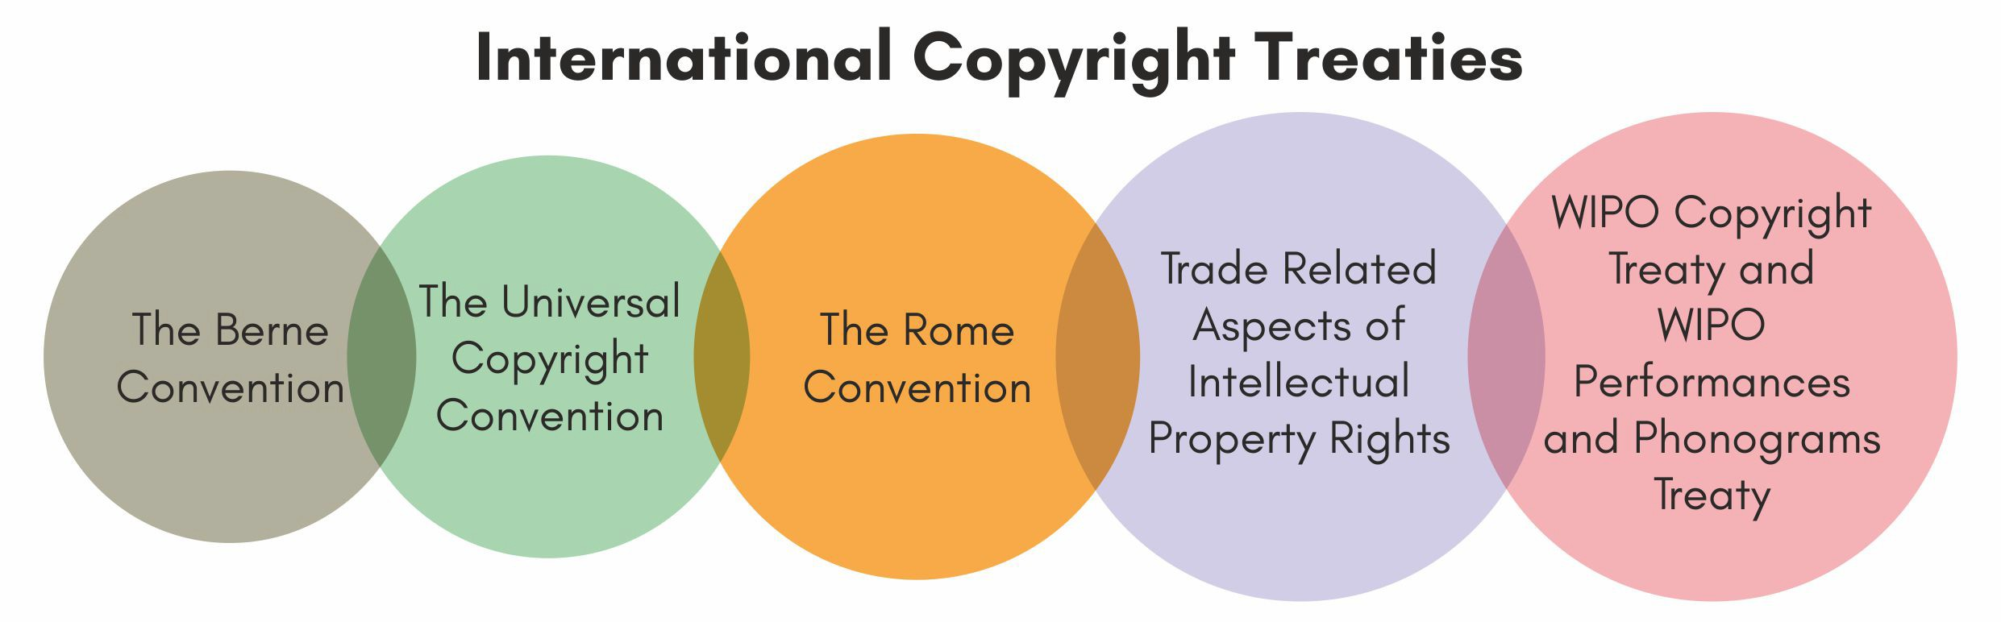

* + **WIPO Copyright Treaty, 2002:** It is a **Special agreement under Berne Convention** and it has been adopted by **96 contracting parties**.
    - It has provisions to **extend the protection of copyrights** contained therein to the **digital environment** to address ‘on-demand’ and other interactive modes of access.
  + **WIPO Performances and Phonograms Treaty (WPPT), 2002:** It deals with rights of two kinds of beneficiaries, particularly in digital environment- **performers** (actors, singers, musicians etc.), and **producers of phonograms** (Sound recordings).
    - The treaty empowers right owners and recognizes moral rights of the performers for the first time & provides exclusive economic rights to them.

##### India is not a signatory to Rome Convention.

* + The Rome Convention secures protection in **performances for performers, in phonograms for producers of phonograms and in broadcasts for broadcasting organizations**.
    - **WIPO (World Intellectual Property Organization)** is responsible for the administration of the convention jointly with the International Labour Organization (ILO) and the United Nations Educational, Scientific and Cultural Organization (UNESCO).

In this context, the amendment to the Copyright (Amendment) Rules, 2021 aims to **bring parity of the rules with existing legislations** and **enable smooth adoption of electronic means as primary mode of communication and working** in the Copyright Office.

##### Provisions of new amendment

* **Publication in official gazette:** It included a new provision that **eliminates the mandatory requirement** of publication in the Official Gazette.
* **Royalty management**: It aims to **encourage accountability and transparency** by introducing new provisions to deal with the undistributed royalty amounts and use of electronic and traceable payment methods for collection and distribution of royalties.
* **Registration of software works:** The compliance requirements for **registration of software works have been reduced** and the applicant can file the first 10 and last 10 pages of source code, or the entire source code if less than 20 pages, with no blocked out or redacted portions.
* **Annual Transparency Report:** The copyright societies will be required to draw up and make public an Annual Transparency Report for each financial year. It is aimed to **reinforce transparency** in working of copyright societies.
* **Institutional mechanism:** The amendments have harmonised the Copyright Rules with the provisions of

##### Finance Act, 2017 whereby the Copyright Board has been merged with Appellate Board.

* **Powers to High Courts**: New rules replace powers in favour of the **Intellectual Property Appellate Board (IPAB)** from the Copyright Board but due to **newly notified Tribunals Reforms** (Rationalization and Conditions of Service) Ordinance, 2021 that has abolished the IPAB, all the powers that are supposed to vest with the IPAB are actually vesting with the **High Courts**.
* **Time limit:** The time limit for the Centre to respond to an application made before it for registration as a copyright society is extended to 180 days.

|  |  |  |  |
| --- | --- | --- | --- |
| * 1. **INFRASTRUCTURE**       1. **MAJOR PORT AUTHORITIES BILL, 2020**   **Why in News?**  Recently, Parliament passed the Major Port Authorities Bill, 2020.  **About the Bill**   * Bill seeks to provide for regulation, operation and planning of major ports in India and provide greater autonomy to these ports.   o It seeks to replace the Major Port Trusts Act, 1963.   * Application: To major ports of Chennai, Cochin, Jawaharlal Nehru Port, Kandla, Kolkata, Mumbai, New Mangalore, Mormugao, Paradip, V.O. Chidambaranar (Tuticorin), and Vishakhapatnam. * **Key features of the Bill include:** | |  | |
|  | **Major Port Authorities Bill, 2020** | | **Major Port Trusts Act, 1963.** |
| **Major Port Authorities Board** | * A Board of Major Port Authority for each major port will be formed. * These Boards will replace the existing Port Trusts. | | * Under this, all major ports were managed by the respective Board of Port Trusts that have members   appointed by the central government. |
| **Composition of Board** | * **Board will comprise of a Chairperson and a deputy Chairperson,** both appointed by central government on the recommendation of a selection committee. * **Other Members:**   + One each from respective state governments, Railways Ministry, Defence Ministry, and Customs Department.   + Board will also include two to four independent members, and two members   representing the interests of the employees. | | * **Board of Port Trusts consisted of:**   + Chairman to be appointed by the Central Government.   + one or more Deputy Chairman.   + such number of persons, as the Central Government may, from time to time from amongst persons namely Mercantile Marine Department, Customs Department, Defence Services   etc. |
| **Powers of the Board** | * Bill allows the **Board to use its property, assets and funds as deemed fit** for the development of the major port. * **The Board can also make rules on**   + Declaring availability of port assets for port related activities and services.   + Developing infrastructure facilities such as setting up new ports, jetties.   + Providing exemption or remission from payment of any charges on any goods or vessels. | | **It included:**   * Power to raise loans. * Power to make regulations w.r.t employees. * Power to execute works and provide appliances. * Power with respect to landing places and bathing ghat. * Power of Board to order sea-going vessels to use docks, wharves, etc |
| **Fixing of rates** | * Board or committees appointed by the Board will **determine rates for assets and services available at ports.** * Such fixing of rates will not be with retrospective   effect. | | * Currently, the Tariff Authority for Major Ports, established under the 1963 Act, fixes the scale of rates for assets and services available at ports. |
| **Financial powers of the Board** | * **Board may raise loans** from any scheduled bank or financial institution **within India, or any financial institution outside India.** * However, for loans above 50% of its capital reserves, the Board will require prior sanction of   the central government. | | * Board had to seek prior sanction of the central government to raise any loan. |

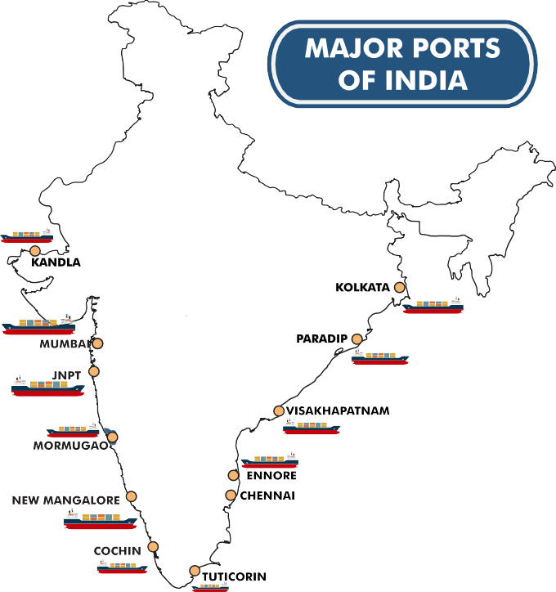



|  |  |  |
| --- | --- | --- |
| **Adjudicatory**  **Board** | * It provides for the constitution of an Adjudicatory   Board by the central government. | * Under this Tariff Authority for Major   Ports were constituted for this role. |
| **Penalties** | * Any person contravening any provision of the Bill or any rules or regulations will be punished with a   fine of up to one lakh rupees. | * There were various penalties for contravening provisions of the Act. |
| **Public Private Partnership (PPP) projects** | * Bill defines PPP projects as projects taken up through a concession contract by the Board. * For such projects, the Board may fix the tariff for the initial bidding purposes. |  |
| **Corporate Social Responsibility** | * Board may use its funds for providing social benefits. This includes development of   infrastructure in areas such as education, health, housing, and skill development. |  |

**3.9. INDICES IN NEWS**



|  |  |  |  |  |  |
| --- | --- | --- | --- | --- | --- |
| **National Coal Index (NCI)** | * **Ministry of Coal** has started **Commercial Auction of coal mines on revenue share basis using NCI.** * NCI is a price index which **reflects the change of price level of coal** on a particular month relative to the fixed base year.   + The **base year for the NCI is FY 2017-18**. * NCI is composed of a set of **5 sub-indices: 3 for Non-Coking Coal and 2 for Coking Coal.**   + As per the grade of coal pertaining to a mine, the appropriate sub-index (Coking and Non- coking) is used to arrive at the revenue share.   + **Coking coal** is a grade of coal that can be used to produce good-quality coke, one of the key inputs for the production of steel.   + **Non-coking coals** have higher ash content and does not have any caking properties. It is mainly used as thermal coal for power generation. * **Prices of coal from all the sales channels of coal, including import**, as existing today are   **considered** for compiling the NCI. | | | | |
| **National Council of Applied Economic Research (NCAER)**  **Land Record Services**  **Index** | * The Index is part of the **NCAER Land Policy Initiative (NLPI) launched in 2019** with the aim of filling the gaps in economic research, policy analysis, and systematic data on land.\   + NCAER is an economic policy think tank.   + National **average improved by 16.2% between the two rounds (2019 and 2021)**, showing considerable progress in **digitizing records and the registration processes.** (details in infographic). * **Earlier, SVAMITVA** (Survey of Villages and Mapping with Improved Technology in Village Areas) scheme was launched to confer **land titles in so far unmapped and inhabited parts of rural India.** | | | | |
| **Ease of Living Index (EoLI) &**  **Municipal Performance Index (MPI)** | * Both were released by **Ministry of Housing & Urban Affairs**. * 111 cities participated in EoLI and MPI was released for 111 municipalities. * EoLI is an assessment tool that **evaluates the quality of life and the impact of various initiatives for urban development.**   + It provides a comprehensive understanding of participating cities across India based on   **quality of life, economic-ability of a city, sustainability and Citizen perception**.   * + **First edition of the index** was launched in 2018.   + Bengaluru, Pune, Ahmedabad were best cities in EoLI 2020 (Million Plus Category)   + Shimla ranked first in EoLI 2020 (Less than Million Category). * MPI was **launched, first time this year,** as an accompaniment to the EoLI.   + MPI seeks to **assess and analyse performance of Indian municipalities** based on their defined set of functions.   + Indore (Million Plus Category) and NDMC (Less than Million Category) were leading municipalities in MPI 2020   + The **Municipal Performance Index framework covers 20 varied sectors** as given follow: | | | | |
|  | 1. Education | 8. Expenditure Management | 15. Plan Implementation |  |
| 2. Health | 9. Fiscal Responsibility | 16. Plan Enforcement |
| 3. Water & Wastewater | 10. Fiscal Decentralization | 17. Transparency & Accountability |
| 4. Sanitation | 11. Digital Governance | 18. Human Resource |
| 5. Registration & Permits | 12. Digital Access | 19. Participation |
| 6. Infrastructure | 13. Digital Literacy | 20. Effectiveness |
| o 7. Revenue Management | 14. Plan Preparation |  |

* It was published by US conservative think-tank**, The Heritage Foundation.**
* The index ranks **12 indicators** from property rights to financial freedom **under four categories: rule of law, size of government, regulatory efficiency and open markets**.
* **India** was ranked at **26th out of 40 countries among Asia-Pacific countries and 121st globally (out of 184).**

o **Improvements made in business freedom** were offset by declines in judicial effectiveness and other scores.

* **Singapore topped the index** followed by New Zealand and Australia.

**Economic Freedom Index, 2021**

 **3.10. ECONOMIC CONCEPTS IN NEWS**

|  |  |
| --- | --- |
| **Credit default swaps (CDS)** | * RBI has unveiled draft guidelines on credit default swaps (CDS). * CDS is a **form of insurance** that a bond investor buys against potential defaults by a corporation. If **the underlying bond defaults, issuer of the CDS pays for the default**. A premium is charged for the risk. * CDS is issued by **insurance company or by any permitted regulated financial entity**, mainly banks. * RBI had **deferred introducing CDS in 2011** as CDS is seen as being responsible for the 2008 global financial crisis. |
| **Currency swap** | * Recently, Central Bank of Sri Lanka settled a USD 400 million currency swap facility with RBI under SAARC currency swap framework (SCSF). * A currency swap between countries is an **agreement to exchange currencies with predetermined terms and conditions.** * SCSF, since 2012, provides a **backstop line of funding for short term foreign exchange** liquidity requirements or short-term balance of payments stress.   + It is **available to all SAARC member countries**, subject to their signing bilateral swap agreements.   + Drawals can be made in **US dollar, euro or Indian rupee.** |
| **Nidhi companies** | * Ministry of Corporate Affairs (MCA) has advised investors **to verify status of Nidhi companies before investing in them** after it found that many such firms were not complying with the rules set for them.   o Earlier Companies Act, 2013 and Nidhi Rules, 2014 were amended for better regulation of such companies.   * A Nidhi company is a non-banking financial company doing the business of **lending and borrowing with its members or shareholders.** * It is notified by the government **under Companies Act, 1956.** * **FDI is prohibited in Nidhi Companies.** |
| **Prompt Corrective Action (PCA)** | * **Recently, IDBI Bank exited from PCA norms.** Now, three banks -Indian Overseas Bank, UCO Bank and Central Bank of India are under PCA. * PCA is a framework under which **banks with weak financial metrics are put under watch by the RBI.**   o PCA framework deems banks as risky if they slip below certain norms on three parameters  — **capital ratios, asset quality and profitability.**   * Under PCA, RBI can **place restrictions on dividend distribution, branch expansion, and management compensation etc.** |
| **Special Purpose Acquisition Companies, or SPACs** | * As per recent reports **SEBI might facilitate launch of SPACs in India**. * SPACs are **listed shell companies created with sole purpose to acquire unlisted or private companies** and then merge with the latter. * SPACs **don’t have business operations of their own** and raise capital through an initial public offering (IPO) to acquire private companies later on.   o SPACs are currently **not allowed to raise capital through IPO in India**.   * These are **also called “blank cheque companies”** as SPAC investors have no idea about where and how their capital will be utilised. |
| **Brent crude** | * Security concerns around Saudi Arabia’s oil fields have pushed **Brent crude price to above $70 per barrel mark.** * Brent crude price is **international benchmark price used by OPEC,** while West Texas Intermediate **(WTI) is a benchmark for US oil prices.**   o While **Brent crude is extracted from North Sea**, **WTI is usually extracted from US oil fields**  in Texas, Louisiana, and North Dakota.   * **Sulfur content of both is well under 1%**, making them both sweet crude. They are **also less dense making them easier to refine** and more attractive to petroleum product producers. |



|  |  |
| --- | --- |
| **Remission of**  **Duties and**  **Taxes on Exported Products**  **(RoDTEP)** | * RoDTEP is a **remission of duties and taxes paid to exporters** on production inputs such as electricity tax, diesel tax, panchayat tax, stamp duty. The idea is to **boost exports and make the Indian exporter competitive** in the international market. * Recently, the **benefit rates payable to exporters under the scheme were delayed** due various issues. |
| **Innovators Growth Platform (IGP)** | * Securities and Exchange Board of India (SEBI) has made it **easier for startups to list on IGP**. * Introduced in 2019, IGP is **aimed providing technology-oriented start-ups or companies with early-stage investors a listing opportunity** with a much more relaxed framework. * IGP as a platform has the **promise to increase capital availability** significantly and has the added advantage of **enabling exits for early-stage investors.** |
| **Index of**  **Industrial Production (IIP)** | * It is an index that **tracks manufacturing activity in different sectors** of an economy. * The IIP number **measures the industrial production** for the period under review, usually a month, as against the reference period * **Mining, manufacturing, and electricity** are the three broad sectors in which IIP constituents fall. * **Core sectors** (Electricity, crude oil, coal, cement, steel, refinery products, natural gas, and fertilizers) constitute **40% of the weight of items** included in the IIP. * IIP data is also **compiled and published by the** MoSPI. |
| **Index of eight core industries** | * The Office of the Economic Adviser, **Department for Promotion of Industry and Internal Trade,**   Ministry of Commerce and Industry released Index of Eight Core Industries for February 2021.   * The **decline of 4.6% is witnessed** in all 8 sectors. * It accounts **40.27% of the weight of items** included in the **Index of Industrial Production (IIP).** * 8 core sectors includes **Refinery Products (28.04%),** Electricity (19.85%), Steel (17.92%), Coal (10.33%), Crude Oil (8.98%) Natural Gas (6.88%), Cement (5.37%), **Fertilizers (2.63%).** |
| **Safeguard Duty** | * Finance Ministry has rejected the recommendations of Directorate General of Trade Remedies under the Commerce Ministry to impose a 10% safeguard duty on importing single-mode optical fibre. * **Safeguard duty is a temporary relief** provided when imports of a product increase unexpectedly to a point where they threaten domestic manufacturing of the same product. * Provisions for **Safeguard Duties have been prescribed under Customs Tariff Act, 1975.** |
| **Countercyclical capital buffer (CCyB)** | * **RBI decided not to activate Countercyclical capital buffer (CCyB).** * CCyB is **equity capital to be kept by a bank to meet business cycle related risks.** Aim is to   + Build up a **buffer of capital in good times** which may be used in difficult times.   + **Restrict banking sector from indiscriminate lending** in the periods of excess credit growth * It was made **part of the BASEL III norm of 2010 (post 2008 recession)** as part of creating more resilient banks and banking systems.   + **RBI issued guidelines on CCyB in 2015 but** has kept the ratio at 0% ever since. |
| **Operation Twist** | * Recently, the Reserve Bank of India (RBI) decided to undertake its own version of Operation Twist to **bring down 10-year yields of government securities (G-Secs)** and drive monetary transmission. * **Operation Twist** is a move in which a central bank decides to **simultaneously buy long-dated securities while selling short-term securities**.   o A conventional Operation Twist involves a central bank buying and selling securities of  the **same durations.** |
| **Currency Watch List** | * US placed 11 countries, including **India, China, Germany and Italy in the currency practices monitoring list.** * List includes countries that US feels are engaging in “unfair currency practices” by **deliberately devaluing their currency against the dollar.**   o Devaluation would reduce cost of exports from that country and artificially show a reduction in trade deficits as a result   * Designation **does not immediately attract any penalties**, but tends to dent confidence about a country in global financial markets |
| **Non-resident taxable persons (NRTPs)** | * **NRTP is any person** who occasionally undertakes transactions involving the supply of goods and/ or services but who **has no fixed place of business or residence in India.** Under GST law there are **separate sets of provisions** for registration, returns, refunds, etc. **for them.**   o **Domestic taxpayers:** Registration under GST needed only if the aggregate turnover exceeds the prescribed threshold.   * **NRTP:** They are required to compulsorily register under the Indian GST laws **irrespective of the quantum of turnover involved.** |

|  |  |
| --- | --- |
| **Convention on the Recognition and Enforcement of Foreign Arbitral Awards (also called New York**  **Convention)** | * It is one of the key instruments **in international arbitration**. Its two basic components include:   + **Recognition and enforcement of foreign arbitral awards**, i.e., arbitral awards made in the territory of another (Contracting) State.   + **Court of a Contracting State**, when seized of a matter in respect of which the parties have made an arbitration agreement, must, at the request of one of the parties, refer them to arbitration. * It is adhered to by more than 160 nations, including India. |

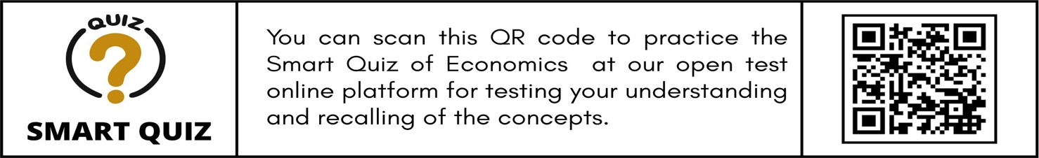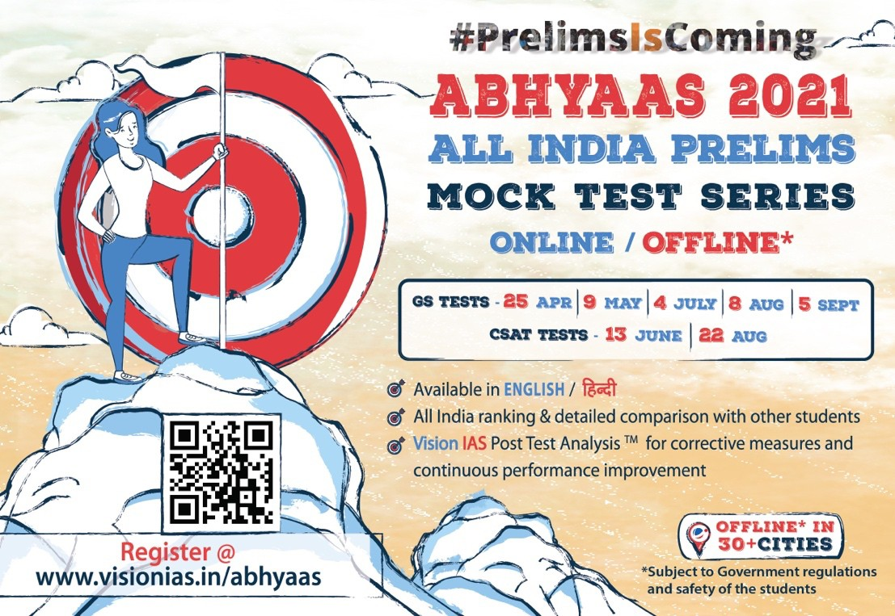

**3.11. ECONOMIC ORGANIZATIONS IN NEWS**

|  |  |
| --- | --- |
| **Better Than Cash Alliance (BTCA)** | * Recently, BTCA along with Indian Government and FICCI **hosted Merchant Digitization Summit 2021.** * BTCA (based at UN) is a **partnership of governments, companies, and international organizations** that **accelerates transition from cash to digital payments** to help achieve Sustainable Development Goals. * BTCA members (including India) are committed to digitizing payments in order **to boost efficiency, transparency, women’s economic participation and financial inclusion,** helping build economies that are digital and inclusive. |
| **Central Revenues Control Laboratory (CRCL),**  **New Delhi** | * CRCL has been recognized as **a Regional Customs Laboratory of the World Customs Organisation (WCO) for Asia-Pacific Region.** * **CRCL:** Established in 1939, under the **Central Board of Indirect Taxes & Customs**.   + Serves as **headquarters of 14 Revenue Laboratories.**   + It assists the field formations in **chemical analysis of samples of various trade commodities to enable duty assessment.** * **The WCO** (HQ- Brussels) develops **international standards and fosters cooperation to facilitate legitimate trade.**   + **India was the vice-chair** of the Asia Pacific region of the **WCO from 2018-2020.** |
| **Financial Action Task Force (FATF)** | * Pakistan seeks time to complete the 27-point (anti-money laundering/combating the financing of terrorism) action plan to help the country exit from the greylist.   o **Pakistan was put under ‘Greylist’** (formally called ‘other monitored jurisdictions’) of FATF for terror financing and money laundering.   * **FATF is an inter-governmental body established in 1989 to combat money laundering, terrorist financing and other related threats** to the integrity of the international financial system. * **India is a member of FATF.** |

# ENVIRONMENT



### 4.1. CLIMATE CHANGE

**4.1.1. CLIMATE-RESILIENT GRAINS**

##### Why in news?

United Nations General Assembly unanimously approved the resolution sponsored by India to declare **2023 as the International Year of Millets.**

##### About Millets

* Millets are a group of **small-seeded grasses**, widely **grown as cereal crops or grains** for human food and as fodder.
* They are classified into **Major Millets and Minor Millets based on their grain size.**

|  |  |  |
| --- | --- | --- |
| **Major millets** | **Minor millets** | **Psuedo millets** |
| **sorgum (jowar), pearl millet (bajra), finger millet (ragi).** | **foxtail, little, kodo, proso and barnyard millet** | **Amaranth (Rajgira) and Buckwheat (Kuttu).**  These are **not part of the botanical family to which 'true' grains belong**; however, they are **nutritionally similar** and used in similar ways to 'true' grains. |

|  |  |  |  |
| --- | --- | --- | --- |
| **Millets in India**   * India is the **largest producer of millets** in the world with a **41.0% global market share**. * During 2017-18, the **maximum area under millets was in Rajasthan,** followed by Maharashtra and Karnataka**.** * **Major Millets grow in Kharif season** (July to October): Pearl millet/bajra, finger millet/ragi (cereals), and jowar are kharif crops. * Millets are mostly grown in arid and semi-arid regions of India.   **Benefits of Millets production** | |  | |
| **Health benefits** | **Ecological benefits** | | **Economic security** |
| * **Aid in fighting malnutrition as they are rich in** fibre, minerals, vitamins **and have more nutrient content.** * **Gluten-free** (advantageous for people suffering from diabetes) | * **Millet crops Sequester carbon from the atmosphere** while **paddy fields emit methane**, a greenhouse gas. * **Less water intensive**. E.g., One **rice plant requires nearly 2.5 times the amount of water required by a single millet plant** of most varieties. | | * Millets are called ‘**Famine reserves’** as they have a short growing season of 65 days and can keep well for two years or beyond. * **Low investment** needed for production as they do not require chemical fertilisers etc.   E.g., Small millet grown in dry |

|  |  |  |
| --- | --- | --- |
| * **Anti-carcinogenic and anti-hypertensive foods** which help prevent obesity and heart diseases * Reduce **inflammation and improves digestion** | * **Hardy, drought-tolerant, and heat- resistant crops** that generally **do not succumb to pests and diseases.**   + **Can grow in areas with less than**   **350 mm of rainfall** and the cultivation cycle completed within 70-100 days.   * + Can **grow on low fertility soil**   + Are also grown to reclaim soils. | land districts of Karnataka, **requires mere INR 5,000 per acre.**   * **High demand for export:** According to FAO, the global millet production was estimated at **28.4 million metric ton in 2019**. |

##### Government measures to promote millet production

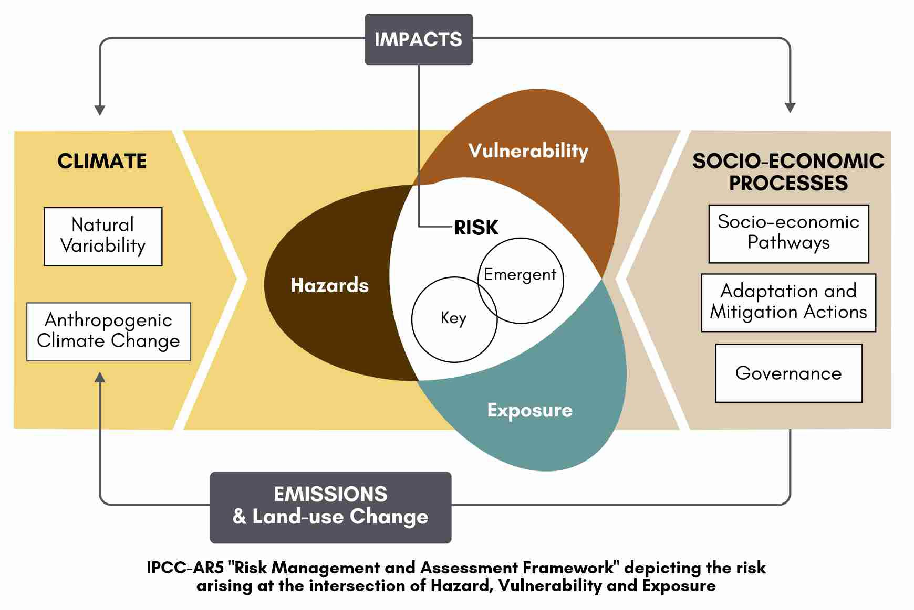

* **Initiative for Nutritional Security through Intensive Millet Promotion (INSIMP)** was launched in 2011-12 to promote millets as “nutri-cereals’ and enhance India's nutritional security. It is a part of **Rashtriya Krishi Vikas Yojana.**
* **Integrated Cereals Development Programmes in Coarse Cereals** under Macro Management of Agriculture scheme to increase the overall productivity under specific crop-based systems.

##### Government allowed inclusion of “Nutri-Cereals” in the Public Distribution System (PDS) and mid-day meal scheme.

* Government is also continuously increasing **the minimum support price (MSP) of millets** (bajra, jowar, and ragi) substantially so as to incentivise farmers to grow millets especially in drought prone areas.
* Government has **declared 2018 as National Year of Millets.**

**Related News**

**Dindori model of Millets**

* International Fund for Agriculture and Development supported an initiative to **revive millets (kodo and kutki cultivation) in Dindori district of Madhya Pradesh.**
  + They have enabled group of farmers to **grow kodo bars containing 33.4% of millets** which are then supplied to anganwadi centres in MP.
  + The project has helped in **meeting nutritional goals** (fighting malnourishment among children) and **reviving millet cultivation** (crop yields are 1.5-2 times higher than before).

**4.1.2. NATIONAL CLIMATE VULNERABILITY ASSESSMENT REPORT**

##### Why in news?

Recently, **Department of Science and Technology (DST)** has released the report titled ‘**Climate Vulnerability Assessment for Adaptation Planning in India Using a Common Framework’**.

##### About the report

* The report aims to **carry out a current-climate state-level and district-level vulnerability** assessment for India and also **building the capacity of states to carry out vulnerability assessments** using a **common methodological framework**.
* Based on an all-India assessment, this report identifies the **most vulnerable states and districts in India**

with respect to current climate risk and the main drivers of vulnerability using a **Vulnerability Index (VI)**.

* The assessment is based on a set of **common indicators and common methodology**. States also carried out district-level vulnerability assessments individually.
* It is essential for **prioritising investment in climate adaptation**.
* It involves **active participation of States and Union Territory governments** based on capacity building exercises which will help policymakers in initiating appropriate climate actions.
* It is part of **two national missions** of the **National Action Plan on Climate Change (NAPCC)**.

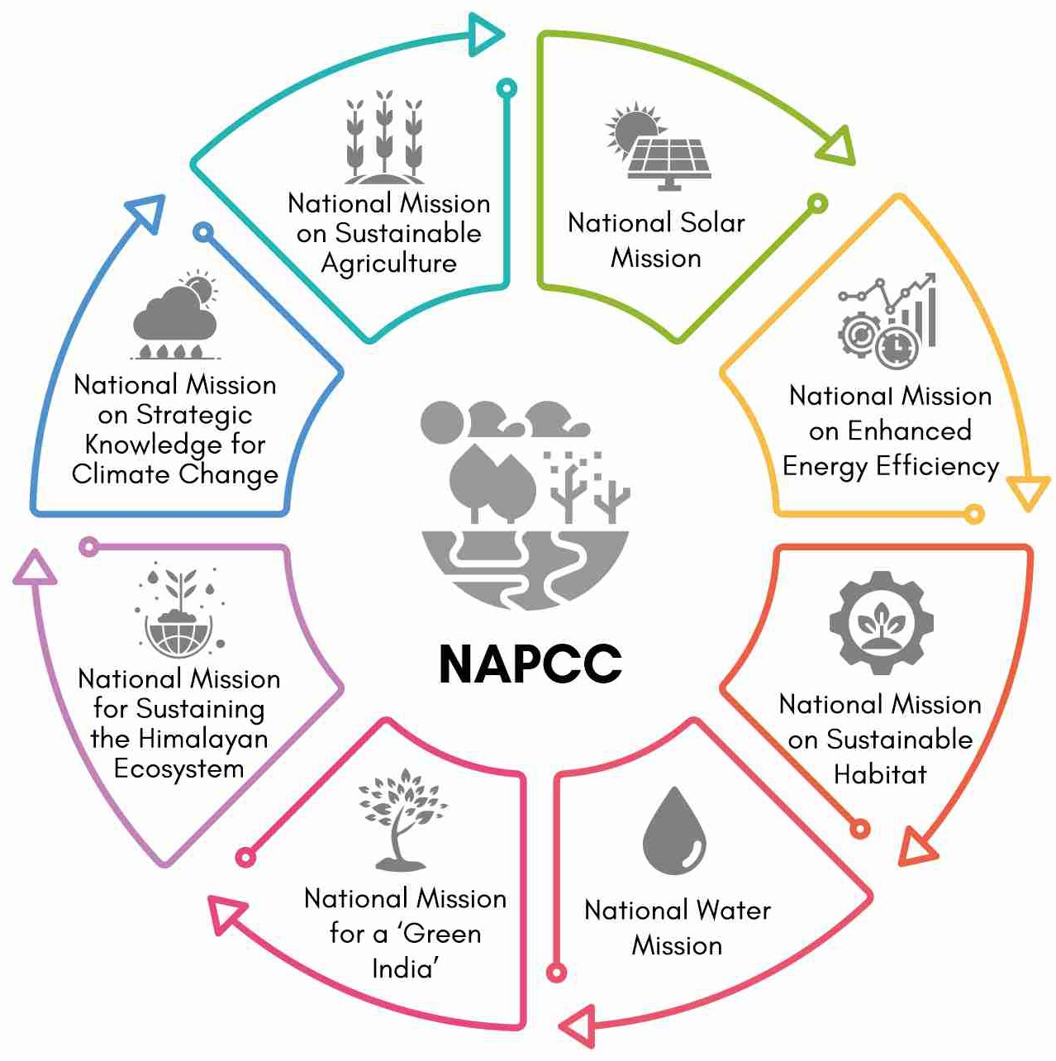

**Global Climate risk Index**

* It is released by **Germany-based think tank Germanwatch.**
* It indicates a level of **exposure and vulnerability to extreme events,** which countries should understand as warnings in order to be prepared for more frequent and/or more severe events in the future. In the CRI 2021, **data from 180 countries were analysed**.
* India has improved its ranking from 5th in CRI 2020 to **7th in CRI 2021. NAPCC**
* In 2008, India announced NAPCC that **includes eight ambitious goals** set for the country to tackle climate change.

**IPCC**

* It is created by the **World Meteorological Organization (WMO)** and the

**United Nations Environment Programme (UNEP)** in 1988.

* It has currently **195 members**.
* It provides **regular assessments of the scientific basis of climate change,**

its impacts and future risks, and options for adaptation and mitigation.

* + **National Mission for Sustaining the Himalayan Ecosystem (NMSHE)**- It aims to prevent melting of the Himalayan glaciers and to protect biodiversity in the Himalayan region.
  + **National Mission on Strategic Knowledge for Climate Change (NMSKCC)-** It builds a dynamic and vibrant knowledge system that informs and **supports national policy and action** for responding effectively to climate change challenges,

while **not**

##### compromising on the nation's growth goals.

* The risk assessment framework is based on the **Fifth Assessment Report of the Intergovernmental Panel on Climate Change, i.e., IPCC-AR5** (IPCC, 2014) which **defines the risk of climate change** at the intersection of ‘Hazard’, ‘Exposure’ and ‘Vulnerability’.

|  |  |  |  |  |
| --- | --- | --- | --- | --- |
| **Key indicators of the assessment (14)** | | | | |
| **Socio-economic and**  **livelihood** | **Agricultural** | **Biophysical** | **Institution and**  **Infrastructure** | **Health** |
| 1. Percentage Below Poverty Line Population 2. Share of income from natural resources. 3. Women participation in the workforce. | 1. Share of horticulture in agriculture. 2. Share of marginal and small landholdings. 3. Yield variability of food grain. 4. Area under crop insurance. 5. Area under rainfed agriculture. | 9. Lack of forest area per 1,000 rural population. | 1. Implementation of MGNREGA. 2. Road and rail connectivity. | 1. Density of   health care workers   1. Vector borne diseases 2. Water borne diseases |

##### Key findings of the report:

* **State-level vulnerability indices**: These indices vary over a **small range of 0.42-0.67** which means all states must deal with concerns related to vulnerability.
* **District-level vulnerability indices:** These indices also vary within a **small range of 0.34 - 0.75**.
  + **Assam, Bihar, and Jharkhand** have over 60% districts in the category of highly vulnerable districts.
* **Vulnerability indices (VI):** These indices are **relative measures** which mean that all districts or states are vulnerable, but some are relatively more vulnerable than others, requiring prioritised adaptation interventions.

**Related news: Effect of Climate Change on Indian Agriculture**

* A district level **vulnerability assessment was taken under National Innovations in Climate Resilient Agriculture**

project of **Indian Council of Agricultural Research** (**ICAR**).

* **Key findings**
  + Climate change aggravates problems such as **land degradation, market volatility, rising input costs, slowing response to added inputs** that hinder agricultural growth.
  + **Rainfed rice yields are projected to reduce marginally** (<2.5%) and irrigated rice yields by 7% in 2050.
    - Further, wheat yield projected to reduce by 6-25% in 2100 and maize yields by 18-23%.
  + **Maximum temperature is expected to increase by 1 to 1.3 degrees in 256 districts** and by 1.3 to 1.6 degrees in 157 districts (2020-2049).
  + **Productivity of crops, livestock and fish is likely to be affected** with implications on food security, livelihoods and sustainability in agriculture.

**4.1.3. INDIA’S THIRD BIENNIAL REPORT TO UNFCCC**

##### Why in News?

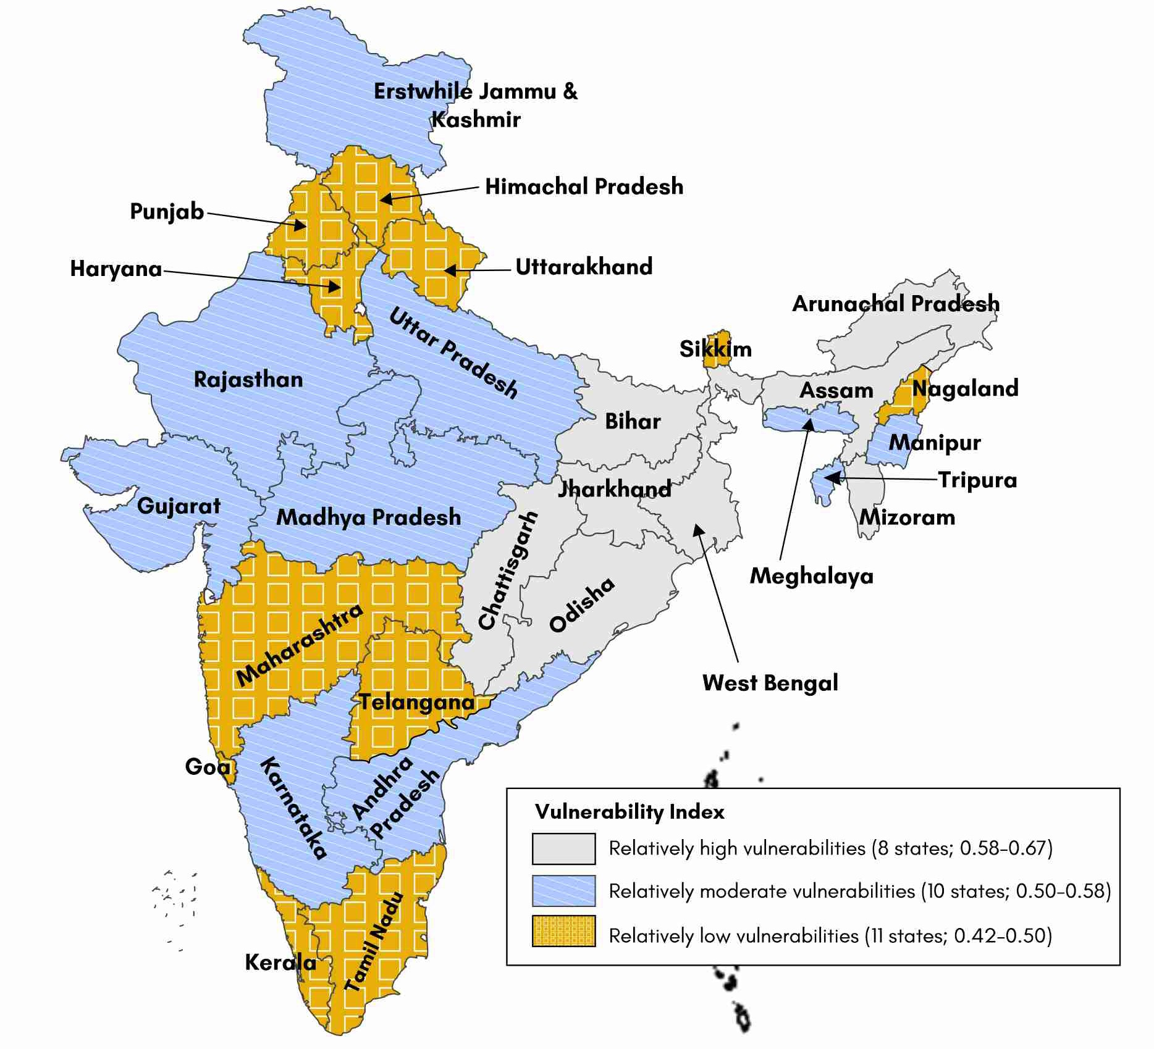

A Biennial Update Report (BUR)-3 by India said that it was **on track to meet its voluntary declaration** to reduce the emission intensity of GDP by 20-25% from 2005 levels by 2020.

##### About the Report

* The report has been submitted by the **Ministry of Environment, Forest, and Climate Change, towards fulfilment of the reporting obligation under the United Nations Framework Convention on Climate Change (UNFCCC).**
* A BUR-3 report by India said that it was **on track to meet its voluntary declaration** to reduce the emission intensity of GDP by 20-25% from 2005 levels by 2020.

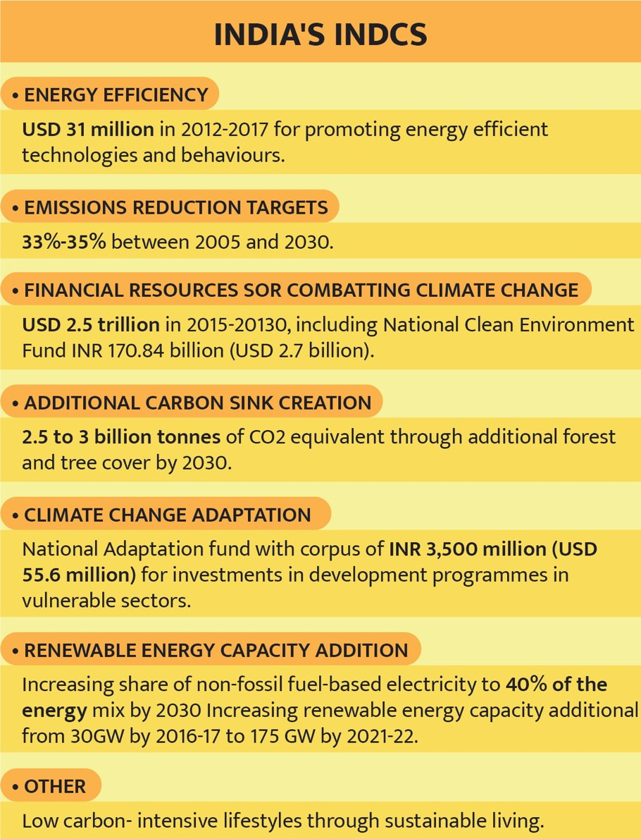

##### Key achievements

* + India’s **emission intensity of GDP has reduced by 24%** between 2005 and 2016.
  + **Installed capacity of solar energy in India has increased** by more than 14 times to 36.91 GW in November 2020.
  + Cumulative **renewable power installed capacity (excluding hydro above 25 MW) has increased by 2.6 times** to 90.39 GW in November 2020.
  + **Forest and tree cover has increased by 1.65%** between 2015 and 2019.
  + **Perform Achieve and Trade (PAT) scheme** for energy efficiency in industries resulted in total **savings of approximately 13.28 Mtoe.**
  + **Reductions in agricultural sector emissions have been achieved** due to expansion of area under horticulture, system of rice intensification, neem

coated urea, direct seeded rice cultivation, etc.

|  |  |  |  |
| --- | --- | --- | --- |
| **Related News: Meeting Renewable Energy (RE) target an uphill task: Parliamentary Standing Committee (PSC) on Energy**   * India is at deficit of 83GW of RE against a target of 175 GW of RE to be achieved by **December 2022.**   o India’s **current installed RE capacity is 93 GW as of March 2021**.   * Recently, the long-term target was pegged at 450 GW by 2030. * **Targets and status on RE** | | | |
|  | **Scheme and target** | **Current Status** |  |
|  | **National Solar Mission** target of 100 GW of solar energy | 39 GW capacity has been installed |
|  | **Rooftop solar energy** target- 40 GW | 4.4 GW |
|  | **Wind energy** target- 60 GW | 37.7 GW added in the decade |
|  | **Green energy corridors** launched in 2015-16 for evacuation of renewable energy from remote locations.  Target: 9,700 circuit kilometres (ckms) | 7,365 ckms |

**4.1.4. OTHER GLOBAL INITIATIVE RELATED TO CLIMATE CHANGE**

|  |  |
| --- | --- |
| **European Climate Law** | * European Union (EU) member states have reached an agreement on the **European Climate Law** that will enshrine the EU’s commitment to reach **climate neutrality by 2050.** * Parties reached an agreement to **reduce net greenhouse gas emissions by at least 55% by 2030**, compared to 1990 levels. * With the law, the target will become a **legal obligation** for EU and its member states. |
| **NZ to launch world- first**  **climate** | * New Zealand becomes the first country to introduce a law that will require **financial firms** (like Banks, insurers and fund managers) **to explain how they would manage climate-related risks and opportunities.** * The country wants to be **carbon neutral by 2050** and says the financial sector needs to play its part. |

|  |  |
| --- | --- |
| **change**  **rules** | * This law will bring **climate risks and resilience into the heart of financial and business decision- making.** |
| **India- US clean energy initiatives** | * **India-US Clean Energy Agenda 2030 Partnership** was launched at the **Virtual Leaders’ Summit on Climate.**   + The summit is part of a **series of global meetings focussing** on climate issues, being held in the run up to the UN Climate Change Conference (COP26).   + Also, US submitted new targets that **aim to reduce its GHG emissions by 50-52% below 2005 levels.** * The India US Partnership will have **two main tracks**: **Strategic Clean Energy Partnership** and **Climate Action and Finance Mobilization Dialogue**, which will subsume a range of existing processes.   + The joint initiative aims to **mobilise investments, demonstrate clean technologies and enable green collaborations** in India. * **Other India-US clean energy initiatives**   + Partnership to Advance Clean Energy (PACE): Launched in 2009, it aims to **accelerate inclusive, low carbon growth by supporting research and deployment**.   + US-India Clean Energy Finance (USICEF) for access to clean energy in underserved regions of India. |

### 4.2. POLLUTION



**4.2.1. COMMISSION FOR AIR QUALITY MANAGEMENT (CAQM)**

##### Why in News?

**The Air Quality Management in National Capital Region and Adjoining Areas Ordinance, 2020** which lapsed recently, has been re-promulgated.

##### More on the news

* Under the original ordinance, **Commission for Air Quality Management (CAQM)** was created as a **statutory body to manage air quality in National Capital Region and adjoining areas** of the Indo-Gangetic plain.
* CAQM replaced the **Supreme Court-empowered** Environment Pollution (Prevention and Control) Authority (EPCA).
* CAQM **enjoys jurisdiction over Punjab, Haryana, Uttar Pradesh and Rajasthan** — states which impact the Delhi-NCR air quality.
* The re-promulgated ordinance has **expanded CAQM by giving additional representations to stakeholders**

from agriculture, industry, transport or construction sectors.

* **Hefty penal provisions** in terms of jail term up to five years or with fine have been provided for **industries, power plants or other polluters except for farmers** causing air pollution by stubble burning.

**4.2.2. NEW EMISSION NORMS FOR COAL-FIRED POWER PLANTS**

##### Why in news?

**Central Pollution Control Board (CPCB)**

* It is a **statutory organisation** which was constituted in 1974 under the **Water (Prevention and Control of Pollution) Act, 1974**.
* It was entrusted with the **powers and functions** under the

**Air (Prevention and Control of Pollution) Act, 1981**.

* It serves as a field formation and also provides **technical services to the Ministry of Environment and Forests** of the provisions of the Environment (Protection) Act, 1986.

The **Ministry of Environment, Forests, and Climate Change (MoEFCC)** had **pushed the deadline** for thermal power plant (TPP) by upto three years for **complying emission norms** in the country.

##### Background

* In 2015, MoEFCC notified environmental

norms for particulate matter, sulphur oxides, nitrogen oxides and mercury and water use for coal based TPPs.

* Initially, India had set a **2017 deadline** for thermal power plants to **install flue gas desulphurisation units that cut emissions of sulphur dioxides**. But this was postponed to varying deadlines for different regions, ending in 2022.
* The **deadline was pushed to December 2022** for all power stations in the country in view of implementation issues and challenges.

##### Key Highlights of new guidelines

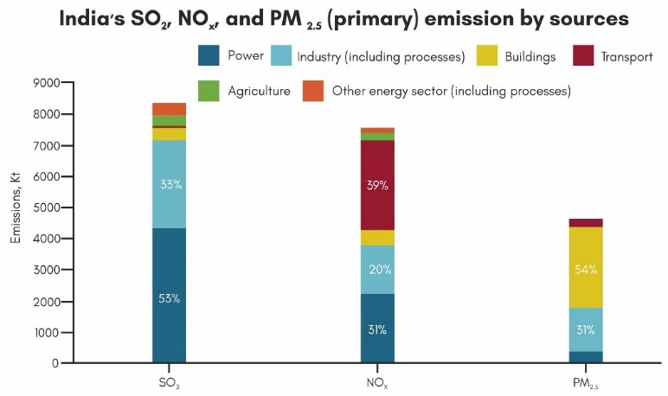

* **Creation of task force**: A task force will be constituted **by the Central Pollution Control Board (CPCB)** to categorise thermal power plants (TPPs) in **three categories (see table) on the basis of their location** to comply with the emission norms within the different time limit.
* **Exemption on ground of retirement:** TPPs declared to **retire before December 31, 2025** are not required to meet the specified norms in case such plants **submit an undertaking** to the CPCB and the CEA (Central Electricity Authority) for **exemption on ground of retirement**.
* **Penalty provisions:** In case of non-compliance, a **penalty of up to 0.20 rupees per unit** will be

levied for electricity generated for continuing the operations beyond the deadlines.

|  |  |
| --- | --- |
| **Category** | **Deadline** |
| **Category A:** TPP **within 10 kilometres** of the National Capital Region (NCR) and **in cities with**  **more than 10 lakh population** | **End of 2022** |
| **Category B:** TPP in **non-attainment cities** (those cities which are not meeting National  Ambient Air Quality Standards) and **those within 10 kilometres of critically polluted areas** | **December 31, 2023** |
| **Category C:** Coal-fired power plants in the **rest of the areas** | **December 31, 2024** |

**Related News: New Fly Ash Utilisation Rule for Thermal Power Plants (TPPs)**

* Centre has made it **mandatory for coal and lignite based TPPs** to **ensure 100% utilisation of fly ash** within three to five years.
* **Key Highlights:**
  + **Non-compliant TPPs** will have to pay a **fine of Rs 1,000 per tonne on un-utilised ash (also called Legacy ash)**

under the **‘polluter pays principle’**, taking into account **utilisation targets from April 2022**.

* + The **collected fines** will be deposited in the designated account of the **Central Pollution Control Board (CPCB).**
* This **in line with the Fly Ash Utilisation policy** which has the objective to consider ash utilization as an integral process of power generation and make all out efforts so as to maximize ash utilization towards 100% on sustainable basis.
* **About Fly-ash**:
  + It is a fine powder that is a **by-product of burning coal** in electric generation power plants.
  + It is **collected from the exhaust gases** by **electrostatic precipitators or** bag filters.
  + It **resembles Portland cement** but it is chemically different.
  + It is **used in concrete and cement products**, road base, metal recovery, etc.
  + Fly ash is **toxic** due to organic pollutants, heavy metals etc.

**4.2.3. MARINE LITTER**

##### Why in news?

Countries from across the oceans decided to **tackle marine plastic litter** under the ambitious global project called ‘**GloLitter Partnerships** Project’.

**GloLitter Partnerships Project**

* The Project is implemented by the **International Maritime Organization (IMO) and the Food and Agriculture Organization of the United Nations (FAO)**, with initial funding from the Government of Norway via the Norwegian Agency for Development Cooperation (Norad).
* The project aims to help the maritime transport and fishing sectors move towards a **low- plastics future**.
* To achieve this goal, this initiative will assist developing countries to apply best practices for **prevention, reduction and control of marine plastic litter** from those sectors.
* **International Maritime Organization** is **United Nations specialized agency** with responsibility for the safety and security of shipping and the **prevention of marine and atmospheric pollution** by ships.

##### About Marine Litter

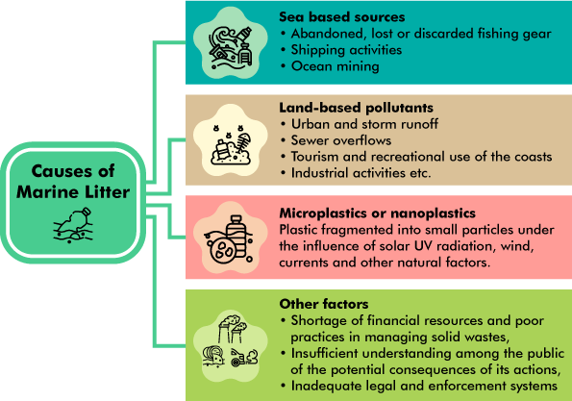

**Other forms of Marine Pollution**

* **Chemical pollution:** Chemical pollution is the **introduction of harmful contaminants**. Common **man-made pollutants that reach the ocean include pesticides, herbicides, fertilizers**, detergents, oil, industrial chemicals, and sewage. Crude oil **lasts for years in the ocean and is difficult to clean up**
* **Light pollution:** Light pollution **penetrates under the water**, creating a vastly different world for species near urban environments. Light **disrupts the normal cues associated with circadian rhythms.**
* **Noise pollution:** The increased presence of loud or persistent sounds from ships, sonar devices, and oil rigs **disrupts natural noises in the marine environment.** Unnatural noises **interrupt communication (whales use echolocation), disrupting migration, hunting, and reproduction patterns** for many marine animals.
* Marine litter is any **persistent, manufactured or processed solid material discarded** into the sea or rivers or on beaches or brought indirectly to the sea with rivers, sewage, storm water or winds. It is a **form of marine pollution.**
* At least **8 million tons of plastic end up in our oceans** every year, and make up **80% of all**

**marine debris** from surface waters to deep-sea sediments.

* + A plastic bottle **can last up to 450 years** in the marine environment.

**Effects of Marine Litter**

|  |  |  |
| --- | --- | --- |
| **On marine environment** | **On food and health** | **Economic loss**: |
| * **Death of marine species** due to ingestion, suffocation and entanglement of marine species. * Floating plastics contribute to **the spread of invasive marine organisms and bacteria**, causing loss of biodiversity. * Excessive nutrients (from Agri runoff) trigger **massive blooms of algae** that rob the water of oxygen, creating **dead zones.**   o Dead zones are the areas which can **no longer sustain life** because they have low or zero oxygen. There are now around **500 of these dead zones**  around the world. | * Fish and other marine life ingest   microplastics which in turn can **find their way into the human food chain** through biomagnification and bioaccumulation.  o Bioaccumulation is the  **accumulation over time of a** | * Coastal communities are facing **increased expenditure on beach cleaning, public health and waste disposal.** * Plastic strewn beaches, garbage filled waters and sea devoid of marine life adversely **affects**   **tourism industry.** |

|  |  |  |
| --- | --- | --- |
| * Plastic litter can become **concentrated in certain areas called gyres** as a result of oceanic currents. E.g., North Pacific Gyre, known as the **Great Pacific Garbage Patch** (see fig). | **substance** and  especially a contaminant in a living organism.  o Biomagnification the process by which a  compound (such as a pollutant) increases **its concentration in the tissues of organisms as it travels up the food chain.** | * The shipping industry is impacted by **higher costs associated** with fouled propellers, removing litter and managing waste in harbours. * The fishing industry faces **reduced and lost catch, damaged nets and other fishing gear**, which also affects coastal aquaculture. |

**Initiatives to reduce marine litter**



|  |  |
| --- | --- |
| **London Convention/Protocol** (1972 Convention on the Prevention of Marine Pollution by Dumping Wastes and Other  Matter) | * Itis **one of the first global conventions to protect the marine environment** from human activities. * London protocol to the convention entered into force in 2006. * It regulates the dumping of wastes from ships, permitting only certain types of non- harmful waste to be dumped. |
| **MARPOL** | * IMO's International Convention for the Prevention of Pollution from Ships (MARPOL) has regulations on **prevention of pollution by garbage**, **which prohibits the discharge of plastics** (including fishing gear) into the sea from ships. |
| **The Global Programme of Action for the Protection of the Marine Environment from Land-**  **based Activities (GPA)** | * It is a unique intergovernmental mechanism to counter the issue of land-based pollution. |
| **GPML (The Global Partnership on Marine Litter)** | * GPML was launched at the **United Nations Conference on Sustainable Development (Rio+20)** in June 2012. It seeks to address the global problem of marine litter by:   + Providing a mechanism for **cooperation and coordination**;   + Harnessing the expertise, resources and enthusiasm of **all stakeholders.**   + Making a significant contribution to the achievement of the **2030 Agenda**, in particular **SDG 14.1** (By 2025, prevent and significantly **reduce marine pollution of all kinds**, particularly from land-based activities, including marine debris and   nutrient pollution). |
| **India and Germany signed agreement on ‘Cities combating plastic entering the marine**  **environment’** | * Project aims to **enhance practices to prevent plastic entering marine environment** and will be **undertaken in Kanpur, Kochi and Port Blair** for a period of three and a half years.   o It is **in line with Swachh Bharat Mission-Urban** focusing on sustainable solid  waste management and **PM’s vision to phase out single use plastic by 2022.** |

**4.2.4. SECOND WORLD OCEAN ASSESSMENT REPORT**

**Why in News?**

**United Nations has recently released WOA 2** which follows an initial report (WOA-1) published in 2015.

##### About the report

* The **Regular Process for Global Reporting and Assessment** of State of Marine Environment is a global mechanism established after **2002 World Summit on Sustainable Development** by the **United Nations General Assembly**.
* The first World Ocean Assessment was completed in 2015.

##### Key findings:

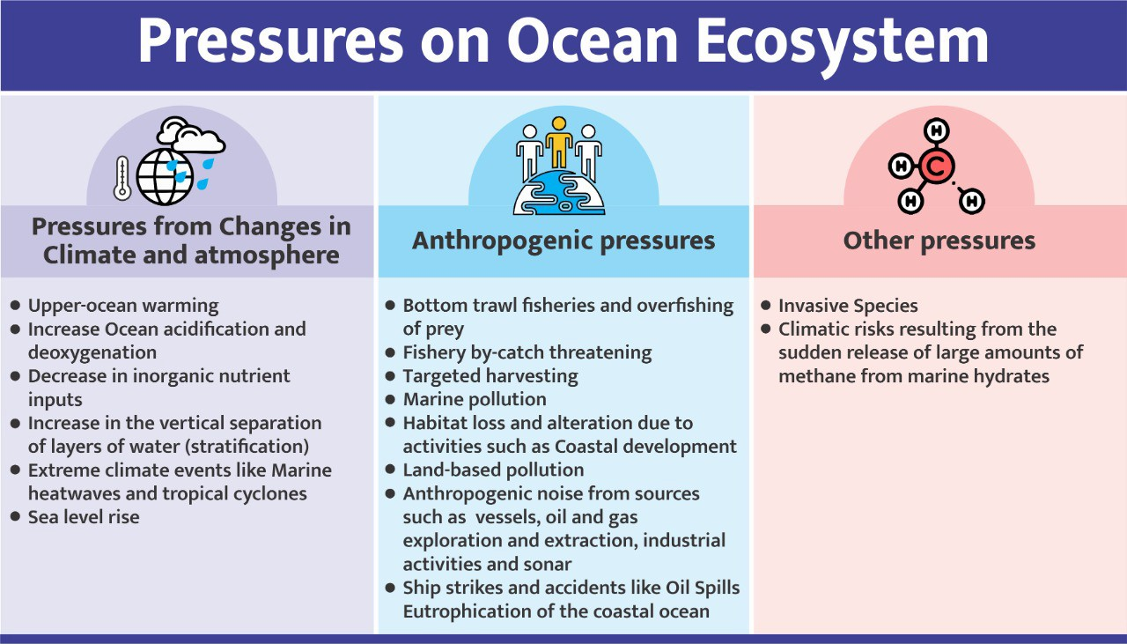

**Related news: Blue Nature Alliance**

* It is a global partnership founded and led by five core partners: **Conservation International**, The Pew Charitable Trusts, **The Global Environment Facility**, Minderoo Foundation, and the Rob & Melani Walton Foundation.
* Their aim is to advance **Ocean Conservation Areas**, inclusive of Marine Protected Areas, Other Effective Area-based Conservation Measures, Indigenous Protected Areas, and other innovative place-based interventions designed to achieve biodiversity conservation outcomes.
* The alliance is working on large-scale efforts in **Fiji’s Lau Seascape, Antarctica’s Southern Ocean and the Tristan da Cunha island group** to collectively secure protections over 4.8 million square kilometers of the ocean.
  + **Drivers having the greatest influence on the marine environment and its sustainability include,** population growth and demographic changes; economic activity; technological advances; changing governance structures and geopolitical instability.
  + Around **90 per cent of mangrove**, seagrass and marsh plant species, as well as more than **30 per cent of seabird species**, are also facing the threat of extinction.
  + Number of ‘**dead zones’ in the ocean has nearly doubled** reaching to about 700 in 2019.
    - Dead zones are **low-oxygen, or hypoxic areas** in the world’s oceans and lakes. Because most organisms **need oxygen to live**, these areas are called dead zones
  + Global warming is already affecting the open ocean, and **marine heatwaves are likely to increase in frequency and strength** in the future.
  + Climate change-induced changes in the open ocean biological pump **will alter the ocean’s ability to take up anthropogenic carbon.**

**4.2.5. ILLEGAL SAND MINING**

##### Why in News?

Bihar government banned sand mining near river bridges.

##### More on the News

* This was done to **check illegal sand mining that threatens bridges in the rivers.**
  + Mining not only diverted the water flow, it also threatened the foundation of bridges.

##### About illegal Sand mining

* **Sand is a minor mineral** under Mines and Minerals (Development and Regulation) (MMDR) Act, 1957;

##### therefore sand mining is regulated by respective state governments.

* **Causes of illegal sand mining**

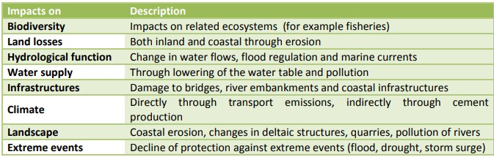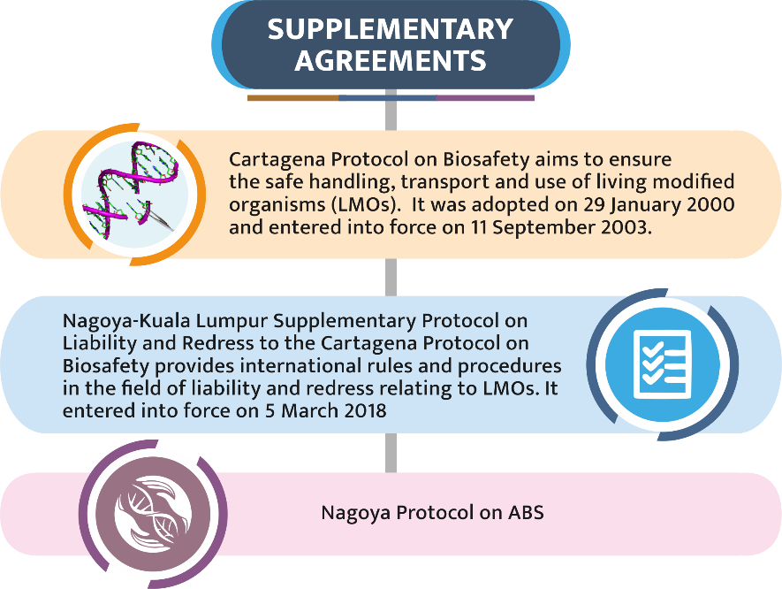

* + **Supply Demand Mismatch:** India’s annual use of construction sand has tripled since 2000, which led

**sand prices to increase by 150-200% in 2 years** and made ideal conditions for growth of sand mafia.

* + Ineffective policies and lackadaisical approach of the administration.

##### Nexus between mining companies, bureaucracy and law enforcement agencies.

* **Steps taken to Promote Sustainable Mining:**
  + Enforcement & Monitoring Guidelines for Sand Mining in 2020 released by Ministry of Environment,

Forest and Climate Change

##### Pradhan Mantri Khanij Kshetra Kalyan Yojana

* + **Mining Surveillance System** to use space technology to check illegal mining
  + **Developing alternative to sand** like fly ash, use of slag, powdered glass etc.

**Impacts of Illegal sand mining**

### 4.3. BIODIVERSITY

**4.3.1. THE NAGOYA PROTOCOL ON ACCESS AND BENEFIT-SHARING (ABS)**

##### Why in news?

Recently, Brazil became the 130th country to ratify the Nagoya Protocol.

##### Nagoya Protocol on ABS

* It was adopted on 29 October 2010 in Nagoya, Japan as a **supplementary agreement to the Convention on Biological Diversity**.
* It entered into force on in 2014, 90 days after the deposit of the fiftieth instrument of ratification.

##### Objective: Fair and equitable sharing of

**benefits** arising from the utilization of genetic resources, thereby contributing to the **conservation and sustainable use of biodiversity.**

* + **Utilization includes research and development** on the genetic or biochemical composition of genetic resources, as well as subsequent **applications and commercialization**.
* The Nagoya Protocol applies to **genetic resources** as well as **traditional knowledge (TK) associated with genetic resources** that are covered by the CBD and the benefits arising from its utilization.
* **3 Core obligations for its contracting Parties:** Access obligations, Benefit-sharing obligations, Compliance obligations

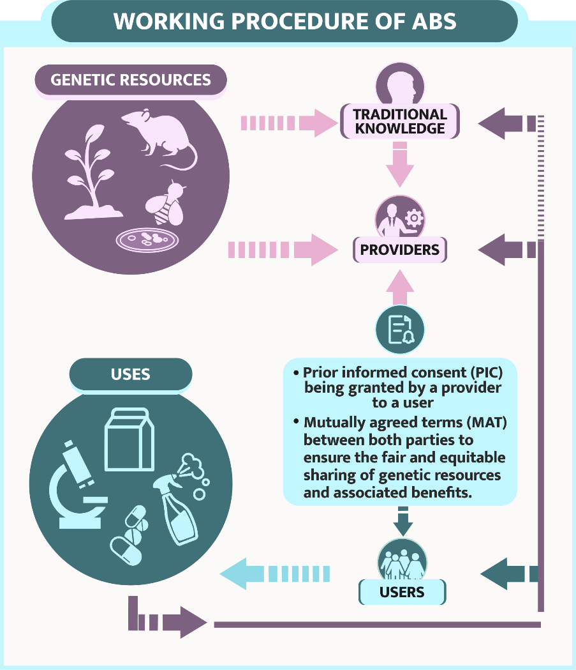

##### Tools and mechanisms to assist implementation

* + Establishing **national focal points (NFPs) and competent national authorities (CNAs)** to serve as contact points for information, grant access or cooperate on issues of compliance
  + **Access and Benefit- sharing Clearing- House:** It is a web based platform to share information to support the implementation of the Nagoya Protocol.
  + **Capacity-building** to support key aspects of implementation.
  + **Targeted financial support** for capacity- building and

development initiatives

through the Nagoya Protocol’s financial mechanism, the **Global Environment Facility [EF).**

* + Awareness-raising, Technology Transfer

**Memorandum of Understanding on the Conservation and Management of Marine Turtles and their Habitats of the Indian Ocean and South-East Asia (IOSEA Marine Turtle MOU)**

* **India, being a signatory of the IOSEA Marine Turtles MOU,** launched ‘National Marine Turtle Action Plan (2021-2026).
* Aim of the IOSEA agreement is **to maintain and recover marine turtle populations** by promoting cooperation among Governments and other organizations that share this common objective.
* **Six species of marine turtles are covered by IOSEA:** the Loggerhead, Olive ridley, Green, Hawksbill, Leatherback and Flatback (Data Deficient).
* All of them are found to migrate and nest within the IOSEA region.
* MOU **applies to the waters and coastal States of the Indian Ocean and South-East Asia and adjacent seas**, extending eastwards to the Torres Strait. This agreement area is considered to cover 44 Range States.
* **For implementation purposes, the area is divided into four sub-regions:** South-East Asia (plus Australia, China, Japan, Republic of Korea and United States), Northern Indian Ocean, Northwestern Indian Ocean, and Western Indian Ocean.

**4.3.2. NATIONAL MARINE TURTLE ACTION PLAN 2021-26**

##### Why in News?

Ministry of Environment Forest and Climate Change (MoEF&CC) had released National Marine Turtle Action Plan.

##### About Marine Turtle Action Plan

* It aims to conserve marine turtles and their habitats for maintaining a healthy marine ecosystem.

##### Goal is to

* + **Conserve Species**, their habitat and reduce negative impacts on survival of marine turtles.
  + **Improve the understanding** of marine turtles and their habitats, through a coordinated mechanism.
  + **Promote Awareness** and Education on conservation of marine turtles and their habitats.
  + **Enhance livelihoods of coastal communities** through promoting sustainable ecotourism.
  + **Increase national, regional and international cooperation** on marine turtle conservation.

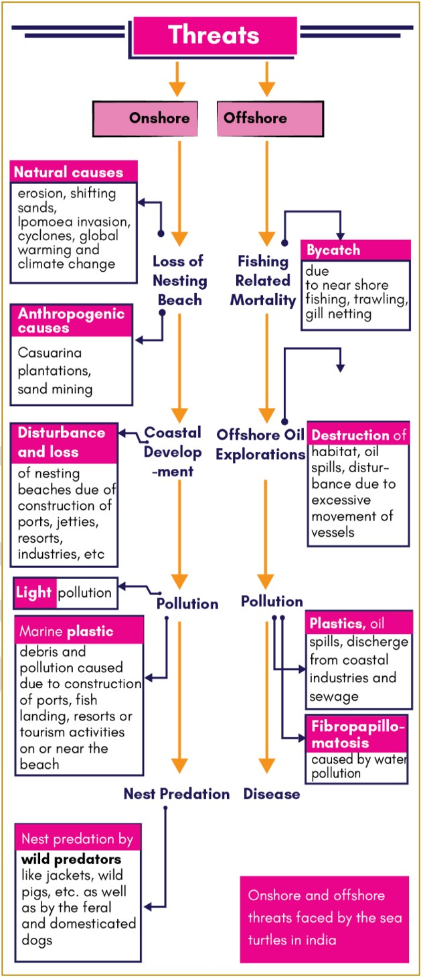

##### Marine Turtles in India

* **Five of the seven species** of sea turtles are known to inhabit **Indian coastal waters and islands**. These are the Olive Ridley, Green, Hawksbill, Loggerhead and the Leatherback turtles.

##### India is home to the largest known nesting population of olive ridley turtles (ORT).

* + ORT, along with Kemps Ridley turtle, **are known for their mass nesting called Arribada,** where thousands of females come together on the same beach to lay eggs.
  + Gahirmatha **is world’s largest rookery of ORT.**
* Leatherbacks, largest of the seven species of sea turtles, **are found in all oceans except Arctic and Antarctic.**
  + Within Indian Ocean, they **nest only in Indonesia, Sri Lanka and A&N Islands.**
* Except Loggerhead turtles, the remaining four species nest along the Indian coastline and islands of India.

##### Importance of Marine Turtles

* + **Considered flagship species** in various marine habitats such as coral reefs, sea grass meadows etc.
  + Play an important role in **shaping the behavior and life history traits of prey species and predators** that is critical for the sustainability of fisheries in the region.
  + **Play Ecological roles like controlling prey populations, supporting coastal vegetation** through their hatchlings etc.
  + Their presence is an **indicator of healthy marine ecosystems** and provides a source of

revenue for local communities through tourism.

##### Measures adopted for their protection



|  |  |
| --- | --- |
| **Turtle Species** | **IUCN Status** |
| Olive ridley (Lepidochelys olivacea) | Vulnerable |
| Green (Chelonia mydas) | Endangered |
| Hawksbill (Eretmochelys imbricata) | Critically Endangered |
| Leatherback (Dermochelys coriacea) | Vulnerable |
| Loggerhead (Caretta caretta) | Vulnerable |

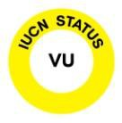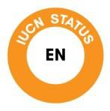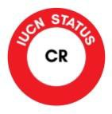

* + These five species of sea turtles are **protected under Schedule I of the Wildlife (Protection) Act, 1972.**
  + Also, MoEF&CC had included marine turtles as **one of the 22 species for taking up focused conservation program under** the centrally sponsored scheme- **Development of Wildlife Habitats.**
  + India has identified all its **important sea turtle nesting habitats as ‘Important Coastal and Marine Biodiversity Areas’ of India** and included in the Coastal Regulation Zone (CRZ) - 1.

##### Marine Turtle Habitat in India

|  |  |  |
| --- | --- | --- |
| **Turtle** | **Habitat** | |
| **Olive Ridley** | **Odisha** | * Rushikulya and Gahirmatha river (Kandhamal and Ganjam) * Devi River (Jagatsinghpur, Puri) |
| **Andaman &**  **Nicobar Islands** | * Bahua, Muhincohn and Kiyang beaches (Little Nicobar Island) * Cuthbert Bay, (Middle Andamans) |
| **Lakshdweep Islands** | * Suheli Island |
| **Andhra Pradesh** | * Godavari River Mouth * Kapasukuddi (Bahuda river mouth) Srikakulam * Beaches along Krishna River and Penneru river mouth |
| **Puducherry** | * Nallavadu, Pannithittu, Narambi and Moorthikuppam villages (Puducherry) * Beaches around Arasalar River |
| **Tamil Nadu** | * Gulf of Mannar Biosphere Reserve * Chennai coast |
| **Gujarat** | * Western Saurashtra coast (Junagadh, Jamnagar and Porbandar) |
| **Maharashtra** | * Sindhudurg Coasts (Raigad and Ratnagiri) |
| **Goa** | * Galgibaga beach (South Goa) |
| **Leatherback** | **Andaman & Nicobar Islands** | * Galathea bay, Indira point, Hingloi, Alexandria, Dagmar, and Renhong beaches (Great Nicobar Island) – Largest nesting Ground in India. * Bahua, Muhincohn and Kiyang beaches (Little Nicobar Island) * West Bay, Jackson Creek beaches (Little Andaman Island) * Cuthbert Bay, (Middle Andamans) |
| **Hawksbi II** | **Andaman & Nicobar Islands** | * Bahua, Muhincohn and Kiyang beaches (Little Nicobar Island) * Cuthbert Bay, (Middle Andamans) * South Reef Island, (Middle Andamans) |
| **Lakshdweep Islands** | * Suheli Island |
| **Green** | **Andaman &**  **Nicobar Islands** | * Bahua, Muhincohn and Kiyang beaches (Little Nicobar Island) * Cuthbert Bay, (Middle Andamans) |
| **Lakshdweep Islands** | * Lagoons of Lakshdweep Islands (Agatti, Kadmat, Kavaratti and other islands). * Suheli Island |
| **Tamil Nadu** | * Gulf of Mannar Biosphere Reserve |
| **Gujarat** | * Western Saurashtra coast (Junagadh, Jamnagar and Porbandar) |
| **Maharashtra** | * Sindhudurg Coasts (Raigad and Ratnagiri) |

**Related News**

* Recently, Ministry of Environment Forest and Climate Change released **Marine Mega Fauna Stranding Guidelines.**

o It is estimated that between **9,000-10,000 cetaceans are bycaught annually across India in mechanised vessels**.

* Objective is **to improve coordination between various independent Government and civil society** responding to Marine megafauna stranding, research and management issues, support, share data and thus promote inter- sectoral coordination.
* Guidelines also provide guidance for the **management of marine megafauna stranded on the shore or entrapped in shallow waters, bays** and potentially unable to return to the sea.

**4.3.3. AFRICAN ELEPHANTS**

**Why in News?**

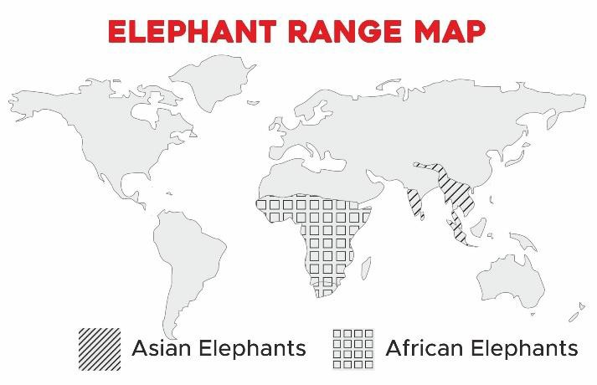

IUCN has categorised, **savanna elephant as “endangered”** and **much smaller, lighter forest elephant as “critically endangered**”.

##### More on news

* These two are **subspecies of African elephants**.
* Both species are facing threat from **poaching for ivory and human encroachment.**
* **Forest elephants occur in the tropical forests of Central Africa** and in a range of habitats in West Africa.
* Savanna elephants are **found in variety of habitats in Sub-Saharan Africa** including grasslands and deserts.
* African elephants are the largest land animals on Earth.

##### About Asian Elephants

* **Asian elephants (found in India) are smaller** than African elephants, and their ears are smaller compared to the large fan-shaped ears of the African species.
  + **Only some male Asian elephants have tusks**, while both male and female African elephants grow tusks.

##### Asian Elephants have 3 subspecies: Indian, Sri Lankan and Sumatran.

* With respect to Indian elephant,
  + The oldest **female in an elephant herd is always the leader**.
  + Female elephants live for **60 to 70 years.**
* Elephants have the **longest gestation period of all mammals**, up to 22 months.

|  |  |  |
| --- | --- | --- |
| **Species** | **Old Status** | **New Status** |
| **Forest Elephant (Loxodonta cyclotis)** | Vulnerable | **Critically endangered** |
| **Savanna/ Bush elephant (Loxodonta**  **africana)** | Vulnerable | **Endangered** |
| **Asian Elephant** | **Endangered** |  |

**4.3.4. INDIAN RHINO VISION 2020**

##### Why in news?

The **Indian Rhino Vision 2020 (IRV 2020)** has officially come to a close with the **translocation of two rhinos** to

**Manas National Park** from Pobitora Wildlife Sanctuary in Assam, India.

##### Indian Rhino Vision 2020 (IRV 2020)

* It was **eighth round** of rhino translocation under IRV 2020.

##### It was designed by Rhino Task Force 2005 with a target to achieve rhino population to 3,000 by 2020 in seven protected areas in Assam.

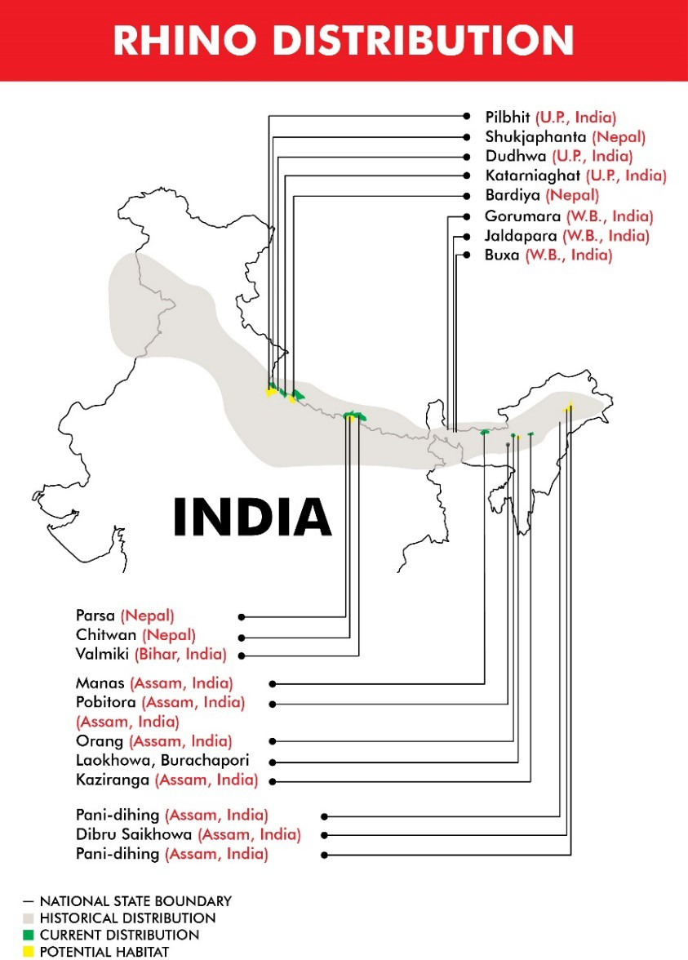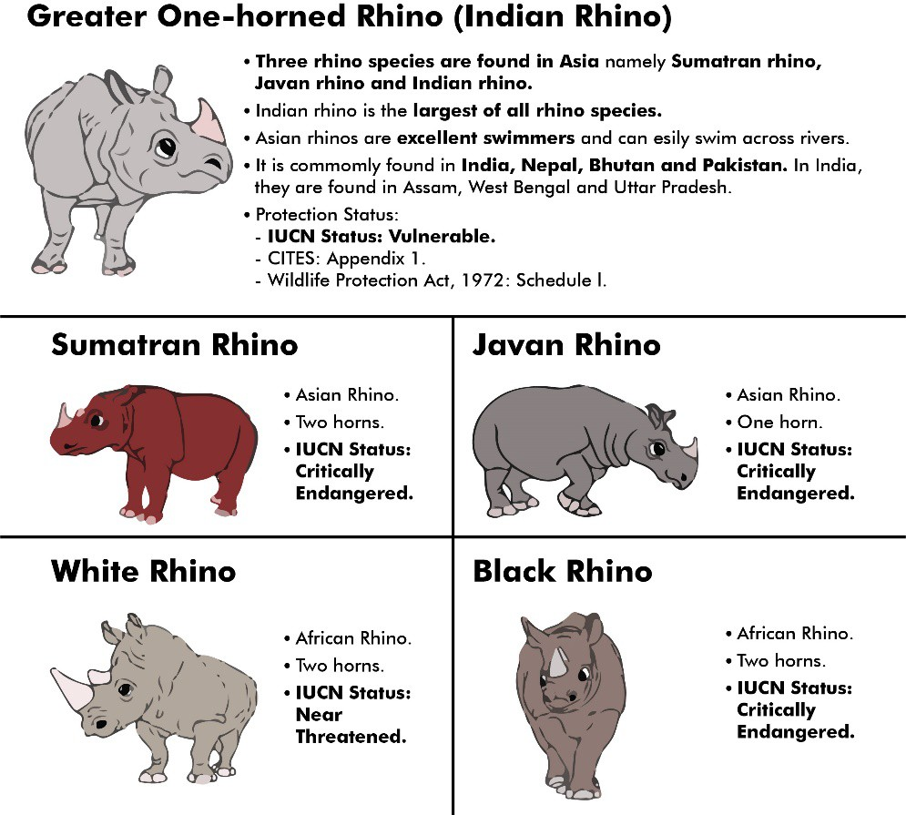

* + These areas include Kaziranga national park, Pobitora national park, Orang national park, Manas national park, Laokhowa wildlife sanctuary, Burachapori wildlife sanctuary and Dibru Saikhowa wildlife sanctuary.
* It also aims to **reduce the risk to the rhino population**, mainly from poachers by spreading the population in multiple parks with enough habitats to encourage population growth.

##### It was a joint programme of the Assam Forest Department, Worldwide Fund for Nature India (WWF- India), Bodoland Territorial Council, International Rhino

**Foundation (IRF)** and **US Fish & Wildlife Service**. The program was implemented with the help of the forest department, College of Veterinary Sciences, WWF India, IRF, WTI, Aaranyak (wildlife NGO in Guwahati) and others.

* The translocated rhinos helped Manas National Park get back its **World Heritage Site status in 2011**.

##### Success of IRV 2020

* Indian rhino numbers have increased from about 2,575 to more than 3,550 - a **38% increase in 9 years.**
  + **According to WWF- India data in 2012**, more than 91 percent of Assam’s rhinos and about 80 percent of India’s rhinos count are concentrated within Kaziranga national park, with a few in Pobitora wildlife sanctuary.
* IRV 2020 is helping to re-populate those areas where the habitat is still suitable by **translocating animals** from other rhino protected areas, such as Pobitora and Kaziranga National Parks.
  + Manas, which did not have even a single rhino 10 years ago, has now become home to 20 rhinos.
* It helped to **reduce the death of the rhinos from poaching** and sickness.
* It helped to **move the IUCN status of Indian rhino from endangered (since 1986) to vulnerable in 2008**.

**Other Conservation efforts for Rhinos**

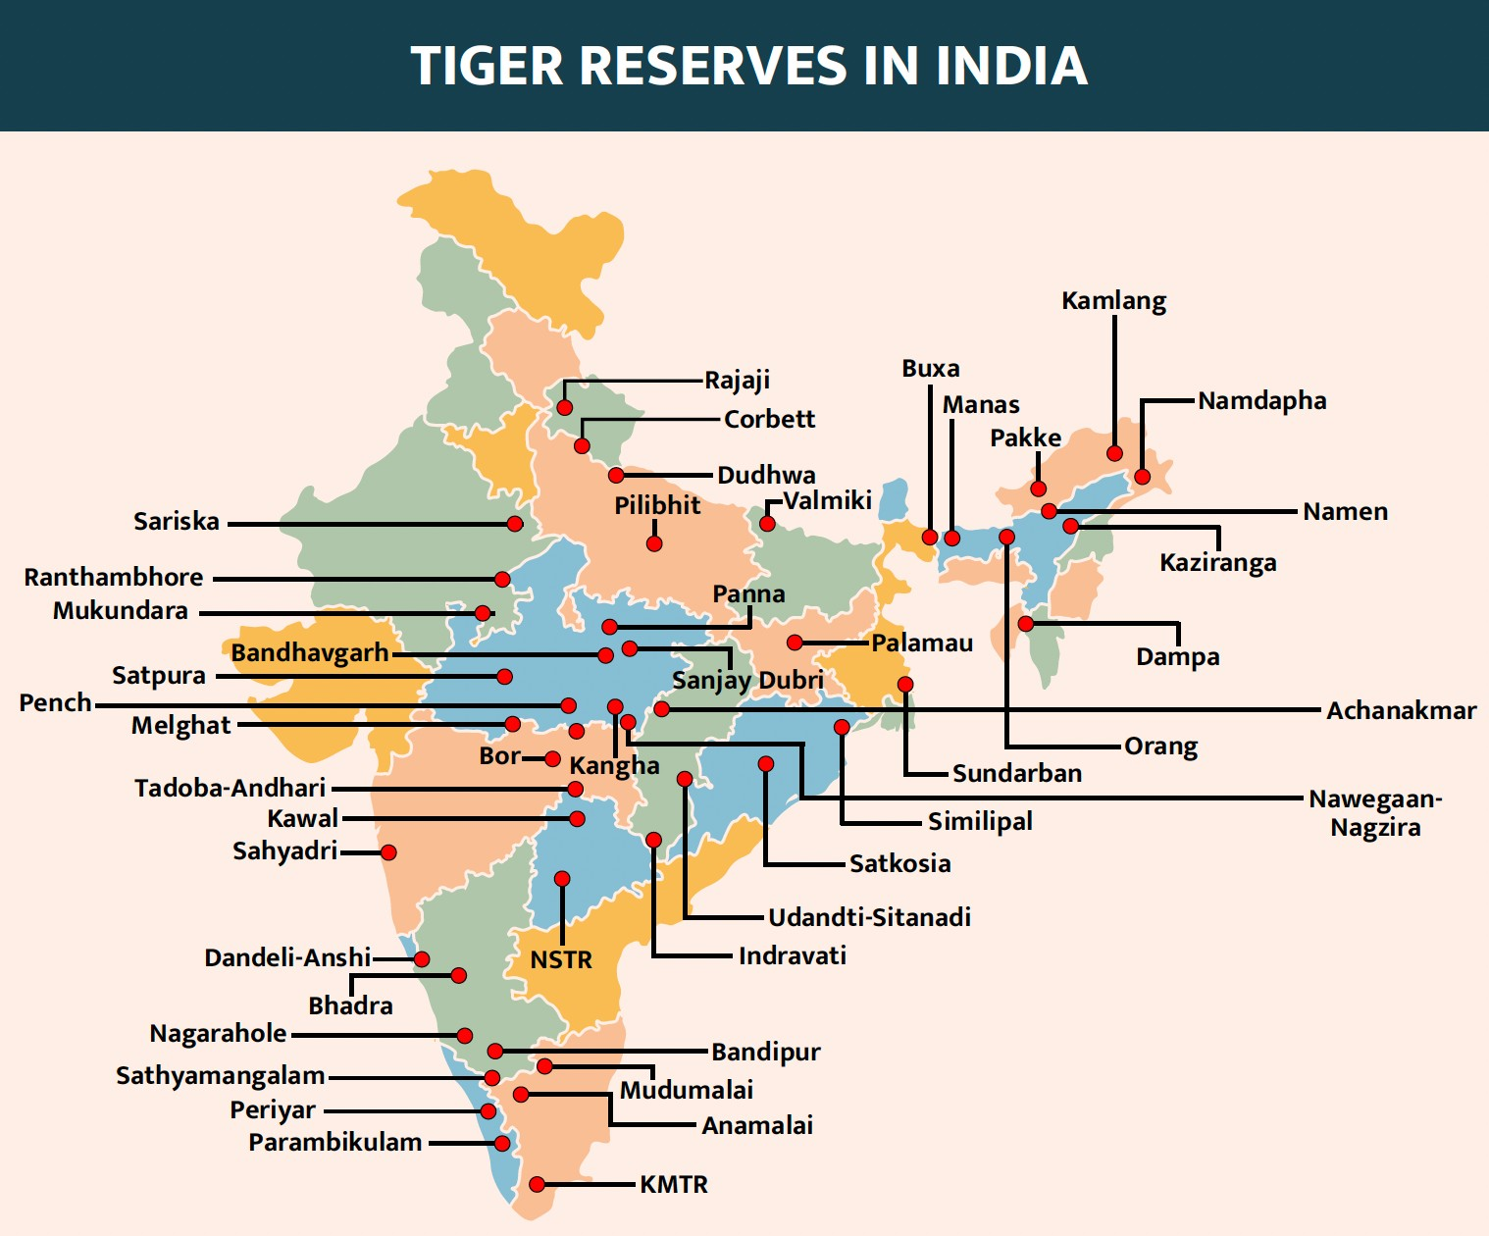

|  |  |
| --- | --- |
| **National Rhino Conservation Strategy** | * It was launched by the **Ministry for Environment, Forest and Climate Change (MoEFCC)** in 2019 on the occasion of **World Rhino Day** to conserve the **greater one-horned rhinoceros.** * It aims to work for the conservation of the species under **five objectives** which includes strengthening protection, expanding the distribution range, research and monitoring, and adequate and sustained funding. * It calls for **active engagement between India and Nepal** to protect the species. * As per the strategy, the single population of rhinos in **Sukla-Phanta (Nepal), Valmiki Tiger Reserve (India) and Chitwan National Park (Nepal) and Dudhwa (India)** is separated by the political   boundary between the two countries. |
| **New Delhi Declaration on Asian Rhinos 2019** | * India collaborates with **Bhutan, Nepal, Indonesia and Malaysia** to increase the population of **three species of Asian rhinos**, including the Greater one-horned rhinoceros found in the Indian sub- continent. * It includes studies on health issues of the rhinos, their potential diseases and taking necessary steps. * It also aims at **collaborating and strengthening wildlife forensics** for the purpose of investigation and strengthening of trans-boundary collaboration among India, Nepal and Bhutan for the   conservation and protection of the Greater one-horned rhino. |

**4.3.5. INDIA’S FIRST INTER-STATE TIGER TRANSLOCATION PROJECT FAILS**

**Why in news?**

Recently, a tigress shifted as part of **India’s first inter- state translocation project in 2018** from Madhya Pradesh to Odisha returned home.

##### More on the News

* Under the project, two big cats, a male (Mahavir) from **Kanha Tiger Reserve** and a female (Sundari) from **Bandhavgarh from Madhya Pradesh** were

relocated to

**Satkosia Tiger**

**Reserve in Odisha.**

* **The relocation was meant to serve two purposes:**
  + **Reducing tiger population in areas with excess tigers** to majorly reduce territorial disputes.
  + To **reintroduce tigers in areas where the population has considerably reduced** due to various reasons.

##### Issues with project

* + Arrival of the tigers was followed by **severe protests by villagers living on the fringes of the reserve**.
  + There was **lack of confidence and trust building measures** prior to translocation between the forest department and the villagers.
  + **Low prey base** forced tigress to human dominated area, causing **human-animal conflict.**
  + Death of male tiger due to **poaching.**
  + Translocation was done in haste and **field staff and tiger reserve management were not prepared.**

##### Other Translocation projects:



* + A Tiger Translocation in Uttarakhand has been planned from Jim Corbett Tiger Reserve (JCTR) to Rajaji Tiger Reserve (RTR).
  + Project for translocation of tigers to the western part of Rajaji **was approved by National Tiger Conservation Authority (NTCA) in 2016.**
    - NTCA is a statutory body under the Ministry of Environment, Forests and Climate Change **for strengthening tiger conservation**
  + **RTR** is located in the **Shivalik range of Himalayas in Uttarakhand** and is the second tiger reserve of Uttarakhand after JCTR.
  + **JCTR** is situated in the Nainital district of Uttarakhand and is the oldest national park in India established in 1936 to protect the endangered Bengal tiger.

##### It was the first to come under the Project Tiger initiative.

**4.3.6. ASIA ENVIRONMENTAL ENFORCEMENT AWARD**

**Why in News?**

**About Wildlife Crime Control Bureau (WCCB)**

* It is an **intelligence and enforcement agency** in the field of wildlife crime. It aims to **conserve wildlife wealth** by proper and effective intervention and by providing professional assistance to create deterrence to the organized wildlife crime.
* It is a **statutory multi-disciplinary body** under **Wildlife Protection Act 1972** working under Ministry of Environment, Forest and Climate Change.
* It is **designated nodal agency for CITES** related enforcement.

Wildlife Crime Control Bureau (WCCB) has received Asia Environmental Enforcement Award-2020 presented by United Nations Environment Programme (UNEP).

##### More on the News

* WCCB has been awarded under the **category ‘Innovation’ for “Operation WILDNET-II**”.
  + **Operation WILDNET**: WCCB organized this operation to drag attention of enforcement agencies on **illegal wildlife trade over internet using Social Media Platforms** such as Facebook, Twitter, Whatsapp etc.
  + Earlier WCCB has received the award in the same category in 2018.

##### About Asia Environmental Enforcement Award

* The award publicly recognises **excellence in controlling transboundary environmental crime** such as illegal trade in wildlife and illegal trade in chemical or waste including plastic.
* The Awards are given to **individuals and/or government organizations/teams** that demonstrate excellence and outstanding leadership in enforcement of national laws to combat transboundary environmental crime.
* **2020 Awards were given by UNEP** in partnership with United Nations Development Programme (UNDP), United Nations Office on Drugs and Crime (UNODC), Convention on International Trade in Endangered Species of Wild Fauna and Flora (CITES), and International Criminal Police Organization (INTERPOL).

**4.3.7. MIYAWAKI TECHNIQUE OF URBAN FOREST MANAGEMENT**

##### Why in News?

Recently, many states **including Maharashtra and West Bengal** have started promoting Miyawaki for creation of forests in the urban areas.

##### About Miyawaki technique

* It is an **afforestation method** based on the work of **Japanese botanist Akira Miyawaki in the 1980s.**
* The technique **compresses layers of a forest – shrubs, trees, canopies – on small plots of land**, turning them into tiny forests.

##### Miyawaki technique process involves following steps

* + Planting **three to four saplings per square meter**, using native varieties adapted to local conditions.
  + Wide variety of species – **ideally 30 or more – are planted** to recreate layers of a natural forest.
  + **Mulching, natural water retention and perforation material** like rice husk and use of organic compost is done to support their growth.
  + The site is monitored and **maintained for a period of 2 to 3 years**, after which the **sites become self- sustainable**.

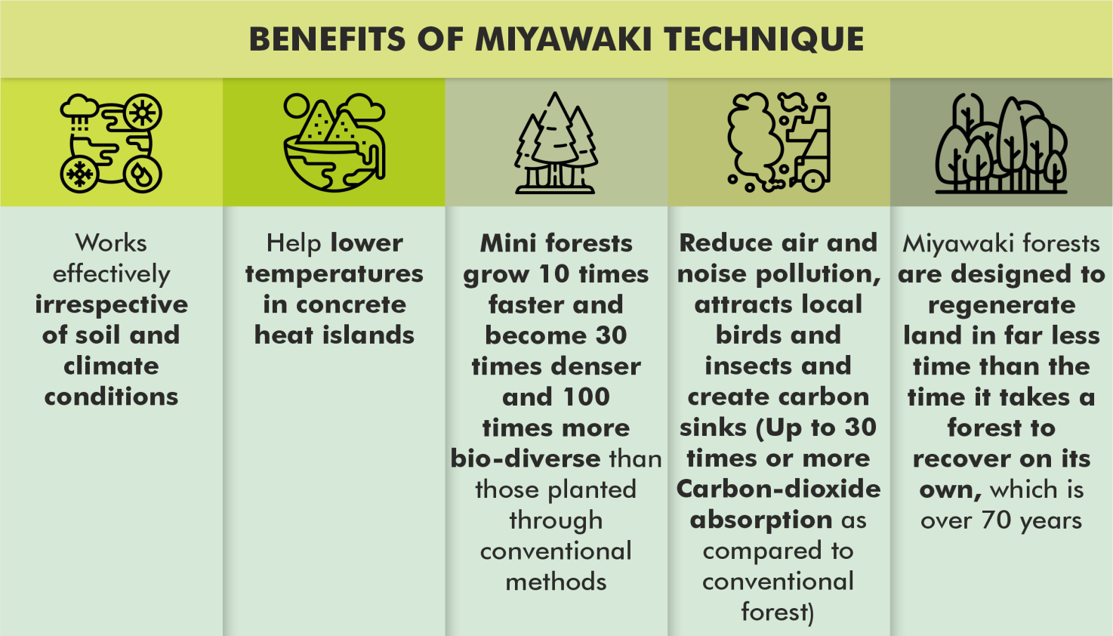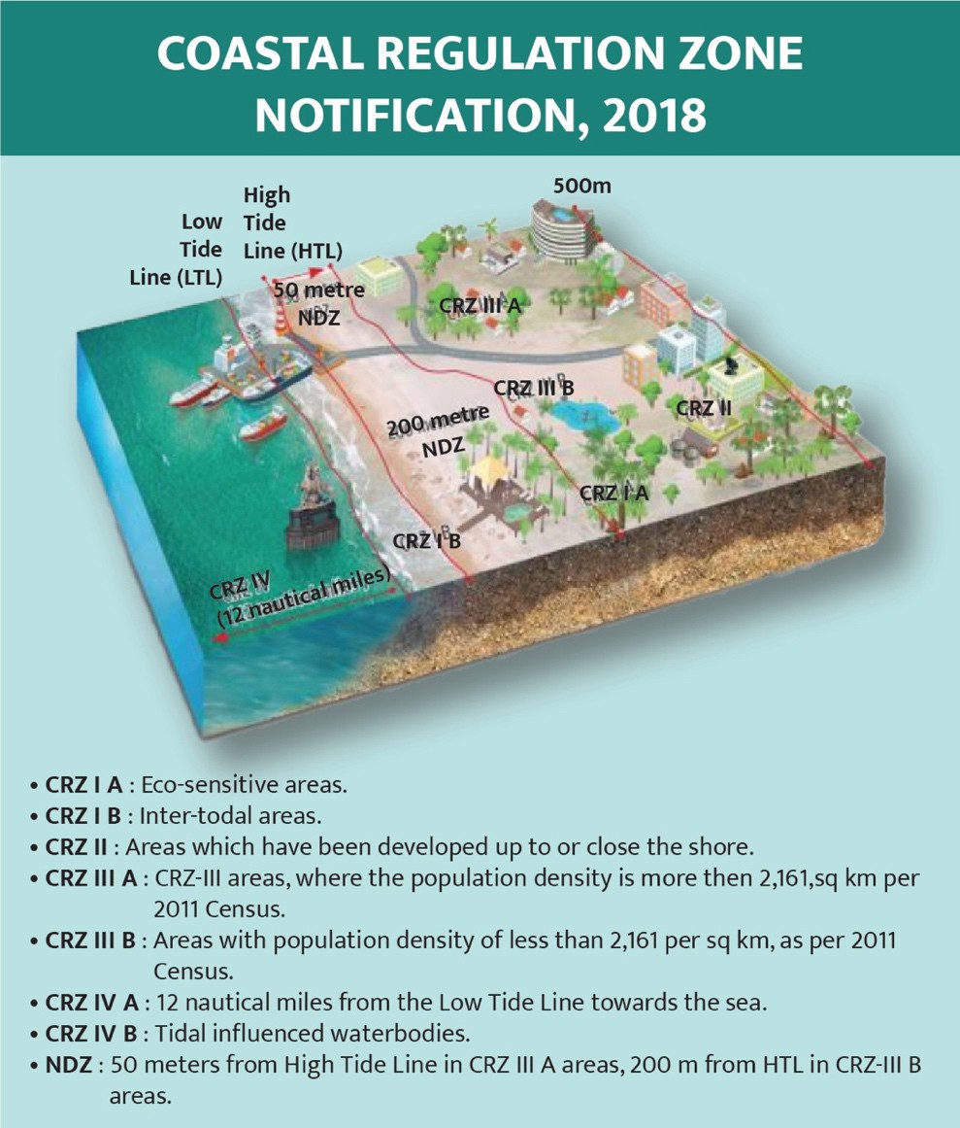

* **Limitations:** Such forests lack some qualities of natural forests, **such as medicinal properties and the ability to bring rain.**

**4.3.8. COASTAL ZONE MANAGEMENT PLAN (CZMP)**

##### Why in News?

Recently a Draft Coastal Zone Management Plan (CZMP) stoked a controversy in Goa.

##### More on the news

* Draft CZMP is being **criticised by locals, environmentalists and political parties** for re- zoning of beach areas, accommodating allegedly illegal constructions etc.
  + It was prepared by the **National Centre for Sustainable Coastal Management (NCSCM)**, Chennai – a research institute under MoEFCC.

##### About Coastal Zone Management Plan (CZMP)

* Under Coastal Regulation Zone (CRZ) notification 2011, **respective state governments and Union Territories were directed to prepare CZMP** by identifying and classifying the CRZ areas.
* **CRZ notification 2011** (issued under Environment

(Protection) Act, 1986) declared coastal stretches of country and India’s territorial waters, excluding Andaman and Nicobar and Lakshadweep islands, as **CRZ.**

* + It **aimed at securing livelihood of fishing communities and other local communities** living in coastal areas, conserve and protect coastal stretches, their unique environment and marine area and promote development in a sustainable manner.
  + For this, it **restricted setting up and expansion of any industry,** operations and manufacture or handling or storage or disposal of hazardous substances in CRZ.
  + In **2018, CRZ notification was revised** to enhanced activities in the coastal regions thereby **promoting economic growth while also respecting the conservation principles of coastal regions.**

**4.3.9. FLORA AND FAUNA IN NEWS**

|  |  |
| --- | --- |
| **Species** | **Details** |
| **Venus flytrap (Dionaea muscipula)** | * A recent study by scientific from Germany found that the **Venus flytrap (Dionaea muscipula) plant is capable of generating small magnetic fields.** * These **plants send electrical signals to trigger the closure of their traps**, to catch an insect, a biomagnetism phenomenon was observed.   o While **leaf stalk, or petiole, is not excitable and is electrically insulated** from the trap.   * Magnetic signals in plants are **very weak and it was extremely difficult to measure**, while using new and advanced atomic magnetometers it is measured at **amplitude of up to 0.5**   **picotesla**, which is millions of times weaker than the Earth's magnetic field. |
| **Lantana camara** | * A recent **study found Lantana camara, a tropical American shrub, has invaded more than 40% of India’s tiger range.** * Lantana **is one of the world’s ten worst invasive species.**   + It **competes with native plants for space and resources**, and also alters the nutrient cycle in the soil.   + It can **tolerate high temperature and moisture.** * If eaten, the **leaves can induce allergies on the muzzles of animals**. In some cases, extensive feeding on lantana has led to **diarrhoea, liver failure, and even the animal’s death.** |
| **Mandarine duck** | * It is a migratory bird that **breeds in Russia, Korea, Japan and parts of China**. * Though it is **not a threatened bird globally** they only make rare appearances. * Recently, it was **spotted at Maguri Motapung wetland of Assam**.   o Located close to the **Dibru Saikhowa National Park,** it is an **Important Bird Area** as  declared by the Bombay Natural History Society. |
| **Coelacanth** | * Recently, fossils of coelacanth were discovered. It is **a giant fish that has been around even before the dinosaurs.** * The fossil was dated **66 million years old** (the Cretaceous era). * Coelacanths **first evolved 400 million years ago** (200 million years before the first dinosaurs). * It had long been **believed to be extinct, but in 1938, a living coelacanth was found off South Africa.** |
| **Himalayan serow** | * In a ‘first’, Himalayan serow **spotted in Assam at Manas Tiger Reserve (MTR).** Earlier it was spotted in Himachal Pradesh’s Spiti valley. * There are several species of serows, and all of them are found in Asia. Himalayan serows are herbivores and **are typically found at altitudes between 2,000 metres and 4,000 metres.** * It is listed under **Schedule I of the Wildlife Protection Act, 1972**. * **IUCN status:** Vulnerable * MTR is named after **Manas river** and is **contiguous with the Royal Manas National Park in Bhutan.** |
| **Three-banded Rosefinch** | * Scientists from the **Bombay Natural History Society (BNHS)** have recorded the presence of new bird named Three-banded Rosefinch in the eastern Himalayas, taking India’s avian biodiversity count to a total of 1,340 species.   + It was sighted in the coniferous forests of the Sela Pass in Arunachal Pradesh. * BNHS is **a non-governmental organisation** established in 1883.   + BNHS specializes in the conservation of nature and natural resources as well as   organizing education activities and exploration of natural history. |
| **New Species discovered in India** | * 2 new **red algal seaweed species** have been discovered along India’s coastline.   o **Hypnea indica** was discovered in **Kanyakumari in Tamil Nadu**, and Somnath Pathan  and Sivrajpur in **Gujarat**. |



|  |  |
| --- | --- |
|  | * **Hypnea bullata** was discovered from **Kanyakumari and Diu island of Daman and Diu**. * They grow in the **intertidal regions** of the sea. * A new **butterfly species NacadubasinhalaramaswamiiSadasivan** is discovered in the Agasthyamala is in the Western Ghats. |

**4.3.10. PROTECTED AREAS IN NEWS**

|  |  |
| --- | --- |
| **Protected Area** | **Details** |
| **Goa** | |
| **Bhagwan Mahaveer Wildlife Sanctuary** | * Raising serious environmental concerns, the Central Empowerment Committee (CEC) of Supreme Court has red-flagged Goa rail projects cutting through **Bhagwan Mahaveer Wildlife Sanctuary (BMWS) and the Mollem National Park (MNP).** * BMWS located on the foothills of the Western Ghats is the largest of Goa’s four protected wildlife areas and contains within it the MNP. * It is also home to the famous **Dudhsagar waterfall and the Devil’s Canyon.** * **Forest:** West Coast tropical evergreen forests, West Coast semi-evergreen forests and moist deciduous forests. * **Fauna:** Deer, sambar, spotted deer, hog, mouse deer and barking deer, tiger, leopard cat, panther, lesser Indian civet, wild dog, hyena, sloth bear, jackal, bonnet macaque, slender lorris, scaly ant eater, giant squirrel, flying squirrel etc. * **Flora:** Primary species of trees found here include Terminalia, Lagerstroemia (crepe myrtle), Xylia and Dalbergia(timber trees). |
| **Gujarat** | |
| **Shetrunjay Hills Reserve Forest Area** | * It is a **habitat of Asiatic lions, leopards as well as herbivores such as blue bulls** in Bhavnagar, Gujarat. * The Forest is a patch of hilly, dry and deciduous forest and **Shetrunji River** flows near the area. * Satrunjay Mahatirth, Palitana temples built on the hills are considered the **most sacred pilgrimage place by the Jain community.** |
| **Kerala** | |
| **Vembanad lake** | * Prime Minister in his ‘Mann ki Baat’ has lauded a Kerala farmer for solely cleaning the   **Vembanad lake**.   * It is the **largest lake in Kerala** and the **longest Lake in India**. * Vallam Kali (a.k.a Nehru Trophy Boat Race) is a **Snake Boat Race** held every year in Vembanad Lake. * It is part of the list of **wetlands of international importance under Ramsar Convention**. * **Kumarakom Bird Sanctuary** is located on the east coast of the lake.**.** |
| **Madhya Pradesh** | |
| **Bandhavgarh Tiger Reserve** | * This is the second tiger reserve where a **forest fire has raised concern** among environmentalists and conservationists. **Earlier** this month, a similar incident was reported at **Odisha's Similipal Reserve**. * Bandhavgarh National Park is spread at **Vindhya hills in Madhya Pradesh**. * **Fauna**: It is known for the **Royal Bengal Tigers**. * Topography varies between steep ridges, undulating, forest and open meadows. |
| **Meghalaya** | |
| **Nongkhyllem Wildlife Sanctuary** | * India’s **first bamboo-dwelling bat with sticky discs** (Eudiscopusdenticulus) was recorded in Nongkhyllem Wildlife Sanctuary. * This sanctuary, **in Ri Bhoi district of Meghalaya, is one of the best protected areas** in the Northeast. * It **falls in the Eastern Himalayan Global bio-diversity hot spot.** * It is drained by rivers and streams like **Umran, Umming, Umpurthih and Umtru.** |
| **Odisha** | |
| **Karlapat Wildlife Sanctuary, Odisha** | * Six elephants died of **haemorrhagic septicaemia** in this sanctuary in last 14 days.   o Haemorrhagic septicaemia is a **contagious bacterial disease** which infects animals that come in contact with contaminated water or soil.   * The sanctuary is located in Kalahandi district, Odisha. * **Fauna**: leopard, gaur, sambar, nilgai, barking deer, mouse deer, soft claws ottawa, etc. * **Phurlijharan waterfall is located** close to the sanctuary. |
| **Satkosia Tiger**  **Reserve** | * Following the closure of the tiger relocation project, tigress in Odisha’s Satkosia reserve may not get a companion. |



|  |  |
| --- | --- |
|  | * Satkosia spreads along the **magnificent gorge over the river Mahanadi in Odisha**. * It comprises two adjoining wildlife sanctuaries; the **Satkosia Gorge sanctuary and Baisipalli sanctuary.** * Satkosia is the **meeting point of two bio-geographic regions of India; the Deccan Peninsula and the Eastern Ghats**, contributing immense biodiversity. |
| **Simlipal Biosphere Reserve** | * Similipal Biosphere Reserve is located in Mayurbhanj district of **Odisha on the eastern end of the eastern ghat**. It is also a **national park and a tiger reserve.** * It comprises of the entire Similipal sanctuary (core and buffer together), the adjoining **Nato and Satkoshia Reserve Forests** forming additional buffer. * It derives its **name from ‘Simul’ (silk cotton) tree**. * It included by **UNESCO in its list of critical biosphere reserves of the world.** * It has the **largest zone of Sal in all of India**. * **Fauna**: black panthers, four-horned antelope or chowsingha, tiger, elephant, giant squirrel, mugger crocodile etc. * **Flora**: Eria meghasaniensis and Tyna hookeriena are two endemic orchids found here. * **Tribes residing in the reserve: K**haria, Bhumija, Bathudi, Kolha, Gonda, Santhal and Mankadia |
| **Tamil Nadu** |  |
| **Srivilliputhur– Megamalai Tiger Reserve** | * Recently, Srivilliputhur–Megamalai Tiger Reserve in Tamil Nadu (TN) was approved by Centre. * **It will be India’s 51st tiger reserve** that will encompass- Meghamalai and Srivilliputhur Grizzled Squirrel Wildlife Sanctuaries. * **Other Tiger reserves in TN:** Kalakkad Mundanthurai, Anamalai, Mudumalai and Sathyamangalam. * **Meghamalai Wildlife Sanctuary is spread across districts of Theni and Madurai** (Highwavys mountains and Cardamom Hills) while **Srivilliputhur Grizzled Squirrel Wildlife Sanctuary lies along Kerala’s Periyar Tiger Reserve.** * **Fauna:**   + Meghamalai hosts ungulates (hoofed mammals), spotted deers, Indian gaurs, wild boars etc.   + Srivilliputhur hosts grizzled giant squirrels, flying squirrels, leopards, Nilgiritahrs,   Sambars, elephants, lion-tailed macaque etc. |
| **Uttarakhand** | |
| **Nanda Devi Biosphere Reserve** | * Recently, a portion of the **Nanda Devi glacier** broke of near Joshimath in Uttarakhand’s Chamoli district and caused an avalanche in the **Alaknanda river system**.   + The Nanda Devi Group of Glaciers lies in the Nanda Devi Sanctuary protected as **Nanda Devi Biosphere Reserve**. * **About Nanda Devi Group of Glaciers**   + It refers to the cluster of glaciers namely- **Bethartoli, Kururntoli, Nanda Devi North, Nanda Devi South, Nandakna, Raunth Bank, Dakshini Rishi Bank, Trishul** and falls within the upper **Rishi Ganga catchment**, central Himalaya.   + The glacier dwells on the **Nanda Devi peak** which is the **second-highest mountain** in the country after Kanchenjunga. Nanda Devi peak forms a part of the Garhwal Himalayas.   + The melted water of the Nanda Devi glacier forms several streams and rivers: The water first flows into the **Rishiganga river** which later joins **Dhauliganga river**. * **About Nanda Devi Biosphere Reserve**   + It includes as **core areas the Nanda Devi and Valley of Flowers National Parks**, which form a **World Heritage site**.   + Together they encompass a unique **transition zone between the mountain ranges of the Zanskar and Great Himalaya**.   + **Biosphere Reserve includes** reserve forests, evamsoyam (civil) forests, panchayat (community) forests, agricultural land, **grassy slopes, alpine meadows (bugiyals) and snow-covered areas.**   + **Fauna:** Several important mammal species find refuge in the area such as the **snow leopard, Himalayan black bear, brown bear, musk deer and bharal/blue sheep.**   + Local communities living here mainly belong to two **ethnic groups, the Indo-Mongoloid**   **(Bhotia) and Indo-Aryan.** |
| **Devalsari region** | * Devalsari region in Tehri Garhwal district is likely to be declared as first **biodiversity heritage site of Uttarakhand.**   + The region is **rich in biodiversity** and has a lot of potential for ecotourism.   + Last year, a **rare day-flying moth, Achelurabifasciata** was spotted in forests of Devalsari   for the first time in history. |

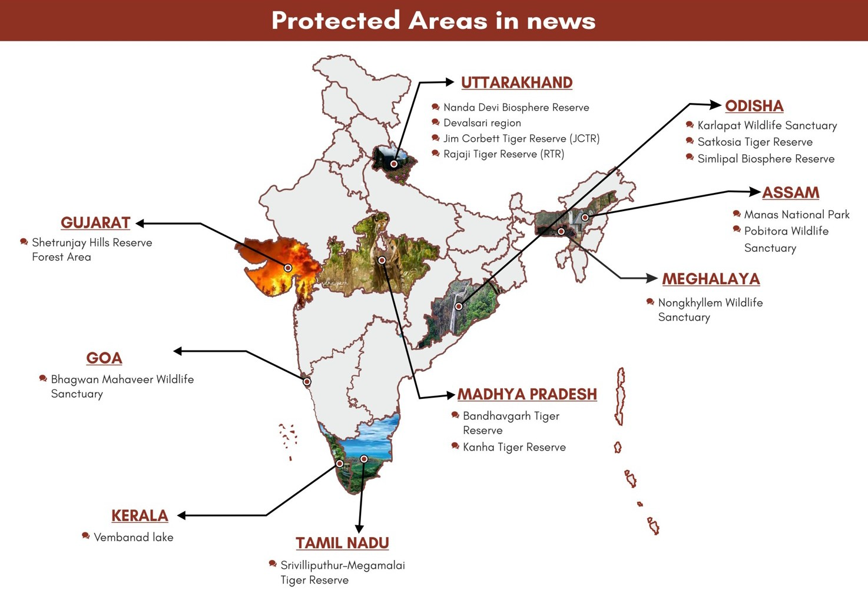

|  |  |
| --- | --- |
|  | * **About Biodiversity Heritage Sites (BHS)**   + BHS are areas that are **unique, ecologically fragile ecosystems** having rich biodiversity comprising of any one or more of the components such as;     - species richness,     - high endemism,     - presence of rare, endemic and threatened species, keystone species, species of evolutionary significance, wild ancestors of domestic species or land races or their varieties,     - past pre-eminence of biological components represented by fossil beds and having cultural or aesthetic values.   + Under **Biological Diversity Act, 2002** State Government in consultation with local bodies may notify the areas of biodiversity importance as BHS.   + Currently, there are 18 BHS in India. |

**4.3.11. OTHER CONSERVATION MEASURES**

|  |  |
| --- | --- |
| **India’s first**  **Centre for Wetland Conservation and Management (CWCM)** | * Ministry of Environment, Forest and Climate Change (MoEFCC) established India’s first Centre for Wetland Conservation and Management (CWCM) on the occasion of **World Wetlands Day**. * CWCM would be a **part of National Centre for Sustainable Coastal Management (NCSCM),**   Chennai, an institution under MoEFCC.   * **Role of CWCM**   + To **address specific research needs and knowledge gaps in conservation and management of wetlands**.   + To aid in **application of integrated approaches** for conservation, management and wise use of wetlands.   + To **serve as a knowledge hub and enable exchange between State/ UT Wetland**   **Authorities,** wetland users, managers, researchers, policy-makers and practitioners. |
| **Chipko**  **Movement** | * Recently, **Reni village in Chamoli district, the birthplace of Chipko movement** has been ravaged by recent glacial outburst in Uttarakhand. |

|  |  |
| --- | --- |
|  | * Chipko movement was a **non-violent agitation in 1973 against the felling of trees** by contractors and maintaining the ecological balance**.** * Chipko Movement **was initiated by Sundarlal Bahuguna**, in 1973 and his appeal resulted in a 15- year ban on chopping of green trees in 1980. * The name of the movement ‘Chipko’ comes from the word **’embrace’, as the villagers hugged the trees and encircled them to prevent being hacked.** * Movement is best remembered for the **collective mobilisation of women for the cause of preserving forests** andalso brought about a **change in attitude regarding the status of women** in society.   + Champions of the movement were local women - **Gaura Devi, Sudesha Devi and Bachni Devi.** * The Chipko Movement **followed Gandhian philosophy of peaceful resistance** and was an uprising against the people destroying ecological balance. * However, the original **Chipko andolan dates back to the 18th century**   + It was started by the **Bishnoi community of Rajasthan**.   + A group of villagers **led by Amrita Devi, laid down their lives while protecting trees** from being felled on the orders of the then King of Jodhpur.   + After this incident, the king, in a royal decree, **banned cutting of trees in all Bishnoi villages.** |
| **2020 Tree City of the World** | * **Hyderabad city** was chosen as one among the **120 ‘Tree Cities of the World’** by Arbor Day Foundation jointly with Food and Agriculture Organisation of UN. * It is the **recognition of the City's commitment to growing and maintaining urban forestry**. * It is the **only Indian city** to get such recognition. |

### 4.4. SUSTAINABLE DEVELOPMENT



**4.4.1. WORLD SUSTAINABLE DEVELOPMENT SUMMIT 2021**

##### Why in News?

Recently, 20th edition of **The Energy and Resources Institute’s (TERI)** flagship event, the **World Sustainable Development Summit** was held online.

##### More on the News

* The theme of the Summit is **‘Redefining our common future: Safe and secure environment for all’**.

##### India’s Ministry of Environment, Forests and Climate Change, Ministry of New and Renewable Energy

and **Ministry of Earth Sciences** are key partners of the Summit.

* The Summit brings together a wide number of governments, business leaders, academicians, climate scientists, youth, and the civil society in **the fight against climate change**.

##### About the Energy and Resources Institute (TERI)

* + It is an **independent, multi-dimensional organization, with expertise in research, policy, consultancy and implementation**.
  + It was established originally as **Tata Energy Research Institute** in **1974**.
  + Its mission is to **transition to sustainable future** through the **conservation and efficient use of energy**

##### with innovative ways of minimizing and reusing waste.

* + It’s work across sectors is focused on:
    - **Promoting efficient use of resources.**
    - **Increasing access and uptake** of **sustainable inputs and practices.**
    - **Reducing negative impact** on **environment and climate.**
  + It is headquartered in **New Delhi, India**.

**4.4.2. SEEA ECOSYSTEM ACCOUNTING (SEEA EA)**

##### Why in news?

**Ecosystem accounting**

* It is a **coherent framework for integrating measures of ecosystems** and the flows of services from them with measures of economic and other human activity.
* In ecosystem accounting as described in the SEEA Ecosystem Accounting (SEEA EA), the **accounting approach recognises that these individual resources function in combination within a broader system** and within a given spatial area.

Recently, India implemented a **new national statistical framework**- **SEEA Ecosystem Accounting (SEEA EA)** that measures the services that natural ecosystems provide to **combat environmental degradation** and **promote sustainability**.

##### About System of Environmental Economic Accounting (SEEA) EA

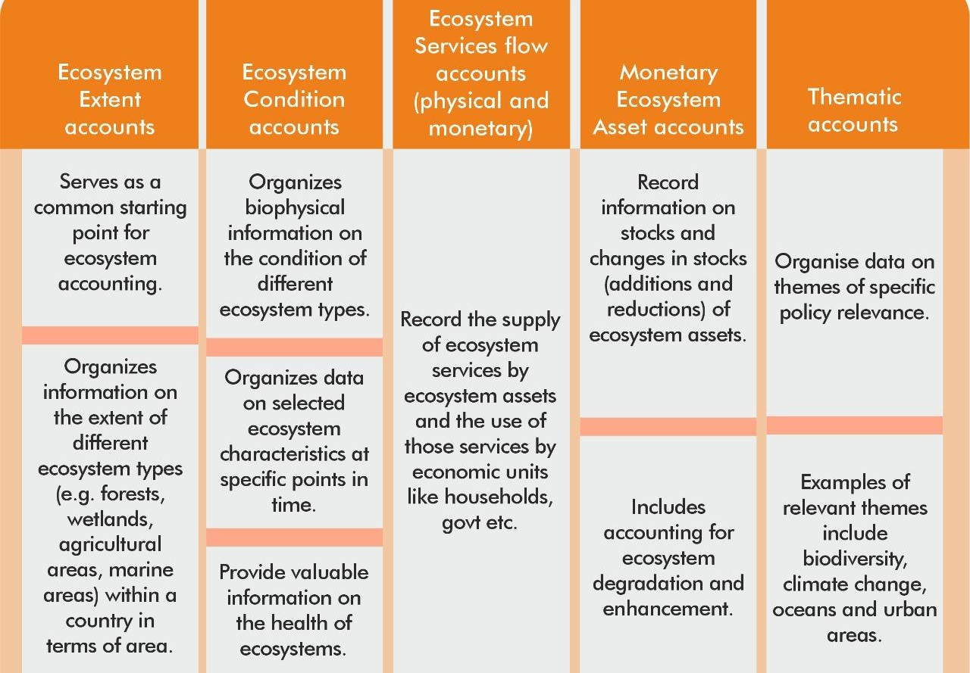

* SEEA EA is an **integrated statistical framework for organizing biophysical data, measuring ecosystem services, tracking changes in ecosystem assets** and linking this information to economic and other human activity.
  + SEEA EA was also adopted as **statistical standard by the United Nations Statistical Commission**

recently.

* SEEA EA is built on **five core accounts:**

**Important Terms and Definitions Natural Capital**

* It can be defined as the **world’s stocks of natural assets** which include **geology, soil, air, water and all living things**.
* It is from this Natural Capital that humans derive a wide range of services, often called **ecosystem services**, which make human life possible.
* Quantifying and valuing the contribution natural assets can help countries **track over-exploitation and invest in protecting and restoring ecosystems.**

**Natural capital accounting**

* It is a tool that can help **measure the full extent of a country’s natural assets** and give perspective on the link between the economy, ecology and our environment.
* Accounting for such goods may occur in **physical or monetary terms**.

##### India’s SEEA EA framework

* India is one of 90 countries that have successfully adopted the ecosystem accounting system including the new framework for **SEEA EA.**
* India’s this effort was led by the **Ministry of Statistics and Programme Implementation (MoSPI)under the Natural Capital Accounting and Valuation of Ecosystem Services (NCAVES) Project** which aims to advance the theory and practice of ecosystem accounting in India.
  + **NCAVES mainstream natural capital accounting and the valuation of ecosystem services** in data- driven decision and policymaking at the national, regional and local levels.
  + NCAVES Project, **funded by European Union**, has been jointly implemented by:
    - **United Nations Statistics Division (UNSD),**
    - **United Nations Environment Programme (UNEP)**
    - **Secretariat of the Convention of Biological Diversity (CBD).**
  + In India, the **NCAVES project** is being implemented by the **MoSPI** in close collaboration with the **Ministry of Environment, Forest and Climate Change (MoEF&CC)** and **the National Remote Sensing Centre (NRSC).**

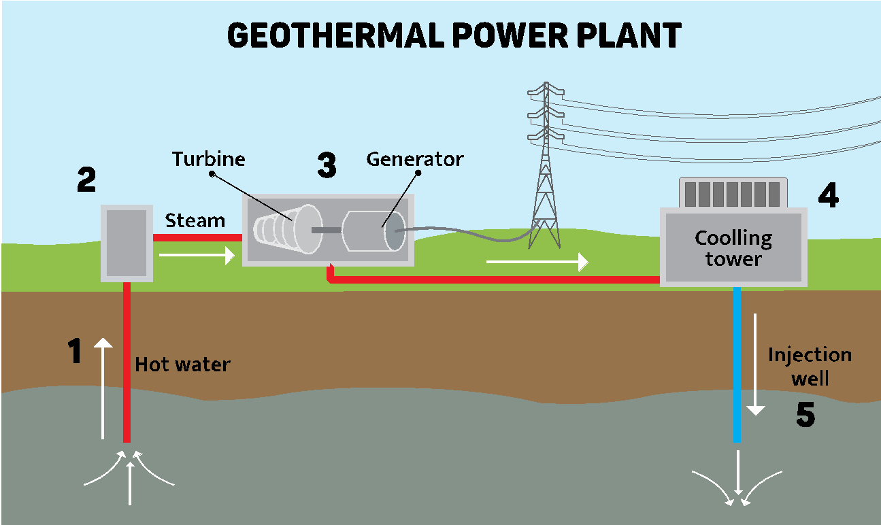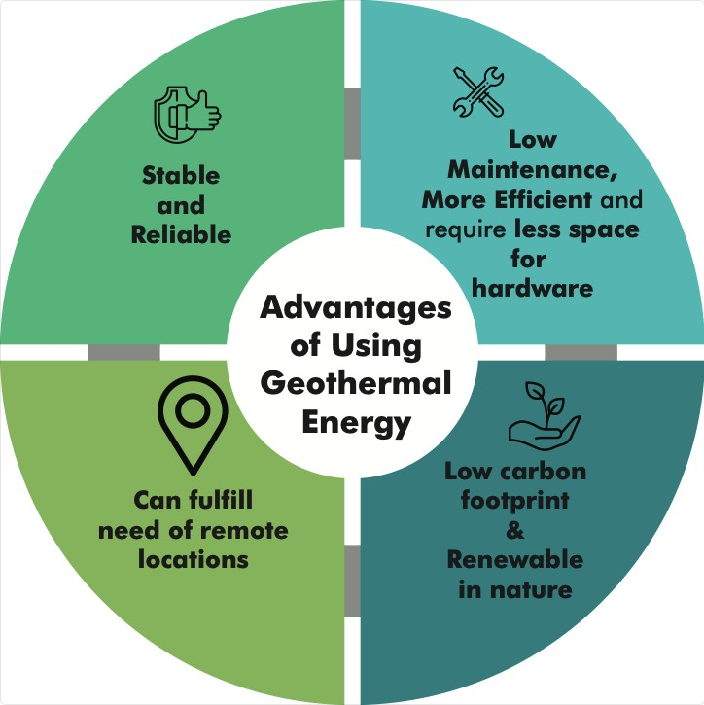

**4.4.3. GEOTHERMAL ENERGY**

##### Why in News?

An agreement for establishing **India’s first-ever geothermal field development project** in Leh has been signed.

##### More on news

* The power project known as **Geothermal Field Development**

**Project** will be established at **Puga village of eastern Ladakh**. Puga has been identified as the hotspot of geothermal energy in the country (potential of more than 100 mw of geothermal energies.)

* It is to be developed by ONGC Energy, Ladakh Autonomous Hill

Development Council, and Power Department of UT Ladakh.

##### What is Geothermal Energy?

* Geothermal energy is the thermal energy generated and **stored inside the Earth’s crust**. Geothermal power is the electricity generated from the heat source within the earth’s crust.
* This geothermal **energy originates from the geological processes** during formation of the planet, radioactive decay of minerals, and from solar energy absorbed at the surface.
* Geothermal energy is converted into electricity in following ways.

|  |  |  |
| --- | --- | --- |
| **Dry steam plants** | **Flash steam plants** | **Binary cycle plants** |
| Hot steam is piped directly from geothermal reservoirs into generators in the power plant. The steam spins turbines, which generate electricity. | Hot water is brought up through a well. Some of the water turns to steam, which drives the turbines. When the steam cools it condenses back into water and is returned to the  ground. | These operate on **water at relatively lower temperatures**. These plants use the heat from the hot water to boil a liquid that boils at a lower temperature than water. When the fluid is heated it turns to  steam and spins the turbines. |

##### Geothermal energy in India

* GSI (Geological Survey of India) has identified 350 geothermal energy locations in the country which have a potential of 10000 MW GE power.
* **There are seven geothermal provinces in India:** Himalayas - Ladakh, Manikaran, Tapoban; Sohana - Haryana, Rajasthan; West coast – Maharashtra; Cambay – Khambet; Son-Narmada-Tapi (SONATA) - Tatapani, Anhoni-Samoni; Godavari – Manuguru; Mahanadi – Bakreshwar. (see map)

##### Uses of Geothermal energy (GE)

* **For houses**: To heat/cool down temperature in house during winter/hot seasons.
* **For Farms**: used by farmers to **heat their greenhouses**. This makes it possible **to grow tropical plants such as citrus trees in the middle of the winter.**
  + Geothermal energy **is necessary in fish farms**. Tropical fish and other aquatic animals need warm water to survive and geothermal energy system is a suitable way to provide it.
* **For Industries:** It can be used in the process of extracting precious metals from ore.

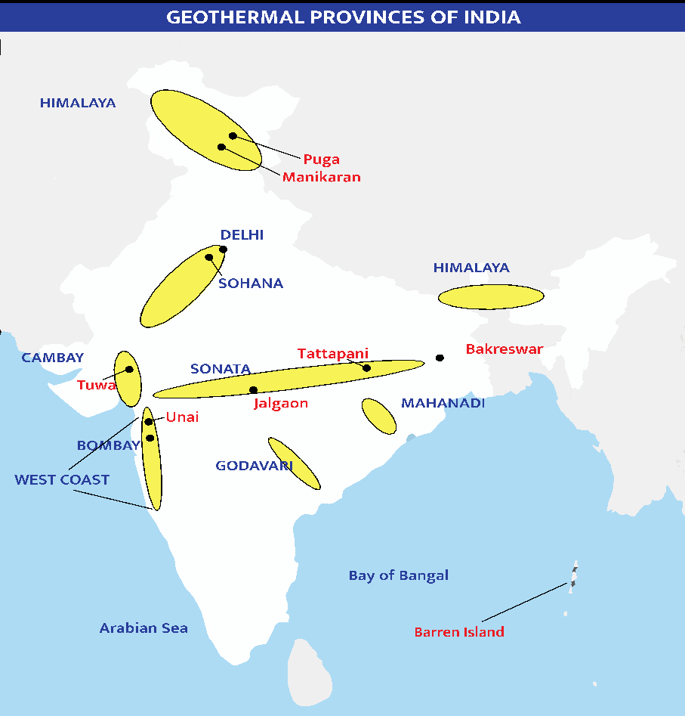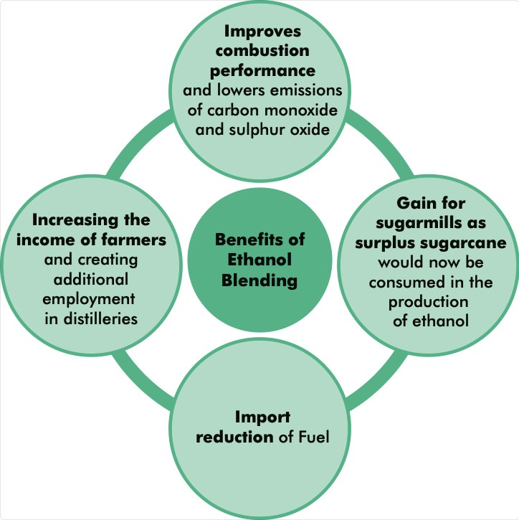

* **For Infrastructure**: It is a great source for preventing sidewalks and roads from freezing in winter. Ex. Netherlands has started to use geothermal energy to keep bike roads from icing in the colder seasons.

##### Government initiative to promote Geothermal Energy

* **Draft Indian geothermal energy development framework released by Ministry of New & Renewable Energy. Key goals include:**
  + Deployment of 1,000 MW (thermal) and 20 MW (electric) Geothermal Energy Capacity in the initial phase till 2022 and 10,000 MW (thermal) & 100 MW (elect) by 2030.
  + **International collaboration** to Harness 10,000 MW (10 GW) of geothermal energy by 2030 through active international collaboration with countries such as the US, Philippines, Mexico and New Zealand.
* **Draft National Policy on Geo-Thermal Energy** which envisions to establish India as a global leader in Geo- thermal power by deployment of Geo-thermal energy capacity of 1000 MW in the initial phase till 2022.
  + It proposes to **assess the potential of geothermal resources in country** and promoting R&D projects of Power production and Geo-exchange Pumps.

**4.4.4. ETHANOL BLENDING**

**Why in news?**

For the first time at **All India level, ethanol blending has reached 7.2% in the first four months of the ethanol supply year (ESY) 2020- 21 (ESY is 1st Dec to 30th Nov).**

**More on the News**

* In states such as Goa, Karnataka, Maharashtra, 9.5-10 per cent ethanol is being blended with petrol closer to 2022 target.

##### Earlier, National policy on Biofuel 2018 has fixed target of achieving 20% ethanol blending with petrol by 2030 and 5% blending of bio-diesel in diesel by 2030.

* + First milestone is **10% of ethanol blending with petrol by 2022**.
  + Policy allows **use of feedstock other than molasses to manufacture ethanol**. This includes sugarcane juice,

damaged foodgrains, rotten potato, corn, surplus foodgrains, etc.

* + **Policy categorises biofuels as** First Generation (1G), Second Generation (2G) and Third Generation (3G) biofuels.

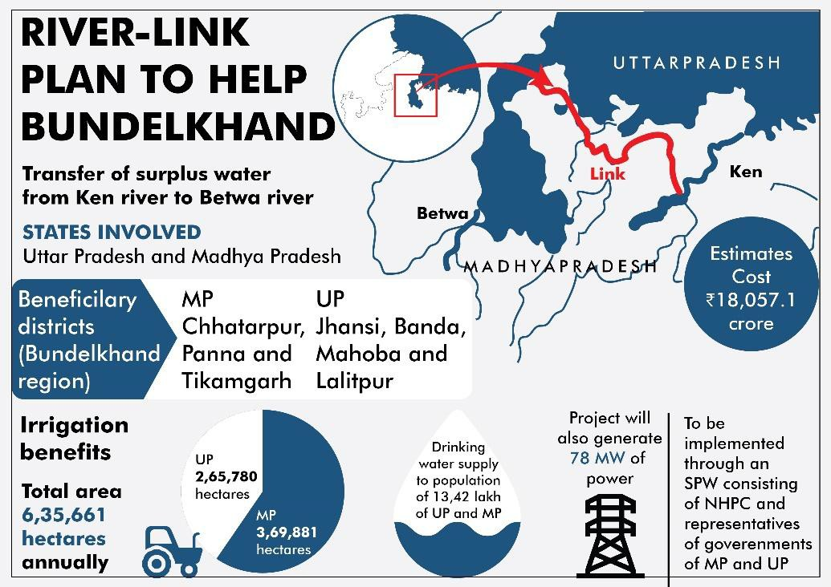

**Related News: World Earth Day 2021- 22 April**

* Earth Day is an **international event** celebrated around the world to pledge **support for environmental protection**.

o The year 2021 marks the 51st anniversary. The theme of Earth Day 2021 is **'Restore Our Earth'**.

•

•

Earth Day, **founded by Senator Gaylord Nelson**, was **first celebrated on April 22, 1970** to **promote ecology and**

**raise awareness** of the growing problems of air, water, soil pollution and need to protect the planet. UN designated it as **International Mother Earth Day** through a resolution adopted in 2009.

**Generations of Bioethanol**

* **First-generation Bioethanol technology** uses **feedstock** such as cereals (rice, wheat, barley, corn and sorghum), sugarcane, sugar beet etc.
* **Second-generation biofuels are produced from non-food crops**, such as cellulosic biofuels and waste biomass (stalks of wheat and corn, and wood)
* **Third-generation biofuels are produced from extracting oil of algae** – sometimes referred to as “oilgae”.
* **Fourth-generation Bioethanol technology** is based on **genetically modified organisms** like genetically modified sugarcane that has content of lipids for simultaneous production of bioethanol.

**4.4.5. EARTH HOUR 2021**

##### Why in news?

**About WWF**

* It is an **international non-governmental organization**, established in **1961** and headquartered at **Gland, Switzerland**.
* It is the **world’s leading conservation organization** with the **objective of conserving nature** and reduce the most pressing threats to the diversity of life on Earth.
* **Other initiatives by WWF -** TRAFFIC, non-governmental organization working globally on trade in wild animals and plants in the context of both biodiversity conservation and sustainable development.
* **Report published by WWF:** Living Planet Report.

Earth hour 2021 was celebrated on March 27th, 2021 under the **theme, “Climate change to Save Earth.”**

##### About Earth hour

* Organized by **World Wildlife Fund (WWF)**, the **one-hour lights out event (8:30 - 9:30 pm)** is held worldwide **toward end of March.**
* It encourages individuals, households, communities and businesses **to turn off their non-essential lights for one hour** as a symbol for their commitment to the planet.
* It started as a **light out event in Sydney, Australia in 2007** and since then has garnered support in 185 countries.
* **Objective** is to unite people to take action on environmental issues and protect the planet.

##### This year's event highlighted the link between destruction of nature and increasing outbreaks of diseases

like Covid-19.

* + According to data**, Delhi saved 334 MW electricity during Earth Hour.**

**4.4.6. NATIONAL RIVER LINKING PROJECT (NRLP)**

##### Why in news?

On the occasion of World Water Day (22 March), a memorandum of agreement was signed between Union Minister of Jal Shakti and the chief ministers of Madhya Pradesh and Uttar Pradesh to implement the Ken-Betwa Link Project (KBLP).

##### More about news

* The KBLP is the first project under the

National River Linking Project (NRLP)**.** Under this project **water from the Ken River will be transferred to the Betwa River.** Both these rivers are **tributaries of River Yamuna.**

* It would be implemented in 2 phases.
* **Phase-I:** Daudhan dam complex and its appurtenances like Low Level Tunnel, High Level Tunnel, Ken- Betwa link canal and Power houses will be completed.

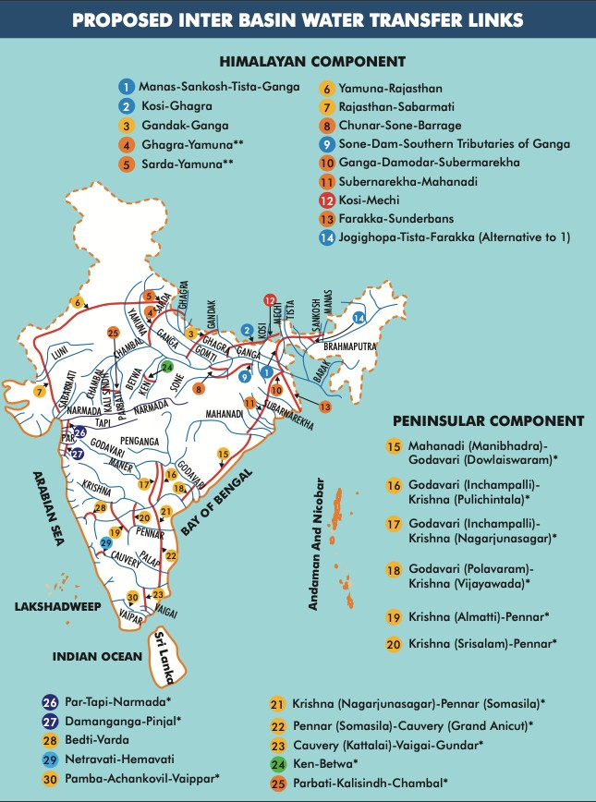

**National Water Development Agency (NWDA)**

* It was set up in **1982 as Autonomous Society** under the society’s registration act 1860.
* It functions under the **Ministry of Jal Shakti.**
* Initially its purpose was to carry out the **water balance and other studies** on a scientific and realistic basis for optimum utilization of water resources of **the peninsular river system.**
* **Functions**
* Manage the **3 components of NRLP.**
* Completion of water resources **projects under Pradhan Mantri Krishi Sinchai Yojana (PMKSY).**
* Act as a **repository of borrowed fund or loan from Banks/ other institutions** for the execution of projects.
* **Phase-II:** Lower Orr dam, Bina complex project and Kotha barrage will be constructed.
* **The Centre will create a special purpose vehicle,** the Ken- Betwa Link Project Authority, for implementation of the project in eight years and will bear **90% of the total cost.**

##### About National River Linking Project (NRLP)

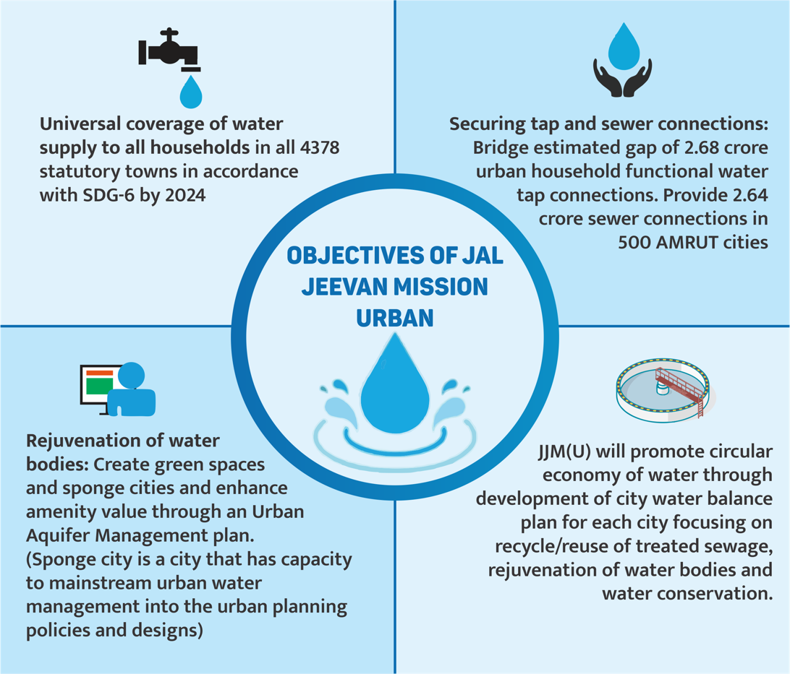

* The idea of interlinking of rivers was **first proposed by Sir Arthur Cotton in 1850s**. It was then revived in 1972 **by K.L. Rao,** then India’s minister of power and irrigation.
* Subsequently, **a total of 30 river links** were identified under NRLP **formally known as the National Perspective Plan** across.
* It envisages the **transfer of water from water ‘surplus’ basins** where there is flooding to water **‘deficit’ basins** where there is drought/scarcity, through inter-basin water transfer projects.
* It is being managed by the **National Water Development Agency (NWDA)**. The project is also called as the

**inter-basin transfer of water which** includes three components:

* + The northern Himalayan rivers interlinking component.
  + The southern peninsular component.
  + The intrastate river linking component.
* On completion of the project country will **have 30 river links, 3,000** storage structures, a canal network stretching almost 15,000 km and can generate **34 GW of hydroelectric power,** create some **87 million acres of irrigated land**, and transfer 174 trillion liters of water a year.

**4.4.7. JAL JEEVAN MISSION URBAN**

##### Why in news?

Jal Jeevan Mission (Urban) was announced by the Ministry of Housing and Urban Affairs in Union Budget 2021- 22.

##### Salient features of Jal Jeevan Mission (Urban)

* **Components under JJM:**
  + Development of **in-village piped water supply infrastructure.**
  + Development of **reliable drinking water sources and/or augmentation of existing sources** to provide long-term sustainability of water supply system.
  + **Greywater management** (domestic non-faecal wastewater).
  + Development of utilities**, water quality laboratories, water quality testing & surveillance, R&D, knowledge centre, capacity building of communities**, etc.
* **Funding:**
  + **100% central funding for Union Territories,**
  + **90% for North Eastern and Hill States,**
  + 50% for cities with less than 1 lakh population, one third for cities with 1 lakh to 10 lakh population and
  + 25% for cities with million plus population.
* **Outcome based Funding**: Funding will be in three tranches of

20:40:40. Third

instalment onwards will be released based on outcomes achieved and credible exclusion.

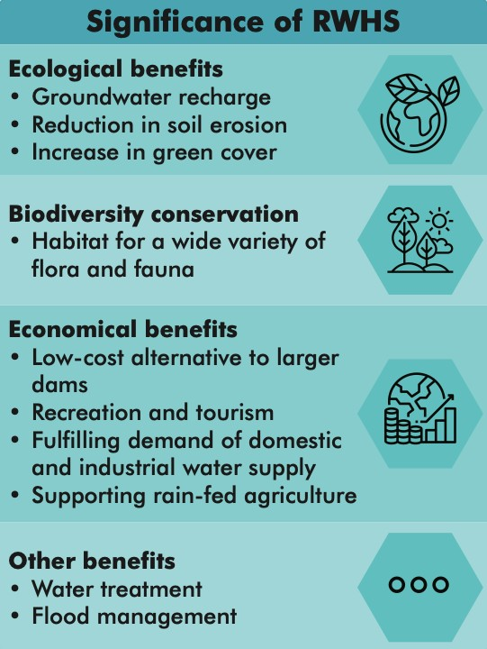

* **Promoting PPP Model:** Mandatory for **cities having millions plus population** to take up PPP projects worth minimum of 10% of their total project fund allocation.

**Jal Jeevan Mission (JJM) (Rural)**

* JJM was launched in 2019, Department of Drinking Water and Sanitation under the Jal Shakti Mantralaya.
* It aims at providing supply of 55 litres of water per person per day to **every rural household** (**Har Ghar Nal Se Jal)** through Functional Household Tap Connection (FHTC) by 2024.
* **FHTC** means a tap connection to a rural household for providing drinking water in adequate **quantity** of prescribed **quality** on **regular basis**.
* About **3.2 crore of rural households have been provided with FTWC since the launch of the Mission**, covering around 34 per cent of the targeted households (65.5 million) in rural India.

##### To leverage latest global technologies a

Technology Sub-Mission for water.

* **To spread Mass Awareness,** Information, Education and Communication (IEC) campaign.
* **Pey Jal Survekshan** survey will be conducted in 10 cities to ascertain equitable distribution of water, reuse of

wastewater and mapping of water bodies with respect to quantity and quality of water through a challenge process.

* + Based on the learnings, it will be **extended to all the AMRUT cities.**
* **Focus on strengthening urban local bodies** by reducing non-revenue water to below 20%, promoting dual piping systems etc.
* Raising funds through issuance of municipal bonds. Non-revenue water is the difference between the volume of water put into a water distribution system and the volume that is billed to customers.

**4.4.8. JAL SHAKTI ABHIYAN: CATCH THE RAIN CAMPAIGN**

##### Why in News?

National Water Mission (NWM), Ministry of Jal Shakti in collaboration with Nehru Yuva Kendra Sangathan (NYKS), Ministry of Youth Affairs & Sports recently launched the “JSA II: Catch the Rain” Awareness Generation Campaign.

##### About Jal Shakti Abhiyan: Catch the Rain Campaign

* The campaign has been launched with tag line “**catch the rain, where it falls, when it falls**” and will run from 22nd March 2021- 30th November 2021. In seeks to nudge all stakeholders to create **Rainwater Harvesting Structures (RWHS)** suitable to the climatic conditions and sub-soil strata.
* To facilitate these activities and provide **technical guidance** in RWHS, states have been requested to open

**“Rain Centers”** in **each district**, in Collectorates/Municipalities or GP offices.

* The **collaboration with NYKS is a step to engage people at the grassroots** through effective campaigning & IEC activities for implementation of the campaign.
* Activities to be taken up under the campaign:
  + **Drives** to make water harvesting pits, rooftop RWHS and check dams;
  + **removal of encroachments** and de-silting of tanks to increase their storage capacity;
  + **removal of obstructions** in the channels which bring water to them from the catchment areas;
  + **repairs to traditional water harvesting structures** like step-wells and using defunct bore-wells and old wells to put the water back to aquifers.

##### About Rainwater harvesting

Rainwater harvesting is the accumulation and storage of rainwater for reuse on-site, rather than allowing it to run off. Common methods of RWHS include:

* **Rooftop Rainwater harvesting**: This method uses the water collected on terraces and rooftops of houses and buildings. It is best applied in residential areas of towns and cities.
* **Surface run-off rainwater harvesting:** This method is used for collecting rainwater flowing through open spaces like roads, grounds, hill, etc. This water is stored underground and is used for public purposes like watering in gardens, roadside trees, beautification, etc.

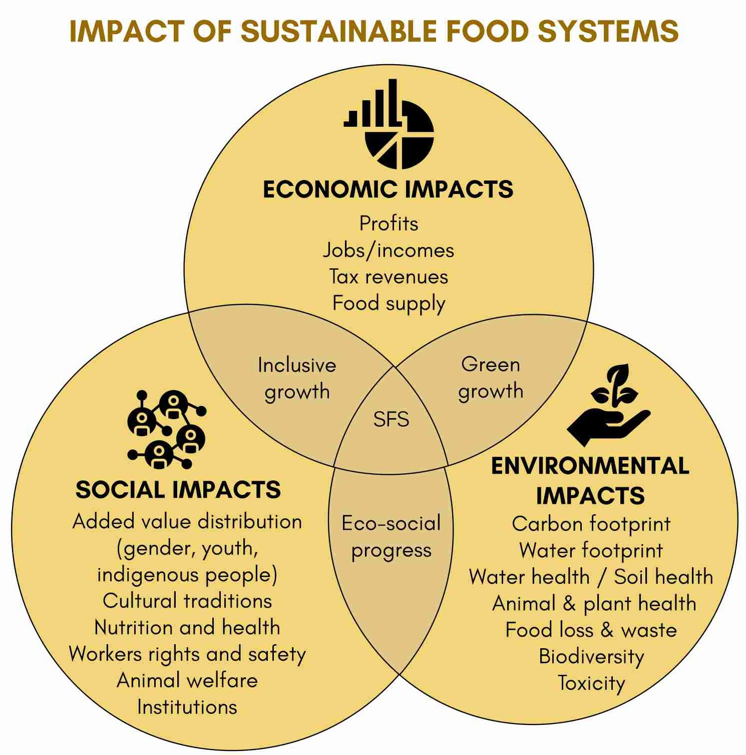

* **Recharge pits:** These are large tank shaped pits dug for storing water usually adjacent to hills, or in fields. These can be used for irrigation. As the name suggests, these have an added advantage of recharging the aquifers.
* **Gully Plugs:** Gully plugs are smaller pits built at regular intervals in an open area where rainwater is likely to run through. It ensures that rainwater is saved at many sites.
* **Contours:** Contours are similar to gully plugs but narrow and long bands.

|  |  |
| --- | --- |
| **Ecological Region** | **Traditional Water Management System** |
| Trans - Himalayan Region | Zing |
| Western Himalaya | Kul, Naula, Kuhl, Khatri |
| Eastern Himalaya | Apatani |
| North Eastern Hill Ranges | Zabo |
| Brahmaputra Valley | Dongs / Dungs/ Jampois |
| Indo-Gangetic Plains | Ahars – Pynes, Bengal’s Inundation Channels, Dighis, Baolis |
| The Thar Desert | Kunds, Kuis/beris, Baoris/Ber/Jhalaras, Nadi, Tobas, Tankas, Khandins, Vav/Bavadi,  Virdas, Paar |
| Central Highlands | Talab, Bandhis, Saza Kuva, Johads, Naada/Bandh, Pat, Rapat, Chandela Tank, Bundela  Tank |
| Eastern Highlands | Katas / Mundas / Bandhas |
| Deccan Plateau | Cheruvu, Kohli Tanks, Bhandaras, Phad, Kere, The Ramtek Model |
| Western Ghats | Surangam |
| West Coastal Plains | Virdas |
| Eastern Ghats | Korambu |
| Eastern Coastal Plains | Eri / Ooranis |
| The Islands | Jack Wells |

**4.4.9. SUSTAINABLE FOOD SYSTEMS**

##### Why in news?

India held the **first National Dialogue on agri- food systems (at Delhi)** for exploring national pathways towards creating sustainable and equitable food systems.

##### More on news

* The dialogue was conducted as consultative processes precursor to **first ever UN Food Systems Summit** to be held in **September 2021** to strategize the **actions for change in global Agri-food systems**.
* The Summit will **focus on pathways to shape food systems nationally and globally** to accelerate progress in the **Sustainable Development Goals 2030**.
* The Summit is planned to be participatory and consultative for **5 Action Tracks:**
  + **Action Track 1**: Ensure safe and nutritious food for all
  + **Action Track 2**: Shift to sustainable consumption patterns
  + **Action Track 3**: Boost nature-positive production
  + **Action Track 4**: Advance Equitable Livelihoods
  + **Action Track 5**: Build resilience to vulnerabilities to shock and stress
* **India has volunteered** to the **Action Track 4: Advance Equitable Livelihoods** for the Summit. But India’s participation is has been in other areas as well.

##### About Sustainable Food Systems



**International efforts on Sustainable Food Systems**

* **FAO-UNEP Sustainable Food Systems Programme (SFSP)**
  + It was **started in 2011** with support from **Government of Switzerland**.
  + Its objective is to :
    - **Spearhead efforts to improve resource use efficiency.**
    - **Reduce the pollution intensity of food systems** from **production to consumption.**
    - **Address issues of food and nutrition security**.
* **Food and Land Use Coalition (FOLU)**
  + It is a **self-governing coalition** composed of over 30 organizations established to transform the global food and land use systems.
  + It was established in 2017 **at United Nations General Assembly. India’s initiatives in the direction of Sustainable Food Systems**
* **National Mission for Sustainable Agriculture (NMSA)** aims at making agriculture more productive, sustainable, remunerative and climate resilient by:
  + It was included as **one of the 8 missions under National Action Plan on Climate Change** in 2008 and operationalized from 2014-15.

•

•

**Pradhan Mantri Krishi Sinchayi Yojana (PMKSY)** aims to Introduce

sustainable water conservation practices, among others.

**Paramparagat Krishi Vikas Yojana** which aims promotion of commercial organic production through certified organic farming.

* A **sustainable food system (SFS)** is **a food system that delivers food security and nutrition for all in such a way that**:
  + It is **profitable throughout** (economic sustainability)
  + It has **broad-based benefits for society** (social sustainability)
  + It has a **positive or neutral impact on the environment** (environmental sustainability)
  + **Need of future generations** are not compromised.

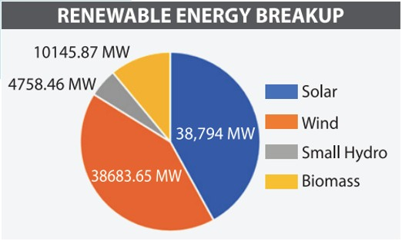

**4.4.10. OTHER IMPORTANT NEWS**

|  |  |
| --- | --- |
| **Solar Outshines Wind Power in Total Capacity** | * As per Ministry of New and Renewable Energy data, total **installed capacity of solar power stood at 38,794 MW,** while total wind power capacity was 38,684 MW.   o In comparison, a decade ago, the **solar segment had a capacity of 18 MW, while wind power’s installed capacity was 13,000 MW.**   * India has target of 175 GW of   renewable energy by the year 2022, with 100 GW of solar power.   * + India also aspires to achieve 450GW of renewable energy by 2030. * However, one key concern **high dependence on China for solar cells and modules** as China accounts for 80% of imports.   + Recently, government launched **PLI scheme for solar photo voltaic sells.** |
| **Solar ‘gigawatt club’** | * Nine African nations are on track to join solar ‘gigawatt club’. * Gigawatt club is an **unofficial tag of Nations with installed capacity to produce 1 GW of solar power.** * Currently, 37 countries that are part of the solar ‘gigawatt club’ **(including India)**. |
| **India's biggest**  **floating solar power plant** | * Set up at **Ramagundam in Telangana** with a capacity of 100 MW is set to open in May this year. * It is being commissioned by the **National Thermal Power Corporation (NTPC)** * Under the floating plants, the photovoltaic panels are deployed on the surface of water bodies. They are considered as a viable alternative to land-based solar arrays. * Also, world's largest solar power plant with 600 MW capacity is being set up on   Omkareshwar Dam on Narmada river in Madhya Pradesh. |
| **First farm-based solar power plant in Rajasthan** | * Rajasthan Renewable Energy Corporation Ltd (RRECL) commissioned the country’s first farm-based solar power project under **PM KUSUM scheme** (Kisan Urja Suraksha Evum Utthan Mahabhiyan) in Jaipur. * PM KUSUM was launched by Ministry of New and Renewable Energy for installation of solar pumps and grid connected solar and other renewable power plants for farmers.   o It aims to add solar and other renewable capacity of 25,750 MW by 2022. |
| **Galvanizing**  **Organic Bio-Agro** | * **Ministry of Jal Shakti launched a unified portal** on 'Gobardhan' scheme. |



|  |  |
| --- | --- |
| **Resources Dhan (GOBAR-DHAN)**  **scheme.** | o Under new unified approach, all biogas programmes/schemes will be coordinated by Department of Drinking Water and Sanitation under Swachh Bharat Mission - Grameen (SBMG).   * Gobardhan scheme is **being implemented as part of the SBMG.**   o It is an important **element of achieving Open Defecation Free (ODF) strategy.**   * It aims to support villages in **effectively manage their cattle and biodegradable waste**. * Scheme focus on **keeping villages clean, increasing income of rural households, and**   **generation of energy** from cattle waste. |
| **Energy Efficiency Enterprise (E3) Certifications Programme for Brick manufacturing**  **Sector** | * E3 Certification Scheme, launched by Ministry of Power, is **aimed at tapping huge energy efficacy potential in this sector.**   o It will lead to **adoption of more efficient technologies for making energy efficient bricks**. Such bricks will be useful in complying the requirements of Energy Conservation Buildings Code (ECBC).   * Brick sector contributes nearly 0.7% to GDP and offers seasonal employment generation to over 1 crore workers. |
| **Indian Green Building Council (IGBC) Mission on Net Zero** | * **Confederation of Indian Industry’s (CII)IGBC** has launched ‘IGBC Mission on Net Zero’ to facilitate ‘**India achieve net zero carbon emission status by 2050’.** * Net zero, also called as carbon-neutrality, is a state in which a **country’s emissions are compensated by absorption** and **removal of greenhouse gases** from the atmosphere. * IGBC is part of CII with vision ‘to **enable a sustainable built environment** for all and facilitate India to be one of the global leaders in the sustainable built environment by 2025’. * CII is a **non-government, not-for-profit, industry-led and industry-managed organization**,   playing a proactive role in India's development process, founded in 1895. |
| **ECOPact Green Concrete** | * It is a **New Low-Carbon range of Concrete** introduced for a **high-performing, sustainable and circular construction.** * It comprises **30-50% lower embodied carbon content** as compared to standard concrete. * Also, it has **superior durability and finish** as compared to conventional concrete. |
| **Dutch Indian Water Alliance for Leadership Initiative (DIWALI)**  **Platform** | * This platform has been developed to **enable India and Netherlands** to participate for   **designing solution for water related challenges together**.   * They would explore the **potential and sustainability of Dutch Solutions to resolve challenges in specific water challenged sites in India** which are scalable, sustainable and affordable. |
| **Carbon Watch** | * Chandigarh became the first state or Union Territory in India to launch Carbon Watch. * Carbon Watch is a **mobile application to assess the carbon footprint of an individual**.   o A carbon footprint is the **total amount of greenhouse gases** (including carbon dioxide and methane) that are generated by our actions.   * It aims to make the **people Climate-Smart Citizens while making them capable of accessing their carbon footprint**, along with providing them with steps to reduce it |
| **Bhartiya Prakritik Krishi Padhati (BPKP)** | * Bhartiya Prakritik Krishi Padhati (BPKP), is introduced **as a sub scheme of Paramparagat Krishi Vikas Yojana** for the **promotion of traditional indigenous practices including natural farming.** * BPKP excludes all synthetic chemical inputs and promotes on-farm biomass recycling. * **Financial assistance of Rs 12200/ha for 3 years** has been provided for the scheme. * **About Natural Farming:**   + While organic farming uses organic fertilizers and manures like compost, vermicompost, cow dung manure, etc, in **Natural farming, neither chemical nor organic fertilizers are added to the soil.**   + Here laws of nature are applied to agricultural practices. |
| **Direct Seeded**  **Rice (DSR) Technique** | * **Direct seeded rice (DSR)**: It refers to the process of establishing a rice crop from **seeds sown in the field rather than by transplanting seedlings from the nursery**.   + Direct seeding can be done by **sowing of pre-germinated seed into a puddled soil (wet seeding) or standing water (water seeding) or prepared seedbed (dry seeding).**   + DSR method **saves labour, requires less water, less drudgery, early crop maturity and have low production cost.** * Other methods-   + **System of Rice Intensification (SRI)** is a methodology for **increasing the productivity of irrigated rice by changing the management of plants, soil, water and nutrients** particularly by eliciting greater root growth.   + It makes rice production more **efficient and sustainable** by saving in **seed requirement, Water Savings, Reduced chemicals fertilizer and increased grain yield**. |

### 4.5. DISASTER MANAGEMENT AND GEOGRAPHY

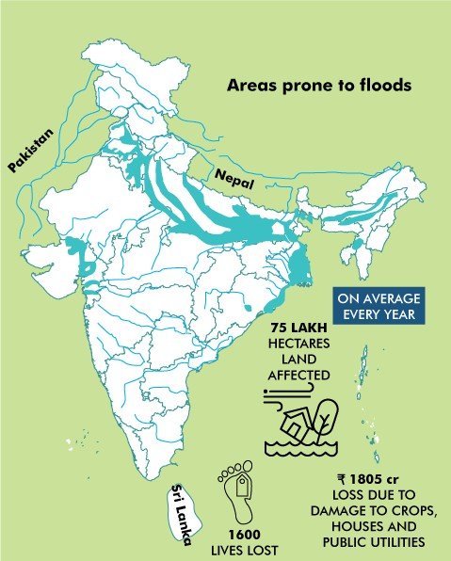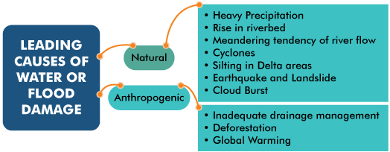

**4.5.1. FLOOD MANAGEMENT**

##### Why in news?

NITI Aayog recently released a report on Strategy for Flood Management in the country.

##### More on news

The report is prepared by a Committee for Formulation of Strategy for Flood Management Works in Entire Country and River Management Activities and Related to Border Areas (2021– 26).

##### Flood situation in India

Works

* Flooding is **caused by the inadequate capacity within the banks of the rivers to contain the high flows** brought down from the upper catchments.
* Flooding is a normal process during monsoon and to some extent, it is **needed to carry out some natural processes** like bringing alluvial soil to fields, groundwater recharge or replenishment of waterbodies.
* India is highly vulnerable to floods. Out of the

total geographical area of 329 million

##### hectares (mha), more than 40 mha is flood prone (around 12% of the total area of India).

* + In recent times, **flood related damages**

**show an increasing trend** and floods

have also occurred in areas, which were earlier not considered flood prone.

* Some of the **biggest flood disasters in the last 10 years** include Uttarakhand in 2013, Kashmir in 2014, Chennai in 2015, Kerala in 2018 and 2019 and Patna in 2019 besides the recurring floods in north-eastern India.

##### Key Highlights of the report

|  |  |  |  |
| --- | --- | --- | --- |
| **Constitutional and Statutory Position** | * Subject of **flood control**, unlike irrigation, **does not figure** as such in any of the lists of 7th Schedule. * **State List**- **Drainage and embankments**. * **Union List**- Regulation and development of inter-State rivers and river valleys. * Central government has enacted **National Disaster Management Act, 2005** and set up of the NDMA, which has been assigned to deal with all types of disasters including the floods. | | |
| **Flood management system** |  |  |  |

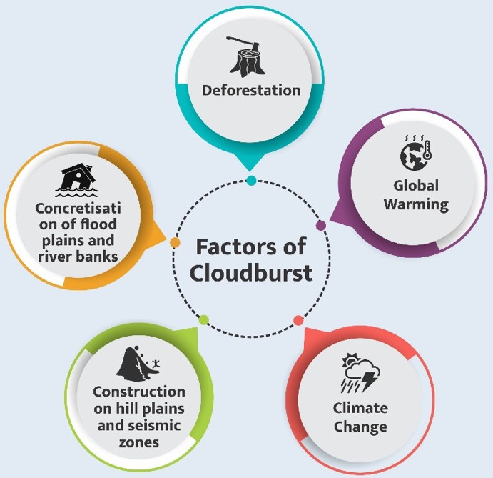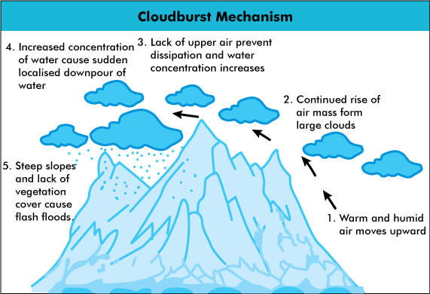

|  |  |
| --- | --- |
| **Issues in flood management** | * High degree of Monsoon variability. * **Inadequate maintenance of flood protection structures** like embankments, spurs etc. * **Flood protection works are done more as a fire-fighting o**ne instead of prevention plans. * **Non-involvement of beneficiaries in the maintenance of flood protection** works. |
| **Recommendations** | * **Flood Management and Border Areas Programme (FMBAP) shall be continued** for the period 2021-26 (initially planned till 2020). * **Structural Measures like** reservoir, Embankments, Interlinking of Rivers; etc. * **Non-Structural Measures** like Flood Plain Zoning; Watershed management; etc |

**Related news: Flood Management and Border Areas Programme (FMBAP)**

* The Scheme "FMBAP" has been framed by merging the components of two continuing XII Plan schemes titled "Flood Management Programme (FMP)" and "River Management Activities and Works related to Border Areas (RMBA)".
* The aim of the Scheme is **to assist the State Governments to provide reasonable degree of protection against floods in critical areas** by adopting optimum combination of structural and non-structural measures and enhancing capabilities of State/Central Government officials in related fields.
* The Scheme caters to **Hydro-meteorological observations, Flood Forecasting and survey and investigations of water resources projects on common rivers with the neighbouring countries** like Pancheshwar Multipurpose Project, SaptaKosi-Sun Kosi Projects in Nepal.

**4.5.2. CLOUDBURSTS**

**Why in news?**

Recently **‘cloudbursts’** were observed **in Uttarakhand’s Chamoli, Tehri and Rudraprayag districts.**

##### What is Cloudburst?

* Cloudbursts are **sudden and extreme rainfall events** over a limited area in a short span of time.
* The **India Meteorological Department (IMD)** defines a cloudburst as any event where **100 millimetres of** rainfall have fallen in a span of an hour over a region that is 20-30 square kilometres in area.
* It is very difficult to predict the cloud bursts due to its very small scale in space and time.
* It is generally more common in India during the **south west monsoon season** that begins in June.
* **National Disaster Management Authority (NDMA)** is the nodal agency responsible for monitoring the relief operation.

##### How does it happen?

* A cloudburst occurs when **moisture- carrying air moves up a hilly terrain**, forming a **vertical column of clouds known as ‘cumulonimbus’ clouds.** Such clouds usually cause **rain, thunder and lightning**. This upward motion of the clouds is known as an ‘**orographic lift’**.
* Cloudbursts do **happen in plains as well,** but there is a greater probability of them **occurring in mountainous zones.**
* Raindrops, instead of dropping down, are carried upwards by the air

##### current. New drops are formed and existing raindrops gain in size.

* + After a point, the raindrops become too heavy for the cloud to hold on to, and they drop down together in a quick flash.

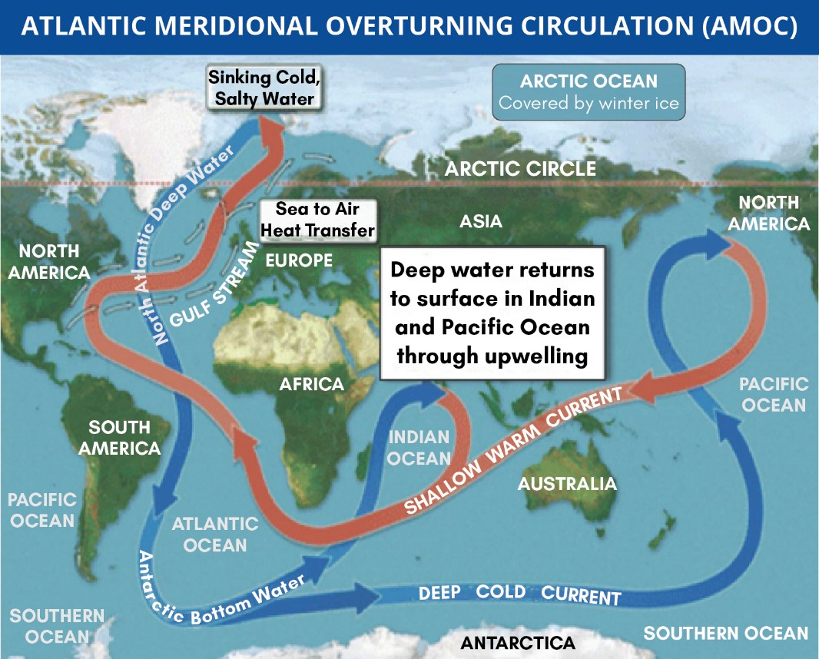

* + **Hilly terrains aid in heated air currents** rising vertically upwards, thereby, increasing the probability of a cloudburst situation.
* The energy necessary for the cloudburst comes from the **upward motion of air**. Cloudbursts mostly occur at **elevations between 1,000-2,500 metres above sea level**.
* The moisture is usually provided by a low-pressure system (usually associated with cyclonic storms in the ocean) over the Gangetic plains associated with low level winds flowing in from the east.
* Sometimes **winds flowing in from the north-west also aid the occurrence of cloudbursts**. The many factors that have to come together to make a cloudburst event happen make them highly unlikely.

**4.5.3. ATLANTIC MERIDIONAL OVERTURNING CIRCULATION (AMOC)**

##### Why in News?

Recent data suggests that **Gulf Stream – also known as the Atlantic Meridional Overturning Circulation (AMOC)**- **is at its weakest in more than a millennium,** and climate breakdown is the probable cause.

##### About Atlantic Meridional Overturning Circulation (AMOC)

* It is a large system of ocean currents **carrying warm surface water from the equator up north, and sending cold, low-salinity deep water back down south.**
* It works like a giant conveyor belt and is **driven by differences in temperature and salt content** – the water’s density.
  + The ocean conveyor gets its **start in the Norwegian Sea,** where warm water from the Gulf Stream heats the atmosphere in the cold northern latitudes.
    - **Low temperature and a high salt content make the water cooler and denser**, causing it to sink to the bottom of the ocean.
  + As more warm water is transported north, **the cooler water sinks and moves south to make room for the incoming warm water.** This cold bottom water flows south of the equator all the way down to Antarctica.
  + Eventually, the **cold bottom waters returns to the surface t**hrough mixing and wind-driven upwelling, continuing the conveyor belt that encircles the globe.
    - Upwelling is a process in which deep, cold water rises toward the surface.
* It **plays a vital role in redistributing heat and energy** throughout earth as the warm water it carries releases heat into the atmosphere, and in absorbing and storing atmospheric carbon.

##### AMOC influences the climate of the east coast of North America and the west coast of Europe.

* + It brings warm and mild weather to Europe.

##### Impact of weakened AMOC

* + It would **raise sea levels on the east coast of the US**, increase the number and severity of **storms hitting Britain, more intense winters** and an increase in damaging heatwaves and droughts across Europe.
  + It may cause more **storms or a drier Sahel in Africa** due to the downward shift of the tropical rain belt.

**Indian ocean and AMOC**

* Recent studies have found that **rising temperatures in the Indian Ocean can help boost the AMOC and delay slow down**.
* **Warming in the Indian Ocean generates additional precipitation**, which, in turn, draws more air from other parts of the world, including the Atlantic.
* The higher level of precipitation in the Indian Ocean **will reduce precipitation in the Atlantic and increase salinity in the waters**.
* This saline water in the Atlantic, as it comes north via AMOC, **will get cold much quicker than usual and sink faster**, acting as a jump start for AMOC, **intensifying the circulation.**

### 4.6. REPORTS IN NEWS

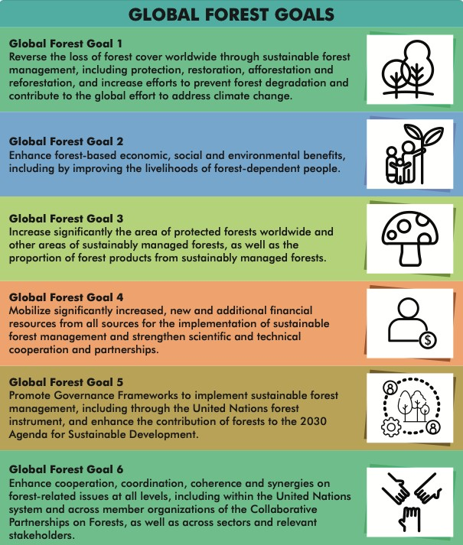

**4.6.1. THE GLOBAL FOREST GOALS REPORT 2021**

##### Why in news?

The report was recently released by **UN Department of Economic and Social Affairs.**

##### More on news

* The report titled **“Realizing the importance of forests in a changing world”** is the first **evaluation** of where the world stands in **implementing the United Nations Strategic Plan for Forests 2017-2030.**
  + It is a blueprint for forests and people expressed through **six Global Forest Goals (see infographic).**

##### Key findings:

* + **18% of forests are designated as protected areas** compared to just over 14% in 2000.
  + **40%of the world’s renewable energy** comes from forests.
  + **40% of the extreme poor in rural areas live in forest** and savannah areas.
  + Forest landscapes, often

**remote and poorly connected to markets,** make it difficult to build out businesses and earn livelihoods.

* + **Forests are not frequently considered in policy decisions related to food security,** hunger, and nutrition.

**4.6.2. OTHER IMPORTANT REPORTS**

|  |  |
| --- | --- |
| **Name of the**  **Report** | **Details and Key Findings** |
| **State of the Global Climate 2020** | * Released by: **World Meteorological Organization (WMO)** * The WMO issued the first **state of the climate report in 1993**. The report was initiated due to the concerns raised at that time about projected climate change. * **Key Findings**   + The **past six years, including 2020, have been the six warmest years on record**.     - Temperatures reached 38.0 °C at Verkhoyansk, Russia, the highest recorded temperature anywhere north of the Arctic Circle.   + The report provides **five key indicators of irreversible changes in the global climate**:     - **Greenhouse Gases:** Concentrations of the major greenhouse gases continued to increase in 2019 and 2020 despite temporary reduction in emissions in 2020 due to COVID-19 response.     - **Oceans:** In 2020 the oceans had the highest heat content on record. Over 80% of the ocean area experienced at least one marine heatwave in 2020.     - **Sea-level rise:** Sea level has recently been rising at a higher rate partly due to the   increased melting of the ice sheets. |



|  |  |
| --- | --- |
|  | * **The Arctic:** In 2020, the Arctic sea-ice extent came down to second lowest on record. * **The Antarctica:** The Antarctic ice sheet has exhibited a strong mass loss trend since the late 1990s. This trend accelerated around 2005. |
| **Making Peace with Nature report** | * Released by: **UN Environment Programme (UNEP)** * The report explains how three interconnected planetary crises- **climate change, biodiversity loss and pollution- put the well-being of current and future generations at unacceptable risk.** * **Key highlights**   + Over the last 50 years, human population has more than doubled, and **extraction of materials, production of primary energy etc. have all more than tripled.**   + **None of the global goals for protection of life on Earth have been fully met**, including those in strategic plan for biodiversity 2011–2020 and its Aichi biodiversity targets.   + **One million** of the world’s estimated 8 million **species of plants and animals are threatened with extinction.**   + **10% of World’s forests area has been lost** through conversions to other land uses since 1990.   + **Wetlands** (remaining only 15%) are the **most transformed and degraded ecosystem** type.   + **Marine plastics pollution has increased tenfold** since 1980, constituting 60–80% of marine   debris. |
| **World’s Forgotten Fishes report** | * Released by: **World Wide Fund for Nature (WWF)** in collaboration with other conservation groups. * **Findings**   + **Nearly a third of all freshwater fish are threatened** with extinction.   + Freshwater fisheries are the main **source of protein to 200 million people.**   + It accounts for **2.5-6% of the global agricultural workforce.** |
| **The India Energy Outlook 2021** | * Released by: **International Energy Agency** * Outlook examines the **opportunities and challenges faced by India** as it seeks to recover from COVID-19 crisis. * **Key highlights**   + India is **world’s third-largest energy consuming country**. Energy use has doubled since 2000, with 80% demand still being met by coal, oil and solid biomass.   + On a per capita basis, India’s energy use and emissions are less than half the world average.   + Because of an expanding economy, population, urbanisation and industrialization, **India will see largest increase in energy demand of any county by 2040.**   + **Solar power is set to match coal’s share in power generation mix** within two decades. Presently solar accounts for less than 4% of India’s electricity generation.   + By 2030, **non-fossil share in total electricity generation capacity will reach 60%** against   target of 40% set out in Nationally Determined Contribution under Paris Agreement. |
| **Global Energy Review 2021** | * Released by: **International Energy Agency** * The report assesses the direction energy demand and carbon dioxide emissions are taking in 2021. * **Key findings**   + Global energy demand is set to **increase by 4.6% in 2021**, offsetting the 4% contraction in 2020.   + Coal demand is on course to rise 4.5% in 2021, with more than 80% of the growth concentrated in Asia.     - China alone is projected to account for over 50% of global growth.   + Global energy-related CO2 emissions are heading for **their second-largest annual increase ever.**   + **Renewables provide more than half of the increase in global electricity supply in 2021**, with Solar PV and wind expected to contribute two-thirds of renewables’ growth.     - China is likely to **account for almost half the global increase in renewable electricity**   **generation,** followed by US, EU and India. |
| **Global EV Outlook, 2021** | * Released by: **International Energy Agency** * Global EV Outlook discusses recent developments in electric mobility across the globe. * **Key findings**   + There were **10 million electric cars on the world’s roads** at the end of 2020.   + **Electric car registrations increased by 41% in 2020**, despite the pandemic. * **Findings about India**   + More than **30% cent of new vehicle sales in India will be electric by 2030**.   + EV deployment will mainly be achieved through the electrification of two/three-wheelers.   + The lack of government spending under the FAME II policy and focus on BS-VI has hindered   EV deployment. |

|  |  |  |
| --- | --- | --- |
| **Fostering Effective Energy Transition 2021 report** | * **Released by:** World Economic Forum (WEF) * The Energy Transition Index (released as part of the report) **benchmarks countries on the current performance of their energy systems** and measures **their readiness to transition** to secure, sustainable, affordable, and inclusive energy systems. * India has been ranked 87th out of 115 countries with Sweden, Norway and Denmark taking the 1st, 2nd and 3rd positions respectively. * **Key findings of the report:**   + **Global average ETI scores have increased** in 8 out of the last 10 years   + **Over the past 10 years, only 10% of countries were able to make consistent gains**, showing need for renewed focus on climate goals.   + **India and China,** collectively **accounting for a third of global energy demand,** have made strong improvements over past decade, despite coal continuing to play a significant role in their energy mix.   + **Global investment in energy transition has doubled** in last 10 years.   + Number of people **without access to** |  |
|  |
| **electricity has declined to 770 million in 2019**, the lowest on record. | |
| **Food Waste Index Report 2021** | * Released by: **United Nations Environment Programme (UNEP).** * As per it, an estimated 931 million tonnes of food equalling**17% of total food available to consumers in 2019 globally wasted.** * For India, waste in kg / capita / year was 50, lower than Nigeria producing waste at 189 kg / capita   / year.   * Report suggests reducing food waste would improve food security, address climate change, save money and lower pressures on the environment. | |

**1MBDFT JO /FXT: *OEJB**

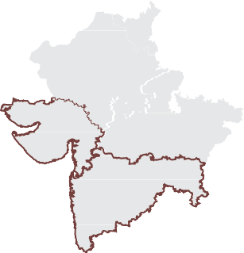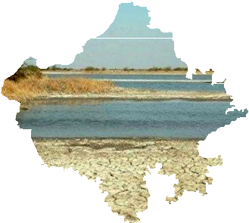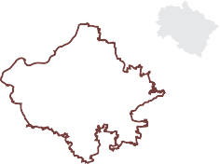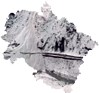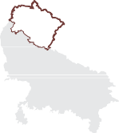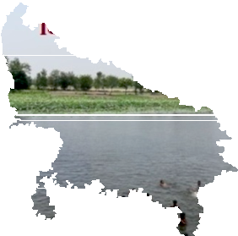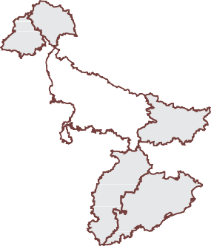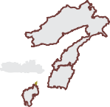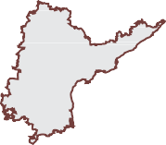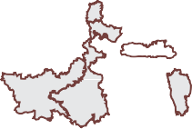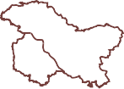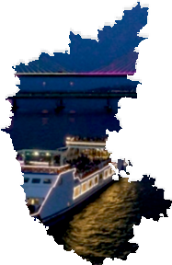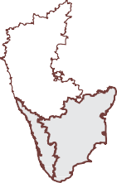

**655"3",)"/%**

*$ JODFLHU KDG EURNHQ RII LQ WKH* **4VNOB BSFB PG /JUJ 7BMMFZ** *LQ &KDPROL GLVWULFW.*

**655"3 13"%&4)**

*)RXQGDWLRQ VWRQH IRU GHYHORSPHQW ZRUN DW* **$IJUUBVSB**

**-BLF,** *D +LQGX SLOJULPDJH VLWH.*

**3"+"45)"/**

*7H[WLOH XQLWV SROOXWHG JURXQGZDWHU DQG WKH DGMRLQLQJ* **-VOJ SJWFS.**

**,"3/"5"," "/% (0"**

*,QWHU-VWDWH ULYHU ZDWHU GLVSXWH RYHU* **.BOEPWJ SJWFS.**

**+"..6 "/% ,"4).*3**

**-BSHFTU UVMJQ** *JDUGHQ LQ $VLD ORFDWHG DW WKH IRRWKLOOV RI =DEDUZDQ UDQJH LQ .DVKPLU YDOOH\.*

*$V SDUW RI )ULHQGV RI* **3JWFS 5BXJ** *PRYHPHQW, ORFDOV DUH WU\LQJ WR FOHDQ WKH ULYHU 7DZL ZKLFK RULJLQDWHV LQ .DLODVK .XQG JODFLHU LQ -DPPX.*

**.&()"-":"**

*6HYHUDO GHYHORSPHQWDO DFWLYLWLHV LQ*

**(BSP IJMMT** *UHJLRQ.*

*5HVLGHQWV RSSRVH GDP RQ* **6NOHPU**

**3JWFS.**

### 4.7. ERRATA

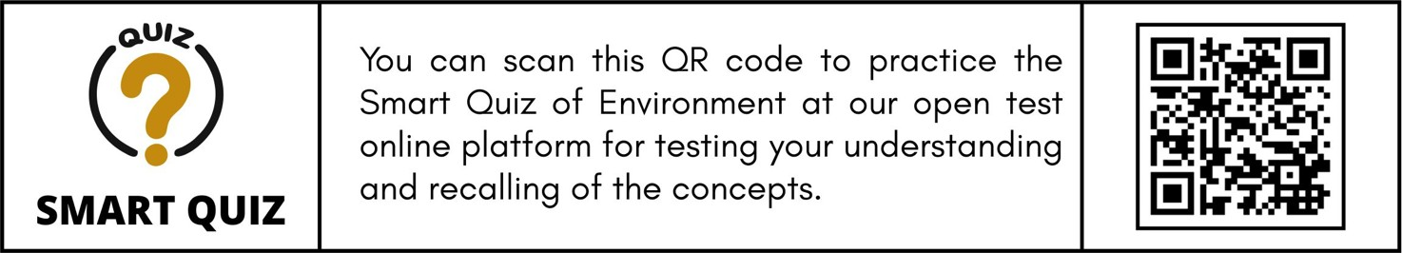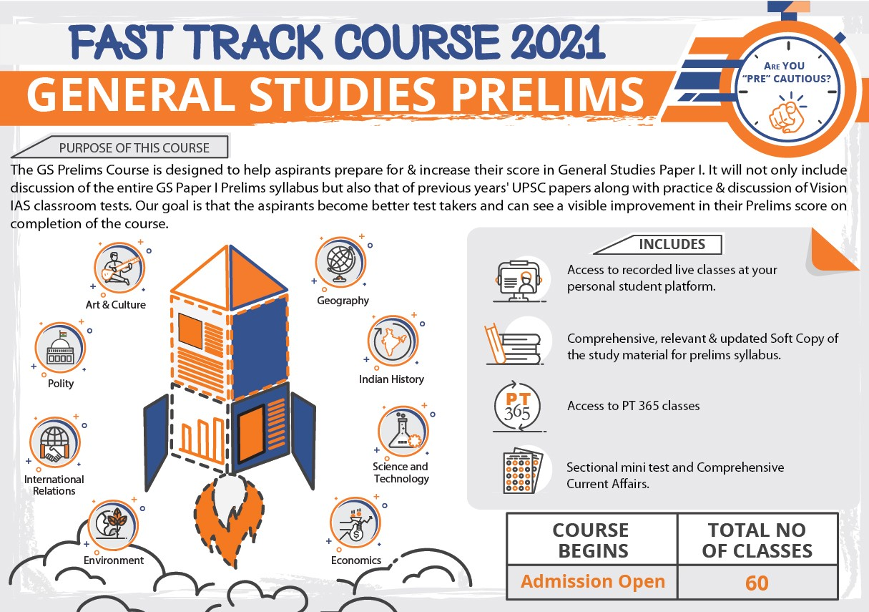

* On page number 47 in the PT-365 Environment, the Chairman of the National Board for Wildlife (NBWL) has been wrongly mentioned as the Union Environment Minister.
* Correct information-
  + **The National Board Wildlife is chaired by the Prime Minister of India**.

# SOCIAL ISSUES



**Related information**

**POCSO Rules, 2020**

* **Mandatory police verification of staff** in any institution housing children or coming in regular contact with children like schools, care homes, sports academies etc.
* **State Governments to formulate a child protection policy** to be adopted by all institutions, organizations, or any other agency working with, or coming in contact with children.
* **Central Government and State Governments shall**
  + **Provide periodic training** (like sensitization workshops etc.) to all persons, coming in contact with the children, to sensitize them about child safety and protection.
  + **Prepare age-appropriate educational material** and curriculum for children, informing them about personal safety, emotional and mental wellbeing, reporting mechanisms including Childline helpline services (toll free number-1098) etc.

•

•

**Capacity building for police personnel and forensic experts** for

building their capacities in their respective roles on a regular basis Any person who has received any pornographic material involving a child or any information regarding such **pornographic material shall report the contents.**

### 5.1. WOMEN AND CHILD

**5.1.1. PROTECTION OF CHILDREN FROM SEXUAL OFFENCES (POCSO) ACT, 2012**

##### Why in news?

Recently, the single-judge bench of the Bombay High Court (HC) set aside charges of sexual assault under POCSO Act against a man accused of molesting a 12-year-old girl child**.**

##### More about the news

* The Bombay HC absolved an accused from the charges under POCSO Act and instead **chose to apply Section 354 of the IPC.**
* The High Court judge held that mere groping **without “skin-to- skin contact” cannot be termed as sexual assault under the POCSO Act.**
* The phrase **“skin-to-skin contact” is not mentioned under the POCSO** Act.
* The **Supreme Court has stayed the order** as it was “likely to set a dangerous precedent”.

##### About POCSO Act, 2012

* It is a comprehensive law for the **protection of children (**under the age of 18) **from the offences of sexual assault, sexual harassment and pornography**.
  + **UN Convention on the Rights of the Child, 1989 (ratified by India in 1992)** requires sexual exploitation and sexual abuse to be addressed as heinous crimes.
* It incorporates **child-friendly mechanisms at every stage of the judicial process** which include reporting, recording of evidence, investigation and speedy trial of offences **through designated Special Courts.**
* It also mandates that the **investigation in the cases is to be completed in two months and trial in 6 months.** For this purpose **Fast Track Special Courts (FTSCs)** are established.
* It also **punishes criminals who are in positions of trust of authority** like public servants, staff of educational institutions, police etc.
* It **does not explicitly recognizes grooming.** However**,** experts say that section 11 of the Act can be interpreted to recognize and criminalise. Grooming involves acts of establishing relationship with a child so as to facilitate sexual contact with the child. Section 67(b) of the Information Technology Act criminalizes grooming.
* **In 2019 the Act was amended** to includes following provisions
  + **Increases the minimum punishment** (including death penalty) for penetrative sexual assault, aggravated penetrative sexual assault.
  + A**ssault resulting in death of child, and assault committed during a natural calamity**, or in any similar situations of violence are covered as **Aggravated penetrative sexual assault**.
  + **Defines child pornography** as any visual depiction of sexually explicit conduct involving a child including photograph, video, digital or computer generated image indistinguishable from an actual child.
  + **Storage of pornographic material**: Includes two other offences (i) failing to destroy, or delete, or report pornographic material involving a child (ii) transmitting, displaying, distributing such material except for the purpose of reporting it.

##### Section 354 IPC vs. POCSO Act, 2012



|  |  |  |
| --- | --- | --- |
| **Specifics** | **Section 354 IPC** | **POCSO** |
| **Age of the**  **victim** | Punishment for the offence  irrespective of **any age of the victim** | For the protection of children |
| **Gender of**  **the victim** | * Female | * Gender neutral |
| **Definition of sexual assault** | * Definition is **generic** * It makes it a crime to use force against a woman, or even threaten to use force, **if the intention is to**   **'outrage her modesty'.** | * The Act for the first time, defines **“penetrative sexual assault”, “sexual assault” and “sexual harassment”** * Acts of **“sexual assault” are explicitly mentioned** such as touching various private parts or doing any other act   which involves physical **contact without penetration.** |
| **Burden of proof** | Lies on the prosecution. The accused in  **‘deemed to be innocent until proven**  **guilty’** | Lies on the accused. The accused is **‘deemed to be guilty until proven innocent’** |
| **Punishment** | **Minimum 1 year,** this may extend to five  years along with a fine. | **Minimum 3 Years** this may extend to 5 years, in addition to  a fine. |

**5.1.2. TWO-CHILD POLICY**

**#AA,;x T;ABB,B$ ,B ,BD,A**

##### Why in news?

Recently, 3 candidates from the Municipal Corporations of Gujarat were disqualified under the two-child policy in place in the state for candidates.

##### About two-child policy in India

* Presently, India has **no national policy** mandating specific number of children.
* The **Family Welfare Programme in India is voluntary in nature.** It enables couples to decide the size of their family and adopt the family planning methods best suited to them according to their

## 1950b

**1980b**

**=] 1983 cWT BPcX^]P[ <TP[cW D^[XRh fPb PS^_cTS d]STa fWXRW "<d\ 8^ <P\PaT 8^" (KT Hf^ Cdab Hf^) fPb _^_d[PaXbTS cWa^dVW \Pbb RP\_PXV].**

**=c fPb SdaX]V 9\TaVT]Rh X] 1970b, cWPc cWT cf^-RWX[S _^[XRh V^c P] PVVaTbbXeT _dbW. AP]h P cX\T cWT V^eTa]\T]c PVT]RXTb fPb bdRW cWPc cWTh aTb^acTS c^ U^aRTS bcTaX[XiPcX^].**

**HWXb QPRZŋaTS fWT] 9\TaVT]Rh fPb [XUcTS P]S cWT R^d]cah bPf P] d]_aTRTST]cTS**

**_^_d[PcX^] Tg_[^bX^].**

**=]SXP fPb cWT ŋabc P\^]V cWT STeT[^_X]V R^d]caXTb c^ U^a\d[PcT UP\X[h _[P]]X]V**

**_a^VaP\\T X] 1951.**

## 1970b

choice without any compulsion.

* **In December 2020, a PIL was filed in the Supreme Court** seeking denial of access to government jobs, subsidies, right to vote, to

**HWT BPcX^]P[ D^_d[PcX^] D^[XRh RP\T X] 2000 fXcW [^]V-cTa\ ^QYTRcXeT ^U bcPQX[XiX]V**

**_^_d[PcX^] Qh 2045.**

property and to free shelter to those with more than two children.

## 2000b

* + However, **Ministry of Health and Family welfare has refused to implement** such a legally enforceable two-child policy.
* **Several states**, including Assam, Maharashtra, Odisha, Rajasthan, Telangana and Andhra Pradesh, already **have some form of the two-child norm in place** for those running for elected government posts or government jobs.

**5.1.3. MEDICAL TERMINATION OF PREGNANCY (AMENDMENT) BILL, 2020**

##### Why in news?

Recently, Rajya Sabha has passed the Medical Termination of Pregnancy (MTP) (Amendment) Bill, 2020.

##### About MTP bill, 2020

* The bill seeks to **amend Medical Termination of Pregnancy Act, 1971** to regulate the conditions under which a pregnancy may be aborted and increases the time period within which abortion may be carried out.
* The Bill decides to set up state level **Medical Boards to decide if a pregnancy may be terminated after 24 weeks** in cases of substantial fetal abnormalities.

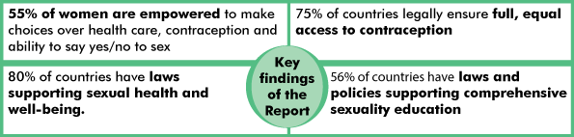

##### Comparison between MTP Act, 1971 and MTP (Amendment) Bill, 2020

|  |  |  |
| --- | --- | --- |
| **Features** | **MTP Act, 1971** | **MTP (Amendment) Bill, 2020** |
| **Time upto 12 weeks since**  **conception** | * Advice of **one doctor** | * Advice of **one doctor** |
| **Time 12 to 20 weeks since**  **conception** | * Advice of **two doctors** | * Advice of **one doctor** |
| **Time 20 to 24 weeks**  **since conception** | * **Not allowed** | * **Two doctors** for some categories of pregnant women |
| **Time more than 24 weeks**  **since conception** | * **Not allowed** | * **Medical Board** in case of substantial foetal abnormality |
| **Any time during the pregnancy** | * **One doctor**, if immediately necessary to save pregnant woman's life, **opinion formed**   **in good faith.** | * **One doctor**, if immediately necessary to save pregnant woman's life, **opinion formed in good faith.** |
| **Termination due to failure of contraceptive**  **method or device** | * pregnancy may be terminated **up to 20 weeks by a married woman** | * The Bill allows **unmarried women to also terminate a pregnancy** for this reason. |
| **Medical Boards** | * No such provision, **only registered medical practitioners can decide** upon termination of pregnancy. | * **Medical Board will decide if a pregnancy may be terminated after 24 weeks** due to substantial foetal abnormalities.   o All state and union territory governments will constitute a Medical Board consisting a **gynaecologist, paediatrician, radiologist/ sonologist**, and **other members notified by**  **the state government**. |
| **Privacy and punishment** | * Any person who wilfully contravenes or wilfully fails to comply with the requirements of any regulation shall be **liable to be punished with fine which may extend to one**   **thousand rupees.** | * A **registered medical practitioner** may **only reveal the details** of a woman whose pregnancy has been terminated **to a person authorised by law.**   o Violation is punishable with **imprisonment up to a year, a fine, or both.** |

**5.1.4. REPRODUCTIVE HEALTH**

**Why in News?**

Recently UNFPA launched the **State of World Population Report, 2021** titled My Body Is My Own.

##### Key highlights of the report

* The report measures women’s access to bodily autonomy through their **power to make their own decisions about their reproductive health care, contraceptive use and sexual relations**.

**United Nations Population Fund (UNFPA)**

* It is the United Nations **sexual and reproductive health** agency.
* It is an **international development agency** that promotes the right of every woman, man and child to enjoy a **life of health and equal opportunity.**
* The State of World Population is an **annual report** published by the UNFPA.
* UNFPA supports countries in **using population data for policies and program** to reduce poverty and to ensure that
  + Every pregnancy is wanted,
  + Every birth is safe,
  + Every young person is free of HIV/AIDS, and
  + Every girl and woman is treated with dignity and respect.
* Despite **constitutional guarantees of gender equality** in many countries, worldwide, on average, women enjoy **just 75 per cent of the legal rights** of men.

##### Reproductive Health and India

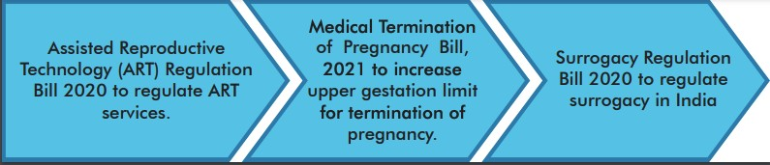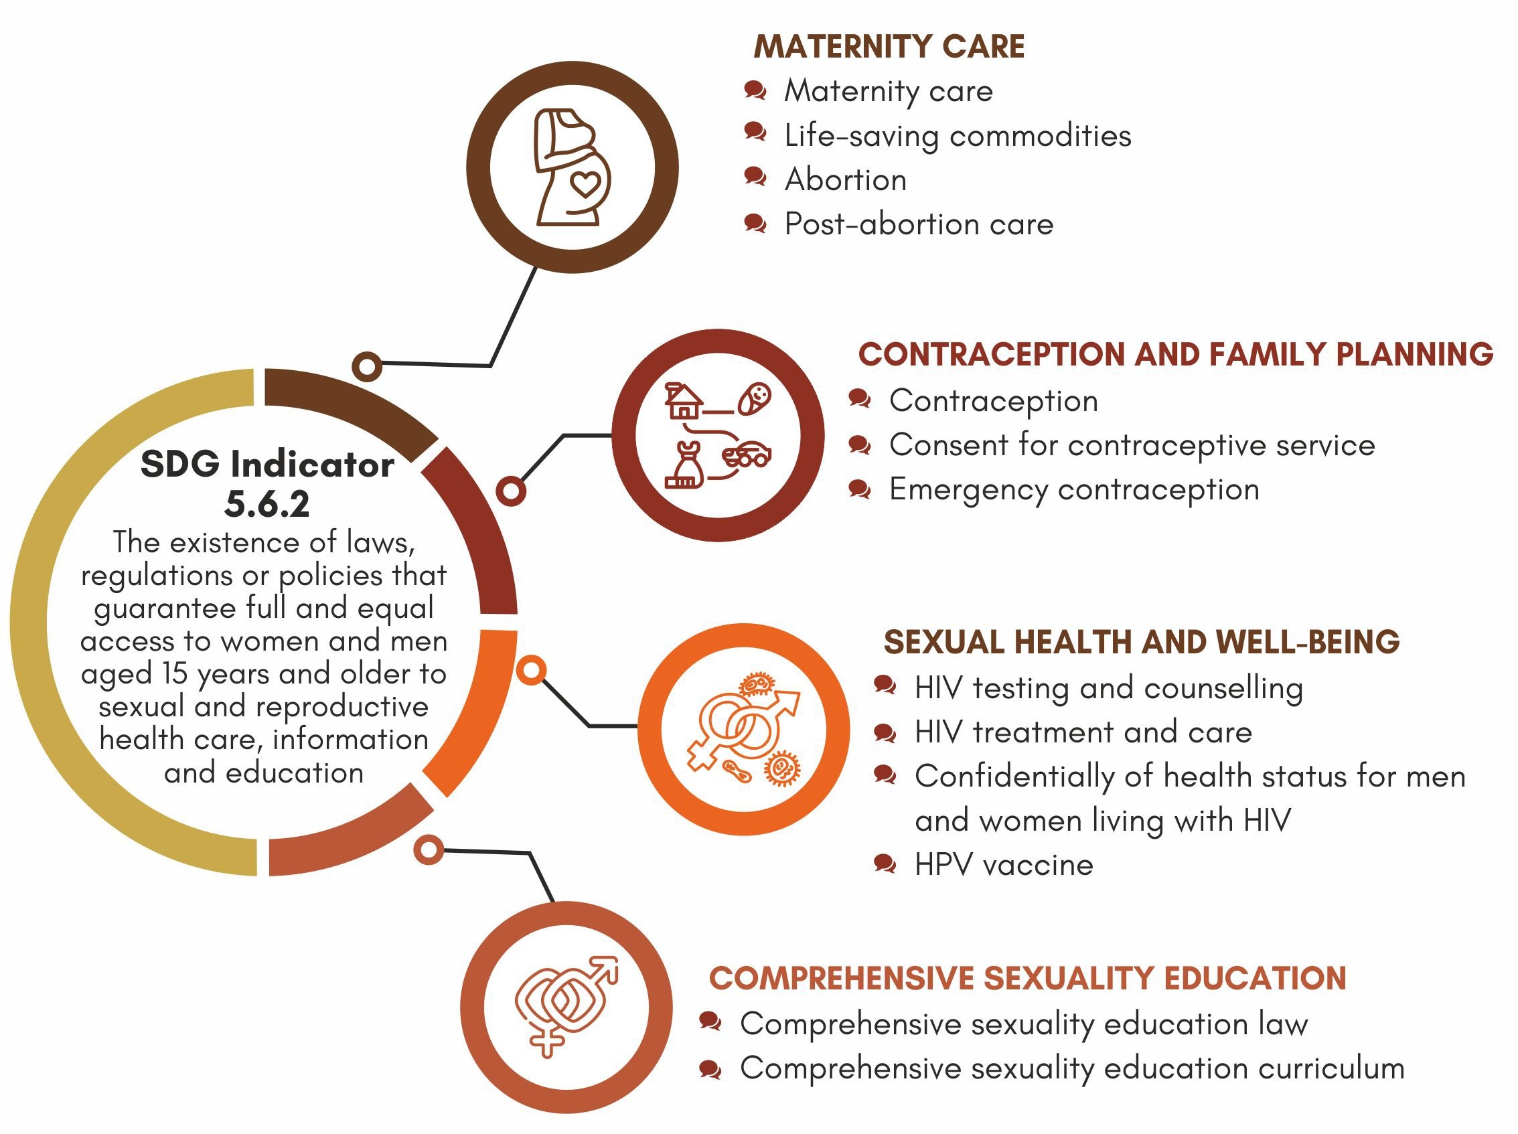

**Key programmes for addressing Reproductive Health of women in India**

* **National Health Mission 2013** included following components:
  + Reproductive Maternal Neonatal Child and Adolescent Health (RMNCH+A) programme.
  + **Janani Suraksha Yojana (JSY**) to reduce maternal and neo-natal mortality by promoting institutional delivery.

•

•

•

•

**Rashtriya Kishor Swasthya Karykram 2014** to enable all adolescents to

realize their full potential by making **informed and responsible decisions related to their health**.

**Pradhan Mantri Surakshit Matritva Abhiyan (PMSA)** to provide assured, **comprehensive and quality antenatal care**, free of cost, universally to all pregnant women**.**

**Pradhan Mantri Matru Vandana Yojana (PMMVY), a maternity benefit programme** in accordance with the provision of the **National Food Security Act, 2013.**

**Following three legislations were proposed to protect the reproductive rights of women.**

* World Health organisation (WHO) defines **reproductive health** as a state of complete **physical, mental and social well-being** and not merely the absence of disease or infirmity, **in all matters relating to the reproductive system** and to its functions and processes.
* **Reproductive matters encompass rights** that enable individuals to make **informed choices and decisions regarding their sexual and reproductive health needs**, and to do so free from discrimination, coercion and violence.

**Global Conventions supporting Reproductive rights**

* International Covenant on **Economic, Social and Cultural Rights**, 1996.
* Convention on the **Elimination of All Forms of Discrimination** against Women, 1979
* **Beijing Declaration** and Platform for Action of the **Fourth World Conference on Women.**
* The **Sustainable Development Goals (SDGs) and the preceding Millennium Development Goals (MDGs)** also encompass several goals that directly as well as indirectly recognise reproductive rights.

o **Target 5.6** of SDG ensure

universal access to sexual and reproductive health and reproductive rights.

**5.1.5. WOMEN AND MEN IN INDIA REPORT**

##### Why in news?

**About National Statistical Office (NSO)**

* NSO is the **statistics wing of Ministry of Statistics and Programme Implementation (**MoSPI) and consists of the Central Statistical Office (CSO), the Computer center and the National Sample Survey Office (NSSO).

o MoSPI has **two wings**, one relating to **Statistics** and the other **Programme Implementation**.

* NSO acts as the **nodal agency for planned development of the statistical system** in the country and lays down and maintains norms and standards in the field of statistics.

Recently, Women and Men in India report, 2020 was released by

**National Statistical Office (NSO).**

**Key Highlights**

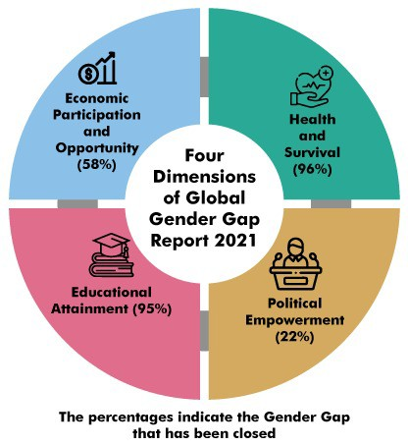

|  |  |
| --- | --- |
| **Population related statistics** | * India’s **projected population in 2021 is 136.13 Crore with 48.65% female population**. * The projected **sex ratio** is likely to increase from 943 in 2011 to **948 in 2021**. * Sex ratio at birth was **899 in 2016-18 against 896 in 2015-17.** (Higher in rural areas than urban). * Women’s **mean age at marriage at all India level in 2018 is 22.3 years** which showed an increase of 0.2 years from 2017. |
| **Health Statistics** | * **Infant Mortality Rate (IMR)** has **decreased** from 39 in 2014 to **32 in 2018**. * **Maternal Mortality Ratio (MMR) decreased** from 212 in 2007-09 to **113 in 2016-18.** * **Total Fertility Rate (TFR)** for literate population of rural India was observed at **2.3 as compared to 1.7 in urban areas**. |
| **Education** | * At all India level, the **literacy rate has increased from 73 in 2011 to 77.7 in 2017** (female and male literacy rate at 70.3 and 84.7 respectively). * Only **3.1 % females and 4.5 % males** were pursuing **technical/professional courses**. |
| **Participation in Economy** | * In rural sector, **Worker Population Ratio (WPR) was 19.0 for females and 52.1 for males**.   o In **Urban sector**, the ratio is 14.5 for females and 52.7 for males.   * Majority of the females (59.6%) and males (57.4%) workers were **self-employed** in rural area. * In urban sector, 54.7% females and 47.2% males were **regular wage/salaried employee**. * **Casual labour** among the female workers and male workers were **higher in rural area as compared to urban.** * On an average **134 minutes were spent in a day by females** for **“Unpaid care giving services for household members**” against 76 minutes spent by males on the same activity. |
| **Participation in Decision Making** | * Percentage of female electors participating in General Elections went up **from 65.6% in Sixteenth to 67.2% in Seventeenth Lok Sabha Elections**. * There is an **upward trend in the number of female candidates contested as well as elected** from 14th to 17th Lok Sabha General Election. |
| **Impediments in Empowerment** | * In 2019, three major crimes viz. **Cruelty by Husband and Relatives (31%), Assault on women with intent to outrage her modesty and Kidnapping & Abduction** constituted 71% of the total crime committed against women. * Percentage **of differently-abled persons** was 1.9% for females and 2.4% for males. |

**Related News**

**Istanbul Convention Action Against Violence Against Women and Domestic Violence**

* Recently, Turkey pulled out of this convention.
* It is **under auspices of Council of Europe, Europe’s leading human rights organisation**.
* It includes **47 member states, including all members of the European Union**.
* Convention seeks to pursue the goal of zero tolerance towards gender-based violence and **lays the groundwork for increasing awareness and making women’s lives safer both within and outside of Europe’s border**

**5.1.6. GLOBAL GENDER GAP REPORT**

**Why in news?**

Recently, **World Economic Forum (WEF)** released

##### Global Gender Gap Report 2021. Global Gender Gap Report

* Global Gender Gap Index was **first introduced by the WEF in 2006** as a framework to benchmark progress on disparities between women and men **across countries, and over time.**
* Global Gender Gap Index measures **scores on a 0 to 100 scale** and scores can be interpreted as the **distance to parity** (i.e., the percentage of the gender gap that has been closed).
* Global Gender Gap Report 2021 benchmarks **156 countries** across **four thematic dimensions (in bracket, percentage of the gender gap that has been closed at global level).**

##### Key highlights of report



**World Economic Forum**

* It was established in 1971 as a **not-for profit foundation**

and is headquartered in **Geneva, Switzerland.**

* It is the **International Organization for Public-Private Cooperation** and engages the foremost political, business and other leaders of society to shape global, regional and industry agendas.
* The overall global gender gap is projected to **close in 135.6 years** (which is a **significant increase from 99.5 years** in previous report).
* Global top 10 continues to be **dominated by Nordic countries**, with —Iceland, Norway, Finland and Sweden—in the **top five**.
* **South Asia is the second**-**lowest performer** after the Middle East and North Africa combined, bridging 62.3% of its gender gap.

|  |  |  |  |
| --- | --- | --- | --- |
| **Performance of India**   * India has **slipped 28 places (as compared last year) to rank 140th** among 156 countries. * India is the **third-worst performer among South Asian countries**, with Pakistan and Afghanistan trailing and Bangladesh being at the top. * India has closed **62.5% of its gender gap** to date. India’s indicators across parameters are as follows: | | | |
|  | **Political empowerment** | * There is a significant **decline in the number of women ministers** (from 23.1 per cent in 2019 to 9.1 per cent in 2021). * **Share of women in parliament** remains stagnant at 14.4%. |  |
|  | **Health and survival dimension** | * India is **among the five worst performers.** * Wide sex ratio at birth gaps is due to high incidence of **gender-based sex-selective practices.** * **More than one in four women has faced intimate violence** in her lifetime. |  |
|  | **Educational Attainment** | * On this subindex, 96.2% of the gender gap has been closed, with **parity achieved in primary, secondary and tertiary education**. * Yet, gender gaps persist in terms of literacy: **one third of women are illiterate** (34.2%) compared to 17.6% of men. |  |
|  | **Economic participation and opportunity** | * Women’s labour force participation rate saw **a decline from 24.8 percent to 22.3 percent**. * In addition, the **share of women in professional and technical roles** declined further to   29.2 percent.   * Women’s estimated earned income is **only one-fifth of men’s**. |  |

### 5.2. OTHER VULNERABLE SECTIONS

**5.2.1. STATE OF THE WORLD’S INDIGENOUS PEOPLES**

##### Why in news?

Recently, the UN Department of Economic and Social Affairs released **State of the world’s indigenous peoples: Rights to Land, territories and resources** report released.

##### About Indigenous peoples

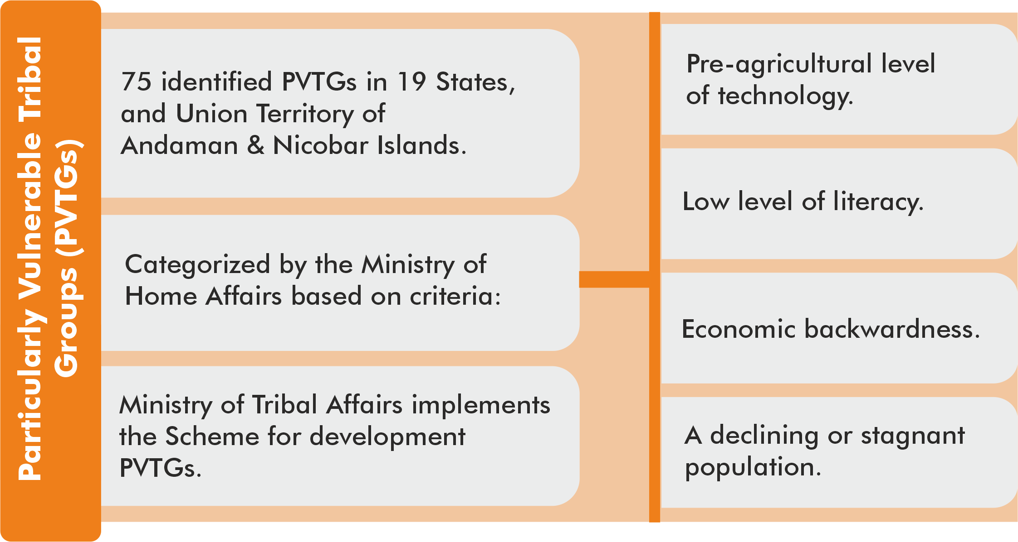

* Indigenous peoples are **inheritors and practitioners of unique cultures and ways of relating to people and the environment.**
* They have retained **social, cultural, economic and political characteristics** that are distinct from those of the dominant societies in which they live.
* Indigenous peoples in India comprise an estimated population of **104 million or 8.6% of the national population, almost 90% of them living in rural areas.**
  + In India, **705 ethnic groups**

**are notified as Scheduled Tribes (STs)** spread across 30 States or Union Territories, these are considered to be **India’s indigenous peoples** that includes **75 identified Particularly Vulnerable Tribal Groups (PVTGs).**

**Provisions at international level**

* **Indigenous and Tribal Peoples Convention 1957**:
  + **First international treaty** to specifically deal with indigenous **rights, concerning the Protection and Integration of Indigenous and other Tribal and Semi-Tribal Populations** in Independent Countries.
  + Article 1 indicates that **self-identification as indigenous or tribal** shall be regarded as a fundamental criterion for determining the groups to which the provisions of this Convention apply.
  + It was replaced with Indigenous and **Tribal Peoples Convention, 1989**
* **United Nations Declaration on the Rights of Indigenous Peoples**: Article 33 of the United Nations Declaration on the Rights of Indigenous Peoples underlines the importance of **self- identification, that indigenous peoples themselves define their own identity as indigenous.**

##### Inherent rights of indigenous peoples:

* + - **Collective and individual right** to their ancestral land, territories and resources.
    - To **self-government by their own institutions** and authorities within their lands and territories.
    - To **fair and equitable benefit sharing** from conservation and

development actions involving their lands, territories, resources, and people.

* + - To **conserve, develop, use and protect** their traditional knowledge.

**Provisions in India to protect rights of indigenous people**

* **Fifth Schedule of Constitution of India (Article 244)**
  + It envisages a special system of administration for certain areas designated as scheduled areas and tribal areas in any state except the four states of Assam, Meghalaya, Tripura and Mizoram.
  + Features of administration in the Fifth Schedule areas:
    - **Declaration of Scheduled Areas** with President of India in consultation with governor of the state concerned.
    - **Tribes Advisory Council**
    - **Law applicable to Scheduled Areas** with governor empowered to direct that any particular act of Parliament or the state legislature does not apply to a scheduled area.
    - **Constitution requires the president to appoint a commission to report** on the administration of the scheduled areas and the welfare of the scheduled tribes in the states.
* **Sixth Schedule of the Constitutions**
  + It deals with the administration of the tribal areas in the **four states of Assam, Meghalaya, Tripura and Mizoram.**
* **Right to Fair Compensation and Transparency in Land Acquisition, Rehabilitation & Resettlement (LARR) Act, 2013**
  + Under this act, consent of 80% land owners is required for private projects, consent of 70% land owners required for Public-Private Partnership projects and no consent is required for government projects.
  + Act exempts 13 laws (such as the National Highways Act, 1956 and the Railways Act, 1989) from its ambit.
  + If land acquired under the Act remains unutilised for five years from taking possession, it must be returned to the original owners or a land bank.
* The Act provides the option of employment to one member of an affected family as part of the rehabilitation and resettlement award.
* The Act provides for the establishment of a Land Acquisition, Rehabilitation and Resettlement (LARR) Authority which may be approached in case a person is not satisfied with an award under the Act.
* **Scheduled Tribes and Other Traditional Forest Dwellers (Recognition of Forest Rights) Act, 2006**

o It is **to recognize and vest the forest rights and occupation** for forest dwelling Scheduled Tribes and other traditional forest dwellers (OTFD).

### 5.3. EDUCATION



|  |  |
| --- | --- |
| **Initiatives in**  **news** | **Details** |
| **‘SARTHAQ’, the NEP**  **Implementation Plan for School Education Launched** | * **Students' and Teachers' Holistic Advancement through Quality Education (SARTHAQ)',** developed by the Department of School Education and Literacy (Ministry of Education), **is an indicative and suggestive implementation plan for school education.** * P**lan is being implemented to meet the following aims of NEP 2020:**   + **pave way for curriculum reforms including new national and state curriculum frameworks** for school education as well as early childhood care and education.   + **focus on the improvement of the enrollment ratio** of children at all levels and a reduction in dropouts and out of school children.   + **provide access to** quality Early childhood care and education (ECCE) and Universal Acquisition of Foundational Literacy and Numeracy by Grade 3.   + **implement** vocational education, sports, arts, knowledge of India, 21st-century skills, values of citizenship, awareness of environment conservation in the curriculum.   + **focus on experimental learning.**   + **improve the quality of Teacher Education Programmes.** * SARTHAQ is aimed at **meeting the diverse national and global challenges of the present and the future and help the students to imbibe 21st-century skills** along with India’s tradition, culture and value system. |
| **Mahatma Gandhi National Fellowship (MGNF)** | * MGNF is a **Certificate Program in Public Policy and Management offered by IIMs.** It has been designed at the initiative of Ministry of Skill Development and Entrepreneurship (MSDE).   o MGNF, first launched as a pilot, is **now expanding to all districts in the country.**   * MGNF fellows **will understand overall skill ecosystem** along with being **attached to District Skill Committees (DSCs)** and help them **manage the skill development planning at district level** through formulating District Skill Development Plans (DSDPs). * MGNF is **in line with objectives of SANKALP programme of MSDE to strengthen the district skill administration and DSCs.** |
| **E9 initiative** | * Recently, consultation meeting of Education Ministers of **E9 countries on E9 initiative: Scaling up digital learning to accelerate progress towards SDG4- Education for all,** was held. * The initiative **aims to accelerate recovery and advance SDG4** agenda by driving rapid change in education systems. * E9 Partnership was **established in 1993** and members countries include Bangladesh, Brazil, China, Egypt, **India**, Indonesia, Mexico, Nigeria, and Pakistan. |

**5.4. HEALTH**

**5.4.1. PRADHAN MANTRI SWASTHYA SURAKSHA NIDHI (PMSSN)**

##### Why in news?

The Union Cabinet has approved the **Pradhan Mantri Swasthya Suraksha Nidhi** (PMSSN).

##### About PMSSN

* It is a **single non-lapsable reserve fund for Health expenditure**.
* It is a **fund for Health in the Public Account**. The **proceeds of Health and Education cess** levied under the Finance Act, 2007 will be credited to it.
  + In the budget speech 2018, existing 3% Education cess is replaced by **4% Health and Education Cess**.
* **Administration and maintenance** of the PMSSN is entrusted to **Ministry of Health & Family Welfare (MoHFW).**
* In any financial year, the **expenditure** on schemes of the MoHFW would be **initially incurred from the PMSSN and thereafter, from Gross Budgetary Support (GBS).**

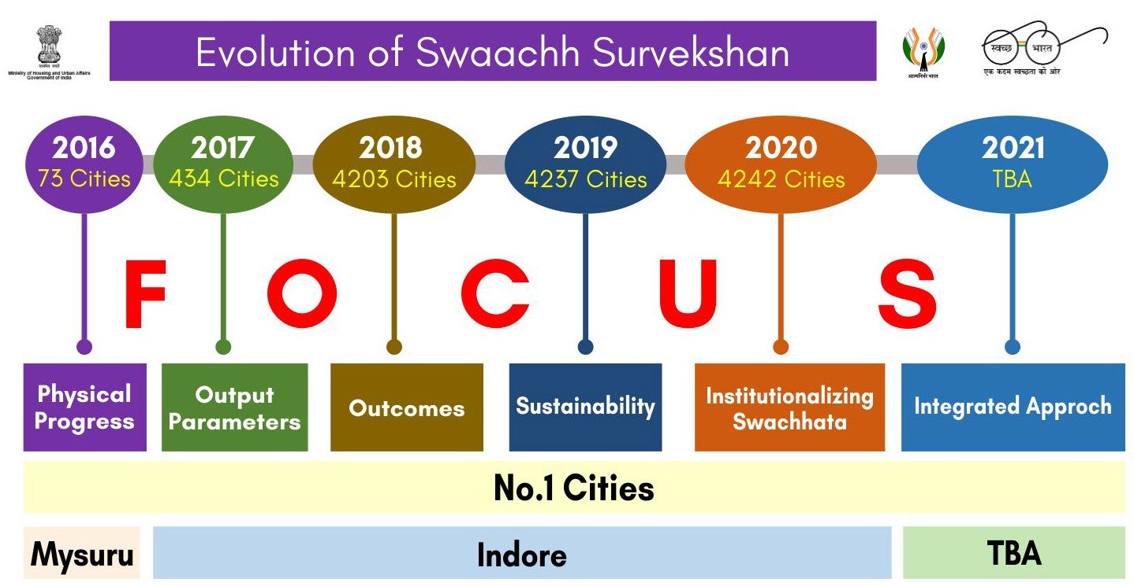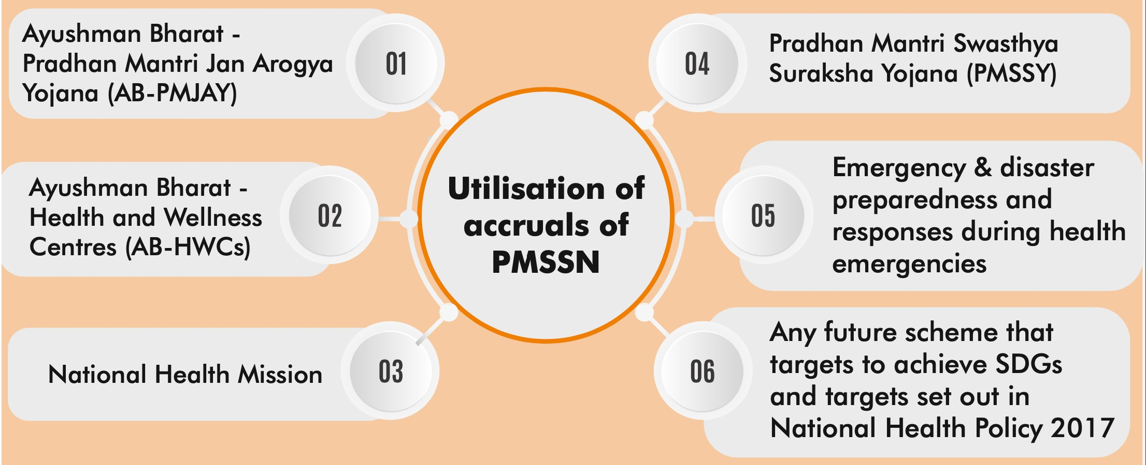

GBS is the government’s support for the central plan which is earmarked for meeting the planned outlays of the Central government during the financial year. It includes the tax receipts and other sources of revenue raised by the Government.

**5.4.2. OTHER INITIATIVES IN NEWS**

|  |  |
| --- | --- |
| **Initiative** | **Details** |
| **Anameya** | * It is **Tribal Health Collaborative initiative** launched by Minister for Health and Family Welfare along with Union Minister of Tribal Affairs. * It is supported by Piramal Foundation and Bill and Melinda Gates Foundation. * Anameya will converge efforts of various Government agencies and organisations to **enhance the health and nutrition status of the tribal communities.** |
| **Manas App** | * The **Principal Scientific Adviser** to the Government of India launched the “MANAS” App to **promote mental wellbeing of citizens across age groups.** * MANAS stands for **Mental Health and Normalcy Augmentation System**. * It is a **comprehensive, scalable, and national digital wellbeing** platform and an app. * It **integrates the health and wellness efforts** of various government ministries, scientifically validated indigenous tools developed/researched by various national entities. |

### 5.5. NUTRITION AND SANITATION

**5.5.1. SWACHH SURVEKSHAN (SS) 2021**

##### Why in news?

Ministry of Housing and Urban Affairs (MoHUA) recently launched the **field assessment of Swachh Survekshan (SS) 2021**, the sixth edition of the annual cleanliness survey conducted by the Government of India*.*

##### About Swachh Survekshan 2021

* SS was introduced in 2016 as a **competitive framework** to encourage cities to improve the status of urban sanitation while encouraging large scale citizen participation.
* Survey is conducted by **MoHUA with Quality Council of India as its implementation partner**.

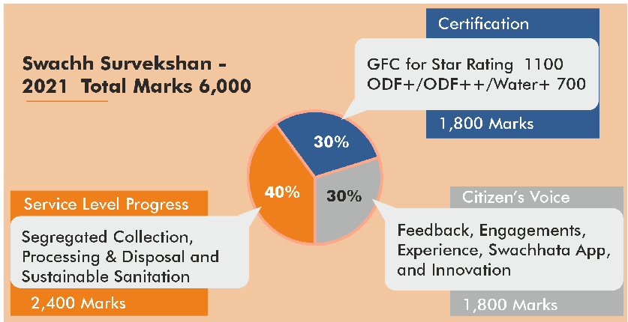

**Quality Council of India (QCI)**

* It is an **autonomous body** set up by the **Ministry of Commerce and Industry** jointly with the Indian Industry.

o Indian industry is represented by the **three premier industry associations** i.e. ASSOCHAM, Confederation of Indian Industry (CII) and FICCI.

•

•

•

•

It aims to **establish and operate national accreditation structure** and promote quality through National Quality

Campaign.

QCI is registered as **a non-profit society** under the Societies Registration Act XXI of 1860 and is governed by a Council with **equal representations of government, industry and consumers.**

It is under the administrative control of **Department for Promotion of Industries and Internal Trade (DPIIT). Chairman of Council is appointed by the Prime Minister** on recommendation of the industry to the government.

* SS 2021 indicators focus on parameters pertaining to **wastewater treatment and reuse** along with faecal sludge management.
* Crucial issues of **legacy waste management and remediation of landfills** have also been brought to the fore in this edition.
* SS 2021 has introduced a new performance category **Prerak DAUUR Samman** which will have five performance categories

**GFC-** Garbage Free City

* **ODF+** focuses on toilets with water, maintenance and hygiene.
* **ODF++** focuses on toilets with sludge and septage management.

(‘Platinum’, ‘Gold’, ’Silver’, ’Bronze’, ’Copper’) based on seven criteria:

* + Segregation of Waste (Wet, dry and hazardous)
  + Processing Capacity against wet waste generated
  + Processing of Wet Waste
  + Processing/ Recycling Dry Waste
  + Construction &

Demolition Waste Processing

* + Percentage of waste going to the landfill
  + Current Sanitation Status (as on 28.02.2021)
* Apart from ranking cities and States, **SS 2021 would also be ranking districts** (basis the performance of their cities).

**Related information Swachhta Saarthi Fellowships**

* Launched by the **office of the Principal Scientific Adviser** under its ‘**Waste to Wealth Mission’** (one of the nine national missions of the Prime Minister’s Science, Technology, and Innovation Advisory Council, PM-STIAC).
* There are **three categories of awards** for **community work of waste management scientifically and sustainably:**
  + **Category-A:** For students from 9th to 12th
  + **Category-B:** For College students (UG, PG, Research Students)
  + **Category-C:** For Citizens working in the community and through SHGs, municipal or sanitary workers working beyond specifications of their job requirement.

### 5.6. MISCELLANEOUS

**5.6.1. OTHER IMPORTANT NEWS**

|  |  |
| --- | --- |
| **Initiative** | **Details** |
| **Global Youth Mobilization Local Solutions Campaign** | * United Nations agencies and youth organisations have launched a campaign to **involve global youth impacted by the COVID-19 pandemic.** * It is mandated to fund youth in communities impacted by the pandemic to take up **innovative programmes to rebuild lives**. * It is being supported by **six of the world’s largest youth organisations** like World Alliance of Young Men’s Christian Associations, World Organization of the Scout Movement etc. |

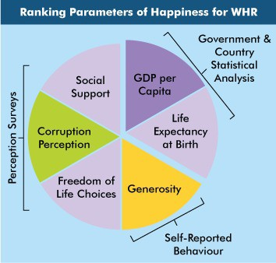

|  |  |
| --- | --- |
|  | * Under this, a **fund of $2 million** will **directly support young people engaged at the grassroots level**   to tackle pressing health and societal challenges resulting from the pandemic.   * Earlier, **International Labour Organization** termed the current young population as the **‘lockdown generation’** citing **impacts on mental health, education disruption, job loss and domestic violence**. |
| **Commitment to Reducing Inequality (CRI) Index** | * Minister of Employment and Labour has recently slammed **2020 Commitment to Reducing Inequality (CRI) Index**, which placed India at rank 151 in terms of workers’ rights and **129 overall out of 158 countries**. * CRI Index monitors **what governments are doing through their policy** commitments to reduce inequality. * It is developed and delivered through a **partnership between Development Finance International and Oxfam International**. * The 2020 index is the **third edition of the CRI Index** which **ranks 158 governments** across the world on their commitment to reducing inequality. * It measures government policies and actions in **three areas** that are proven to be directly related to reducing inequality:   + **Public services (health, education and social protection)**   + **Taxation**   + **Workers’ rights.** |
| **Gender Samvaad Event** | * Ministry of Rural Development launched **Gender Samvaad event**, a joint attempt between **Deen Dayal Antyodaya Yojana-National Rural Livelihood Mission (DAY-NRLM)** and Initiative for What Works to Advance Women and Girls in the Economy (IWWAGE- an NGO). * It aims to **generate awareness on gender related interventions under DAY-NRLM** across the country. * Gender Samvaad provides states with opportunities to:   + **Understand best practices** that other states have been undertaking to improve women’s agency (e.g., facilitating women’s access to land rights), best practices around Food, Nutrition, Health and Water etc.   + Understand **gender interventions globally**.   + **Engage with experts** on suggestions for handling implementation barriers.   + Contribute to creation of a **‘gender repository’** with resource materials on best practices for gender interventions across the country/other countries.   + **Build advocacy** around the need to focus on gender issues across SRLMs and the NRLM. |

**5.6.2. WORLD HAPPINESS REPORT 2021**

##### Why in news?

Recently, World Happiness Report, 2021 was released by the **UN Sustainable Development Solutions Network.**

##### About the World Happiness Report, 2021

* Theme of 2021 report focusses on **the effects of COVID-19 on happiness** and **how countries have differed in their success in maintaining connected and healthy societies.**
* This year, the **report provided two rankings:**
  + The usual one **based on average of three years of surveys** taken in 2018- 2020 by Gallup (American analytics and advisory company).
  + **Another focused on 2020 alone** to help understand the outbreak’s effect on subjective well-being and

how factors contributing to well-being affected pandemic outcomes.

* Respondents are asked to **rate their own current lives on 0 to 10 scale**, (10: best possible & 0: worst possible).

##### Findings of the Report

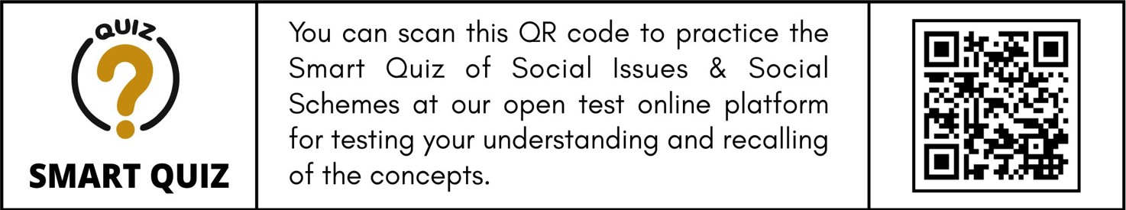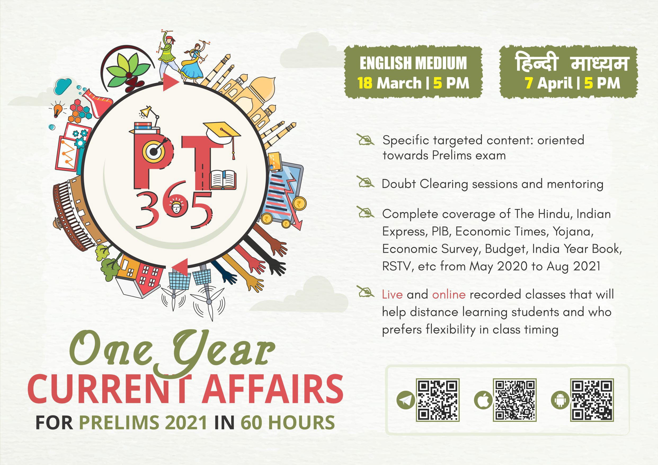

**Sustainable Development Solutions Network**

* It has been **operating since 2012** under the auspices of the UN Secretary-General.
* SDSN mobilizes global scientific and technological expertise to **promote practical solutions for sustainable development**, including the implementation of the Sustainable Development Goals (SDGs) and the Paris Climate Agreement.
* SDSN is also **publishing the annual SDG Index & Dashboards Global Report.**
* **Top 5 countries were** – Finland (topped the list for **fourth straight year)**, Iceland, Denmark, Switzerland, The Netherlands and Sweden.
* **India ranked 139th out of the 149 countries in the list**, a slight improvement since last year(ranked 140th).
* India’s neighbours: **Pakistan (105th), Bangladesh (101st) and China (84th)**.

##### Afghanistan was ranked the least happy country.

* However surprisingly, **on an average there wasn’t a decline in well-being** when measured **by people’s own evaluation of their lives.**

# SCIENCE AND TECHNOLOGY



### 6.1. BIOTECHNOLOGY

**6.1.1. GENETICALLY MODIFIED (GM) FOOD CROPS**

##### Why in News?

**Regulation of GMO levels in imported consumables**

* It was initially with Genetic Engineering Appraisal Committee (GEAC) under the Union environment ministry.
* Its role in this was diluted with the enactment of the **Food Safety and Standards Act, 2006 and FSSAI was asked to take over approvals of imported goods**.

Food Safety and Standards Authority (FSSAI) said that from March 1, imported consignments of some of the major food crops will need to be accompanied with the “non-GM cum GM free certificate”.

##### More in News

**Global regulation of GM food**

* **Codex Alimentarius Commission (Codex), a joint FAO/WHO intergovernmental body, is responsible for developing the standards, codes of practice, guidelines and recommendations** that constitute the Codex Alimentarius, meaning the international food code.

o **Codex principles do not have a binding effect on national legislation**, but are referred to specifically in the Agreement on the Application of Sanitary and Phytosanitary Measures of the World Trade Organization (SPS Agreement), and WTO Members are encouraged to harmonize national standards with Codex standards.

* **Cartagena Protocol on Biosafety**, an environmental treaty legally binding for its Parties which took effect in 2003, regulates transboundary movements of Living Modified Organisms (LMOs). GM foods are within the scope of the Protocol only if they contain LMOs that are capable of transferring or replicating genetic material.
* FSSAI also stated that the **tolerance limit for “adventitious presence” of genetically modified organisms (GMOs) at 1% will be permissible** in these imported food crops consignments.
  + **Adventitious presence refers to unintentional or incidental presence** of trace amounts of GM material in non-GM crops.
  + **Many countries have set thresholds for labeling of “adventitious presence”** of approved GM material in non- GM crops, which **ranges from 0.9-5 per cent**.

##### What are Genetically Modified (GM) Food crops?

* According to WHO, GMOs are organisms in which the genetic material (DNA) has been altered in a way that **does not occur naturally by mating and/or natural recombination**. Foods produced from or using GM organisms are referred to as GM foods.
  + For example, a GM crop can contain a gene that has been artificially inserted instead of the plant acquiring it through pollination.
* Globally **GM crops were commercially introduced in 1996.** Crops such as corn, cotton, and soybean have been engineered to resist insect pests and herbicides and are now planted widely in many parts of the world.
* **Bt cotton is the only GM crop that has been approved for commercial cultivation (in 2002)** by the Government of India.
  + **GM mustard Dhara Mustard Hybrid 11 (DMH 11)** developed by Delhi University is pending for commercial release.
  + **Genetic Engineering Appraisal Committee (GEAC), has allowed biosafety research field trials of two new transgenic varieties of indigenously developed Bt Brinjal** – namely Janak and BSS-793, containing Bt Cry1Fa1 gene (Event 142) – **in eight states** during 2020-23 only after taking no-objection certificate (NOC) from states concerned and confirmation of availability of isolated stretch of land for this purpose.
    - These indigenous transgenic varieties of brinjal hybrids have been **developed by the National Institute for Plant Biotechnology, Indian Council of Agricultural Research (ICAR).**

**Related News**

* Recently, genome editing technology - **CRISPR Cas9** - has been used to change the colour of tomato to yellow and improve its traits by a Kochi based firm.
* This demonstrates that **genome editing can be used in the agricultural crops to improve traits without using GMO technology.**

**6.1.2. GENOME MAPPING IN INDIAN OCEAN**

##### Why in News?

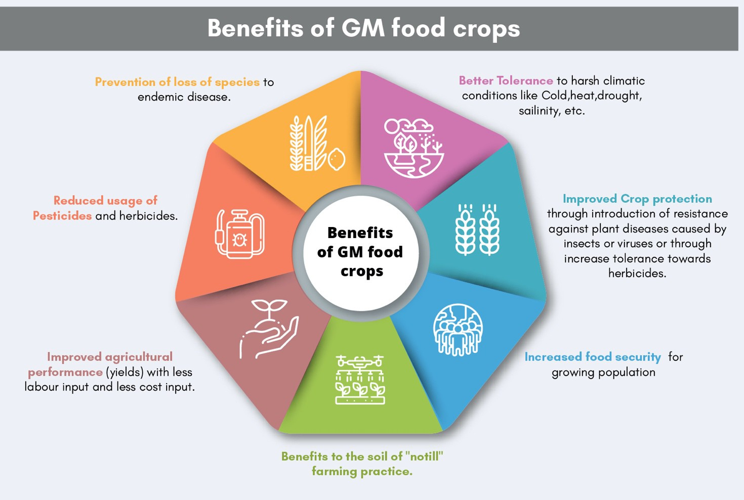

* **Genome mapping** refers to locating of a specific gene on a particular region of a chromosome and also determining the location of and relative distances between other genes on that chromosome.
  + A chromosome is an organized package of DNA found in the nucleus of the cell.
* **Proteome mapping** is the study of protein properties on a large scale to obtain a global, integrated view of disease processes, cellular processes and networks at the protein level.
  + It can identify the biogeochemistry of the organisms under varying ocean conditions.

India is set to kick off its first project to map genomes in Indian Ocean.

##### About the Project

* CSIR-National Institute of Oceanography has been commissioned **to conduct genome and proteome mapping (micro nutrients) present inside single-cell organisms** in the Indian Ocean.
  + Aim is **to sample water, sediments, planktons and various organisms** in search of genomes and micro- nutrients.
* One of the key objectives of the mission is **to identify and characterise genes and proteins in ocean to understand cellular level operations of organisms in ocean.**
  + It will also **map genetic diversity of organisms, micronutrients** and trace metals in them.
* Scientists **will use next-generation sequencing** (massive parallel sequencing of DNA fragments) **and Sanger sequencing techniques** (single DNA fragment at a time) to extract genetic information of the organisms they come across.
* Currently, **only small fractions of the species in deep sea and polar oceans have been identified.** Species in oceans are much more difficult to record and evaluate than on land.

##### Significance of the project

* Will **strengthen research into commercial biotechnology applications** like anticancer treatments etc.
* Will help **to understand cellular biochemistry and response of ocean to climate change,** nutrient stress, increasing pollution etc.

**B;HC9C)A,B BEbrHW9 ABD b)E TWHCE[[ H# ADD,B$ BEr bWAB[ACb,HB bH ;ED$EW**

### 6.2. IT & COMPUTER

**1 2 3**

**6.2.1. NATIONAL STRATEGY ON BLOCKCHAIN**

##### Why in News?

Ministry of Electronics and Information and Technology (MeitY) has released draft National Strategy on Blockchain.

##### What is blockchain?

* A blockchain is essentially a **digital ledger of transactions (DLT) that is duplicated and distributed across the**

**7[XT]c []XcXPcTb**

**cWT HaP]bPRcX^]**

**5**

**GcPZTW^[STab**

**DTTa c^ DTTa BTcf^aZ**

**4**

**JP[XSPcX^]**

##### entire network of computer systems

on the blockchain.

**eTaXŋTb cWT**

**caP]bPRcX^] STcPX[b**

**JTaXŋRPcX^] P]S 5SSX]V c^ cWT [TSVTa**

* Blockchain is a specific type of DLT in which **blocks are linearly connected to each other.** (This may not be the case in other types of DLT.)

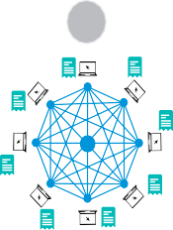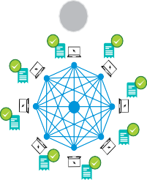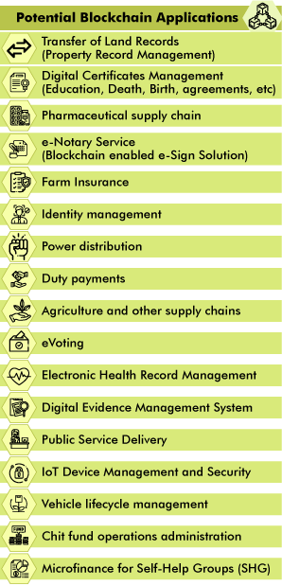

##### Thus, all blockchains are DLT; however, all DLT platforms are not blockchains.

* Each block in the chain contains a number of transactions, and every time a new transaction occurs on the blockchain, a record of that transaction is added to every participant’s ledger.
* **Copy of each transaction along with its hash is stored in the ledger** shared across all participants of the network.
* **Blockchains create trust by acting as a shared database**, distributed across vast peer-to-peer networks that have no single point of failure and no single source of truth, implying that no individual entity can own a blockchain network, and no single entity can modify the data stored on it unilaterally without the consensus of its peers.

##### Blockchain can be used in Permissioned and Permission less models.

* + Most of the first generation blockchains are permissionless such as Bitcoin and Ethereum. Permissionless blockchain systems are highly transparent, as everyone can see all the transactions on the ledger.
  + Permissioned model has applications in various domains such as healthcare, cyber security, Governance, media, logistics & hospitality, education, legal, energy, smart cities and so on.
* Salient properties of the Blockchain technology **are user anonymity, cryptography-based security, immutability (i.e., an entry cannot be changed without recreating it), shared read & write, accountability, transparency and distributed ownership**.
* Blockchain was first introduced in the design and development of cryptocurrency, **Bitcoin in 2009 allegedly by a Japanese entrepreneur named Satoshi Nakamoto.**

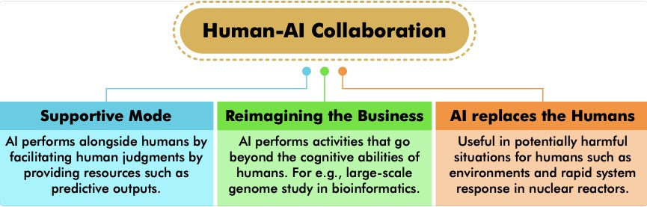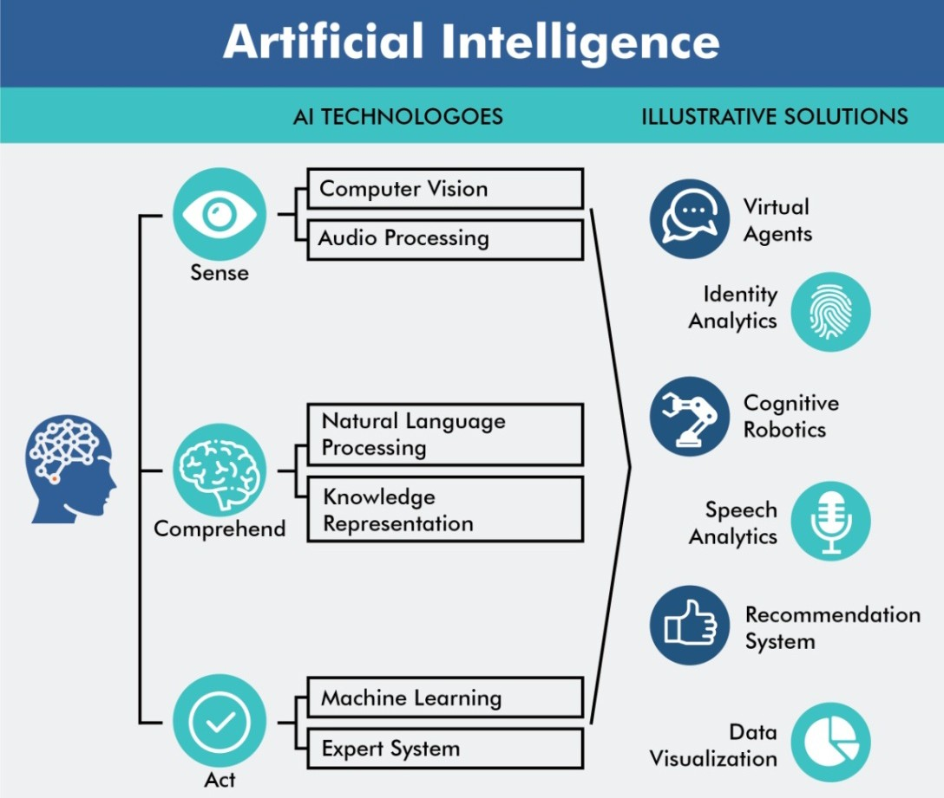

**6.2.2. ARTIFICIAL INTELLIGENCE (AI)**

##### Why in news?

**Indo-U.S. Science and Technology Forum (IUSSTF)**

* It was established under an **agreement** (March 2000).
* It is an **autonomous bilateral organization jointly funded** by both the Governments that **promotes Science, Technology, Engineering and Innovation** through substantive interaction among government, academia and industry.
* It operates through **two bilateral agreements**: Indo-U.S. Science and Technology Forum **(IUSSTF)** and United States- India Science and Technology Endowment Fund **(USISTEF).**

o **USISTEF seeks to support and foster joint applied R&D** to generate public good through commercialization of jointly developed technology.

* The **Department of Science & Technology**, Governments of India and the **U.S. Department of States** are respective **nodal departments** for IUSSTF.

Recently, U.S. India Artificial Intelligence (USIAI) was launched for working in the field of Artificial Intelligence (AI).

##### More about News

* USIAI is an **initiative of IUSSTF.**
* USIAI will serve as a **platform to discuss opportunities, challenges, and barriers for** bilateral AI R&D collaboration, enabling AI innovation, share ideas for developing an AI workforce and recommend modes and mechanisms for catalyzing partnerships.
* **It will provide breakthrough solutions in a range of sectors, like** agriculture, energy, climate change, affordable housing and smart cities etc.

##### About Artificial Intelligence

* It is the branch of computer science concerned with **making computers mimic human-like intelligence**. In contrast to normal hardware and software, AI enables a machine to perceive and respond to its changing

environment.

* AI has the potential to boost the **national growth rate by 1.3% and**

##### add $957 bn by 2035 to India’s economy.

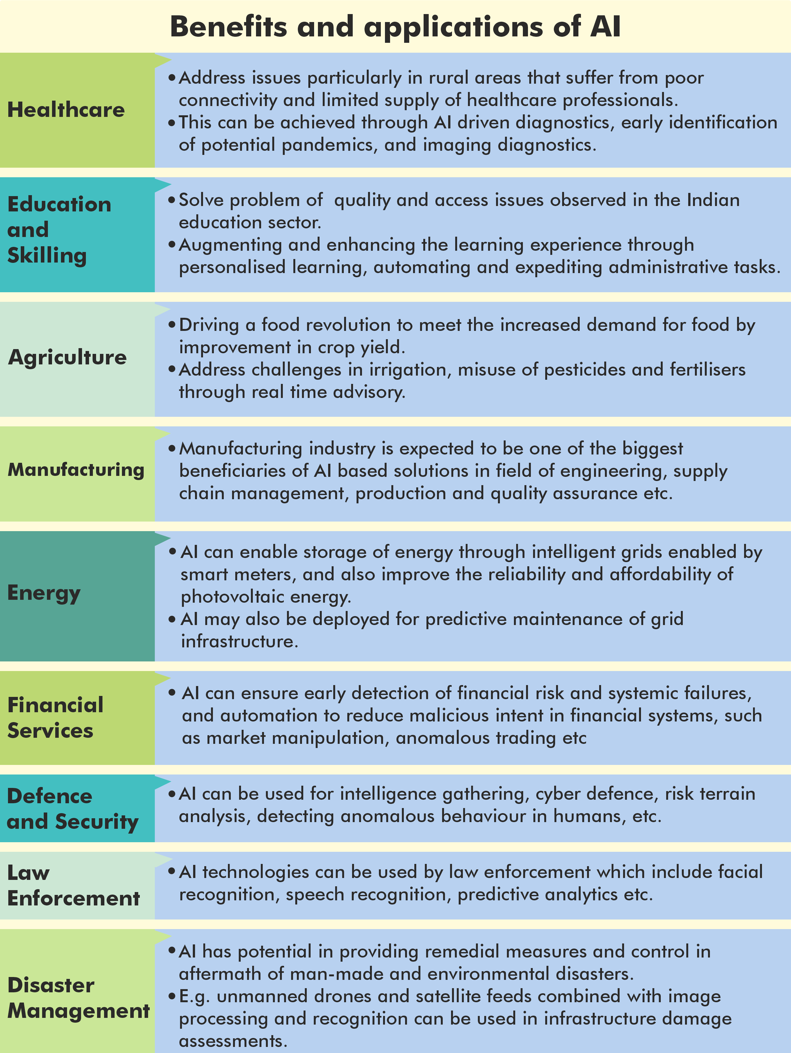

**Steps taken for AI in India**

* **Personal Data Protection Bill, 2019** to tackle cyber threats and data security, It has been referred to Standing committee.
  + Also, India has adopted **National Cyber Security Strategy 2020** for ensuring a safe, secured, trusted and resilient cyber space.
* **Centre of Excellence for Artificial Intelligence** was established **by National Informatics Center** for innovative new solutions in AI space, a gateway to test and develop solutions for projects undertaken at central and state level.

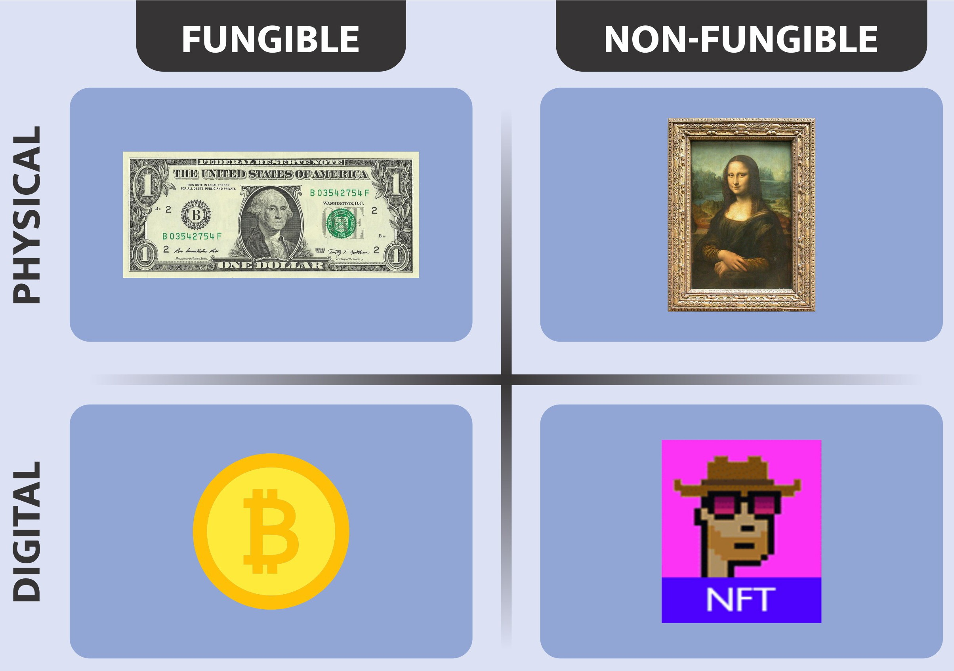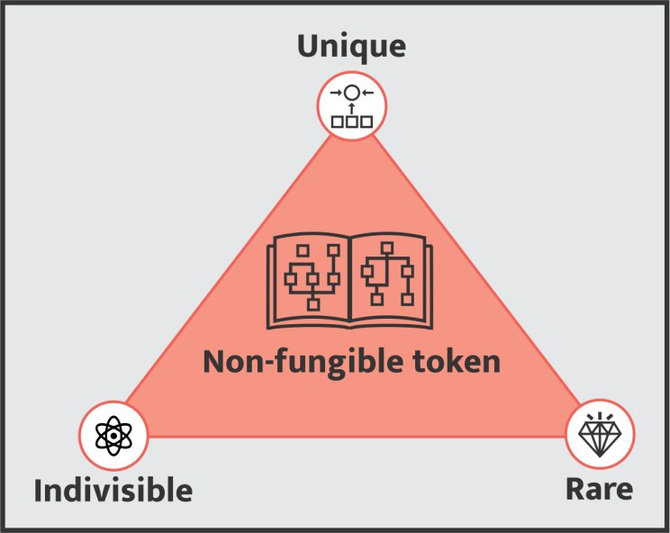

* **INDIAai is the National AI Portal of India** - a central hub for everything AI in India and beyond was joint initiative of **Ministry of Electronics and IT, National e-Governance Division and NASSCOM.**
* **National Association of Software and Services Companies (NASSCOM) has started ‘Future Skills Prime initiative’** which aims to foster an ecosystem that enhances India’s digital talent with the right set of skills through remote and self-paced learning.
* **India’s own AI-first compute infrastructure, AI Research, Analytics and knowledge Assimilation platform (AIRAWAT)** was developed to address issues of cloud computing for Big Data analytics with advanced AI processing capabilities.
* To create a policy framework and to develop the ecosystem for Artificial Intelligence MeitY has constituted four **committees covering all the aspects of AI**:
  + Committee on platforms and data for AI
  + Committee on Leveraging AI for identifying National Missions in Key Sectors
  + Committee on Mapping Technological capabilities, Key policy enablers, Skilling, Re-skilling, R&D
  + Committee on Cybersecurity, Safety, Legal and Ethical issues.

**6.2.3 NON-FUNGIBLE TOKEN**

##### Why in news?

Indian cryptocurrency exchange, WazirX has launched a non-fungible tokens (NFT) marketplace for Indian artists.

##### What are NFTs?

* An NFT is a **digital object** that can be a drawing, animation, piece of music, photo, or video **with a certificate of authenticity created by blockchain technology**.
  + In simple terms, NFT is a **unique proof of ownership** over something you can't

**Fungibility**

Fungibility refers to an asset's ability to be exchanged with a similar asset without sacrificing its value.

* For example, a Rs. 100 note is fungible, because if one person has a Rs.100 bill and another person also has a Rs. 100 note, they could interchange the bill and the value does not change. **A bitcoin is a fungible asset as well.**
* **NFTs are not fungible** as they **cannot be traded directly**

with each other because they are unique.

usually hold in your hand — a piece of digital art, a digital coupon, maybe a

video clip.

* + For e.g. Twitter founder Jack Dorsey can auction off an NFT for his first-ever tweet for $2.9 million.
* The virtual object, which is actually a computer file, can be exchanged or sold with its certificate.
* "Tokenizing" these assets allows them to be bought, sold, and traded more efficiently while reducing the probability of fraud.
* NFTs can also be used to **represent people’s identities, property rights,** and more.

##### Characteristics of NFT

* All NFTs have a **unique quality** and a **distinct value** from any other similar token.
  + The metadata of each NFT is an unalterable record that gives it the certificate of authenticity.
* They are **digitally rare**.
* They must **be sold or purchased as a whole** as they **cannot be divided** unlike fungible tokens.
  + For example, a plane ticket cannot be purchased and used partially — someone must buy it in full because only a single person can use the seat.

##### Importance

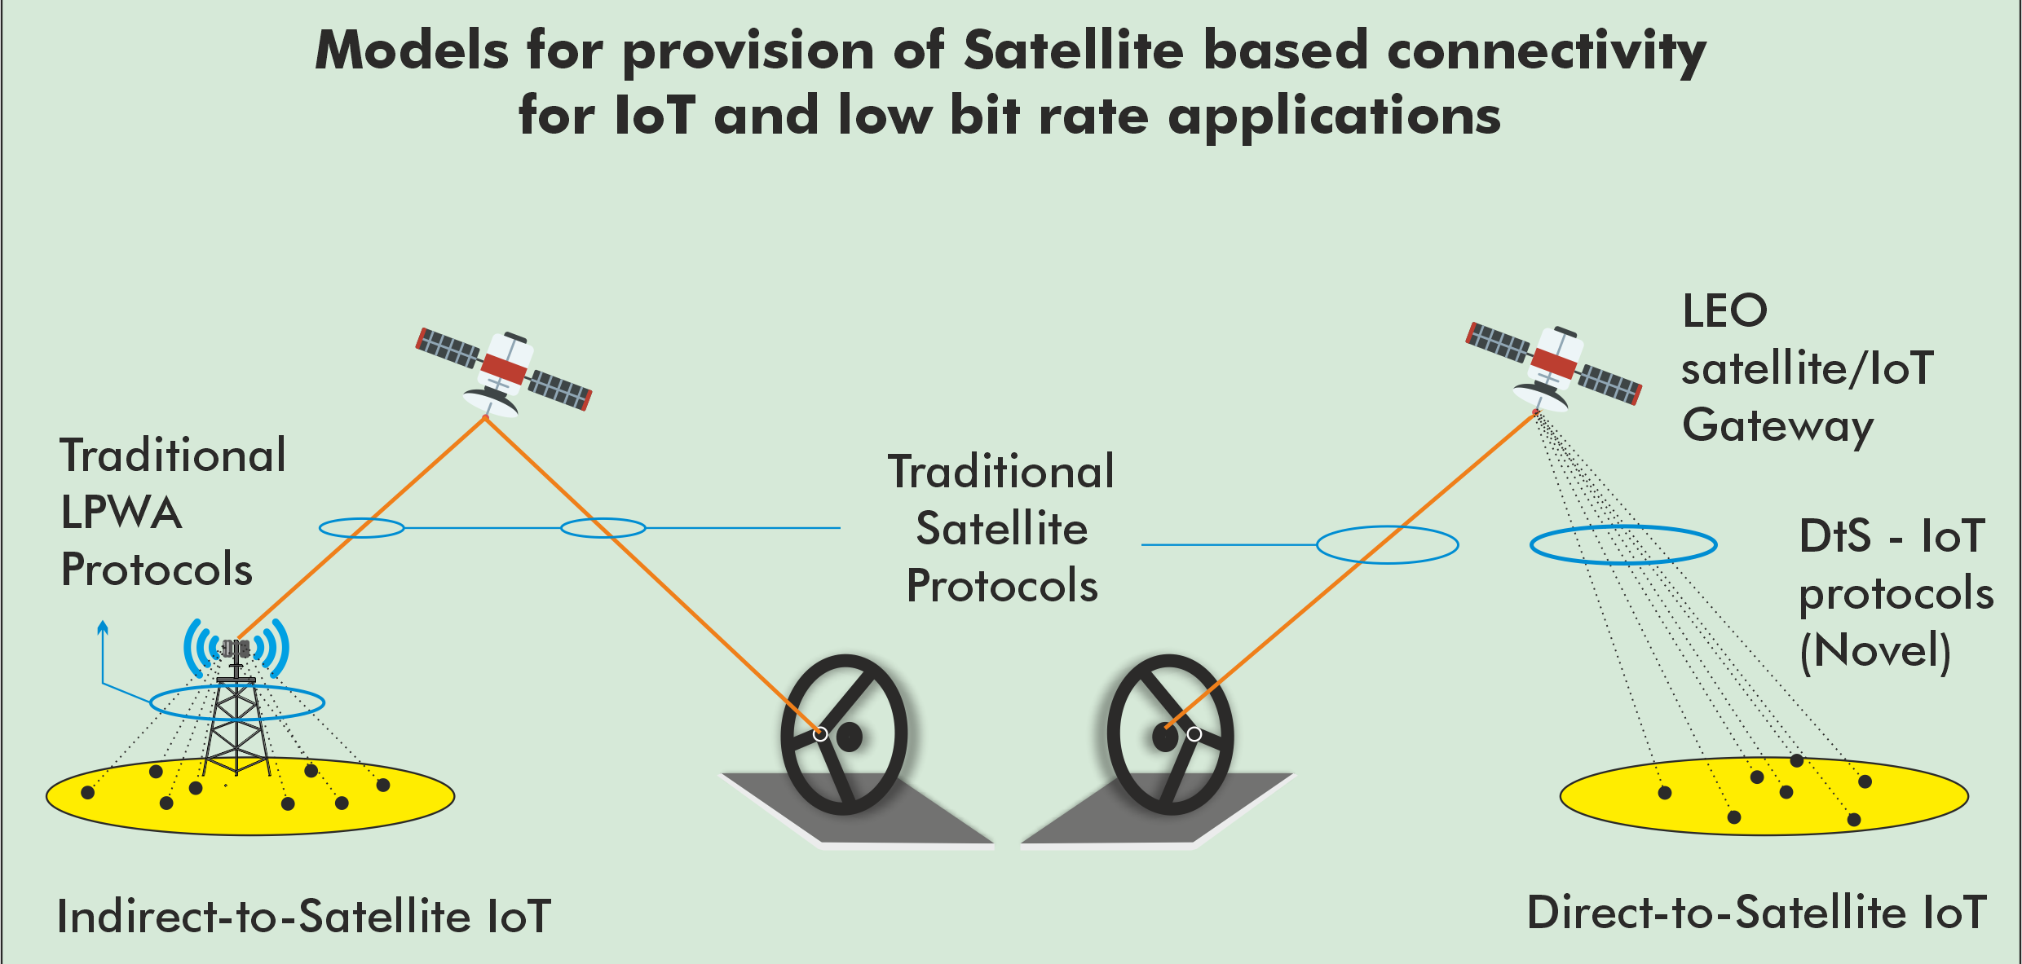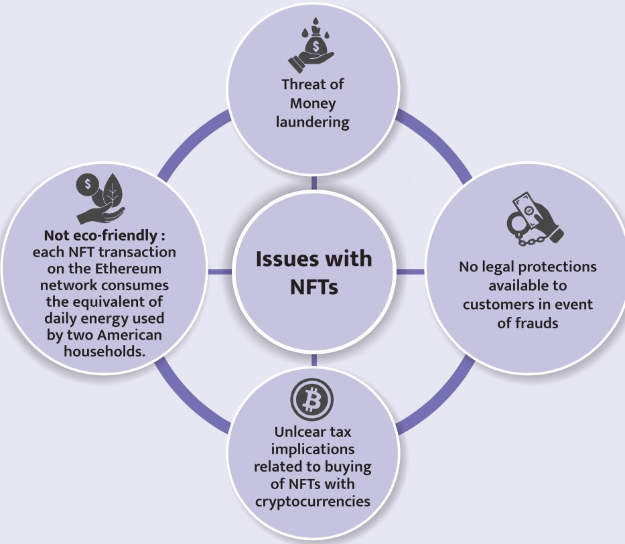

**It seeks to solve the problem of** Ownership tracking, Value storage, and Decentralisation.

* **Monetisation:** Artists, musicians, influencers and sports franchises are using NFTs to monetise digital goods that have previously been cheap or free.
* **Authenticity:** Contemporary artists can now archive their collections through the blockchain and have NFTs to authenticate their works and ensure no fakes exist in the future.
  + NFTs can still be copied, of course, but only one file has a certificate of authenticity, which cannot be replicated.
* **Protecting intellectual property rights of Artisans:** who can use NFTs to verify their original work.

**6.2.4 SATELLITE BASED INTERNET CONNECTIVITY**

##### Why in news?

Telecom Regulatory Authority of India released a Consultation Paper on Licensing Framework for Satellite- based connectivity for low bit rate applications.

##### About Satellite based connectivity

* Rather than using an underground copper/fibre network, satellite based broadband connection operates by sending and receiving broadband signal to a satellite in space.
* Satellite-based low-bit-rate connectivity is possible using Geo Stationary, Medium and Low Earth orbit Satellites.
* **Factors favouring development of Satellite based connectivity are** Innovation of technologies (like AI, cloud and big data), Smaller and cheaper satellites etc.

**Satellite Connectivity Models**

|  |  |  |  |  |  |  |
| --- | --- | --- | --- | --- | --- | --- |
|  | **Hybrid (LPWAN + Satellite) or Indirect Model**   * In such architecture, each sensor and actuator in a network may communicate with the satellite through an intermediate sink node, i.e., Low Power Wide-Area Network (LPWAN) or LPWA gateway. * In LPWAN, a network server coordinates several gateways through a reliable backhaul and in turn gateways interact through wireless links with potentially billions of low power devices. | | | **Direct to Satellite Model**   * This type of architecture allows devices to directly communicate with the satellite without the need of any intermediate ground gateway. * The satellite receives data from IoT devices and transmits the data to the ground station nearest to the device and the data gets stored in the application server for further processing. | |  |
| **Potential applications/use cases utilizing a satellite networking protocol** | | | | | | |
| **Remote health services**: Ambulance and medical logistics tracking in  remote areas, live monitoring of patient’s vitals etc. | | **Internal security**: Tracking patrol vehicles, monitoring critical logistics supplies in remote areas, monitoring of vessels at sea. | **Disaster management**:  Real-time delivery of alerts and geo- location services in case of natural calamities, emergency broadcast alerts and SOS messaging, monitoring and controlling remote forest fires and managing logistics of NDRF (National Disaster Response Force)/SDRF (State Disaster Response Force) vehicles, boats, fire  engines, ambulances etc. | | **Railways**: Real-time geo- location of assets, monitoring of safety systems in the trains, mission-critical communication etc. | |
| **Supply-chain management**: Asset tracking, vehicle fleet management, and cold-chain management for food/medicines etc. | | **Fisheries** Sensor-based connectivity is used for location and vessel monitoring, maritime boundary alerts; Geo-fenced fishing zones, for monitoring the cold-chain of stored fish, two-way emergency messaging system for distressed vessels, inclement  weather | **Smart Agriculture:**  Monitoring soil conditions for critical inputs such as water, fertilizers and pesticides, etc.; Harvest prediction, crop infestation/damage, yield, severe weather prediction, etc.; Reaching out to remote villages, farmland | | **Smart Grids:**  Remote transmission towers monitoring, load distribution, supply/demand management, Sensor- based applications for Remote Industries and Connected Healthcare, Supervisory Control and  Data Acquisition (SCADA) | |

* **Benefits associated with Satellite connectivity:** Easier to deploy and wide coverage, Enabler for IoT ecosystem, Stronger bandwidth capabilities, Boosting mobile broadband coverage in rural areas etc.

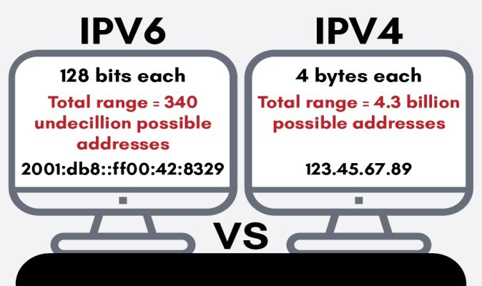

* **Issues related to Satellite connectivity:** High cost of services ($15-$20 per GB), Lack of enough domestic satellite capacity, Worries over the accumulation of space debris in the LEO, Operational issues (poor latency, disturbance in weather can affect signal and quality of internet) etc.

#### 6.2.5 NEW INITIATIVES BY NATIONAL INTERNET

|  |  |
| --- | --- |
| **IPv6**  **Expert Panel (IP Guru)** | * It’s a **joint effort** of Dept. of Telecommunication, MeitY & community to promote adoption of IPv6. * The expert panel group has members from government and private organizations, |
| **NIXI**  **Academy** | * To **educate technical/non-technical people** in India to learn and relearn technologies like IPv6. |
| **NIXI-IP- INDEX** | * It is a **portal for the Internet community to showcase the IPv6 adoption rate in India** and across the world. |

**EXCHANGE OF INDIA**

##### Why in News?

The Secretary, Ministry of Electronics and Information Technology (MeitY) and Chairman NIXI launched **three initiatives** from NIXI for awareness and adoption of IPv6 in India (refer infographic).

##### About Internet Protocol version 6 (IPv6)

* It is the **most recent version** of the Internet Protocol (IP).
* It is a **communications protocol** that provides an **identification and location system** for computers on networks and routes traffic across the Internet known as **IP address**.
* Also, IPv6 is **more secure and fast** as compared to IPv4.

##### About National Internet Exchange of India



* It is a **not-for-profit organization** (section 8 of the Companies Act 2013), **established in 2003**.
* It acts as a neutral meeting point of the Internet service providers (ISPs) with the primary objective of

**facilitating the exchange of domestic internet traffic** between peering ISP members.

**6.2.6. OTHER IMPORTANT NEWS**

|  |  |
| --- | --- |
| **Quantum Key Distribution (QKD)** | * Recently, ISRO demonstrated free-space QKD over 300 meter. * Experiment is a major **breakthrough towards ISRO’s goal of Satellite Based Quantum Communication,** where ISRO will demonstrate the technology between two Indian ground stations. * QKD technology provides a **secure method of communication that would not be vulnerable to attacks** from any amount of computational power |
| **Sandes** | * It is an instant messaging platform launched by **National Informatics Centre (NIC),** Ministry of Electronics and Information Technology**.**   o Initially it was **open only to government officers**, and now has been released for the common public.   * It has an **additional safety feature** that allows a user to mark a message as confidential. This in turn will make the recipient aware that the message should not be shared with others. * It was launched as part of the government strategy to **push for use of India-made software** and build an ecosystem of indigenously developed products. |
| **Frontier technologies** | * ‘**Technology and Innovation Report 2021’ released by United Nations Conference on Trade and Development (UNCTAD),** finds India as the top "over-performer" in terms of readiness in using, adopting and adapting frontier technologies among developing countries.   + **UNCTAD** is a **permanent intergovernmental body** established by the **United Nations General Assembly** in **1964.**   + **Other notable reports by UNCTAD:** World Investment Report, Trade and Development Report. * Frontier technologies” are **a group of new technologies that take advantage of digitalization and connectivity** which enable them to combine to multiply their impacts.   + Frontier technologies include **artificial intelligence, the internet of things, big data, blockchain**, fifth-generation mobile telephony, three-dimensional printing, robotics, drones, gene-editing, nanotechnology and solar power — the ones that take advantage of   digitalisation and connectivity. |
| **DearCry** | * It is a **new family of ransomware,** detected by Microsoft, **attacking business email servers**. It is being used after an initial compromise of unpatched on-premises Exchange Servers.   + **Ransomware** is malware that employs encryption to hold a victim's information at ransom.   + **Malware is the collective name** for a number of malicious software variants, **including viruses,**   **ransomware and spyware.** |
| **Spectrum Auction concluded** | * Spectrum refers to the **radio frequencies that wireless signals travel over.** The frequencies we use for wireless communication **are a portion of the broader electromagnetic spectrum.** * Portions of electromagnetic spectrum are grouped in “bands” and **allocated to the mobile industry and other sectors** for communication over the airwaves. * **Spectrum is a sovereign asset and Department of Telecommunications is the custodian and manager of spectrum** and decides on the framework for spectrum allocation, licensing, and pricing. |

### 6.3. RESEARCH AND DEVELOPMENT

**6.3.1. AIM-PRIME (PROGRAM FOR RESEARCHERS ON INNOVATIONS, MARKET- READINESS & ENTREPRENEURSHIP)**

##### Why in News?

Recently, AIM-PRIME was launched by the **NITI Aayog in collaboration with Bill & Melinda Gates Foundation (BMGF).**

##### About AIM-PRIME

* It is an initiative to **promote and support science-based deep-tech startups & ventures** across India.
  + This initiative **builds on the foundation laid by Atal Innovation Mission (AIM)** to support startups and provides specialized services to transition research to industry.
  + It will be **implemented by Venture Center** - a non-profit technology business incubator.



* + The program is catalyzed by the **office of the Principal Scientific Advisor,** and the Pune Knowledge Cluster.

**About Atal Innovation Mission (AIM)**

* It is NITI Aayog’s flagship initiative **to promote a culture of innovation and entrepreneurship** in the country and was setup in 2016.
* **Objective:**
  + To **develop new programmes and policies for fostering innovation** in different sectors of the economy
  + To **provide platforms and collaboration opportunities** for different stakeholders.
  + Create an **umbrella structure to oversee the innovation & entrepreneurship ecosystem** of the country.
* **Initiatives under AIM:** Atal Tinkering Lab, Atal Incubation Center, Mentor India, Atal New India Challenge, Atal Community Innovation Centre, Aatmanirbhar Bharat ARISE.

##### The program is open to:

* + - **Technology developers** (early-stage deep tech start-ups, and scientists/ engineers/ clinicians) with **strong science-based deep tech business ideas.**
    - **The CEOs and Senior incubation managers of AIM Funded Atal Incubation Centers t**hat are supporting deep tech entrepreneurs.

**6.3.2. OTHER IMPORTANT NEWS**

|  |  |
| --- | --- |
| **DSIR-Promoting Innovations in Individuals, Startups and MSMEs (DSIR-**  **PRISM) scheme** | * Recently, awareness program for Department of Scientific and Industrial Research (DSIR) – PRISM was launched.   o DSIR, part of Ministry of Science and Technology, carries out **activities relating to indigenous technology promotion, development, utilization and transfer**.   * PRISM is **aimed at transforming an individual innovator into a successful technopreneur** by promoting, supporting, and funding implementable and commercially viable innovations created for the society. * Under PRISM, an innovator of Indian nationality is **provided technical, strategic, and financial assistance.** * It is **implemented across various sectors** from energy to healthcare to waste management and others. |
| **RESPOND**  **(Research Sponsored) programme** | * Indian Space Research Organisation (ISRO) has announced that it **will support eight joint research projects mooted by IIT-Delhi** under its RESPOND programme. * ISRO started the RESPOND programme in the **1970s,** with the objective of **encouraging academia to participate and contribute in various Space related research activities.** * Under RESPOND, **projects are taken up by Universities/Academic Institutions in the areas of relevance to Space Programme.** |

### 6.4. SPACE TECHNOLOGY

**6.4.1. HUMANS IN SPACE POLICY**

##### Why in news?

The Department of Space has put up for public consultation, the draft "Humans in Space Policy for India -- 2021" and guidelines and procedures for its implementation.

##### About the policy

* **Applicability:** The guidelines are applicable to activities presently postulated under Indian human space program (IHSP) and for those activities which shall be defined and carried out in future in conjunction with IHSP.
* **Aim:** It envisages undertaking demonstration of human spaceflight to LEO (low-earth orbit) in the short- term and lay the foundation for a sustained exploration in the long run that will enable presence in LEO and beyond.

**Indian Human Spaceflight Programme(IHSP)**

* IHSP was initiated in 2007 by the Indian Space Research Organisation (ISRO) to develop the technology needed to launch crewed orbital spacecraft into Low Earth orbit.

o Under it, first unmanned mission is planned in December 2021. Second unmanned flight is planned in 2022-23, followed by human spaceflight demonstration **(Gaganyaan).**

* Gaganyaan has been designed to carry **three Indian astronauts to the low earth orbit** (an orbit of 300-400 km) for a period of five to seven days.

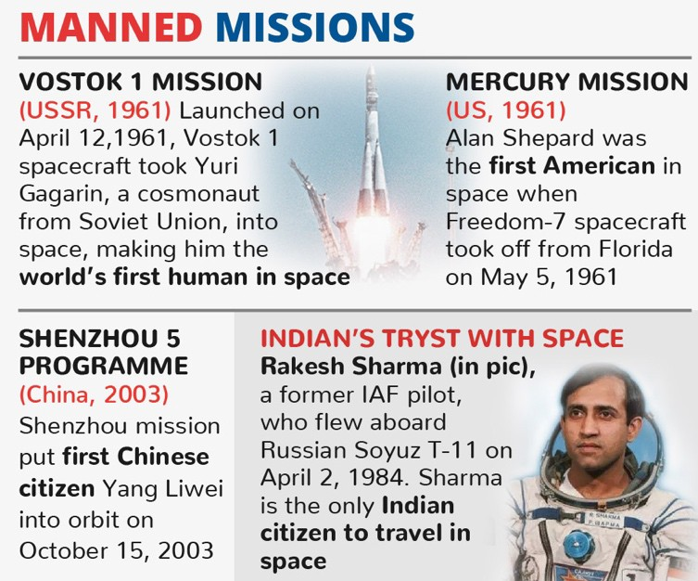

* It will take off on a **GSLV Mk III** which is capable of launching four-tonne satellites in the **Geosynchronous Transfer Orbit (GTO).**
  + GSLV Mk III is configured as a three stage vehicle: Two solid strap-on motors; One liquid core stage and a high thrust cryogenic (mixture of liquid oxygen and liquid hydrogen) upper stage.
* **Gaganyaan National Advisory Council** has been created with members from different institutions and industries to deliberate on various aspects of the mission.
* **Gaganyaan includes** a Space Capsule Recovery Experiment (SRE-2007), Crew module Atmospheric Reentry Experiment (CARE-2014), GSLV

Mk-III (2014), Reusable Launch Vehicle Technology Demonstrator (RLV-TD), Crew Escape System and Pad Abort Test.

**Types of Space Orbits**

* **Low Earth Orbit:** It is normally at an **altitude of less than 1000 km but could be as low as 160 km above Earth.** LEO satellites do not always have to follow a particular path around Earth in the same way – their plane can be tilted. Thus, there are more available routes for satellites in LEO. LEO is a very **commonly used orbit for satellite imaging**, as being near the surface allows it to take images of higher resolution.
  + It is also the orbit **used for the International Space Station (ISS)**. Satellites in this orbit travel at a speed of around 7.8 km per second; and takes approximately 90 minutes to circle Earth, (**ISS travels around Earth about 16 times a day**).
* **Geostationary orbits:** Satellites in geostationary orbit (GEO) circle Earth above the equator from west to east following Earth’s rotation at an **altitude of 35,786 km** by travelling at exactly the same rate as Earth. This makes satellites in GEO appear to be ‘stationary’ over a fixed position. GEO is used by satellites that need to stay constantly above one particular place over Earth, such as **telecommunication satellites.**
* **Medium Earth orbit (MEO):** It comprises a wide range of orbits anywhere between LEO and GEO. It is similar to LEO in that it also does not need to take specific paths around Earth, and it is used by a variety of satellites with many different applications. It is very commonly used by navigation satellites, like the European Galileo system.
* **Polar orbit and Sun-synchronous orbit (SSO):** Satellites in polar orbits **usually travel past Earth from north to south** rather than from west to east, passing roughly over Earth's poles. Polar orbits are a type of low Earth orbit, as they are at **low altitudes between 200 to 1000 km.**
  + **Sun-synchronous orbit (SSO)** is a particular kind of polar orbit. Satellites in SSO, travelling over the polar regions, are synchronous with the Sun. This means that the satellite always visits the same spot at the same local time. Image series by these satellites are used to investigate how weather patterns emerge, to help predict weather or storms; monitoring emergencies like forest fires or flooding; etc.
* **Transfer orbits and geostationary transfer orbit (GTO):** Transfer orbits are a special kind of orbit used to get satellites from one orbit to another. Often, the satellites are instead placed on a transfer orbit: an orbit where, by using relatively little energy from built-in motors, the satellite or spacecraft can move from one orbit to another.
  + Geostationary Transfer Orbits are characterized by a low perigee (altitude of a few hundreds of kilometres) and a high apogee (altitude typically identical to that of geostationary satellites).
* **Lagrange points:** Lagrange points, or L-points, allow for orbits that are much, much farther away (over a million kilometres) and do not orbit Earth directly. These are specific points far out in space where the gravitational fields of Earth and the Sun combine in such a way that spacecraft that orbit them remain stable and can thus be ‘anchored’ relative to Earth.

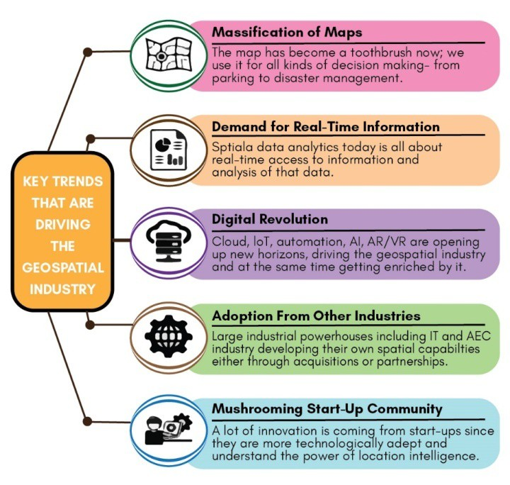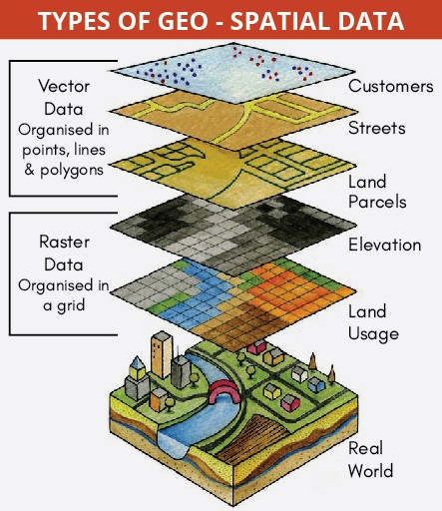

**6.4.2. GEO SPATIAL DATA**

##### Why in news?

Recently, the Ministry of Science and Technology released **new guidelines for the Geo-Spatial Sector** in India, liberalising the policies governing the acquisition and production of geo-spatial data.

##### About Geo-Spatial Data

* Geospatial data (also known as “**spatial data**”) is used to describe data about objects, events, or phenomena (man-made or natural) that have a location on the surface of the earth. At present, **80% of any data has a geo spatial component.**
  + Examples include the location of a road, an earthquake event, malnutrition among children, or dynamic like a moving vehicle or pedestrian, the spread of an infectious disease etc.
* The two main types of geospatial data are vector data and raster data.
  + **Vector Data**: It uses geometric shapes to show the location and shape of

geographic features. Points, lines and polygons can represent things like cities, roads and waterways. Vector data is scalable, has small file sizes and ideal for depicting boundaries.

* + **Raster Data**: It represents data through a digital image such a scanned map or photograph. It also includes aerial and

satellite imagery. Raster data uses a cell-based format called stair-stepping to record data as pixels or grids with an image. Spatial analysis depends heavily on raster datasets.

* **Geospatial technology** is used to collect, analyse and store geographic information. It uses software to map geographic locations while analysing the impact of human activity.
  + Various forms of geospatial technology includes Geographic Information System (GIS), Global

Positioning System (GPS), remote sensing, geofencing etc.

**6.4.3. NASA’S MARS 2020 PERSEVERANCE ROVER MISSION**

##### Why in news?

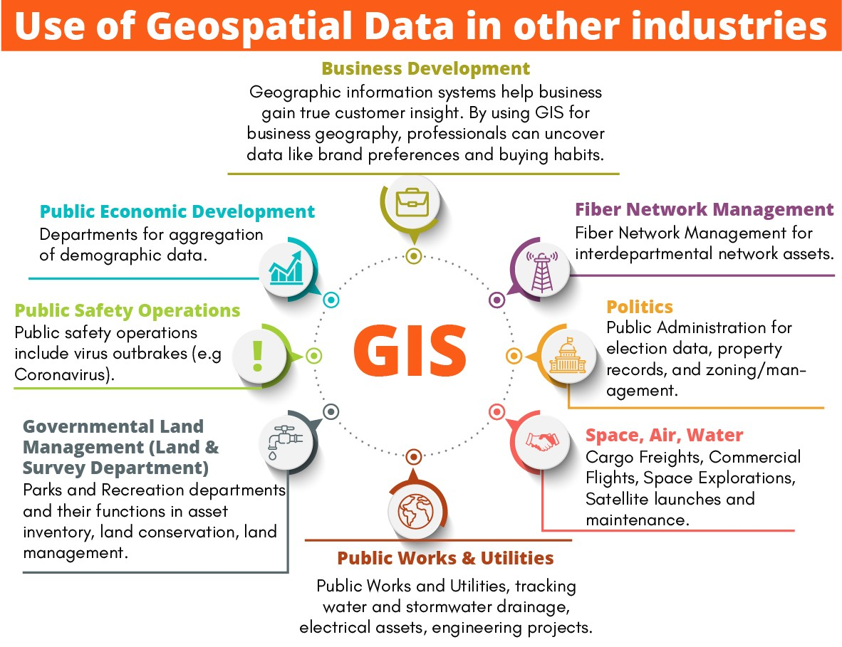

**Other missions to Mars**

Till now **6 countries US, Russia, China, the EU, India and UAE** are successful to reach the Martian orbit.

* **NASA**

o o o o o o o **EU**

o o o

Viking spacecraft

Odyssey spacecraft Curiosity rover Insight

Reconnaissance Orbiter MAVEN

Phoenix

•

Mars Express

ExoMars Trace Gas Orbiter (along with Russia) Beagle 2

* **India:** Mangalyaan
* **UAE:** Hope Mission
* **China:** Tianwen-1 (includes Zhurong rover).
* **Russia:** Fobos-Grunt

National Aeronautics and Space Administration’s (NASA) Perseverance Rover successfully touched down on Mars.

##### About NASA’s Mars 2020 Perseverance Rover mission

* It is **part of NASA's Mars Exploration Program**, a long-term effort of robotic exploration of the Red Planet-Mars.
  + It was **launched in July 2020.**
  + Mission **seeks signs of ancient life and will collect samples of rock and regolith** (broken rock and soil) for possible return to Earth.
* Perseverance rover will begin its two-year-long **investigation in Jezero Crater to assess the geology and past climate** of the Red planet.
  + The **crater had its own river delta and was filled with water** nearly 3.5 billion years ago.
  + Perseverance is also ferrying **a helicopter**

**named Ingenuity**, the first aircraft to attempt powered, controlled flight on another planet.

* + It also includes **most advanced astrobiology laboratory** sent to Mars till date.
* Perseverance is intended to be the **first part of a robotic sample return mission from Mars**. **Why is Mars being explored?**
* It is believed that **four billion years ago environments on Venus, Earth and Mars were habitable.**
* Mars had a **thick atmosphere, which enabled the stability of water on the surface of Mars**, hence there is a real possibility that microscopic life evolved on Mars.



* Mars is only about **one-half the diameter of Earth**, but both planets have **roughly the same amount of dry land surface area.**
* **Mars has volcanoes (Olympus Mons), canyons (Valles Marineris), and impact basins** much like the ones on the Earth.
* Mars is seen as **only planet that humans can visit or inhabit** in the long term.
  + Mars is comparatively **hospitable in terms of temperature**, with an approximate range between 20 degrees C at the Equator to minus 125 degrees C at the poles.
  + **Venus and Mercury have extreme temperatures** the average temperature is greater than 400 degree C, or hotter than a cooking oven.
    - However, Astronomers recently discovered **compelling evidence pointing to life floating in the clouds of Venus.**
  + **All planets in the outer solar system** are made of gas that **does not have silicates or rocks** and are

##### very cold.

|  |  |
| --- | --- |
| **Comparison of Mars, Earth & Venus** | |
| **Parameter** | **Description** |
| **Atmosphere (composition)** | * **Atmosphere of Mars has abundance of CO2** (95.32%). * **Atmosphere of Earth has abundance of Nitrogen** (77%). * **Atmosphere of Venus has abundance of CO2** (96%). |
| **Atmospheric pressure** | * **Venus > Earth > Mars** |
| **Gravity** | * **Earth** (9.81 m/s²)> Venus (8.87 m/s²) > Mars (3.711 m/s²) |
| **Length of Day** | * **Venus**> Mars > Earth * **Note:** Length of the day of Earth (24 hours) & Mars (24 hours, 37 minutes) is nearly same. |
| **Length of Year** | * **Mars > Earth > Venus** |
| **Tilt of Axis** | * **Venus**> Mars > Earth * **Note:** Tilt of axis of Earth (23.45 degrees) & Mars (25 degrees) is nearly same. |
| **Satellites** | * **Mars:** 2 (Phobos and Deimos) * **Earth:** 1 (Moon) * **Venus**: No moons |

**6.4.4. SATELLITE LAUNCH VEHICLES BY ISRO**

**Why in News?**

Recently, ISRO’s PSLV-C51 put Brazil’s Amazonia-1 and 18 other satellites into orbit.

##### More on News

* Out of 18 satellites, 4 are from **new Indian National Space Promotion and Authorisation Centre (IN-SPACe)**

and 14 from **New Space India Limited (NSIL).**

##### Satellite-Launch Vehicles Developed By ISRO

* India has two operational launchers: **Polar Satellite Launch Vehicle (PSLV) and Geosynchronous Satellite Launch Vehicle (GSLV).**
* **PSLV:** It is the **third generation launch vehicle** of India. PSLV is a **four-staged launch vehicle with alternating solid and liquid stages.**
  + PSLV is designed mainly to **deliver the “earth-observation” or “remote sensing” satellites** with lift- off mass of up to about 1750 Kg to Sun-Synchronous circular polar orbits of 600-900 Km altitude.
  + PSLV is also used to launch the satellites of lower lift-off mass of up to about 1400 Kg to the elliptical Geosynchronous Transfer Orbit (GTO).
    - During 1994-2017, the vehicle has **launched 48 Indian satellites and 209 satellites for customers from abroad.**
    - Besides, the vehicle successfully launched two spacecraft – **Chandrayaan-1 and Mars Orbiter Spacecraft.**

o **PSLV is classified into its various versions** like core alone version (PSLV-CA), PSLV-G or PSLV-XL variants depending on the number of these strapon boosters.

* **GSLV:** It is designed mainly to deliver the **communication satellites to the highly elliptical** (typically 250 x 36000 Km) **GTO.** Two versions of the GSLV:

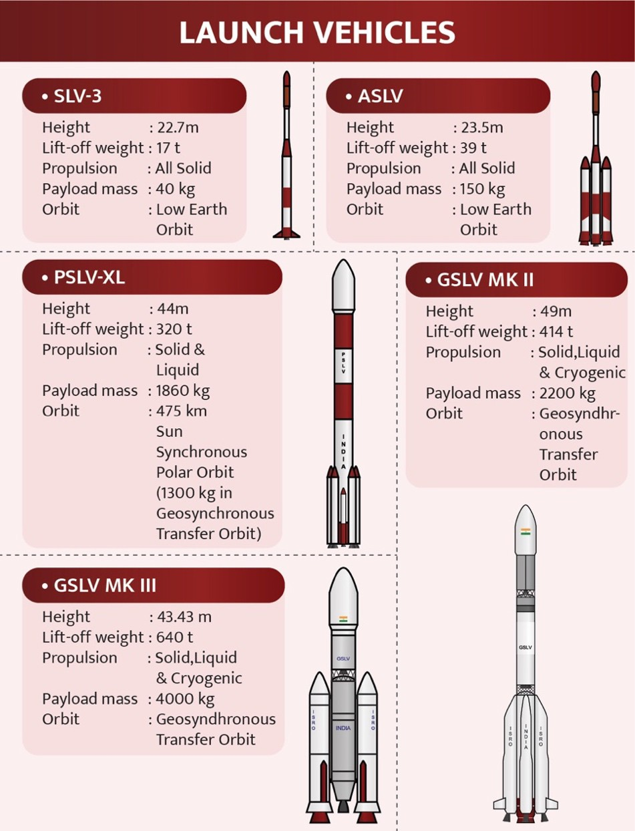

* + **GSLV Mk-II:** It is a three stage vehicle with four liquid strap-ons. First stage using solid rocket motor, second stage using Liquid fuel and Cryogenic Upper Stage (CUS) forms the third stage of GSLV Mk II.
    - It has the capability to launch satellites of liftoff mass of up to 2,200 kg to the GTO and satellites of up to 5,000 kg lift-off mass to the LEO (low earth orbit).
  + **GSLV MK-III:** It is a three stage vehicle with an indigenous cryogenic upper stage engine (C25) with two solid fuel strap- on engines in the first stage, a liquid propellant core as second stage.
    - It has been designed to carry heavier

communication satellites weighing up to 4000 kg into the Geosynchronous Transfer Orbit or satellites weighing about 10,000 kg to LEO.

* + - The indigenous cryogenic C25 engine helps to keep fuel loads on the rocket relatively low. India is among six nations — apart from the US, Russia, France, Japan and China — to possess cryogenic engine technology.

##### Other Vehicles used by ISRO

* **Satellite Launch Vehicle-3 (SLV-3)** was India's first experimental satellite launch vehicle, which was an all solid, four stage vehicle capable of placing 40 kg class payloads in LEO.
* **Augmented Satellite Launch Vehicle (ASLV)** Programme was designed to augment the payload capacity to 150 kg, thrice that of SLV-3, for Low Earth Orbits (LEO).

**6.4.5. SPACE DEBRIS**

##### Why in News?

**The Kessler Syndrome**

* Also called the **Kessler effect,** is a scenario in which the density of objects in Low Earth Orbit (LEO) is high enough that collisions between objects could cause a cascade where **each collision generates space debris that increases the likelihood of further collisions**.
* It may lead to a situation in which orbit would become **impassable in the long run**.

China has launched a robot prototype in April 2021 that can **scoop up debris left behind by other spacecraft** with a big net.

##### More on news

* **The robot,** NEO-01 will use a net to capture debris and then **burn it with its electric propulsion system.**
* It will also **peer into deep space** to observe small celestial bodies, paving the way for future technologies capable of **mining on asteroids.**

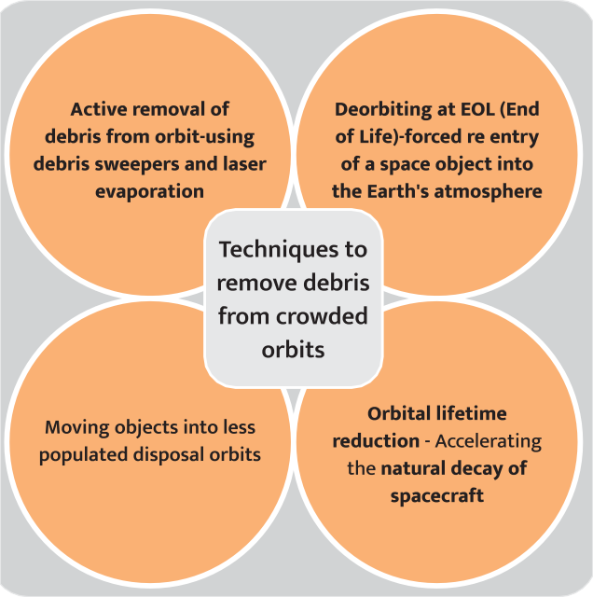

##### About Space Debris

* Space debris encompasses both **natural (meteoroid) and artificial (man-made)** particles. Meteoroids are in orbit about the sun, while most **artificial debris is in orbit about the Earth** which is commonly referred to as **orbital debris.**
* Orbital debris is any man-made object in orbit about the Earth which **no longer serves a useful function.** Such debris includes **non-functional spacecraft, abandoned launch vehicle stages, mission-related debris and fragmentation debris**.
* Much of the debris is in **low Earth orbit** (within 2,000 km of Earth’s surface), though some debris can be found in **geostationary orbit** (35,786 km above the Equator).
* There are **about 500,000 pieces of debris** the size of a marble or larger orbiting the Earth, travelling at speeds up to 17,500 mph.
* International guidelines suggest removing spacecrafts from low-Earth orbit **within 25 years of the end of their mission**.
  + However, **only 60 percent of missions** follow the guidelines.

##### Strategies to Tackle Space Debris

* **Mitigating Damage**: Space debris is **tracked by a number of countries**, including Germany, France, the UK and the USA.
  + ISRO has come up with ‘**Project NETRA’** - an

early warning system in space to **detect debris and other hazards** to Indian satellites.

* + Indraprastha Institute of Information Technology Delhi is working on a project titled “**Orbit computation of Resident Space Objects for Space Situational Awareness”** to predict collision from space debris.
* **Avoiding future debris:** Various space organisations have been working on **reducing the amount of trash by adopting better designs** of rockets and other objects.

##### Removal of the debris:

* + End-of-Life Services by Astroscale Demonstration (**Elsa-D), by Japan** was launched to **locate and retrieve used satellites** and other space junk.
  + **RemoveDebris is an EU research project** to give **in orbit demonstrations of cost-effective technologies** that can be used to observe, capture and dispose of space debris. It has performed key technology demonstrations including:
    - **Net capture:** It involves a net that will be deployed at the target CubeSat.
    - **Harpoon Capture:** Which will be launched at a target plate made of “representative satellite panel materials”
    - **Vision-based navigation**: Using cameras and LiDAR (light detection and ranging), the platform will

**send data about the debris** back to the ground for processing.

* + - **De-orbiting process:** As it enters Earth’s atmosphere, the spacecraft will burn up, leaving no debris behind.

**International efforts to tackle Space debris**

* **Inter-Agency Space Debris Coordination Committee (IADC) Space Debris Mitigation** Guidelines (2002).
  + IADC is an **international governmental forum** for the worldwide coordination of activities related to the **issues of man-made and natural debris in space.**
  + ISRO is one among 13 member agencies of IADC.
* **Committee on the Peaceful Uses of Outer Space (COPUOS)** concluded **various international treaties** (like Outer Space Treaty, Liability Convention etc.) which **deal with issues** like **liability for damage** caused by space objects, **Prevention of harmful interference** with space activities and **registration of space activities** etc.
  + COPUOS was set up by UN General Assembly in 1959 to govern the exploration and use of space for the benefit of all humanity.

**6.4.6. PINK MOON**

##### Why in news?

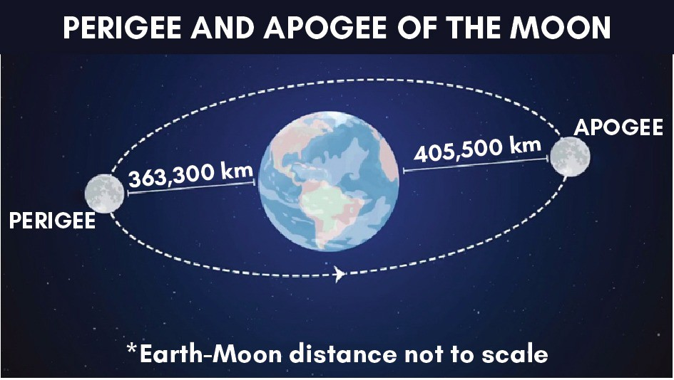

The **first super moon of 2021** has been named **‘Pink Moon’** as per **a naming convention established in USA**.

##### More on news

* It is **named after herb moss pink,** also called creeping phlox, moss phlox, or mountain phlox, one of the earliest spring flowers appearing in the United States.
* A book titled **‘Maine Farmer’s Almanac’** provides names for supermoon in each month of the year as they occur.

##### About Supermoon

* The term **"supermoon"** was coined by **astrologer Richard Nolle in 1979**.
* The **Moon orbits Earth in an ellipse** which brings it **closer to and farther from Earth as it goes around**.
* The **farthest point in this ellipse is called the apogee** and the closest point is the **perigee**.
* **Supermoon** refers to **either a new or full Moon that coincides with moon being at the perigee**(the point where moon is closest in its elliptical orbit around the Earth)**.**
  + **New Moon** is when **Sun and Earth are on opposite sides of the Moon**. A new moon is not visible due to following reasons:

##### The alignment is such that it leaves the side of the Moon that faces Earth in darkness.

* + - New Moon **rises and sets around the same time as the Sun**, bringing it **closer to the Sun’s glare to be seen with the naked eye.**
  + **Full Moon** is when the Sun and the Moon are aligned on opposite sides of Earth, and **100% of the Moon's face is illuminated by the Sun.**
* During a supermoon, that **brightness can increase up to 30 percent** as a result of the Moon being closer to Earth.

##### Other moon events:

* + **Micromoon** is when a Full Moon or a New Moon coincides with apogee.

##### Blood Moon

* + - It refers to **red colour of moon during the total lunar eclipse**.
    - During the total lunar eclipse, the **Earth comes in between the Sun and the Moon**.
    - The red colour appears because the **shorter wavelengths of sunlight are scattered by Earth’s atmosphere** and what reaches us is the longer wavelength red light.
  + Whenever **Sun, Earth and Moon are in alignment** it is called a **conjunction or Syzygy**.

**6.4.7. THE UNICORN–CLOSEST BLACK HOLE TO EARTH EVER DISCOVERED**

##### Why in news?

Scientists have discovered the **smallest-known black hole** which is dubbed as **'the Unicorn’** in the Milky Way galaxy and **closest to the solar system**.

##### More in news

* The **black hole ‘Unicorn’ is roughly three times the mass of the sun**.
* 'The Unicorn' falls into what the researchers called a **‘mass gap’ between the largest-known neutron stars** (around 2.2 times the mass of the sun) and what previously had been considered the smallest black holes (around five times the sun's mass).

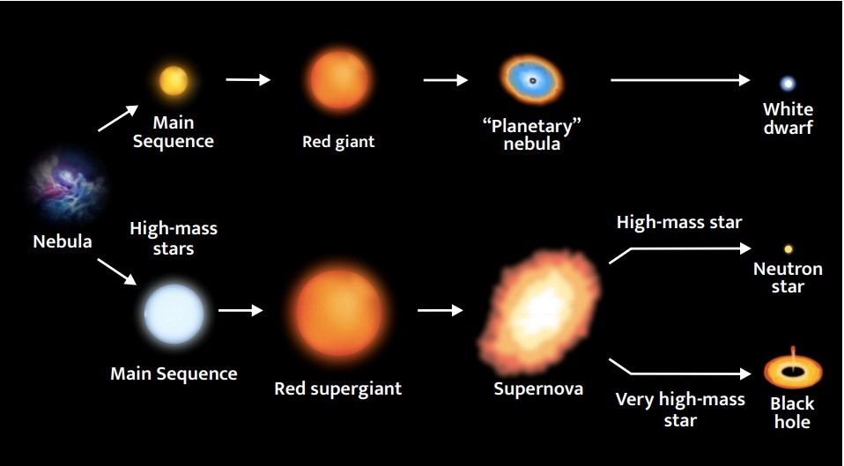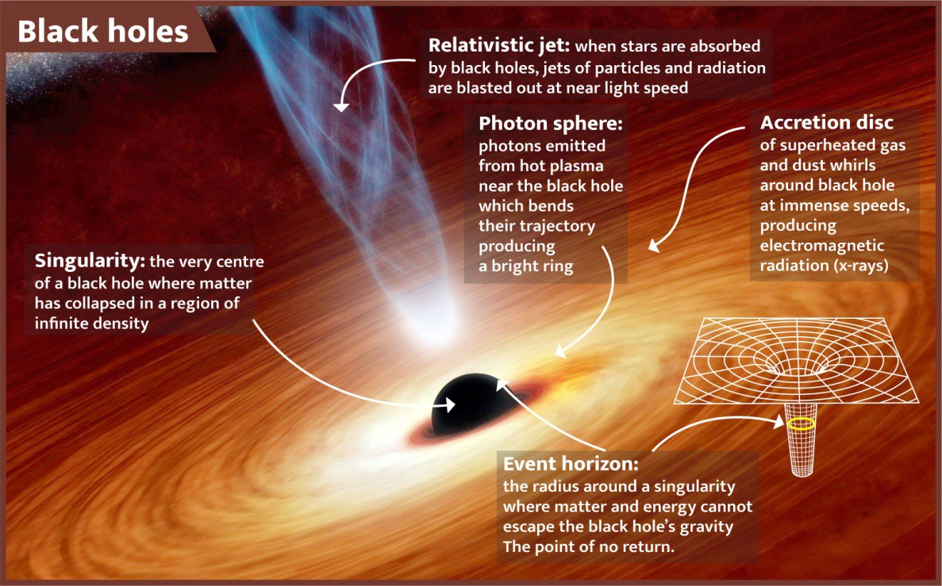

**Evolution of a star**

* **Red star:** Fusion reaction stops in the core of a star when its Hydrogen gets exhausted. Pressure of the core diminishes and core starts shrinking. Fusion takes place as some Hydrogen remains in the envelope/outer shell. It makes the star unstable. The star Expands and turns Red.
* **Dwarf star:** When mass of star < 1.44 times the mass of Sun (Chandra Shekhar limit), it ends up as a white dwarf.

o The Red Giant Star loses its outer envelope and core shrinks into an extremely dense ball of matter due to gravitation. This leads to another set of fusion reaction where Helium fuses to form carbon. The fuel gets completely exhausted and the core shrinks under its own weight and becomes a white dwarf.

•

•

•

**Supernova:** When mass of star > 1.44 times that of Sun, there remains enough

Helium in the core for fusion reaction. The outer envelope explodes causing Supernova Explosion.

**Neutron Star:** When mass of the star is between 1.44 to 3 times that of Sun, it becomes a Neutron Star.

**Black hole:** When mass of the star is bigger than 3 times that of Sun, it becomes a Black hole.

* Its **strong gravity alters the shape of its companion star** in a phenomenon known as **tidal distortion**, making it **elongated** rather than spherical and causing its light to change as it moves along its orbital path.

##### Black holes

* A black hole is a **place in space where gravity pulls so much that even light cannot get out**. The gravity is so strong because matter has been squeezed into a tiny space. This can happen when a star is dying.
* They are **invisible** and electromagnetically dark. Space

telescopes with **special tools can help find black holes**. The

special tools can see how stars that are very close to black holes act differently than other stars.

* Black holes can be **big or small**.
* There are **three categories of black holes** namely, **stellar black holes**

##### (also called unicorn),

**supermassive black holes, and intermediate-mass black holes.**

* + There may be many stellar mass black holes in **Milky Way**.

**Related News**

* Magnetic field around a Black Hole has been observed for the first time.
* Astronomers have obtained a **new view of the supermassive black hole at the center of galaxy M87 or Messier 87,** some 55 million light years away from Earth.

o Images of **polarized light were released by the Event Horizon Telescope (EHT**) collaboration, a network of radio telescopes.

* **Light becomes polarized when it goes through certain filters** like, for instance, the lenses of polarized sunglasses, or when it is emitted in hot regions of space that are magnetized, hence it **suggests that presence of strong magnetic fields around the black hole.**

**Related News**

* Recently, NASA’s Hubble telescope discovered **concentration of smaller black holes** in globular cluster NGC 6397 instead of one super-massive blackhole.
  + Hubble is the **first major optical telescope to be placed in space** to observe the most distant stars and galaxies as well as the planets in our solar system.
* **Globular clusters are extremely dense stellar systems,** which host stars that are closely packed together. Roughly spherical in shape, they **contain hundreds of thousands, and sometimes millions, of stars.**
  + Globular clusters **contain some of the oldest stars in a galaxy** and are thought to have formed early in its history.
  + Studying those **helps estimate age of the universe or figure out where the center of a galaxy lies.**

**6.4.8. SPACE HURRICANE**

##### Why in News?

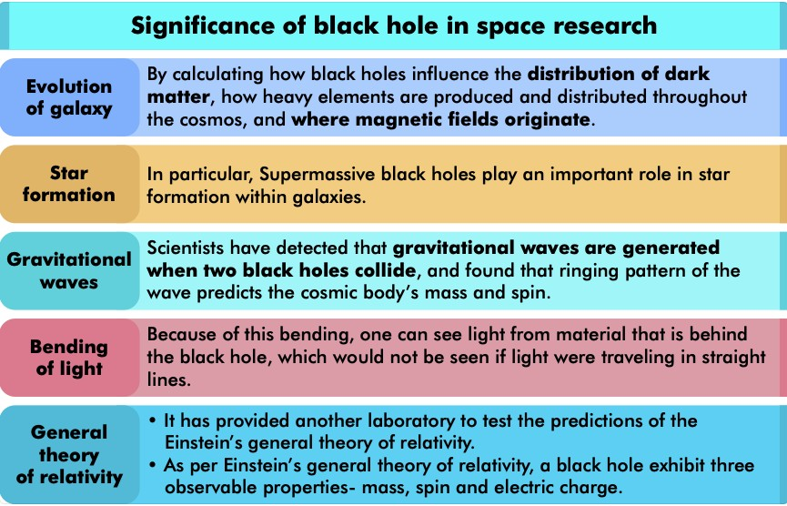

**About Auroras**

* Auroras are **caused by the interaction of energetic particles** (electrons and protons) **of the solar wind with atoms of the upper atmosphere.** Aurora occurs primarily in high latitudes of both hemispheres.
* Auroras in the **Northern Hemisphere are called aurora borealis, aurora polaris, or northern lights**, and in the **Southern Hemisphere aurora australis, or southern lights.**

Recently, For the First Time, a 'Space Hurricane' was detected over the North Pole.

##### More on News

* It ranged from **110 to 860 kilometres in altitude and consisted of plasma with multiple spiral arms,** swirling in an anticlockwise direction.
* **Centre of hurricane was almost still**, similar to hurricanes we see on Earth.

##### What is a Space Hurricane?

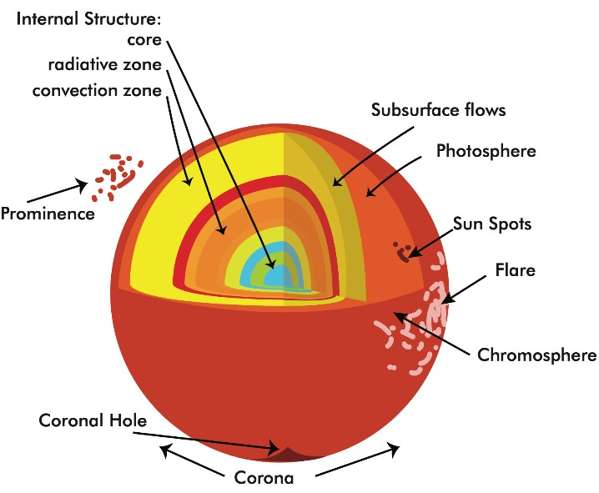

* It is a **swirling mass of plasma and it rains electrons into ionosphere.** This led to a huge, **cyclone-shaped aurora** below the hurricane.
  + **Plasma is a hot ionized gas** consisting of approximately equal numbers of positively charged ions and negatively charged electrons. **Plasma is the fourth state of matter** (Solids, liquids and gases are other three).
  + **Ionosphere stretches roughly 50 to 400 miles above Earth's surface,** right at the edge of space.
* As per scientists, space hurricanes **must be created by unusually large and rapid transfer of solar wind energy** and charged particles into the Earth's upper atmosphere.
* **Significance**: It will help in understanding important space weather effects like satellite drag, disturbances in high frequency radio communications, and errors in over-the-horizon radar location, satellite navigation and communication systems.

**6.4.9. NOVEL TECHNIQUE FOR TRACKING CORONAL MASS EJECTIONS (CMES)**

##### Why in News?

Recently, Scientists from **Aryabhatta Research Institute of observational sciences (ARIES)** have developed an algorithm, **CMEs Identification in Inner Solar Corona (CIISCO)** to detect and track CMEs in lower corona.

##### More on News

* The parameters determined by **CIISCO** are useful to characterise these **eruptions in the lower corona**, a region where the properties of such eruptions are less known.
* Technology **will be used in Aditya-L1**

India’s first solar mission.

* + Implementation of CIISCO on the Aditya-L1 data will provide new

##### insight into the CME properties in this less explored solar corona region.

**About Coronal Mass Ejections (CMEs)**

* CME is a **giant cloud of solar plasma drenched with magnetic field lines** that is blown away from the Sun often during strong, long-duration solar flares and filament eruptions.
  + A CME contains **particle radiation (mostly protons and electrons) and powerful magnetic fields**. They cause disruption of space weather and satellite failures, and power outages, etc.
* **Computer Aided CME Tracking Software (CACTus)** was used to detect and characterise such eruptions automatically in the outer corona.
  + However, this algorithm **could not be applied to the inner corona observations** due to the vast acceleration experienced by these eruptions.

**6.4.10. MISCELLANEOUS**

|  |  |
| --- | --- |
| **Arktika-M** | * This is Russia’s **first Arctic monitoring satellite** to monitor the climate and environment in the Arctic region. * The Arctic has warmed **more than twice as fast as the global average** over the last three decades. * This opens up **opportunities for huge oil and gas reserves** that are being eyed by countries including the United States, Russia, Canada etc. |
| **P172+18 Quasar** | * Quasars are very **luminous objects in faraway galaxies that emit jets at radio frequencies.** * Quasars give off enormous amounts of energy - they **can be a trillion times brighter than Sun.** * Quasars are believed to **produce their energy from massive black holes** in the center of galaxies in which quasars are located. |



|  |  |
| --- | --- |
|  | * Because quasars are so bright, **they drown out light from all other stars in same galaxy.** * Study of quasars **can provide information about the early stages of the universe.** |
| **Martian Blueberries** | * In 2004, NASA’s **Opportunity rover found several small spheres on Mars,** informally named Martian blueberries.   + Mineralogy study of these spheres found **they were made of iron oxide compounds called haematites** (suggesting presence of water on Mars). * A recent research on **Jhuran formation in Gujarat suggests that haematite concretions in this area resemble the ones on Mars.** * Jhuran formation is marked by first **occurrence of ironstone band and last occurrence of calcareous sandstone.**   + Jhuran Formation is **present in the offshore (GK-29A-1 well), Kutch mainland and Banni graben.**   + **Age:** Upper Jurassic (Agrovian –Neocomian). |
| **James Webb Space Telescope** | * It is an **orbiting infrared observatory** which is planned to be launched in October 2021.   o It will **complement discoveries of Hubble space telescope** of NASA, with longer wavelength coverage and improved sensitivity.   * It will **study every phase in the history of Universe**, ranging from Big Bang to the evolution of our Solar System. * It is an **international collaboration** between NASA, European Space Agency, and Canadian Space Agency. |
| **Devasthal Optical Telescope (DOT)** | * It is a 3.6-m **optical telescope at Devasthalin Nainital, Uttarakhand**. * It is **Asia’s largest fully steerable optical telescope.** * It was established by **Aryabhatta Research Institute of Observational Sciences**, an autonomous research institute under the Department of Science and Technology. * **Devasthal ("Abode of God") is a mountain peak near Dhana-chuli**, which has the advantages of having dark skies and excellent observing conditions. |
| **Square Kilometer Array Observatory (SKAO)** | * SKAO Council held its maiden meeting and approved the **establishment of the world’s largest radio telescope.**   o Unlike optical telescopes, **radio telescopes can detect invisible gas and,** therefore, they can reveal areas of space that may be obscured by cosmic dust.   * The proposed telescope will be **located in Africa and Australia** whose operation, maintenance and construction will be overseen by SKAO. * SKAO is **intergovernmental Organisation** dedicated to radio astronomy and is headquartered in the UK. * **Members of SKAO** include Australia, Canada, China, **India**, Italy, New Zealand, South Africa, Sweden, the Netherlands and the UK. |
| **NASA-ISRO**  **Synthetic Aperture Radar (NISAR)** | * Recently, **ISRO has prepared the S-band Synthetic Aperture Radar (SAR)** and shipped it to NASA for integration with L-band payload being developed by it.   + SAR refers to a **technique for producing fine-resolution images** from a resolution- limited radar system. * NISAR is a **joint Earth-observing mission between ISRO and NASA**. It is the world’s first twin- radar satellite mission.   + It will be **launched in 2022** from the Satish Dhawan Space Center in Sriharikota into a   **near-polar orbit**   * For NISAR, **NASA will provide** one of the radars, high-rate communication subsystem, GPS receivers and a payload data subsystem.   + **ISRO will provide** the spacecraft bus, a radar, launch vehicle and associated launch services.   + It will be equipped with the **largest reflector antenna** ever launched by NASA. * **Significance**   + It will track subtle changes in Earth’s surface, spotting **warning signs of imminent volcanic eruptions**, monitor groundwater supplies and ice sheets melting rate etc.   + Can **collect data day and night in any weather**. |
| **Sounding Rockets** | * Recently, ISRO launched Sounding rocket RH-560. * **Sounding Rockets** are one or two stage solid propellant rockets used for **probing the upper atmospheric regions and for space research.** * They also serve as **easily affordable platforms to test or prove prototypes** of new components or subsystems intended for use in launch vehicles and satellites. * ISRO has developed a **series of sounding rockets called Rohini series. Ex -** RH-200, RH-300 (The number indicates the diameter of the rocket in mm). |

|  |  |
| --- | --- |
|  | o **RH-560** aims to study attitudinal variations in the neutral winds and plasma dynamics  from Sriharikota spaceport. |
| **Novel bacterial strains discovered at International Space Station (ISS)** | * **Bacterial strains belonging to the family Methylobacteriaceae were isolated** from different locations aboard the ISS. * New bacteria **contains genes that fix nitrogen, dissolve phosphate and assimilate potassium**   — three nutrients important for plants to grow both on earth and space.  o New bacterial species has been found to **bust stress that plants undergo in zero gravity in space.**   * Discovery **could help in space agriculture to meet the long-term food needs of astronauts**   and space tourists to the moon or Mars. |

### 6.5. HEALTH

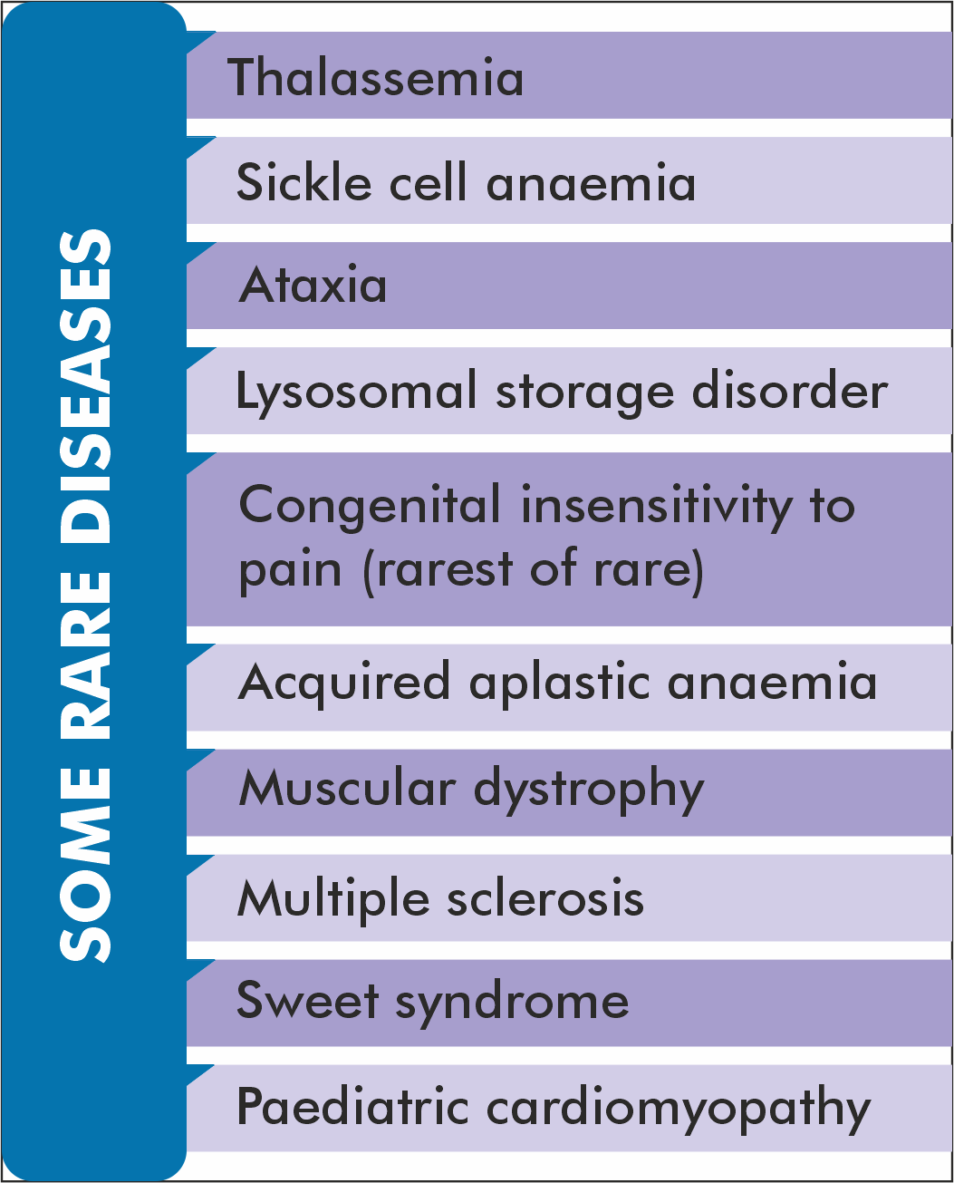

**6.5.1. RARE DISEASES**

##### Why in news?

Ministry of Health & Family Welfare approved the National Policy for Rare Diseases(NPRD) 2021.

##### About Rare Diseases

* There is **no universal or standard definition of rare disease** but broadly defined as diseases that infrequently occur in a population, and **three indicators are used to identify**— the total number of people with the disease, its prevalence, and the availability/non-availability of treatment options.

##### There is no standard definition of rare diseases in India.

* **WHO defines rare disease as often debilitating lifelong disease or disorder with a prevalence of less than 10 per 10,000 people** (or 1 per 1000 population). However, different countries have their own definitions to suit their specific requirements.
* The term “**Orphan diseases**” is often used for these and drugs to treat them are called “**Orphan drugs**”.
  + **India is yet to have a legislation** on the development of Orphan Drugs
* New diseases are discovered each year and added to the databases such as **Orphanet database** maintained by the **European Union** that is freely accessible to everyone.

##### Key provisions of the Policy

**Public Health and hospitals being a State subject**, the Central Government through the NPRD, would encourage & support the States in their endeavour towards screening and prevention of rare diseases. Major provisions of the policy include:

##### Aim of the policy:

* + **To lower the incidence and prevalence of rare diseases** based on an integrated and comprehensive preventive strategy.
  + **To enable access to affordable health care** to patients of rare diseases.
  + **To increase focus on indigenous research** and local production of medicines**.**

##### Categorization of rare diseases in 3 groups:

* + **Group1:** Disorders amenable to **one-time curative treatment.**

##### Group 2: Those requiring long term or lifelong treatment.

* + **Group 3:** Diseases for which definitive treatment is available but challenges are to make optimal patient selection for benefit, very high cost and lifelong therapy.

##### Financial Support for treatment :

* + The **assistance of Rs 20 lakh to be provided by the Central government** to patients suffering from rare diseases under Group1 under the umbrella scheme of **Rashtriya Arogya Nidhi(RAN).**
* RAN Scheme provides for financial assistance to patients, living below poverty line (BPL) and who are suffering from major life threatening diseases, to receive medical treatment at any of the super specialty Government hospitals / institutes.
  + **Beneficiaries for such financial assistance however would not be limited to BPL families**, but extended to about 40% of the population, who are eligible as per norms of Pradhan Mantri Jan Arogya Yojana, for their treatment in Government tertiary hospitals only.

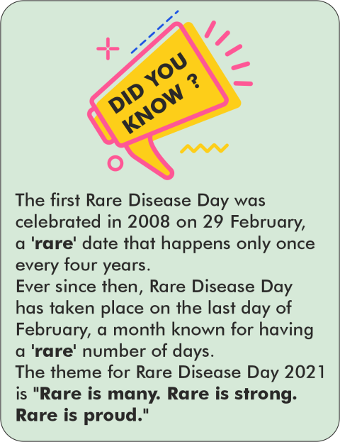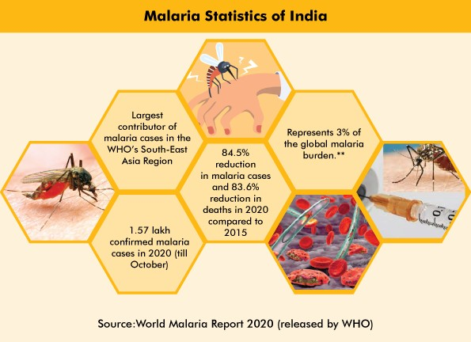

* + **For diseases listed under Group 2**, State Governments can consider supporting patients of such rare diseases with special diets or hormonal supplements or other relatively low cost interventions.
* **Alternate Funding mechanism:** Provision for voluntary crowd- funding for treatment through setting up a digital platform for voluntary individual and corporate donors to contribute to the treatment cost of patients of rare diseases especially those under Group 3.

##### Centres of Excellence and Nidan Kendras:

* + Certain medical institutes will be certified as Centre of Excellence and will be provided one-time financial support of up to Rs. 5 crore for upgradation of screening and diagnostics facilities.
  + Nidan Kendras set up by Department of Biotechnology (DBT) under Unique Methods of Management and treatment of Inherited Disorders (UMMID) project will be performing screening, genetic testing and counseling for rare diseases.
    - Currently Nidan Kendras are supporting aspirational districts for screening of rare diseases.
* **Creation of Database on rare diseases :** A national hospital-based registry of rare diseases will be created by ICMR to ensure adequate data and comprehensive definitions of such diseases are available for those interested in research and development.
* **Research & Development:** Creation of an integrated research pipeline to start the development of new drugs, repurposing the drugs and use of biosimilars (the reference medicine).

**6.5.2. MALARIA**

##### Why in News?

World Health Organisation (WHO) and partners recently organised **“Reaching Zero” forum** on malaria elimination to celebrate **World Malaria Day** (25th April)**.**

##### More on news

* This year’s theme for the day

##### is “Reaching the Zero Malaria target.’’

* On this occasion,

WHO launched **E-2025 initiative**, under which group of 25 countries have been identified that have the potential to stamp out malaria within a 5-year timeline. These countries will **receive specialized support and technical guidance** as they work towards the target of zero malaria.

* Earlier, in 2017, WHO launched **E-2020 initiative**, to support 21 countries in their efforts to get to zero malaria cases within the 2020 timeline.
* Malaria is a **life-threatening disease** caused by parasites that are transmitted to people through the bites of infected **female Anopheles mosquitoes.** It is **preventable and curable.**
  + Out of 5 malaria causing parasite species, **Plasmodium falciparum and Plasmodium vivax pose greatest threat.**

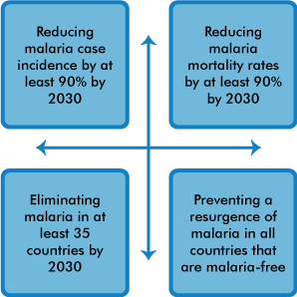

**WHO Global technical strategy (GTS) for malaria 2016-2030 has following targets:**

##### Initiatives taken by India

* **National Vector Borne Disease Control Programme** (launched in 2003-04): It is an umbrella programme for the **prevention and control of six vector borne diseases** namely **Malaria**, dengue, chikungunya, Japanese encephalitis, kala-azar and lymphatic filariasis.
* **National Framework for Malaria Elimination (NFME)** 2016– 2030 was launched in line with the **WHO Global Technical Strategy** for Malaria 2016–2030 (GTS). The goals of **NFME** are:
  + **Eliminate malaria** (zero indigenous cases) throughout the entire country **by 2030**; and
  + Maintain **malaria–free status** in areas where malaria transmission has been interrupted and
  + prevent re-introduction of malaria.
* **National Strategic Plan (NSP) for Malaria Elimination** 2017-2022 was launched **based on NFME** which specifies for phased elimination of Malaria. Specific objectives of NSP are:
  + Achieve **universal coverage of case detection and treatment services** in endemic districts.

##### Strengthen the surveillance system.

* + An appropriate **vector control** intervention.
* WHO’s **High Burden to High Impact (HBHI) strategy** has been initiated in four high endemic states i.e., West Bengal, Jharkhand, Chhattisgarh and Madhya Pradesh in July 2019.
  + HBHI builds on the principle that **no one should die from a disease that can be prevented and diagnosed**, and that is entirely curable with available treatments.

**Related News**

**El Salvador certified as malaria-free**

* Certification of **malaria elimination is granted by WHO** when a country has proven, beyond reasonable doubt, that the chain of indigenous transmission has been interrupted nationwide for **at least the previous 3 consecutive years.**
* Globally, a total of 38 countries and territories have reached this milestone.
* **El Salvador has become the first country in Central America** and the third in all Americas (Paraguay and **Argentina**

are other two) to get the malaria-free certificate from WHO in recent years.

**6.5.3. REDUCING RISK OF ZOONOSES IN FOOD PRODUCTION**

##### Why in news?

**World Organisation for Animal Health (OIE):**

* It is an **international organisation with 182 Member Countries (India is a member)**, which have given it a mandate to **improve animal health and welfare** throughout the world.
* It works to **achieve the transparency** of the global animal health situation including diseases transmissible to humans, to **update and publish disease prevention** and control methods, to **ensure the sanitary safety of world** trade in animals and their products and to **strengthen national animal health systems**.

The guidelines to **reduce the risk of transmission of zoonotic pathogens to humans in food production** and marketing chains has been prepared by the **World Health Organisation (WHO), World Organisation for Animal Health (OIE) and United Nations Environment Programme (UNEP)**.

##### What is zoonosis?

* According to WHO, a zoonosis is an **infectious**

**disease** that jumps from a **non-human animal to humans.** (The transfer of pathogen from animal to human has been explained in the infographic.)

* **Zoonotic pathogens** may be **bacterial, viral, parasitic or fungal**. They can spread to humans through direct contact or through food, water and the environment.
* Zoonoses can cause **disruptions in the production and trade of animal products** for food and other uses.
* **Causes of zoonosis:** Climatic change, deforestation, animal adaptation and migration, vectors, lack of hygiene, human- animal interface, pathogen mutation and factors leading to its adaptability, urbanisation, laboratory escapes, etc. are some of the causes of zoonoses.
* **Population at risk:** Wild animal’s meat sellers, agricultural workers, and people living adjacent to wilderness areas etc. face higher risk of zoonotic disease.

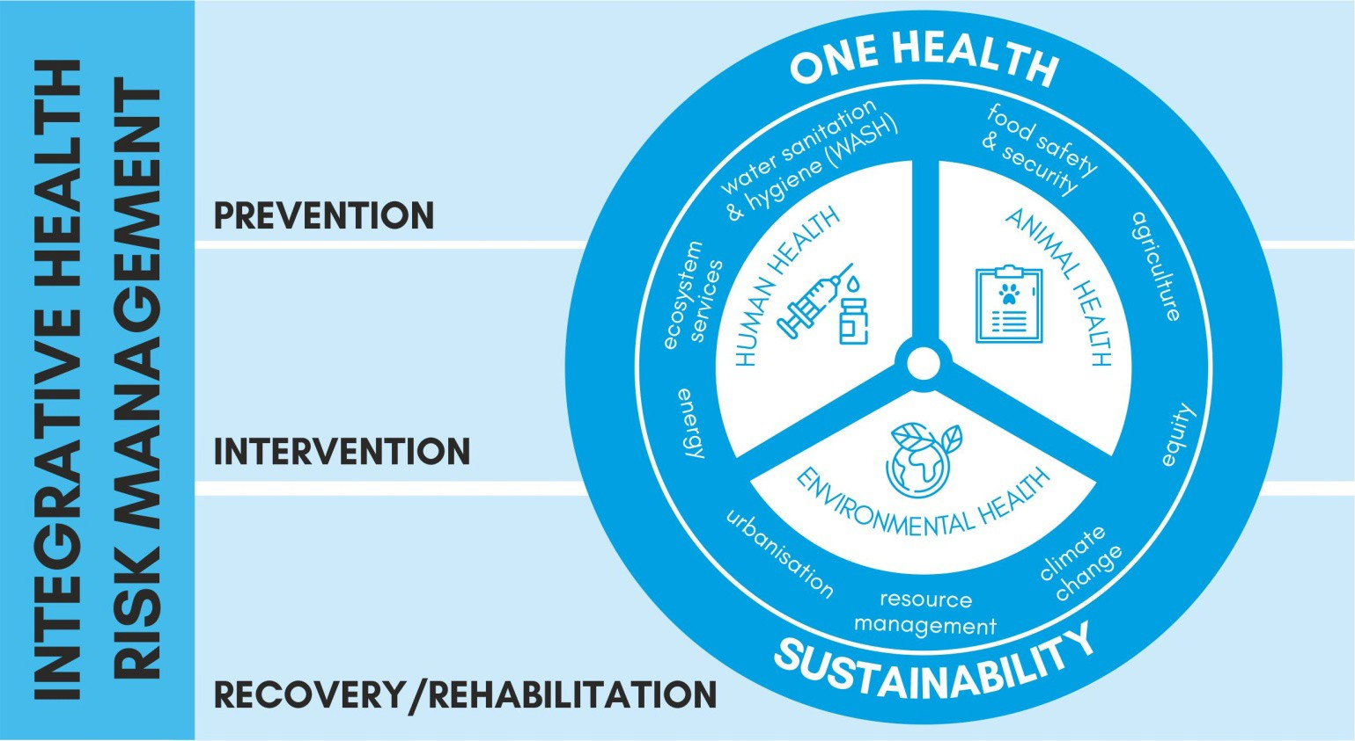

* **Examples of zoonotic diseases:** Japanese encephalitis (JE), Kyasanur forest disease (KFD), Nipah virus infection, Ebola virus disease, Middle East respiratory syndrome (MERS) etc.

**Key guidelines by WHO includes:** Suspension of trade in wild animals, Strengthening the regulatory basis**,** Conducting risk assessments, Strengthening animal health surveillance systems, food safety information campaigns etc.

##### Measures taken to control zoonotic diseases:

* **One health approach:** The concept of ‘**One Health’ recognised by WHO** as health of human beings is connected to health of animals and environment.
  + The **Ministry of Science and Technology** has constituted a **National Expert Group on One Health** to identify priority areas for better understanding of mechanism of virulence, infections and their transmissions.
* **Integrated Disease Surveillance Programme (IDSP):** It strengthens the disease surveillance in the country by establishing a **decentralized State based surveillance system for epidemic prone diseases** to detect the early warning signals so that timely and effective public health actions can be initiated.
* **National Programme for Containment of Anti-Microbial Resistance:** It carries out surveillance of antimicrobial usage, strengthen infection control practices and promote rational use of antimicrobials through Antimicrobial stewardship activities.
* **Inter-Sectoral coordination for Prevention and Control of Zoonotic Diseases**: It strengthens inter-sectoral co-ordination between medical, veterinary, wildlife sector and various relevant stakeholders for prevention and control of zoonotic diseases.

**6.5.4. MEDICAL OXYGEN**

##### Why in news?

**Oxygen Cylinders**

* Compressed oxygen and medical air cylinders are **dedicated refillable containers for holding oxygen/medical gases in a high-pressure, non- liquid state**.
* They are fitted with a valve and a pressure regulator.
* The cylinders can be made of steel, aluminium/alloy, carbon fibre or other composite material and are available in various standard sizes.
* They contain a high purity of oxygen gas and no other types of gases are allowed in the cylinder to prevent contamination.

India has been facing shortage of medical oxygen (MO) at several locations amidst a massive surge in Covid-19 infections.

##### About medical oxygen

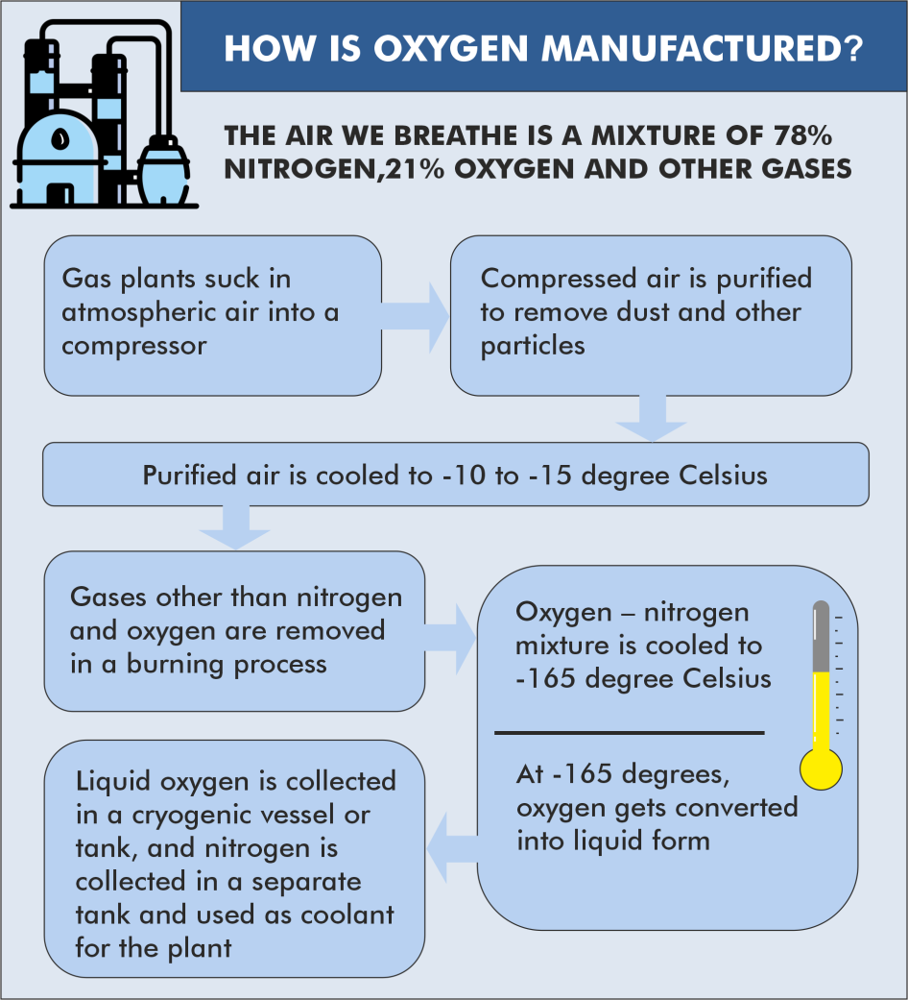

* The term ‘medical oxygen’ means high-purity oxygen, which is used by hospitals and clinics in the treatment of various illnesses that cause oxygen saturation levels in the body to drop.
* It generally comprises of **minimum 90% oxygen** (O2) with 5% nitrogen and 5% argon.
* Medical grade oxygen is highly concentrated and can be obtained in several ways:

##### Liquifying air through a process called cryogenic distillation:

In this method Liquid Medical Oxygen (LMO) with 99.5% purity, is manufactured in large plants using cryogenic distillation techniques to compress atmospheric air, feed it into distillation columns

and get liquid oxygen **(see infographic).**

* + - This LMO is then supplied to distributors where it undergoes a process of regasification to convert the oxygen into gaseous form and fill it in cylinders.
  + **Oxygen concentrator**: It is an electrically powered medical device designed to concentrate oxygen from ambient air.

|  |  |  |
| --- | --- | --- |
| **Differences between Oxygen concentrators and Oxygen cylinders** | | |
|  | **Oxygen concentrators** | **Oxygen cylinders** |
| **Purity of O2 supply** | 90-95 per cent pure | 99.5 per cent pure |
| **Operational Lifespan** | Designed for continuous operation and need just a power source to draw in  ambient air | Require continuous refilling |
| **Suitability for COVID 19**  **patients** | Good enough for mild and moderate Covid-19 patients with oxygen saturation levels of 85% or above, but not  advisable for ICU patients | Can be used for treating all types of Covid-19 patients |
| **Rate of O2 supply** | Low-Moderate (5-10 litres of  oxygen per minute) | High (upto 25 litres of  oxygen per minutes) |
| **Portability** | Portable and lightweight | Cylinders are bulky  and heavy |
| **Temperature requirements** | Need no special temperature for storing oxygen | Need cryogenic tankers for storage and transportation of  LMO |
| **Cost effectiveness** | More expensive than cylinders, but lower operational cost in the long  run | Less expensive but involve refilling and transportation costs |

* + - The device takes in surrounding air, filters it through a sieve (nitrogen-absorbing zeolite membranes), releases the nitrogen back into the air, and works on the remaining oxygen.
    - Concentrators can be attached with multiple tubes to serve two patients at the same time, but experts don’t recommend it due to risk of cross-infection.
  + **Pressure swing absorption (PSA) plants:** A PSA oxygen plant employs a technology that absorbs nitrogen from

ambient air to concentrate oxygen for supply to hospitals. They help hospitals become self-sufficient in their requirement for medical oxygen while also reducing the burden on the national grid for supply of medical oxygen.

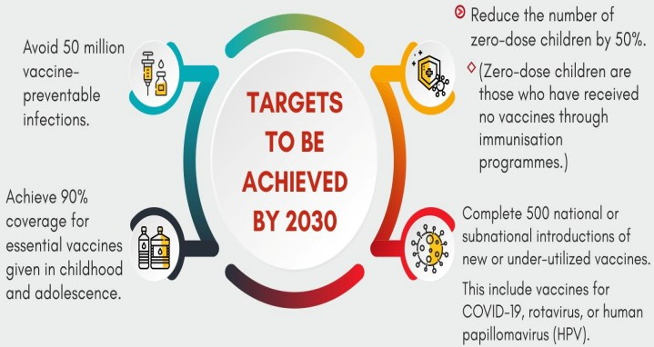

* + - They operate at near-ambient temperatures and use specific adsorbent materials (that trap a substance on their surface) like zeolites, activated carbon, molecular sieves etc., to trap oxygen at high pressure.
    - The oxygen that remains 92-95 per cent pure is compressed and fed into oxygen pipelines.

**6.5.5. IMMUNISATION AGENDA 2030**

##### Why in News?

Recently, global agencies like the World Health Organization (WHO), UNICEF, GAVI and others have launched the **Immunisation Agenda 2030** (IA2030) during World Immunisation Week.

##### About IA2030

* The Immunization Agenda 2030 (IA2030) sets a **global vision and strategy for vaccines and immunization for the decade 2021–2030**.
* **IA2030 envisions** “A world where everyone, everywhere, at every age, fully benefits from vaccines for good health and well-being.”
* It is **based on learnings from Global Vaccine Action Plan (GVAP)** and aims to address the unmet targets of the GVAP.
  + The Global Vaccine Action Plan **2011–2020 (GVAP)** was developed to realize the ambitions of the Decade of Vaccines – that all individuals and communities enjoy lives free from vaccine-preventable diseases through more equitable access to vaccines.

**World Immunisation & Logistics Summit**

* Recently, the **Union Minister for Health and Family Welfare of India digitally participated** in the two-day virtual Summit, hosted by Abu Dhabi, United Arab Emirates (UAE).
* The summit was **organised by the HOPE Consortium’ of UAE** with a call to enhance **collaboration in the world’s approach to tackle COVID-19** and ensure a healthier future for all.
* **About HOPE Consortium**
  + It is a UAE-based **public-private partnership, launched in November, 2020.**
  + It envisages to provide **a complete supply chain solution** to address vaccine transport, demand planning, sourcing, training, and digital technology infrastructure, and **facilitate vaccine availability across the world.**
  + Abu Dhabi Ports has the **Middle East’s largest capacities for cold chain and ultra-cold storage.**
    - UAE will leverage its capabilities as an innovation epicenter serving the Middle East and wider world through Abu Dhabi as a **supply chain gateway connecting East and West.**

**6.5.6. INTENSIFIED MISSION INDRADHANUSH**

##### Why in news?



* Immunization Programme in India was **introduced in 1978 as ‘Expanded Programme of Immunization’ (EPI)** by the Ministry of Health and Family Welfare.
* In 1985, the **programme was modified as ‘Universal Immunization Programme’ (UIP)** to be implemented in phased manner to cover all districts in the country by 1989-90 with the one of largest health programme in the world.
* Under UIP, immunization is providing **free of cost against 12 vaccine preventable diseases**:
  + **Nationally against 9 diseases** - Diphtheria, Pertussis, Tetanus, Polio, Measles, Rubella, severe form of Childhood Tuberculosis, Hepatitis B and Meningitis & Pneumonia caused by Hemophilus Influenza type B
  + **Sub-nationally against 3 diseases** - Rotavirus diarrhoea, Pneumococcal Pneumonia and Japanese Encephalitis.

•

•

•

UIP targets to vaccinate nearly 2.7 crore new-borns each year with all primary doses and an additional ~10 crore

children of 1- 5-year age with booster doses. In addition, nearly 3 crore pregnant mothers are targeted for TT vaccination each year.

The two major milestones of UIP have been the elimination of polio in 2014 and maternal and neonatal tetanus elimination in 2015.

Despite being operational for many years, **UIP has been able to fully immunize only 65% children** in the first year of their life.

Union Health Minister launched Intensified Mission Indradhanush 3.0.

##### About Intensified Mission Indradhanush (IMI)

* In 2014, **Mission Indradhanush** was launched to strengthen and re-energize the programme and **achieve full immunization coverage for all children and pregnant women at a rapid pace.**

##### Aim of IMI

* + The **focus of special drive was to improve immunisation coverage in select districts and cities to ensure full immunisation to more than 90%** by December 2018.
  + **Enhance political, administrative and financial commitment** through advocacy with key ministries/ departments and stakeholders towards full immunization coverage for each child.
  + **Reach all children with all UIP vaccines due for the age** as per the national immunization schedule in the geographic area with focus on children up to 2 years of age and pregnant women. However, vaccination will be provided to children up to 5 years of age.
  + **Sustain the gains made through Intensified Mission Indradhanush through routine immunization** by using IT based platforms for further planning and follow-up.
* In 2017, Intensified Mission Indradhanush was launched to further intensify the immunization programme.
* In 2019, IMI 2.0 launched to **achieve targets of full immunization coverage in 272 districts in 27 States and at block level (652 blocks) in Uttar Pradesh and Bihar** among hard-to-reach and tribal populations.

##### Focus of the IMI 3.0 will be the children and pregnant women who have missed their vaccine doses during the COVID-19 pandemic.

* IMI is closely **monitored at the district, state and central level at regular intervals.** Further, it would be reviewed by the Cabinet Secretary at the National level and will continue to be monitored at the highest level under a **special initiative ‘Proactive Governance and Timely Implementation (PRAGATI)’**.

**6.5.7. INTEGRATED HEALTH INFORMATION PLATFORM (IHIP)**

##### Why in news?

**Integrated Disease Surveillance Programme** (IDSP)

* IDSP was **launched in 2004 with World Bank assistance**.
* It aims to **strengthen/maintain decentralized laboratory- based IT enabled disease surveillance system for epidemic prone diseases** to monitor disease trends and **to detect and respond to outbreaks in early rising phase through trained Rapid Response Team.**

Minister of Health & Family Welfare launched Integrated Health Information Platform (IHIP).

##### More on news

* IHIP is a **web-enabled near-real-time electronic information system** to provide

state-of-the-art single operating picture with geospatial information for managing disease outbreaks and related resources.

* IHIP is the next generation highly refined version of **Integrated Disease Surveillance Programme** (IDSP).
* It is world's biggest online disease surveillance platform and is in sync with the **National Digital Health Mission (NDHM).**

o NDHM is **a voluntary healthcare programme** that aims to reduce the gap among stakeholders such as doctors, hospitals, citizens etc by connecting them in an integrated digital health infrastructure

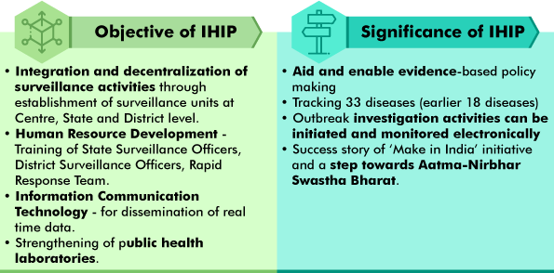

**6.5.8. OTHER IMPORTANT NEWS**

|  |  |
| --- | --- |
| **Trachoma** | * Gambia has become second African state to eliminate Trachoma, after Ghana. * **Trachoma is a neglected tropical disease** and the **leading infectious cause of blindness worldwide.** * It is caused by **repeated infection of the eye** with the bacterium **Chlamydia trachomatis**. * It is **contagious,** spreading through contact with the eyes, eyelids, and nose or throat secretions of infected people. * WHO has set a target for **global elimination** of trachoma **by 2030**.**India eliminated trachoma in 2017.** |
| **Anaemia Mukt Bharat (AMB)** | * AMB strategy was launched in 2018 with the **objective of reducing anaemia prevalence among children, adolescents and women in reproductive age group.** * Intervention under AMB includes giving **prophylactic Iron folic acid supplementation, Deworming, Behaviour change communication programme** etc. * Anaemia is a condition in which the **number of red blood cells or their oxygen-carrying capacity is insufficient** to meet physiologic needs.   o **Iron deficiency is the most common cause** of anaemia. |
| **Acute Encephalitis Syndrome (AES)** | * Year's first AES case has been reported in Bihar. * AES is characterized by an acute **onset of fever and clinical neurological manifestation that includes mental confusion, disorientation, delirium, or coma**. * It is caused by several different **viruses, bacteria, fungus, parasites, spirochetes, chemicals/ toxins etc**. * It predominantly affects the population **below 15 years.** * Locally called ‘**chamkibukhar’**, AES usually surfaces during **summer in the flood-prone districts**   **of north Bihar**. |
| **Guinea Ebola outbreak** | * This marks the first time this disease has been reported in the country since the end of devastating West Africa Ebola outbreak in 2016. * Ebola Virus Disease (EVD) is a rare and **deadly disease in people and non-human primates**. * The viruses that cause **EVD are located mainly in sub-Saharan Africa**. * People can get **EVD through direct contact** with an infected animal (bat or non-human primate) or a sick or dead person infected with Ebola virus. * U.S. Food and Drug Administration **has approved Ebola vaccine rVSV-ZEBOV (tradename “Ervebo”) for the prevention of EVD.** |
| **Pneumococcal Conjugate Vaccine (PCV)** | * Serum Institute of India to start supplying 1st made-in-India PCV to Centre. * Pneumococcal conjugate vaccine **acts against potentially fatal pneumococcal infections,** include any illness caused by pneumococcal bacteria **such as pneumonia, septicaemia and meningitis.** * Conjugate vaccine is a substance that is composed of a polysaccharide **(complex sugars on the surface of bacteria)** antigen fused (conjugated) to a carrier molecule. This enhances the stability and the effectiveness of the vaccine. |

|  |  |
| --- | --- |
|  | * In most conjugate vaccines, the polysaccharide is attached to **diphtheria or tetanus toxoid protein.** * The immune system **recognises these proteins very easily** that helps to generate a stronger immune response to the polysaccharide. * PCVs for pneumococcal **can potentially reduce the dependence on antibiotics** by nearly 50 fifty percent per year. * PCV **can have side effects** ranging from fever, loss of appetite to headache, fussiness |
| **Ketoprofen** | * Recently, Bangladesh banned painkiller ketoprofen. * **Ketoprofen** is painkiller which is used widely to treat the cattle. * Diclofenac and ketoprofen are Non-Steroidal Anti-Inflammatory Drugs (NSAIDs) which are the **primary threats to the vultures of South Asia** and responsible for the catastrophic 99.9% declines of white-rumped vultures in the region. * **In India, diclofenac drug was banned by the Drug Controller General of India** in 2006. |

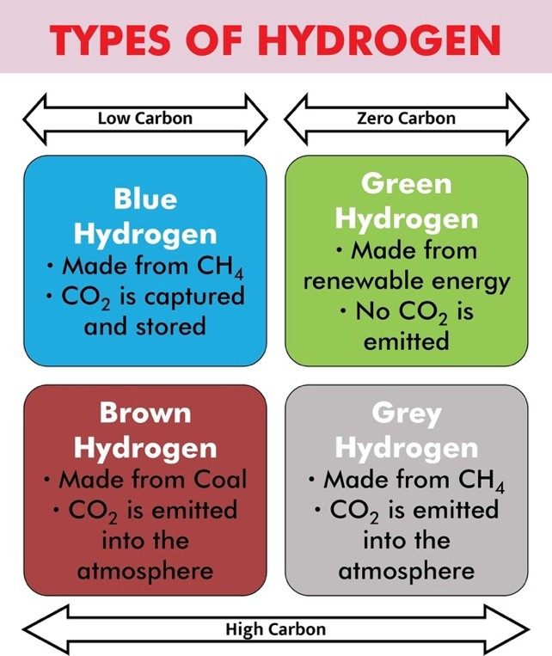

### 6.6. DEFENCE

|  |  |
| --- | --- |
| **Arjun Main Battle Tank (MBT) (Mk-**  **1a)** | * Recently, Prime Minister handed over **indigenously developed MBT to Indian army.** * **Project was initiated by Defence Research and Development Organisation (DRDO) in 1972** with the Combat Vehicles Research and Development Establishment (CVRDE) as its lead laboratory. * Arjun MBT Mk-1A is a weapon platform with **superior firepower, high mobility, excellent protection and crew comfort.** * It also has a **computer-controlled integrated fire control system** with stabilised sighting that **works in all lighting conditions.** |
| **PYTHON-5** | * India's indigenous Light Combat Aircraft, Tejas, has added **the fifth generation Python-5 Air-to-Air Missile (AAM)** to its weapons capability.   + The Python-5 is the **second AAM of Israeli origin to be integrated on the Tejas fighter.**   + It is an infra-red guided missile with a range of at least 20km. * The first missile was the **Beyond Visual Range (BVR) AAM Derby** which is a radar-guided weapon with a range of over 50km. |
| **‘Helina’ and ‘Dhruvastra’ successfully test fired** | * Helina (the Army version) and Dhruvastra (IAF version), are **third-generation anti-tank guided missiles**. * The system has **all-weather day-and-night capability** and can defeat battle tanks with conventional armour as well as with explosive reactive armour. * These have been **designed and developed indigenously** by the Defence Research and Development   Organisation. |
| **NanoSniffer** | * India has developed the world's first **micro-sensor based explosive trace detector (ETD), using a micro-electromechanical system (MEMS), called NanoSniffer.** * It can accurately detect a wide range of military, commercial, and home-made explosives threats. * It provides trace **detection of nano-gram quantity of explosives & delivers result in seconds**. |

**6.7. ALTERNATIVE ENERGY**

**6.7.1. NATIONAL HYDROGEN ENERGY MISSION**

##### Why in news?

Recently, the National Hydrogen Energy Mission was formally announced in the Union budget for 2020-21.

##### About the mission

* The mission emphasizes on **generating hydrogen from green power resources (known as green hydrogen)** and enabling its commercial use.

##### Major activities envisaged under the mission include:

* + Creating volumes and infrastructure;
  + Demonstrations in niche applications (including for transport, industry);
  + Goal-oriented Research & Development;
  + Facilitative policy support; and

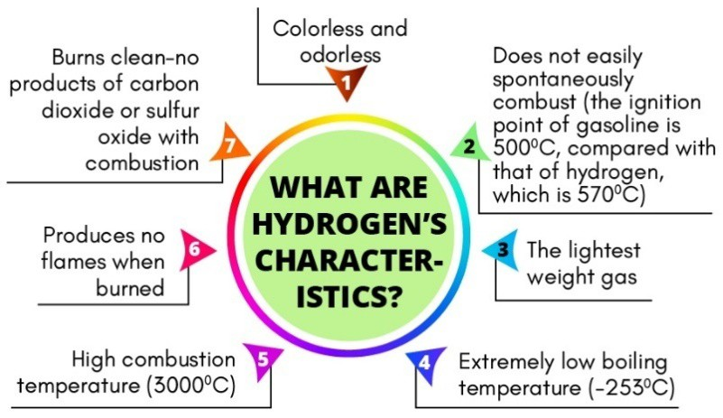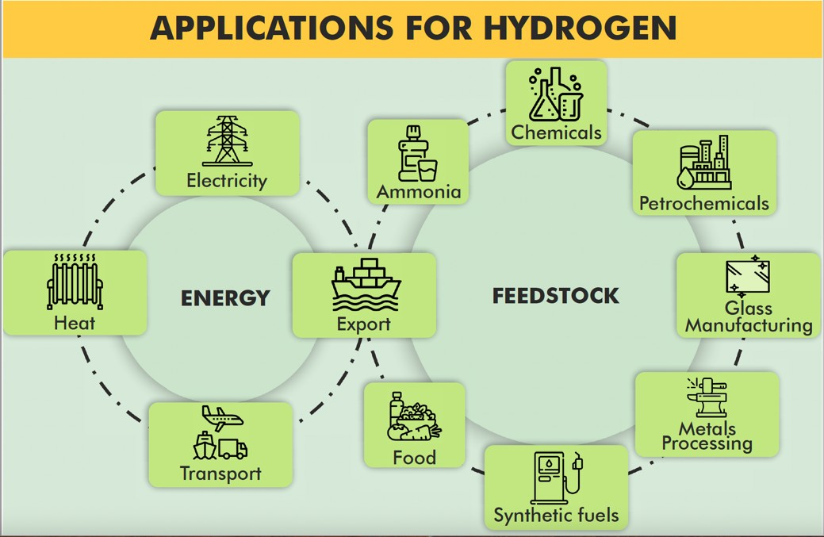

**Related News**

**Hydrogen Roundtable**

* A Hydrogen Roundtable **titled “Hydrogen Economy- the Indian Dialogue-2021”** was organised by Energy Forum (TEF) (an independent think tank) and Federation of Indian Petroleum Industry (FIPI) (an apex Society of entities in the hydrocarbon sector that acts as an industry interface with Government and regulatory authorities) **under the aegis of Ministry of Petroleum and Natural Gas.**
* The objective of the Roundtable is to understand the progress of Hydrogen ecosystem across continents and contribute to creating synchrony among the thinktanks, Governments and the industry to join forces for developing innovative and sustainable technologies at attractive costs.

**India H2 Alliance (IH2A)**

* It is an alliance of energy and industrial firms led by **Chart Industries and Reliance Industries Ltd**.
* The alliance will aid the government efforts towards:
  + Development of **National Hydrogen Policy and Roadmap** by 2030
  + Creation of a **National Hydrogen Taskforce and Mission** in PPP format
  + Creating a **National Hydrogen Fund**, and
  + Developing **Hydrogen-linked capacities** covering hydrogen production, storage and distribution, industrial use cases, transport use cases and standards.

•

•

This includes work on building hydrogen economy and supply chain in India with focus on **blue and green hydrogen**

**production** and **storage.**

The alliance will collaborate with private sector partners, the government and the public.

* + Putting in place a robust framework for standards and regulations for hydrogen technologies.

##### Benefits of using Green Hydrogen Energy

* **Clean source of energy**: Hydrogen is about two to three times as efficient as burning petrol.
* **Potential to transform transportation:** Hydrogen can be used for both fuel cell and internal

combustion engines and is being seen as a direct replacement of fossil fuels.

* **Channelizing renewable energy**: Renewable energy that cannot be stored or used by the grid can be channeled to produce hydrogen. Hydrogen can act as an energy storage option, which would be essential to meet intermittencies (of renewable energy) in the future.
* **Hydrogen FCEV (Fuel cell electric vehicles) are better in comparison to Battery electric vehicles:** Hydrogen FCEV enables a refueling time of just five minutes, compared to 30-45 minutes charging for a BEV (Battery electric vehicles).
  + This also has the **potential to reduce India’s demand for rare earth minerals** that

are used in the manufacturing of batteries for electric vehicles.

* Recently researchers at IITD have successfully split water by a process known as **Sulphur-Iodine (SI)**

thermochemical hydrogen cycle to **generate low-cost, clean hydrogen fuel for industrial consumption.**

o Cycle consists of chemical reactions **whose net reactant is water and net products are hydrogen and oxygen.**

* It might prove favorable for the **commercial production of hydrogen on a large scale.**

**6.7.2. ALUMINIUM-AIR BATTERIES**

##### Why in News?

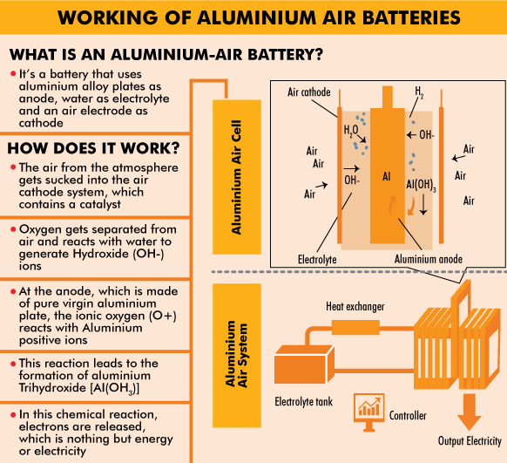

**Recently, Indian Oil Corporation Ltd. entered into a joint venture** with Israel-based battery technology startup Phinergy **to develop aluminium-air technology-based battery systems** for electric vehicles and stationary storage, as well as hydrogen storage solutions.

Apart from aluminium-air, other metal–air batteries that have been extensively studied are **sodium (Na)–air, potassium (K)–air, zinc (Zn)–air, magnesium (Mg)–air etc.**

##### Benefits of Aluminium-air batteries over Lithium-ion batteries.

* + **Significantly cheaper, lighter and more energy-dense** alternative.
  + **Expected to offer much greater range of 400 km or more per battery** compared to lithium-ion batteries (150-200 kilometres) per full charge.
  + Unlike other batteries, aluminium plate in an aluminium-air battery **can be recycled and traded directly for industrial uses.**
* One of the key downsides of aluminium-air batteries is that **they cannot be recharged like lithium-ion batteries.**

### 6.8. MISCELLANEOUS



**About CERN**

* European Organization for Nuclear Research (CERN) is one of the **world's largest centres for scientific research** uses complex scientific instruments **to study the basic constituents of matter – fundamental particles.**
* Here, **subatomic particles are made to collide together** at close to the speed of light and their interaction is studied to provide insights into the fundamental laws of nature.
* The instruments used at CERN are like
  + **accelerators to boost beams** of particles to high energies before the beams are made to collide with each other
  + **detectors to observe and record** the results of these collisions.

•

•

•

It is founded **in 1954, the Franco-Swiss border near Geneva**.

Currently CERN have **23 member states, while India is an associate member state.**

**Japan, Russian Federation, United States of America, European Union and UNESCO** currently have **Observer status.**

**6.8.1. LARGE HADRON COLLIDER BEAUTY EXPERIMENT (LHCB)**

##### Why in news?

Researchers at University of Zurich and European Organization for Nuclear Research (CERN) have found new results at Large Hadron Collider beauty (LHCb) experiment.

##### About Large Hadron Collider beauty experiment (LHCb)

* The LHCb experiment is one of the four large experiments at the **Large Hadron Collider (LHC) at CERN in Geneva.**
* It is **designed to study decays of particles containing a beauty quark,** the quark with the highest mass forming bound states.
  + Beauty quarks are **produced during the collision of high-energy proton beams** in the Large Hadron Collider the particle accelerator at CERN.
    - **Quark are elementary subatomic particles** that interact by means of the strong force and are believed to be among the

##### fundamental constituents of matter.

* + - There are six types of quarks that differ from one another in their mass and charge characteristics, that are grouped in three pairs: **up and down, charm and strange, and top and bottom.**
    - Beauty quarks (bottom

##### quark) are much heavier than the up and down quarks and particles containing b quarks are also unusually long-lived,

which make them very useful to physicists looking for physics beyond the standard mode.

* As per **Standard Model the decay process** involves the conversion of a beauty quark into a strange quark with the production of an electron and anti-electron or a muon and anti-muon.
  + **Electrons are the subatomic particles that orbit the nucleus** of an atom and generally negative in charge. While anti-electron is positively charged also called as positron.
  + **Muon is elementary subatomic particle similar to the electron** but 207 times heavier. It has two forms, the negatively charged muon and its positively charged anti-muon.
* But **results at LHCb show anomalies** in decaying process than standard model with new **fundamental force in addition to four fundamental ones**.
  + Four fundamental forces of standard model are **Gravity, electromagnetism, weak nuclear interactions responsible for radioactivity and strong nuclear forces that hold matter together.**
* This anomalies in result gives **hint of the possible existence of a hypothetical particle called a leptoquark**

has appeared as an unexpected difference in how beauty quarks decay to create electrons or muons.

##### Large Hadron Collider (LHC)

* It is the **world’s largest and most powerful particle accelerator** at CERN’s accelerator complex.
* The LHC consists of a 27-kilometre ring of **superconducting magnets with a number of accelerating structures to boost the energy** of the particles along the way.
* The **beams inside the LHC are made to collide at four locations** around the accelerator ring, corresponding to the positions of **four particle detectors ATLAS, CMS, ALICE and LHCb**.
* The project was officially approved in 1997, and construction began on a 16.5-mile-long (27 kilometers) ring that passed beneath the French-Swiss border capable of **accelerating particles up to 99.99 percent the speed of light and smashing them together.**
* In 2012, the researchers at the LHC announced the **discovery of the Higgs boson**, particle named after physicist Peter Higgs.
  + Hoggs boson is an **elementary particle gain their mass from a fundamental field (Higgs field) through its interactions.**

**6.8.2. OTHER IMPORTANT NEWS**

|  |  |
| --- | --- |
| **Vigyan Jyoti programme** | * Programme now spreads to 100 districts in 2nd phase. * Vigyan Jyoti programme aims to **promote STEM (**Science, Technology, Engineering, and Mathematics) **learning among girl students and to inspire them towards STEM careers** by creating a level-playing field for meritorious girls from grades 9 to 12 to pursue STEM in their higher education.   + It was **launched by Department of Science & Technology** in collaboration with IBM in 2019. * The program provides **a scholarship, visit to nearby scientific institutions, science camps, lecturers from eminent women scientists, and career counselling**.   + It had **been running in 50 Jawahar Navodaya Vidyalayas (JNV)** and has now been   expanded to 50 more JNVs for the year 2021-22. |
| **Kalam Program for Intellectual Property Literacy and Awareness (KAPILA) scheme** | * This scheme is being implemented by **Ministry of Education.** * The **objective of the scheme include**:   + Creating **awareness regarding Intellectual Property Rights (IPR) in Higher Education Institutions (HEIs),**   + **Enabling of IP protection of inventions** originating from faculty and students of HEIs,   + **Training program on IPR for faculty and students** of HEIs and sensitization and   development of vibrant IP filing system. |
| **TECHNOGRAHIS** | * An **Enrolment Module** for **TECHNOGRAHIS** has been launched by Ministry of Housing and Urban Affairs (MoHUA). * TECHNOGRAHIS are **students from IITs, NITs, engineering, planning and architecture colleges**, faculty members etc. * These students **will visit Live Laboratories at six Light House Projects (LHPs)** sites for learning, consultation, generation of ideas and solutions, experimentation, innovation, and technical awareness.   o LHPs are **model housing projects** with houses built with shortlisted alternate technology  suitable to the geo-climatic and hazard conditions of the region. |
| **National Technology Awards (NTA) 2020** | * The awards were given by the Technology Development Board (TDB). * Every year, TDB seeks applications for **NTA for commercialization of technologies under three categories:** * **National Award for successful Commercialization of Indigenous Technology**   + **National Award for MSMEs**   + **National Award for Technology Start-ups** * TDB is a **statutory body, under Department of Science of Technology,** * TDB **provides financial assistance to Indian industrial concerns and other agencies**, attempting development and commercial application of indigenous technology, or adapting imported technology to wider domestic applications.   o Since its inception, TDB **has funded more than 300 companies** for commercialization of technologies. The notable are Bharat Biotech International Limited, Reva Electric Car  Company Tata Motors etc. |
| **Einsteinium** | * Scientists have **reported some of the properties of element 99 in periodic table called “Einsteinium”,** named after Albert Einstein.   o It was discovered in 1952 in the debris of the first hydrogen bomb.   * Because of **difficulty in creating, short half-life of all its isotopes and of its radioactive nature**, scientists were not able to perform experiment on it. * Studying its atomic arrangement **may prove useful for nuclear power production and radiopharmaceuticals.** |
| **Cadmium (Cd) doped Silver Antimony Telluride (AgSbTe2)** | * It is a **new Lead-free material** which can efficiently **convert waste heat to power small home equipment and automobiles**. * It is based on **thermoelectric energy conversion** that allows generation of electrical voltage when one end of a material is heated while keeping the other side cold.   o Most efficient thermoelectric materials developed by scientists so far **use Lead (Pb) as a**  **major constituent element, restricting their use for mass-market applications.** |

|  |  |
| --- | --- |
|  | * **It was developed by scientists from Jawaharlal Nehru Centre for Advanced Scientific Research (JNCASR), Bengaluru**, an autonomous institution of the Department of Science & Technology. |
| **Gelatin sticks** | * **Gelatin sticks are cheap explosive materials** used for mining and construction related work, like building structures, roads, rails and tunnels etc. They cannot be used without a detonator. * Manufacturing of gelatin sticks is **regulated by Petroleum and Explosives Safety Organization (PESO)**. * **PESO, under Ministry of Commerce, is the nodal agency** for regulating safety of hazardous substances such as explosives, compressed gas and petroleum. |

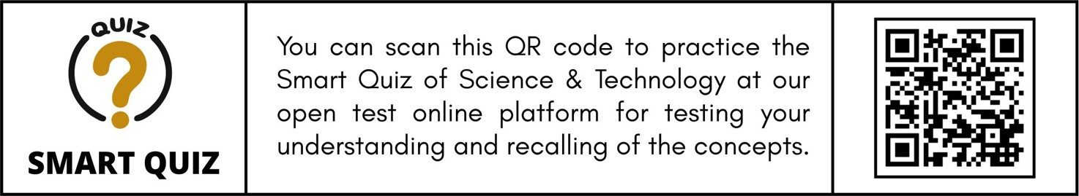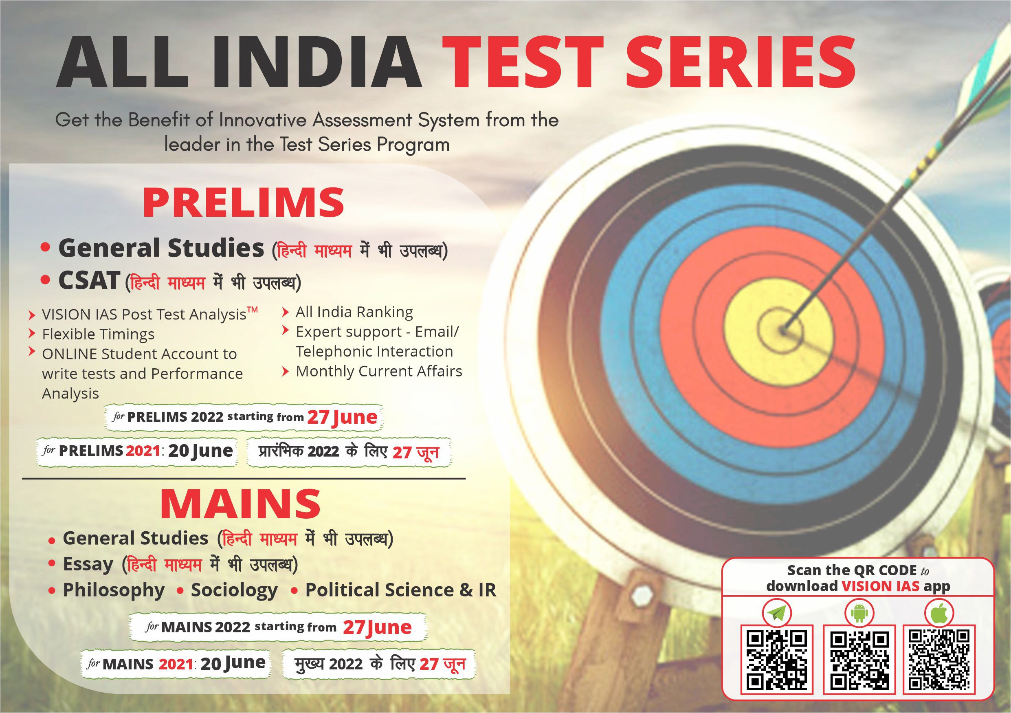

# CULTURE

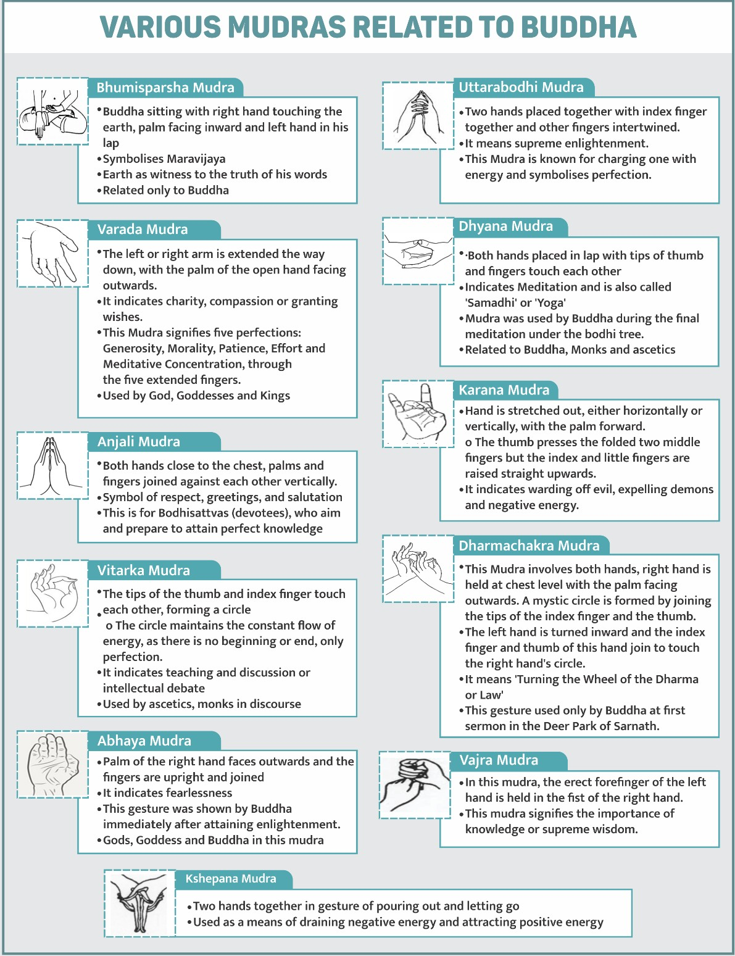

### 7.1. SCULPTURE AND ARCHITECTURE

**7.1.1. ANCIENT BUDDHIST MONASTERY**

##### Why in news?

A 900 years old Ancient Buddhist monastery was recently unearthed by Archaeological Survey of India (ASI) in Sitagarhi Hills, Hazaribagh district of

Jharkhand.

##### More about Findings

* It is a 10th century structure resembling a **small ‘Buddha Vihar’ (Buddhist shrine-cum- monastery).**

##### Discoveries around the site o Four

statues of **deity Tara in ‘Varad Mudra’** (gesture of hand showing dispensing of boons)

* + Six statues of the

**Buddha in ‘Bhumisparsa Mudra’** (gesture of hand showing five fingers of right hand towards the earth symbolising the Buddha’s enlightenment).

* + Discovery of the statue of **deity Taara** shows that the **region was an important centre of Vajrayana sect of Buddhism (Tantric Buddhism).**
    - **Nagri script** (a previous version of **Devanagri script**) on a Tara statue was found.
  + Sculpture similar to **Shaivite deity Maheswari** (with a coiled crown and chakra) indicates **cultural assimilation in the area**.
* Monastery is **on the old route to Varanasi, from Sarnath** (where the Buddha gave his **first sermon).**
* Some findings at excavation site **represents about Pala period**, but **need to be confirmed** with scientific dating of structures.

**17cW**

**7T]cdah**

**(@PSPZW)**

**BP\VhP[ 8h]Pbch**

**GWTh A^]PbcTah**

**(@PSPZW)**

**BP\VhP[ 8h]Pbch**

**<T\Xb A^]PbcTah**

**17cW**

**7T]cdah**

**15cW**

**7T]cdah**

**\1X1cW 1&2cW**

**RT]Sc-dah**

**HWXZbTh A^]PbcTah**

**(@PSPZW)**

**>P]VbT\ GWTaPQ NP]V_^**

**11cW**

**7T]cdah**

**[P 8h]P**

**(6XWPa)**

**DP bch**

**JXZaP\bWX[P A^]PbcTah**

**8cW-9cW**

**7T]cdah**

**7cW**

**7T]cdah**

**7**

**5 -6**

**T]cdah**

**CSP]cP_daX A^]PbcTah**

**(6XWPa)**

**DP[P 8h]Pbch**

**5cW**

**7T]cdah**

**bXSSPRPahP**

**(@PSPZW)**

**APWP BPa^_P**

**@P\Phdad A^]PbcTah**

**(6XWPa)**

**;d_cP 8h]Pbch**

**BP[P]SP A^]PbcTah**

**>PVPSSP[P A^]PbcTah**

**(B^acW 6T]VP[, 6P]V[PSTbW)**

**DP[P 8h]Pbch**

**JP[[PQWX A^]PbcTah**

**(;dYPaPc)**

**APXcaPZP 8h]Pbch**

**cW cW**

**1**

**2**

**3**

**4**

**S 6**

**7**

**8**

**9**

**b,AE;,BE #HW AHBA[bEW,E[**

**Vajrayana Buddhism (Tantric Buddhism)**

* Vajrayana School developed as a result of royal courts sponsoring both Buddhism and Shaivism and said to be influenced by Hinduism.
* The main deity is Tara and is based on Mahayana Buddhist philosophy.
* Also, said that it borrows tenets from both Mahayana and Theravada Buddhism while adding an innovation of its own.
* It involved combining Brahmanical (Veda based) rituals with Buddhist philosophies.
* This school believes in Tantra’s, Mantras and Yantras superiority to achieve Buddhahood without the difficulties.

**7.1.2. AHOM KINGDOM**

##### Why in news?



**About Pala dynasty and Buddhism**

* **Pala dynasty ruled Bihar and Bengal** from the 8th to the 12th century.
  + Its founder was **Gopala** and other important rulers were **Dharmapala**, **Devapala, Mahendrapala and Mahipala I**.
* Pala rulers were **supporters of Buddhism.**
  + Under the Palas the **Vajrayana form** of Buddhism became a major intellectual and religious force.
  + They **made monasteries (viharas) and temples** in eastern India to promote Buddhism.
  + **Dharmapala**, the second Pala ruler, **founded the Vikramshila University** in Bihar and **revived Nalanda University**.
    - **Devapala granted five villages** for the maintenance of Nalanda monastery.
  + Other important Buddhist centers of learning were

**Odantapura, Vikramashila,**

**Mahavihara**.

**and**

**Somapura**

* **Pala’s sent missionaries** and Buddhism was

established in **Tibet**.

* At **Mahabodhi Temple** at Bodhgaya, many **sculptures** are dated to the 8th century **Pala Period.**
* A **miniature terracotta image** of a fasting Buddha, a six-foot-tall votive stupa and a black stone statue of Buddha in abhay mudra (fearless mode) from the **Pala period** reflect the ubiquity of Buddhism then.
* It is said that last **great phase of Buddhist art** in India is attributed to the **Pala period**, with the **collapse of the Pala dynasty** in the 12th century, Indian **Buddhism suffered setback** and the Buddhist presence in India became negligible.

Prime Minister made visit to **Sivasagar’s Jerenga Pothar in Assam**, which has historical significance related to Ahom Kingdom.

##### More on news

* Sivasagar (formerly known as Rangpur) was the **seat of the powerful Ahom dynasty, who ruled Assam**

for six centuries (1228-1826).

* Jerenga Pothar in Sivasagar town is popularly connected to **the valour of 17th century Ahom princess Joymoti (wife of the Ahom prince Gadapani).**

##### About Ahom Kingdom

* Ahoms **migrated to the Brahmaputra valley from present-day Myanmar.**
* Ahom kingdom was **founded by first Ahom king Chao Lung Sui-Kha-Pah** in 13th-century.

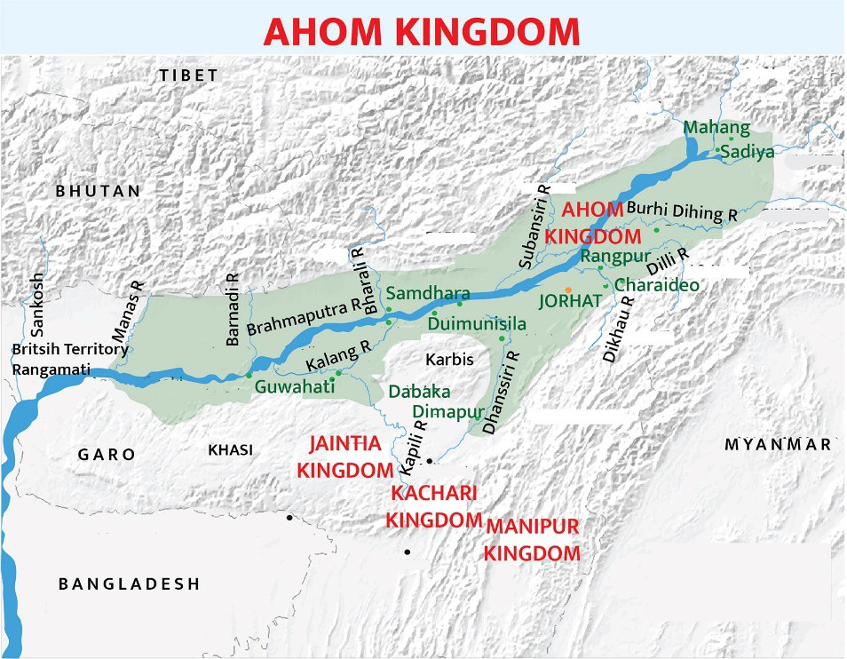

* + Before his arrival the region was thickly forested and **inhabited by local kings Sootias, Boharis, Kacharis and Bhuiyan’s (landlord).**
  + Sui-Kha-Pah was **successful in assimilation of different communities and tribes.**
  + He is widely referred to as the **architect of** “**Bor Asom” or “greater Assam”.**
* During the 16th century, they **annexed the kingdoms of the Chhutiyas (1523) and of Koch-Hajo (1581)** and subjugated many other tribes.
* Ahom Dynasty governed the region for six centuries from 1228 CE till it **was annexed by the British in 1826 CE**, and coexisted with Delhi Sultanate (1206-1526 CE) and Mughals (1526-1857 CE).

##### Kingdom laid the foundation for present day Assamese culture, tradition, art and architecture.

* **Ahoms’ religion**
  + The founders of the Ahom kingdom **had their own language and followed their own religion.**

##### Later during Rudra Simha’s reign that the Ahoms officially adopted the Assamese

**religion and language**, also with blend of traditional folk and Mughal influence.

* + - Later Ahom rulers **embraced Hinduism** due to influence of Brahminism and became devout **patrons of the Neo-Vaishnavite** movement led by Shankardeva. However, **did not completely give up traditional beliefs.**

##### Ahom’s Society

* + Ahom society was divided into **clans or khels who controlled several villages.**
  + Ahom state depended upon **forced labour** and those who forced to work for the state were called **paik**.
  + Ahom kingdom had very **few castes of artisans**, so artisans in the Ahom areas **came from the adjoining kingdoms.** Ahom society used to give **land grants to poets and scholars**.
  + The **peasant was given land by his village community** and even the king could not take it away without the community’s consent.
  + Almost all **adult males served in the army during war**, while at other times, they were **engaged in building dams, irrigation systems and other public works**.
  + **Ancestor worship** was and still remains a very important part of the Ahom culture, which is reflected in the elaborate **maidams (burial tombs)** that the Ahoms built in the **sacred city of Charaideo.**

##### Ahom’s Art and architecture

* + Ahom style of **architecture presents a unique blend of distinct architectural styles** ranging from domes and arches inspired by **Mughal architecture** to great shikhara and mandapas of **Hindu architecture.**
    - During the **early years**, Ahom architects **primarily used wood and bamboo** to construct their palaces and other important structures.
    - Later started to **use of bricks and an organic cement made out of eggs, fish, molasses, pulses and lime**. **Gargaon Palace** was the first structure to be constructed using these materials
    - **Rudra Simha, Ahom king invited many skilled architects, painters, dancers and musicians** from Bengal and other parts of India to his new capital of Rangpur, commissioning them to build a majestic city.
    - Magnificent temples like **Shivdhol, Devidol and Vishnudol on the banks of the Sibsagar tank**, **Rang Ghar sports complex** are unique to the Ahoms.
    - Another defining feature of Ahom architecture is **the excavation of large tanks**, most notably

**Joysagar**, which is the **largest tank** to be excavated under the patronage of Rudra Simha in 1698.

##### Ahom encouraged theatre and important works of Sanskrit were translated into the local language.

* + - Historical works, known as **buranjis, were also written first in the Ahom language and then in Assame.**



**Related news**

* PM also visited **martyr town of Dhekiajuli in Assam.**
* Dhekiajuli is **associated with Quit India Movement** of 1942 where Assam’s freedom fighters laid down their lives.

o It is also home to **Tileswari Barua who is considered the youngest (12 year old) martyr of Indian freedom struggle.**

**7.1.3. ART FORMS IN NEWS**

|  |  |
| --- | --- |
| **Pattachitra paintings** | * Originated as early as the 12th century, Pattachitra style of painting is **one of the oldest art forms of Odisha.** * Pattachitra is a **picture painted on a piece of cloth, and is manifested by rich colourful application,** creative motifs and designs, and portrayal of **simple themes, mostly mythological in depiction.** * This **form of art is closely related to the cult of Shri Jagannath** and the temple traditions in Puri. |
| **Tholpavakkoothu** | * It is a **shadow puppetry** which is prevalent in Bhagavathy temples (mother Goddess) in Palakkad district and nearby regions in Kerala. * In this, **Tholppava (Thol means leather, Pava means puppet)** are moved with the help of strings, and their shadows are depicted on a screen with the help of a row of oil lamps in background. * Story of Tholppavakoothu performance is **from the Indian epic, Ramayana.** * **Some major shadow puppetry in India:** TogaluGombeyatta,   Karnataka; TholuBommalata, Andhra Pradesh; Ravanachhaya, Orissa |
| **Sattras** | * Sattras are **monastic institutions created as part of 16th century Neo-Vaishnavite reformist movement** started by saint Srimanta Sankaradeva (1449-1596) in **Assam**. * Today, there are about 900 Sattras across Assam, promulgating Sankardeva’s unique **“worship through art” approach with music (borgeet), dance (xattriya) and theatre (bhauna).** * Sankardeva **propagated a form of Bhakti called eka-sharana- naam-dhrama**, and espoused a society based on equality and fraternity, free from caste differences, orthodox Brahmanical rituals and sacrifices. * His teaching focused on **prayer and chanting (naam) instead of idol worship.** |
| **Bhaona** | * 'Bhaona' is a traditional **theatrical performance of Assam.** It was **created in Assamese and Brajavali languages by 16th century Srimanta Sankardeva.** * He created the form, usually staged **in “namghars” (places of worship) and “xatras” (Vaishnavite monasteries),** to convey religious messages to villagers through entertainment. * The special features of Bhaona include **plays, dialogues, dances, costumes, ornaments, entry and foot-steps of characters.** * Majuli is the centre of Assam’s Vaishnavite culture and Bhaona. * Musical instruments include **Khol, Taal, Doba and Nagara.** |
| **Kambala** | * It is **an annual buffalo race which is a tradition in Karnataka’s**   Dakshina Kannada and Udupi districts’ farming community.   * Festival is purely **dedicated to Kadri's God Manjunatha,** who was an incarnation of Lord Shiva |

### 7.2. HISTORICAL EVENTS

**7.2.1. GURUDWARA REFORM MOVEMENT**

##### Why in news?

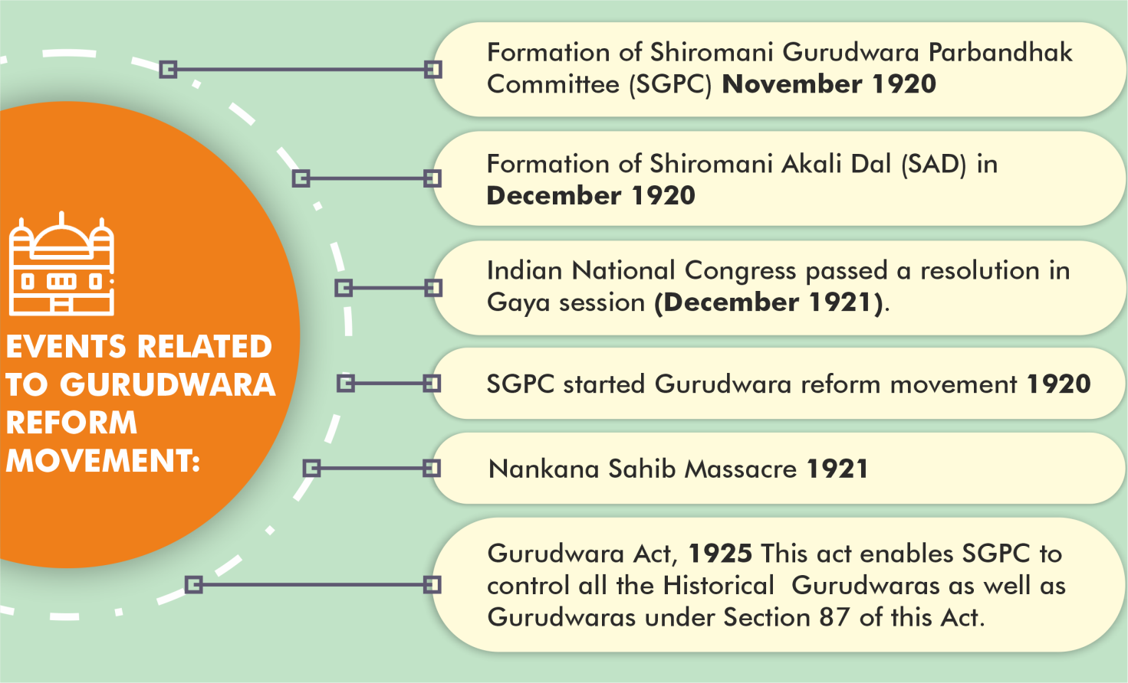

**Sikh Gurudwara Parbandhak Committee (SGPC)**

* It is an **organization which manages the historical Sikh Gurudwaras of** Punjab, Haryana, Himachal Pradesh and Chandigarh.
* **Present composition**: 140 elected members, 5 head ministers and 15 co-opted members. 20 seats are reserved for scheduled caste Sikhs.
* Tenure of the committee is **5 years.**
* The three Sikh takhts in Punjab are directly controlled by SGPC.

Recently, the **centenary of the Sri Nankana Sahib massacre (popularly known as Saka Nankana Sahib)** was marked. This agitation was a big leap in the Gurudwara Reform movement.

##### About Gurudwara Reform movement

* Gurudwara Reform movement/ Akali

##### Movement was Sikhs’ long-drawn campaign between 1920 to 1925 for the liberation of their gurudwaras

or holy shrines from the preists (Mahants) who had asserted property rights over Gurudwaras.

* + It was an **offshoot of the Singh Sabha Movement** (1873).
* The properties of places of worship of Sikhs were **transferred and given over to the Udasi Mahants by Britishers.**
  + Mahants considered the Gurudwara as their fiefdom and **encouraged practices** such as idol worship, discrimination with Dalits, drinking etc. in **violation of the tenets of Sikhism.**
  + Sikhs claimed that **Gurudwaras were public property; hence, the public could remove mahanats** in case of their inability to conform to the wishes of people.
* People, who agitated against such persons, were suppressed by the Government and the **result was Gurudwara Reform movement/ Akali Movement** in which

Sikhs had to face imprisonment, suffer atrocity and death.

**7.2.2. CHAURI CHAURA**

##### Why in news?

Prime Minister released a postage stamp to **mark the centenary of the event Chauri Chaura (4th February, 1922).**

##### About Chauri Chaura incident

* It happened **during Non-Cooperation Movement (NCM) in Chauri Chaura village of Gorakhpur, Uttar Pradesh.**
* During the movement, **group of protesters were thrashed by the police** for mocking foreign cloth, meat and liquor.

##### In return, on 4 February 1922 a mob set the police station on fire, killing 23 policemen.

* More than 200 protesters were put on trial by the British administration for the Chauri Chaura incident, **19 sentenced to death and six of them died in police custody**.
* In response to the violence at Chauri Chaura in 1922, **Gandhi called off the NCM unilaterally** and thus**,** on 12 February 1922, the Non-Cooperation Movement came to an end.
* **Gandhi’s decision to call off** the Non-Cooperation Movement on 12 February 1922 after Chauri-Chaura incident, due to fear of the growth of radical forces **was not supported by many and said unjustifiable.**
  + Leaders like C. R. Das, Motilal Nehru, Subhash Chandra Bose, Jawaharlal Nehru, Sardar Patel and Rajendra Prasad **reluctantly accepted Gandhi’s call**.
  + Lala Lajpat Rai famously said on Gandhi’s decision: **Our defeat is in proportion to the greatness of our leader.**
  + Some critics also claimed that movement was called off **to protect the interests of landlords and capitalists.** Their criticism was based on the **Bardoli resolution of 12 February 1922** which while announcing the withdrawal, **asked the peasants to pay taxes and tenants to pay rents.**
  + Despite withdrawing from the movement, **in March 1922 Gandhi was sentenced to six years in prison,** but was released in February 1924 on health grounds.

### 7.3. PERSONALITIES IN NEWS

|  |  |
| --- | --- |
| **Personalities** | **Details** |
| **Raja Suheldev** | * Recently, the Prime Minister laid down the **foundation stone for a statue of Raja Suheldev** as well as for the development work at Chittaura Lake **in Bahraich,** Uttar Pradesh (UP). * Raja Suheldev was **an 11th century ruler of Shravasti** (present day Bahraich), UP. * Suheldev is said to have been a Rajbhar or Bhar Rajput, and is **celebrated as a king who saved the Hindu religion from Turkish invaders.** * He is credited with gathering together heads of tribes including the **Tharu and Banjara**, and the rulers of several small estates, **to resist the Turkish invaders.** * **In battle in Bahraich in 1034 AD**, he defeated and **killed Ghaznavi general** Ghazi Salar Masud also known as Ghazi Miyan (nephew of Mahmud of Ghazni)**.** * This battle of Bahraich is mentioned in the Persian hagiography **‘Mirat-i-Masudi** (or Mirror of Masud) written **by Abdur Rahman Chishti** in the 1620s. * **Chitaura lake** is a Hindu pilgrimage site, centred around a pond in Bahraich, UP.   o The site is believed to be the place where **the fight between**  **Raja Suheldev and Ghazi Salar Masud took place in 1034 AD.** |
| **Bir Chilarai** | * Bir Chilarai (1510-1571 AD) was a **general of the Koch Royal Dynasty of Assam** and played a crucial role in expanding empire of his elder brother, Nara Narayan. * He was **son of Maharaja Viswa Singha,** the founder ruler of Koch royal dynasty. * Assam government confers **Bir Chilarai Award**, the highest honor for bravery to individuals. |
| **Mannathu Padmanabhan** | * Mannathu Padmanabhan ( 1878 –1970) was a **social reformer and freedom fighter from Kerala.** He is recognized as **founder of Nair Service Society (NSS)**, organization working for welfare of Nair community. * He **took part in Vaikkom (1924) and Guruvayoor Sathyagraha**   (1929) related to temple entry.   * He became **president of the Travancore Devaswom Board in 1950.** * In 1959 he l**ed the united opposition's 'Vimochana Samaram'**   against the State Communist Ministry.   * He was awarded Padmabhushan in 1966. |
| **Ayya Vaikunda Swamikal** | * Ayya Vaikunda Swamikal (1809-1851) was a **social thinker and reformer who lived in the Princely Kingdom of Travancore** in 19th century Kerala. * He **critiqued caste discrimination and religious hierarchy** and fought against **practice of untouchability.** He **discouraged idol worship.** * His gave the call '**One Caste, One Religion, One Clan, One World, One God'.** |

|  |  |
| --- | --- |
| **Pandit Bhimsen Joshi** | * Recently, **year-long Birth Centenary celebrations** of Pandit Bhimsen Joshi (February 4, 1922 - January 24, 2011) started. * He was a **Hindustani classical vocalist from Karnataka.** * A **member of the Kirana Gharana,** he is renowned for the khayal form of singing, as well as for his popular renditions of devotional music (bhajans and abhangs). * He was **honoured with Bharat Ratna in 2008.** * In 1975, he was awarded the **Sangeet Natak Akademi Award**. |

**7.4. FESTIVALS**

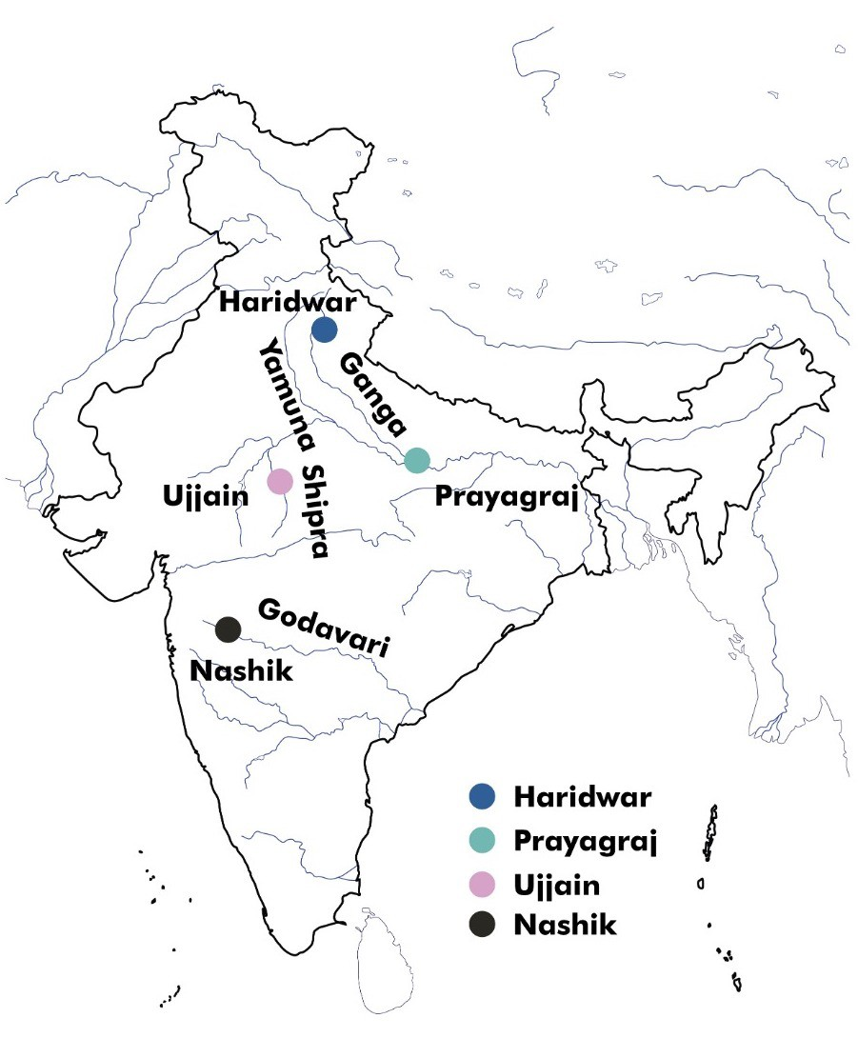

**7.4.1. KUMBH MELA**

##### Why in news?

Recently Kumbh Mela was held at Haridwar, Uttarakhand.

##### About Kumbh Mela

* After more than 100 years the Kumbh Mela was **held earlier because of specific auspicious dates.**
  + Generally, it is **celebrated once in 12 years** and the previous kumbh in Haridwar was held in 2010, while next one was to be held in 2022.

##### Kumbh Mela is a mass congregation of pilgrims who gather to take a bath/dip (Shahi Snan) in a sacred river.

* + People from **irrespective of caste, creed or gender** are present in the festival and believe that by **bathing in the river one is freed from their past sins (karma)**, and, thus, one becomes **eligible for liberation from the cycle of birth and death**.
* The geographical location for

the Kumbh Mela spans across **four cities within India.**

* + **Prayagraj (Uttar Pradesh)- confluence of Ganga, Yamuna, and the mythical Saraswati**
  + **Haridwar (Uttarakhand)- Ganga river**
  + **Ujjain (Madhya Pradesh)- Shipra river**
  + **Nasik (Maharashtra)- Godavari river**
* **Types of Kumbh Mela and its occurrence**
  + **Kumbha Mela**: held at all four places every 3 years
  + **Ardha Kumbha Mela**: held at Haridwar and Prayagraj every 6 years
  + **Purna Kumbha Mela**: held only at Prayagraj every 12 years
  + **Maha Kumbha Mela**: held only at Prayagraj every 144 years or after 12 Purna Kumbh Mela.
* Kumbh Mela comes under the **UNESCO's Representative List of Intangible Cultural Heritage of Humanity.**

**/**{**A •**  [www.visionias.in](http://www.visionias.in/)

#### 7.4.2. 14TH APRIL: HOW INDIA CELEBRATES ITS NEW YEAR



•

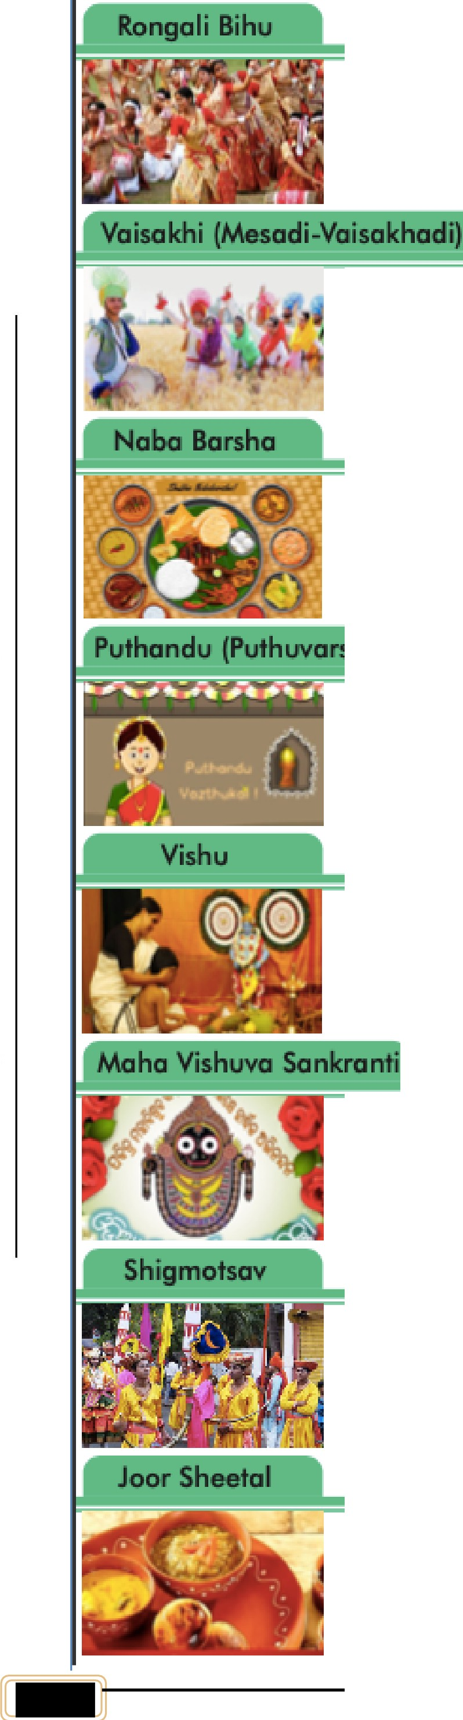

|  |  |  |
| --- | --- | --- |
| It is celebrated in **Assam .**   * It is a lso coUed **Bahag Biku.** * It marks the beginnili'll!J of **Aua:rnese New Year .** | | |
| * It is a ha rwi:st festival c:e le b rutedl in **P,** | | **un,jab .** |
| * It a lso has histo rica l sig nifica nce for iihe **Sikhs** as in 169'9, **Guru Gobind 5,i n g'.h** {l Oiih spfritual guru of Sik hs.) chose iihe fes.t, iva ll 0 1s the moment to esto1 blis h **Khalsa.** | | |
| * It is celebrated in **Wes1 Be:ngal** and is. also oolle d **Poila Ba isak h.** * It is **cele 'bra t i:on of** fhe **new yeal!'** as per the **Beng ali Calendar.** | | |
| **sham/Pirappu)** |  | |
| * It is celebrated in **Tamil Neid** u a s new r ear. * It is a lso m,entioned in **Sa:ngam lite r a ture .** | | |
| * It rs ce le bm te d in **Ke..ala** as newyeor. * This. fest i,va l irnrolves wors hip of **Lol!'d Vishnu** and **Loni Krishna** by he devotees. | | |
| * It rs ce le bm te d in **Odisha** as new year; * Special pujc:s me oonducted at **S:ri Ja:gannath Temple,** Puri. | | |
| * Po p ulla rlly kli'llown0 1s **Shigm o,** It is. **celebrated i'n Goa** on a fo ll moon day   d uring Ma rch .   * It is us ua lly celebrated **2 weeks befo..e H ol ii.** * It **:sig n ifiia . change iin season** from wfmer to summer and l(le le bro tes paddy   ha rvest .   * **Tra:ditiional folk da:rtees** like **Ghode M odni** (da nce of, e q ue stria n wa rr r.o rs },   **Gopha and Phuga,d i a** re performed a lon g1 with pro cess ions . | | |
| * It is celebrated in **B.i ha r .** * It is a lso coUed **Ma ifihili New Yea !!'.** * In t his. fe st iva l peo plle **donaite earthen pitcher containing water to priie st,s**   i n **tem pl e s.** | | |

-**fl**

I.·-

.**a**..,**,**

**fl**

:E

.**:**.**:**.**:s**,

**-a**

"E'

**0**

**0**

I. **UI UI**

-

**fl**

**u**

**-a**

.**a**..,**,**

**fl**

**-aa.**

::::,

**155**

**r**

DELHI | JAIPUR | PUNE | HYDERABAD | AHMEDABAD | LUCKNOW | CHANDIGARH | GUWAHATI © Vision IAS



### 7.5. MISCELLANEOUS

|  |  |
| --- | --- |
| **Particulars** | **Details** |
| **Dickinsonia** | * Researchers believe that they have found **India’s first fossil of Dickinsonia in Bhimbetka.** * Dickinsonia is **considered to be Earth’s oldest animal,** dating back 570 million years ago (late Ediacaran period). It is an **extinct genus of a basal animal** (animals which have radial symmetry in their body plans).   + It is considered an **integral links between the early, simple organisms and then explosion of life in Cambrian Period** that was around 541 million years ago.   + Dickinsonia has been found in Australia, Russia, Ukraine, China. * Dickinsonia’s discovery in India **will pave way for further assessment of biogeographic provinces and also plate tectonic reconstructions** for late Ediacaran.   + It also confirms **assembly of Gondwanaland (ancient supercontinent) by 550 Ma.** * **Note-** Earlier, in 2019 **fossils of Denisovans (an extinct species or subspecies of archaic human) was found in a Siberian Cave.** * **About Bhimbetka**   + Bhimbetka Caves are situated in **foothills of the Vindhyan Mountains (Near Bhopal) in Madhya Pradesh.**   + It is also a **UNESCO world heritage site**.   + Oldest cave paintings in Bhimbetka are **believed to be about 12,000**   **years old** mostly made in red and white. |
| **Gandhi Peace Prize for Year 2019 and 2020 announced** | * 2019 award is conferred to **Majesty Sultan Qaboos bin Said Al Said of Oman**   and 2020 award to Bangabandhu **Sheikh Mujibur Rahman of Bangladesh.**   * It is an **annual award since 1995, the 125th Birth Anniversary commemoration year of Mahatma Gandh**i. The award is open to all persons regardless of nationality, race, language, caste, creed or sex. * It carries an amount of Rs. **1 crore, a citation, a plaque and an exquisite traditional handicraft item.** * Recent awardees include Ekal Abhiyan Trust, India (2017) and Shri Yohei Sasakawa, Japan(2018). |
| **Sahitya Akademi Fellowship (SAF)** | * Recently, Sahitya Akademi Fellowship was awarded to a distinguished scholar, writer, translator and critic, **Professor Velcheru Narayana Rao.** * SAF is the **highest literary honour in the country awarded by Sahitya Akademi**.   o Sahitya Akademi is an **autonomous organization under Ministry of Culture** working to promote literature in the languages of India including English.   * This honour is reserved for **'the immortals of literature' and limited to 21 only at any given time.** * Sahitya Akademi has also **instituted a Premchand Fellowship named after Premchand during his 125th Birth Anniversary in 2005.** |
| **Places of Worship (Special Provisions) Act, 1991** | * Supreme Court sought the Centre’s response on PIL challenging Constitutional validity of the Act. * The Act **prohibits conversion of any place of worship** and to provide for the maintenance of the religious character of any place of worship as it existed on the 15th day of August, 1994. * It seeks to **impose a positive obligation to maintain the religious character** of every place of worship. * It however, excluded the disputed site of Ayodhya. |
| **Zo tribe** | * These are indigenous people found in India, Bangladesh and Myanmar.   o Recently, **Zo Reunification Organisation (ZORO)** has asked Centre to revoke order directing four north-eastern States bordering Myanmar to deport people who have taken refuge in India following military  coup. |
| **Matua Community** | * Prime minister on his visit to Bangladesh **met the Matua community members of Orakandi (**the birthplace of community's spiritual guru Harichand Thakur) in Gopalganj, India. |

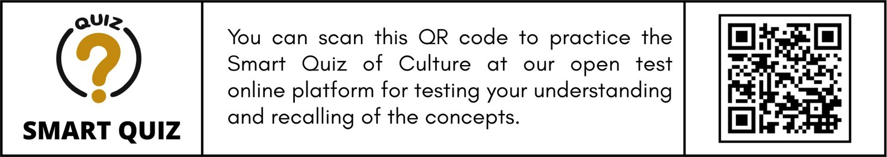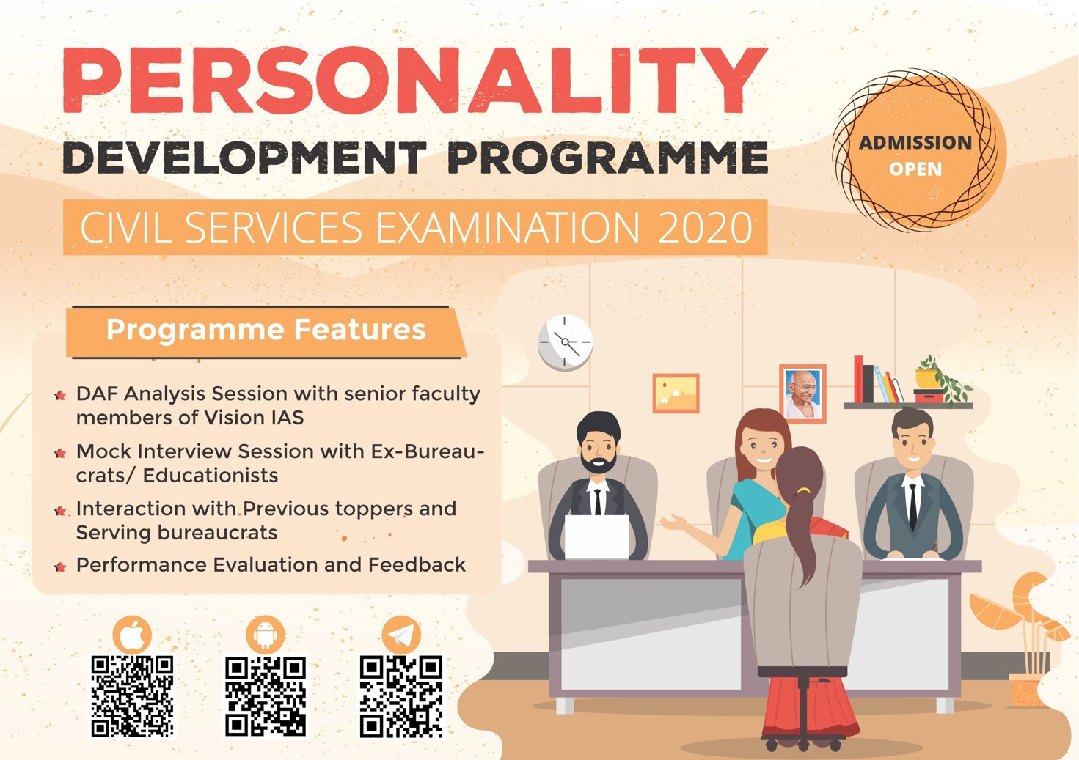

|  |  |
| --- | --- |
|  | * They are **Namasudras**, a **Scheduled Caste group** which **trace their ancestry to East Bengal**, and many of them entered West Bengal after the formation of Bangladesh. * The **Matua Mahasangha**, a religious reforms movement and a sect, was formed by **Harichand Thakur (1812-1878)** in East Bengal in the mid-1800s. * Matua politics revolved around anti-Congressism, including their   **opposition to the Swadeshi Movement (1905-1908)**.   * In later times, they were close to rural **Bengal’s Vaishnava tradition**. Their only ritual was singing devotional songs in the Bhakti tradition and songs defied the Brahmanical rituals. |
| **Kutia Kondhs** | * They are **Particularly Vulnerable Tribal Groups (PVTGs) in Kalahandi**, Odisha.   o Families are mostly **nuclear and patriarchal**. Adolescent females live  separately at **‘youth dormitories’.** |

**Copyright © by Vision IAS**

*All rights are reserved. No part of this document may be reproduced, stored in a retrieval system or transmitted in any form or by any means, electronic, mechanical, photocopying, recording or otherwise, without prior permission of Vision IAS.*



**157**

DELHI | JAIPUR | PUNE | HYDERABAD | AHMEDABAD | LUCKNOW | CHANDIGARH | GUWAHATI

© Vision IAS

t> 7 IN

TOP 10

SELECTIONS **IN CSE 2019**

FROM VARIOUS PROGRAMS OF VISION IAS



6

A

VISHAKHA YADAV

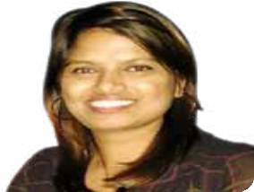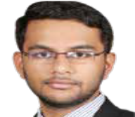

7

AIR

GANESH KUMAR BASKAR

t> 9 IN

TOP 10

SELECTION **IN CSE 2018**

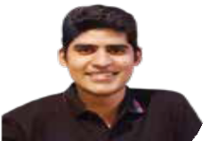

KANISHAK KATARIA

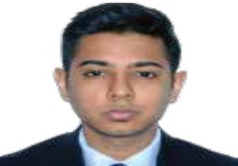

A

2

AKSHAT JAIN

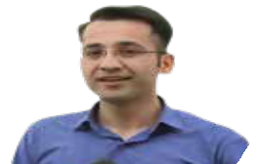

3

A

JUNAID AHMAD



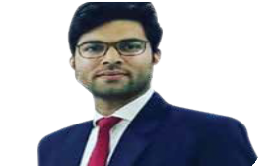

4

A

SHREYANS KUMAT

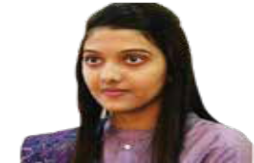

5

AIR

SRUSHTI JAYANT DESHMUKH

**8468022022** @ WWW.VIS IO NIA S . IN

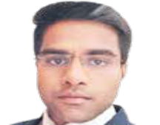

AIR

KARNATI VARUNREDDY

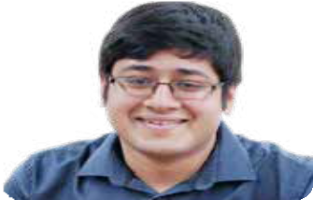

JATIN KISHORE

2

AIR

*I I*

DELHI I JAIPUR I PUNE I AHMEDABAD I HYDERABAD I CHANDIGARH I LUCKNOW

I GUWAHATI